Srihari Rao and Sagar Patel

flickrMap Project

GitHub: https://github.com/kinghenry8/flickrMap

This map project was created using the mapbox API and integrated with the flickr API. Using the photo.search and photo.get.geo methods we are able to retrieve public photos within a bounding area defined by the initial mapbox viewport with a degree of accuracy representing how wide want to search for public photos. The data retrieved from flickr was retrieved using jQuery ajax calls and the data was parsed to JSON allowing us to rebuild the flickr info into the mapbox markers. If a new image is added into the flickr database in our viewport we can see it just by clicking show flickr photos again. Rather than using backbone to handle our delete and addFaves method calls to store/retrieve data into mongoDB we simply used two separate get requests.

Sagar Patel was responsible for the front end. He got the mapbox API initially figured out and provided the CSS structure and added some jquery UI stuff to polish out the presentation. Srihari Rao was responsible for flickr API research and integrating the two APIS to work together. Most of the JavaScript was done by Srihari and front end work done by Sagar.

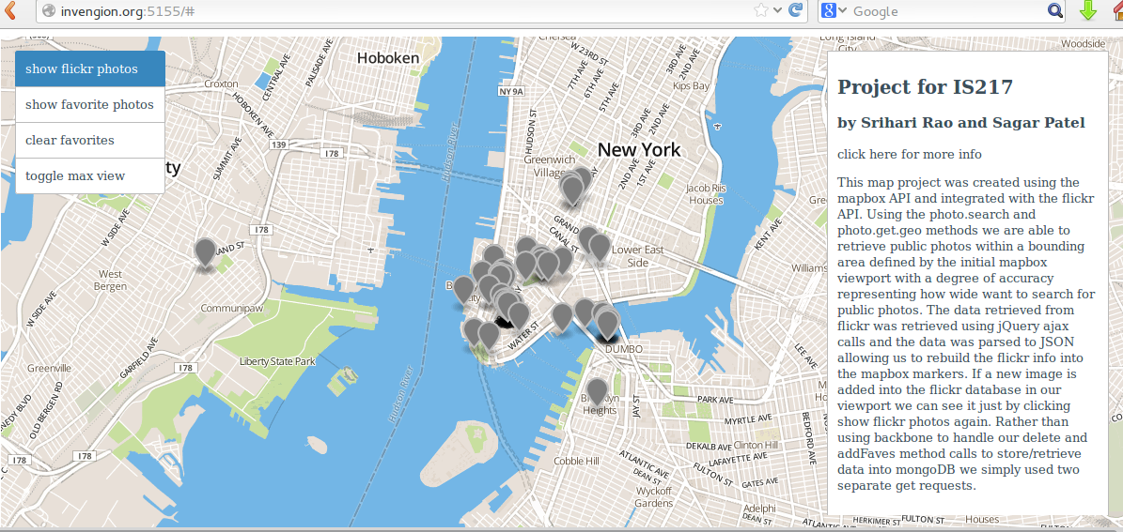

Here we see all the public flickr photos selected to be viewed.

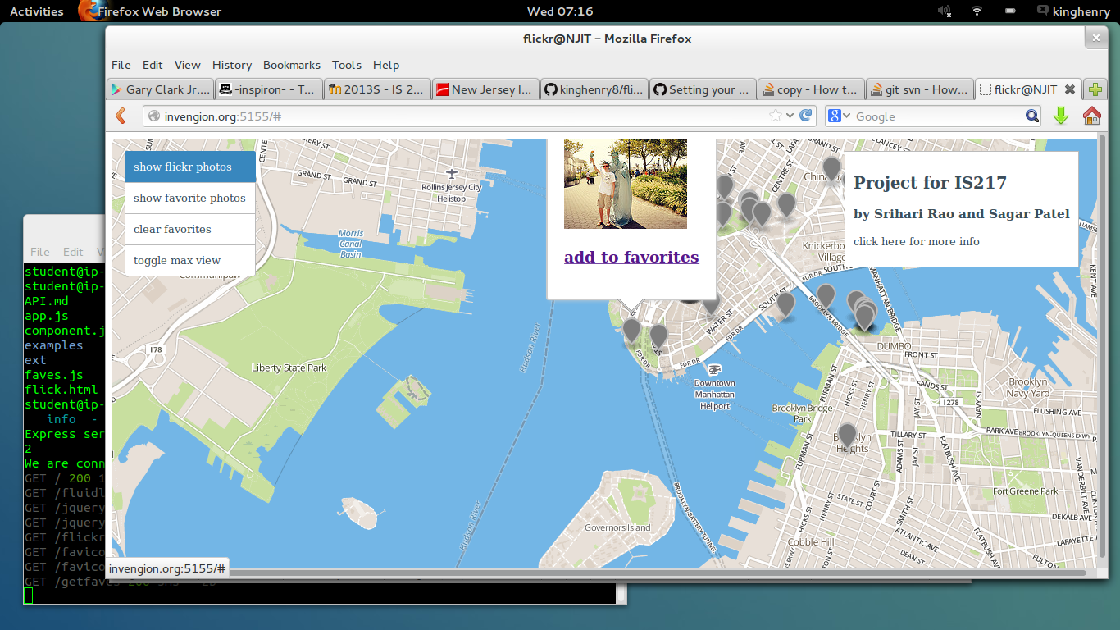

Here wee see that the tooltips contain an add to favorites link.

Here we see a javascript alert confirmation of the favorite being succesfully added to mongoDB.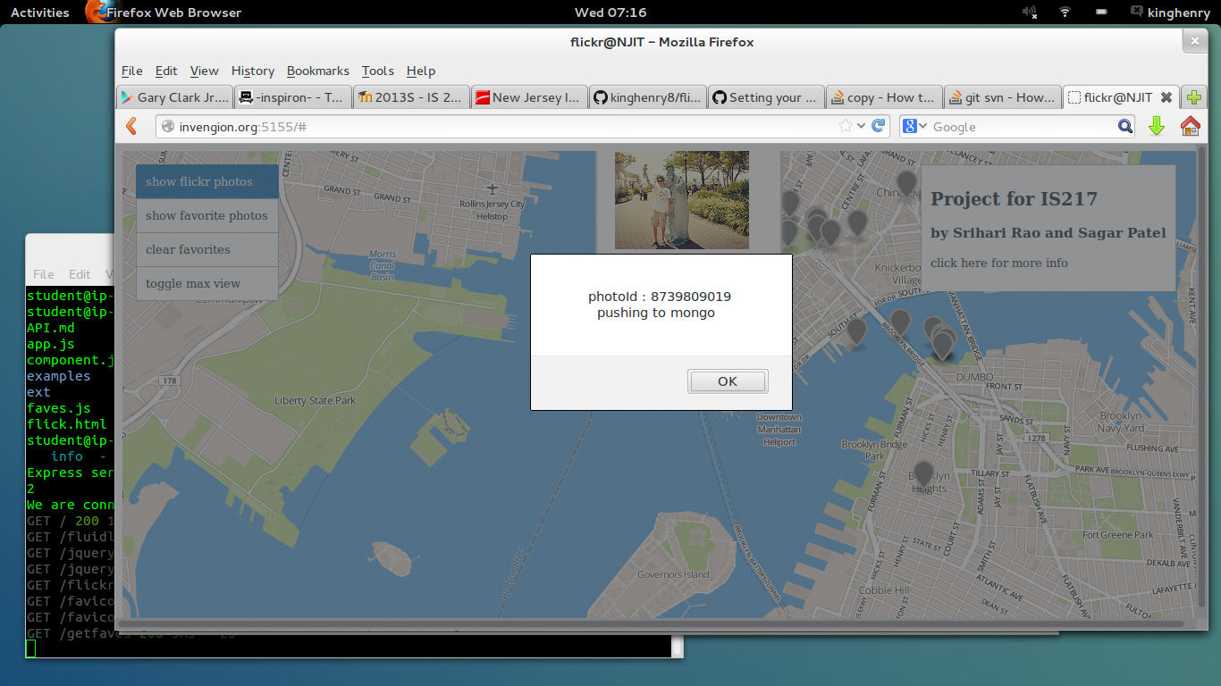

Here wee see just the favorites selected.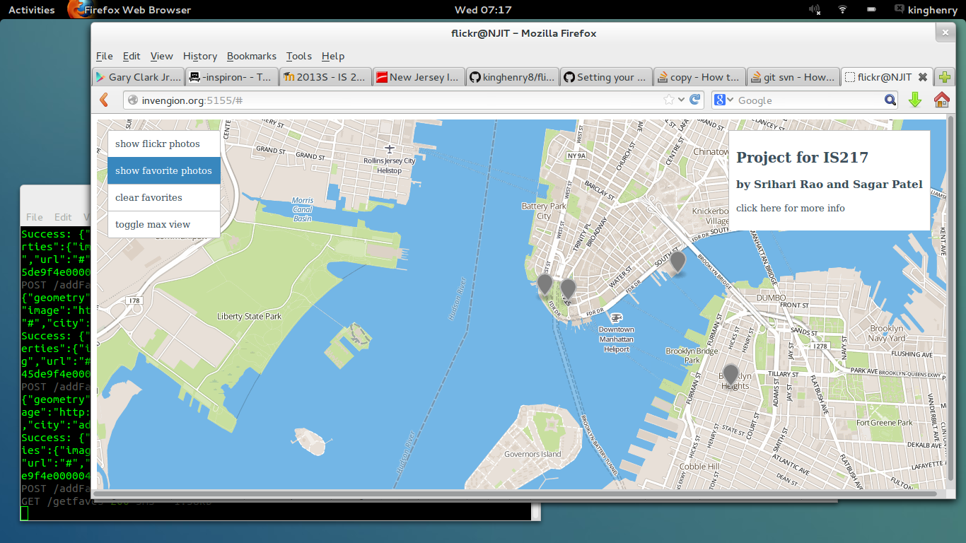

Here we see the favorites cleared.