**MEDIA STREAMING WITH**

**IBM CLOUD VIDEO**

**STREAMING**

**PHASE 4- DEVELOPMENT**

**PART-2**

**AGENGDA**

•

OBJECTIVE

•

BUILDING A VIRTUAL PLATFORM

USING IBM CLOUD VIDEO

STREAMING INVOLVES SEVERAL

STEPS, AND RESULTS FROM

PUBLISHER AND USER

•

CONCLUSION

**OBJECTIVE:**

The goal of this project is to create a virtual platform that leverages IBM Cloud Video Streaming to facilitate interactive and secure video experiences. By the last development part-1 followed by integrating video streaming services and enabling on demand play back. Implement the functionality for users to upload their movies and videos to the platform. Integrate IBM Cloud video streaming services to enable smooth and high-quality experience.

|  |  |  |  |
| --- | --- | --- | --- |
|  | | |  |
|  | |  | | --- | | WATCH THE NEW VIDEO  <https://video.ibm.com/channel/v3JnHuKBSMx> | | |
|  | | |
|  | |  |

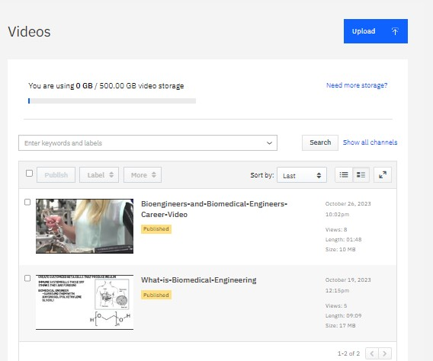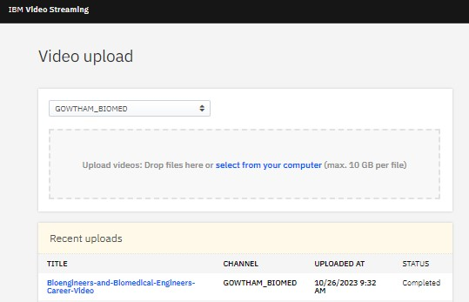

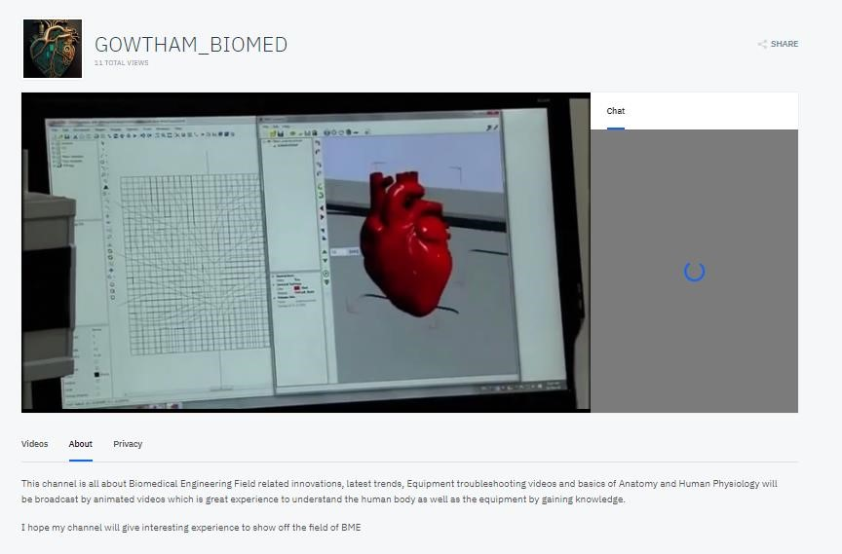

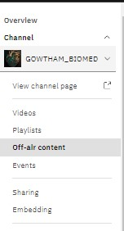

MY PC R

ESULT

USER WATCH THE VIDEO BY

OFF-AIR STREAMING-RESULT

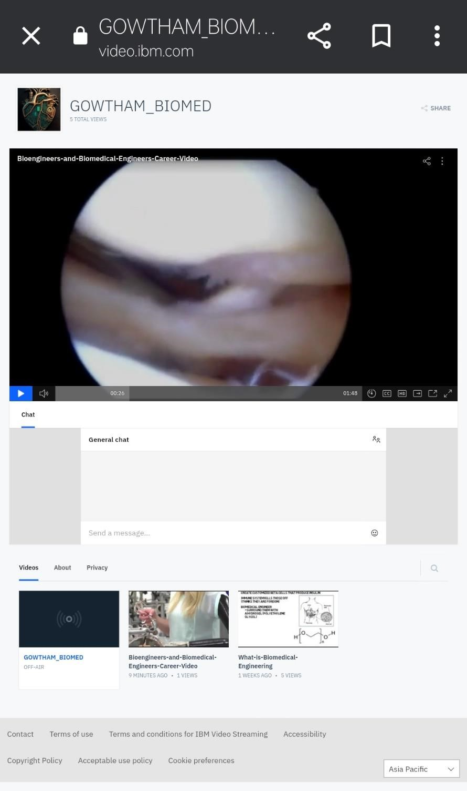

**CONCLUSION:**

By integrating on-demand video playback, user video uploads, and leveraging IBM Cloud Video Streaming services, the virtual platform becomes a dynamic and user-centric hub for creating, sharing, and enjoying video content. It offers a diverse range of features for both content creators and viewers, ensuring high-quality video delivery and user engagement.