# Basic Flow of Events

## Create Audit(s) - Basic Flow

|  |  |  |  |
| --- | --- | --- | --- |
| **Brief Description:** Audit Manager clicks “Create Audit” Hyperlink from the left navigation bar of the “Plan Audit” menu to create audit and selects a dealer and assigns an auditor. | | | |
| **Precondition:** The Audit Manager has already selected the audit candidate. Application has already downloaded Dealer data into FDAS database. | | | |
| **Post condition:** Audit is created and assigned to Auditors. | | | |
| **Flow** | **Step** | **User Actions** | **System Actions** |
| B | 1 | Clicks on the “Plan Audit” tab on the left navigation bar | Displays the options under “Plan Audit” including “Create Audit” |
|  | 2 | Clicks the “Create Audit” link under “Plan Audit” from the left navigation bar | Displays the “Select Dealer” screen indicating the 4-step process bar on the top of the screen and displays the following columns and will allow user to sort and search based on any column   * Dealer Code, * Business center, * Dealer name, * State * Country   Display 4 step process bar Highlighting the “Select Dealer” step |
|  | 4 | If user desires, clicks on the button next to header label of any column to sort the list based on that column | Sort the list of dealers based on the header Audit Manager clicked to sort |
|  | 5 | Selects a dealer by clicking on the dealer row of the search results table | Selects the dealer and displays “Dealer Information” screen which contains the selected dealer information.  Displays following details:  **Dealership Details:**   * Business Center * Dealer Code * Dealer Name * DBA * Dealer Principal * Dealer name for letter greeting * Sales Group Size * Inception Date   **Address:**   * Address Line 1 * Address Line 2 * City * State (Province) * ZIP * Country   **Contact Details:**   * Phone * Email   Display 4 step process bar Highlighting the “Dealer Information” step |
|  | 6 | If user desires, may edit any of the following fields   * Business center * Dealer Principal * Name for letter greeting * Address Line 1 * Address Line 2 * City * State * Zip * Country * Phone * Email.   Click on next button at lower right corner of the screen | Stores the dealer data in temporary space to create the Audit when user confirms in step 4 of Create Audit process  Displays “Assign Auditor” screen with the following details.   * Audit Type * Reports Language * Reason Audit was selected * Date assigned * Number of months data * State Legal Limitation * Comments * Lead Auditor * Lead Auditor Work percentage * Button to add one more auditor   Display 4 step process bar Highlighting the “Assign Auditor” step |
|  | 7 | Enter the following details   * Audit Type * Reports Language * Reason Audit was selected * Date assigned * Number of months data * Comments * Lead Auditor * Lead Auditor Work Percentage * Optionally Assistant Auditors and work percentages * If desired on Warranty data type, Include Parts data   Click next button on the lower right corner of the screen | Display the “Review & Submit” screen with summary details of Dealer and Audit Assignment Information retrieved or entered by the user  Display 4 step process bar highlighting the “Review & Submit” step |
|  | 8 | Check the summary of Dealer details and Audit Assignment details and clicks on the Submit button on lower right side of the screen | Create the audit using the information (Save the new audit details in FDAS tables) and Assigns the Audit to the Auditors  Displays a flash message box indicating that Audit is successfully created with OK button. |
|  | 9 | Clicks on OK | Displays the Dashboard.  This flow ends here. |
| E2 | 1 | **Work allocation is not 100%:**  On “Assign Audit” screen if the total work percentage for all the auditors is not 100% | System displays an error message and will not allow Audit Manager to next screen till the Percentage is 100% |
| E3 | 1 | **Assigned Date entered is past date:**  Enters a past date for date assigned on Assign Auditor screen | Display an error message and will not allow Audit Manager to continue with Create Audit Process  Base Flow Step 7 (Assign Auditor) will continue |
| E4 | 1 | **Duplicate Audit:**  When the Audit Manager clicks on Next button on “Assign Audit” screen and the Dealer name and Audit type and Assign date is matching with another audit in the system | System displays an error message and will not allow the Audit Manager to continue with the duplicate audit creation. |

# Acceptance Criteria

**Step B2: Search and Select Dealer**

* By Default, the page should have search fields (Dealer code, Dealer Name and Country) for selecting the Dealer.
* Ability to filter the result set as per the selected search criteria and show selected number of entries per page.
* Ability to sort the Dealer selection by Dealer Code, Business Center, Dealer Name, Dealer State, Country.
* Ability to select the Dealer from the search result set.
* Ability to search using full or partial Dealer Code or Dealer Name.

**Step B5: Dealer Information**

* By Default, the page should be prepopulated with the selected dealer data.
* Ability to Edit Business center, Dealer Principal, Name for letter greeting, Address, Phone and email.
* Ability to Cancel the Audit creation and this should bring the user to Dashboard.
* Ability to go back to Dealer search screen.
* Ability to proceed to Auditor selection.

**Step B6: Assign Auditor**

* Ability to assign an auditor for any Audit Type (Sales, Warranty, RSA and Other).
* Ability to assign multiple Auditors for single audit.
* Perform check and error message is displayed to ensure that all auditors have work allocation percentage before proceeding to create an Audit.
* Perform Check and error message is displayed to make sure that work allocation percentage is 100% before proceeding to create Audit.

**Step B7: Review and Create Audit**

* Ability to review Dealer information and Audit Assignment details before creating Audit.
* Perform duplicate check and ensure an error message is displayed on creating an Audit.
* Ability to Cancel an Audit in any step of the process

# Alternative Flows

.

## Alternate Flow (A1) – Cancel Audit creation

|  |  |  |  |
| --- | --- | --- | --- |
| **Brief Description:** Audit Manager can cancel the create Audit process | | | |
| **Precondition:** Audit Manager has started creating an audit | | | |
| **Post condition:** Create Audit process has been cancelled and no data has been saved in the FDAS tables | | | |
| **Flow** | **Step** | **User Actions** | **System Actions** |
| A1 | 1 | If desired, from basic flow Step 3 to Step 7 clicks the cancel button to cancel the audit creation process | Display a warning message  On confirmation system will cancel the process and display the Home screen |

## Alternate Flow (A2) – Select Auditor from Search window

|  |  |  |  |
| --- | --- | --- | --- |
| **Brief Description:** Audit Manager can select an auditor from the list of existing Auditors | | | |
| **Precondition:** Audit Manager has started creating an audit and selected a dealer | | | |
| **Post condition:** Auditor was selected and displayed | | | |
| **Flow** | **Step** | **User Actions** | **System Actions** |
| A2 | 1 | At Step 7 of base flow Audit Manager clicks on Search button next to Auditor field in Assigned Auditors section | System will show the list of Auditors and allow user to select one Auditor  Following fields will be displayed:   * Last Name * First Name * City * State * Number of Open Audits for Sales, RSA and Warranty (With status less than file mail date) assigned to the Auditor |
|  | 2 | Audit Manager will select an Auditor by clicking on the Auditor row | System will assign the Auditor for the Audit and Assign Auditor screen will be displayed  The Create Audit flow will continue from Step 7 of Main flow. |

## Alternate Flow (A3) – Add Assistant Auditors

|  |  |  |  |
| --- | --- | --- | --- |
| **Brief Description:** Audit Manager can Add additional Auditors | | | |
| **Precondition:** Audit Manager has started creating an audit and selected a dealer | | | |
| **Post condition:** Multiple Auditors were assigned to the Audit | | | |
| **Flow** | **Step** | **User Actions** | **System Actions** |
| A3 | 1 | At Step 7 of base flow, clicks on Add button next to Auditor Assignment field in Assigned Auditors section | Display additional fields to enter Assistant Auditor name and work allocation percentage. Also Display button to remove the assistant Auditor.  Also System will display button to add one more Auditor by clicking Add button |
|  | 2 | Select an assistant Auditor by following Alternate flow A2 and assigns work percentage to assistant auditor | Reduce the work percentage from Lead auditor (First Auditor in list) and assign the percentage to Assistant auditor |
|  | 3 | Audit Manager removed one of the Assistant Auditors | System will add the deleted Auditors work percentage to Lead Auditor (First in the list of Auditors)  Audit Manager can continue flow from Step 7 of main flow if total work percentage is 100 |

# Business Rules

|  |  |
| --- | --- |
| **Business Rule #** | **Business Rule** |
| UC-PL01_BR01 | Audits can be created only for Active Dealers |
| UC-PL01_BR02 | Audits can be assigned only for Active Auditors |

# UI Prototype

## Create Audit – Select Dealer

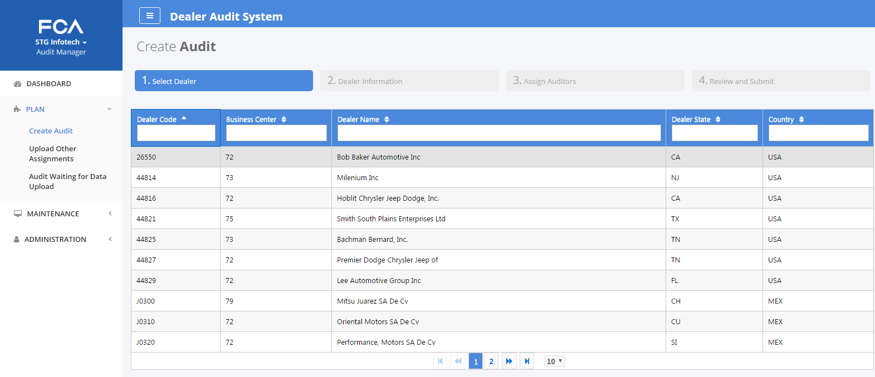

### **Screen Definition – Create Audit – Select Dealer**

| **Field/Attribute Name** | **Field Type** | **Length/ Constraints** | **Description** | **Rules / Error Messages** |
| --- | --- | --- | --- | --- |
| **Create Audit** | Page Heading |  |  |  |
| **Select Dealer** | Step Name in the progress bar |  | Display Create Audit steps on top of the page and the current step highlighting “Select Dealer” tab |  |
| **Results Table – Display records for matching criteria**  Audit Manager can sort by clicking on sort button next to column label  Search using the search box under each column  Display 10 rows per Page by default | | | | |
| Dealer Code | NA | 5  Alpha Numeric | Dealer code from FDAS tables (Data received from SPOT for this table) | When Audit Manager click on the dealer row in search results dealer will be selected and next page “Dealer Information” will be displayed |
| Business Center | NA | 2  Text | Business Center from FDAS Dealer table (Data received from SPOT for this table) |  |
| Dealer Name | NA | 34  Text | Dealer Name from FDAS tables (Data received from SPOT for this table) |  |
| Dealer State | NA | 2  Text | Dealer State from FDAS tables (Data received from SPOT for this table) |  |
| Country | NA | 3  Text | Dealer Country from FDAS tables (Data received from SPOT for this table) |  |
| Buttons | | | | |
| Sort Button next to Search results header labels |  |  | Sort the search results in ascending order.  In next click the results will be displayed on descending order |  |

## Create Audit – Dealer Information

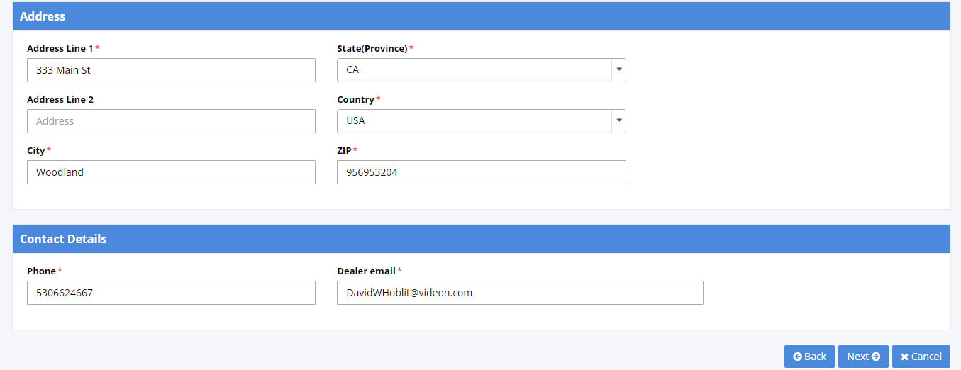

### **Screen Definition – Create Audit – Dealer Information**

| **Field/Attribute Name** | **Field Type** | **Length/ Constraints** | **Description** | **Rules / Error Messages** |
| --- | --- | --- | --- | --- |
| **Create Audit** | Page Heading |  |  |  |
| **Dealer Information** | Step Name in the progress bar |  | Display Create Audit steps on top of the page and the current step highlighting “Dealer Information” tab |  |
| **Dealership Details – Section**  **Fields will be display data for the dealer selected on “Select Dealer” page** | | | | |
| Business Center | Text Box | 2  Text | Business Center from FDAS Dealer table (Data received from SPOT for this table) | Editable, Optional  Allow Spaces |
| Dealer Code | Text box | 5  Alpha Numeric | Dealer code from FDAS tables (Data received from SPOT for this table) | Non-Editable |
| Dealer Name | Text Box | 34  Text | Dealer Name from FDAS tables (Data received from SPOT for this table) | Non-Editable |
| DBA | Text Box | 68  Text | DBA from FDAS tables (Data received from SPOT for this table) | Non-Editable |
| Dealer Principal* | Text Box | 60  Text | Dealer Principal from FDAS tables (Data received from SPOT for this table) | Editable; Mandatory  Update the Modified value in dealer details |
| Dealer Name for Letter Greeting* | Text Box | 60  Text | Copy from Dealer Principal and let Audit Manager Edit this field | Editable; Mandatory  Save the Modified value in Audit details  Prefix “Mr. “ |
| Sales Group Size | Text Box | 1  Character | Sales Group Size from FDAS tables (Data received from SPOT for this table) | Non-Editable |
| Inception Date | Date |  | Inception Date from FDAS tables (Data received from SPOT) | Optional; Editable  Cannot be Future Date |
| **Address – Section** | | | | |
| Address Line 1 | Text Box | 255  Text Box | Address from FDAS tables (Data received from SPOT for this table) | Editable; Mandatory  Update the modified value in dealer details |
| Address Line 2 | Text Box | 255  Text Box | Address from FDAS tables (Data received from SPOT for this table) | Editable; Optional  Update the modified value in dealer details |
| City* | Text Box | 50  Text Box | City from FDAS tables (Data received from SPOT for this table) | Editable; Mandatory  Update the modified value in dealer details |
| State (Province)* | Dropdown |  | State (Province) from FDAS tables (Data received from SPOT for this table) | Editable; Mandatory  Update the modified value in dealer details |
| Country* | Dropdown |  | Country from FDAS tables (Data received from SPOT for this table) | Editable  Update the modified value in dealer details |
| ZIP* | Text Box | 10  Text Box | ZIP from FDAS tables (Data received from SPOT for this table) | Editable  Update the modified value in dealer details |
| Contact Details | | | | |
| Phone* | Text Box | 15  Text Box | Phone from FDAS tables (Data received from SPOT for this table) | Editable; Mandatory  Update the modified value in Audit details |
| Dealer email* | Text Box | 500  Text Box | Email from FDAS tables (Data received from SPOT for this table) | Editable; Mandatory  Update the modified value in Audit details  Allows multiple emails separated by comma |
| Buttons | | | | |
| Cancel |  |  | Cancel the Audit creation and take the screen back to Home page | Modified data will not be saved in FDAS tables |
| Back |  |  | Go back to the previous page “Select Dealer” and allow user to select another dealer | Modified data will not be saved in FDAS tables |
| Next |  |  | Validate the mandatory fields and navigate to next step in the Audit Creation process “Assign Auditor” | Modified data will not be saved in FDAS Tables at this point. But it Will be preserved to save in tables once the Audit Creation is completed |

## Create Audit – Assign Auditor

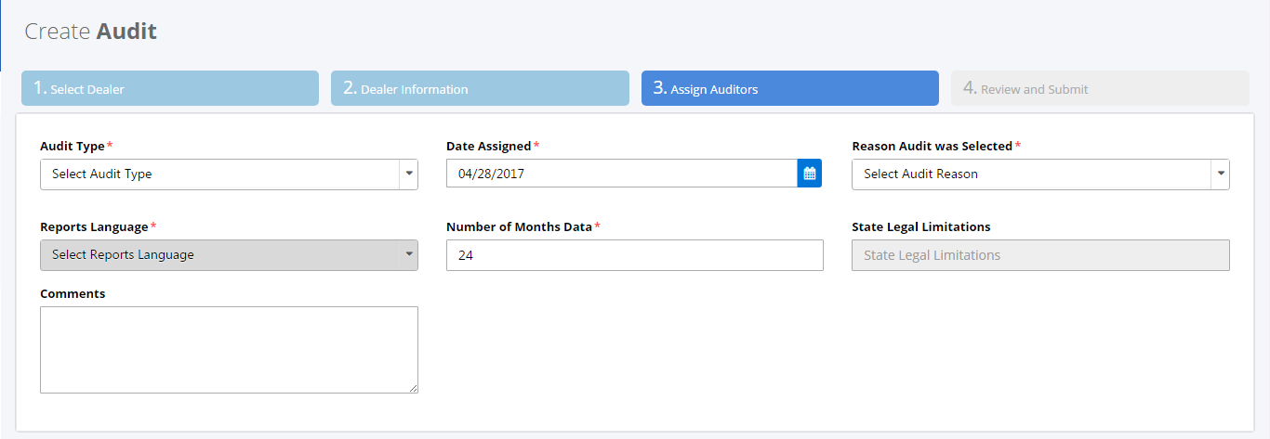

### **Screen Definition – Create Audit – Assign Auditor**

| **Field/Attribute Name** | **Field Type** | **Length/ Constraints** | **Description** | **Rules / Error Messages** |
| --- | --- | --- | --- | --- |
| **Create Audit** | Page Heading |  |  |  |
| **Assign Auditors** | Step Name in the progress bar |  | Display Create Audit steps on top of the page and the current step highlighting “Assign Auditors” tab |  |
| **Fields** | | | | |
| Audit Type* | Dropdown | Allowed Values will be  Sales, Warranty, RSA | Audit Type. | Editable, Mandatory  Default Value –” Select Audit Type”  Values will be saved in Audit Information |
| Reports Language* | Dropdown | Allowed Values will be  English, Spanish and French | Language in which reports can be generated | Editable, Mandatory  Default value - “English”  Values will be saved in Audit Information |
| Reason audit was selected* | Dropdown  To select multiple Values | Values will be populated from User fields in FDAS | Dealer Name from FDAS tables (Data received from SPOT for this table) | Editable, Mandatory  Default value – Blank  Values will be based on Audit Type (Sales and RSA will use same values)  Values will be saved in Audit Information |
| Date Assigned* | Date | Date in MM/DD/YYYY format | Audit Assigned Date | Editable, Mandatory  Default Value – Current Date  Past date is not valid  Values will be saved in Audit Information |
| Number of Months Data* | Text Box | 2  Number | Number of months data to be downloaded | Editable, Mandatory  Default Value – 24  Cannot be more than 27  Values will be saved in Audit Information |
| State Legal Limitation | Text Box | 2  Number | State Legal Limitation from FDAS tables | Non-Editable, Mandatory  Values will be saved in Audit Information |
| Comment | Text Box | 500  Text | Comments area to enter any comments while creating audit | Editable  Default Value – Blank  Cannot be more than 27  Values will be saved in Audit Information |
| Assign Auditors - Section | | | | |
| Auditor-1 | Text Box with Search option to select Auditor | 30  Text | Assigned Auditor Name | Editable, Mandatory  Default Value – Blank  Values will be saved in Audit Information |
| Work Allocation % - 1 | Text Box | 4  Text | % of work allocated to the selected Auditor | Editable, Mandatory  Default Value – 100  Values will be saved in Audit Information |
| Auditor (Additional) | Text Box with Search option to select Auditor | 30  Text | Assigned Auditor Name | Editable, Mandatory if the field is available  Default Value – Blank  Values will be saved in Audit Information |
| Work Allocation % - (Additional) | Text Box | 4  Text | % of work allocated to the selected Auditor | Editable, Mandatory if the field is available  Default Value – 0  Change in the % will reduce from Lead auditor in first row  Values will be saved in Audit Information  Total work % for all Auditors should be 100% |
| Buttons | | | | |
| Add (In Assign Auditors – Section) |  |  | Add one more row of “Auditor”, “Work Allocation %” and Action buttons | Can be added unlimited number of Auditors |
| Remove (In Assign Auditors – Section) |  |  | To remove any additional Auditor added | Will be displayed only for Additional Auditors |
| + & - (In Assign Auditors – Section) |  |  | To increase or decrease the % | Will be displayed only for Additional Auditors |
| Search |  |  | Will Display a popup with list of auditors |  |
| Cancel |  |  | Cancel the Audit creation and take the screen back to Home page | Entered data will not be saved in FDAS tables |
| Back |  |  | Go back to the previous page “Select Dealer” and allow user to select another dealer | Entered data will not be saved in FDAS tables |
| Next |  |  | Validate the mandatory fields and navigate to next step in the Audit Creation process “Review & Submit” | Entered data will not be saved in FDAS Tables at this point. But it Will be preserved to save in tables once the Audit Creation is completed  Do not allow to next page if there is a duplicate audit for the Dealer and Audit type |

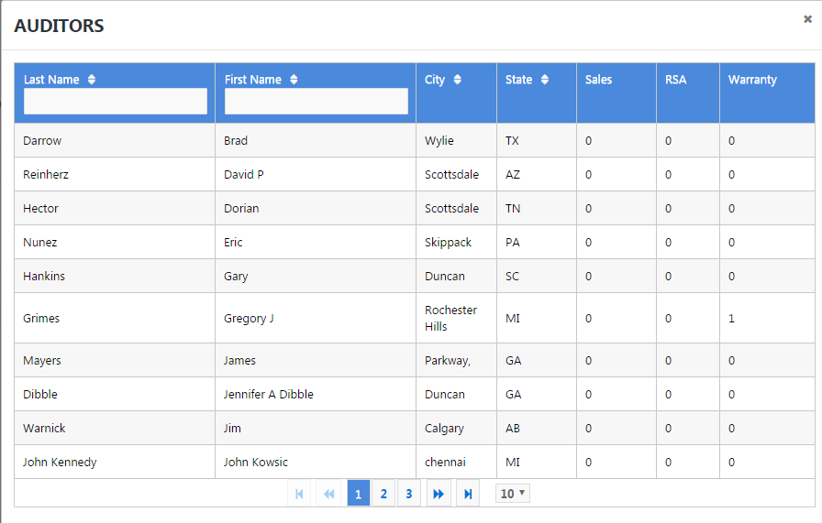

### **Screen Definition – Create Audit – Assign Auditor – Search Auditor popup**

| **Field/Attribute Name** | **Field Type** | **Length/ Constraints** | **Description** | **Rules / Error Messages** |
| --- | --- | --- | --- | --- |
| **Auditors** | Page Heading |  |  |  |
| **Results Table – Display records for matching criteria**  Audit Manager can sort the search results by clicking on sort button next to column label  Default 10 records per page | | | | |
| First Name |  | 60  Text | Auditor Name from FDAS Auditor Profile tables | Only Active Auditors will be displayed   * On selecting the Auditor on this page, Auditor name will be copied to “Assign Auditor” page |
| Last Name |  | 60  Text | Auditor Name from FDAS Auditor Profile tables |  |
| City |  | 20  Text | City from FDAS Auditor Profile tables |  |
| State |  | 2Text | State from FDAS Auditor Profile tables | If the State is not in State Legal limitation then show error and let user enter new state in State Legal Limitation screen |
| Assigned Audits  Sales  RSA  Warranty |  | 2  Number | Number of Audits currently assigned to the Auditor. Calculated from FDAS audit assignment tables |  |
| Buttons | | | | |
| Close (X) |  |  | Cancel the search and go back to Assign Auditor page |  |

## Create Audit – Review & Submit

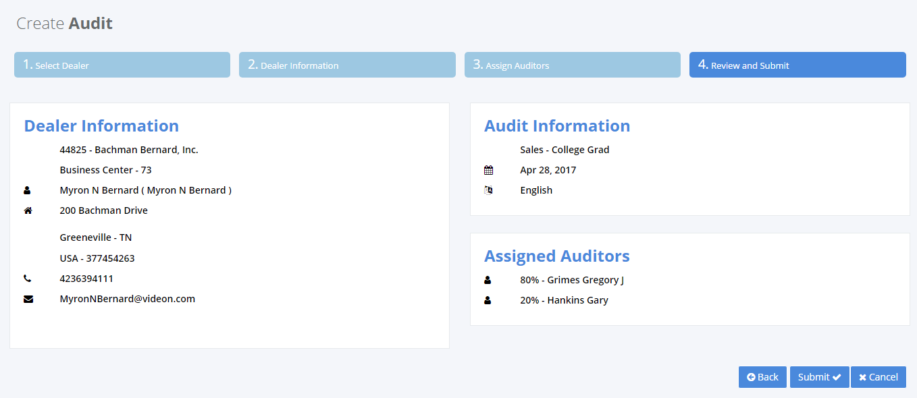

| **Field/Attribute Name** | **Field Type** | **Length/ Constraints** | **Description** | **Rules / Error Messages** |
| --- | --- | --- | --- | --- |
| **Create Audit** | Page Heading |  |  |  |
| **Review & Submit** | Step Name in the progress bar |  | Display Create Audit steps on top of the page and the current step highlighting “Review & Submit” tab |  |
| **Fields** | | | | |
| All the fields from “Dealer Information” & “Assign Auditor” |  |  | Display all the fields from “Dealer Information” & “Assign Auditor” in read-only summary format |  |
| Buttons | | | | |
| Back |  |  | Allow User to go back and modify any information entered |  |
| Submit |  |  | Create the Audit | Show Confirmation dialogue box  “Audit Successfully Created” message  Display error if there is a duplicate audit. And do not create audit record.  Save data in FDAS Audit record tables as new Audit |