INTRODUCTION

System Requirement Specification (SRS) describes the overview of the application and functional requirements viz. Input/output, Screens, Reports and Business logic of each module in the system. The Document is the primary source of application requirements and design for the developer. This document in its approved form will be the basis for application software development.

1.1 Purpose

This Document forms the System Requirement Specification for the Vehicle Regulation during the process of entry and exit in VSP. The purpose of the SRS is to clearly specify the requirements of the above system. It defines various functions to be realized and procedures to be followed.

The SRS is the result of the discussions with the Personnel at CISF of VSP. It is put before the users of the system for review so that exact functionalities of the system can be clarified and confirmed. The user, to make it more precise and user friendly can suggest modifications to the same. After the user acceptance of the SRS, a detailed system design will be materialized.

1.2 Proposed system

A three-node network will be proposed at the BC Gate, CISF post, operated with the Windows 2000. VB6 and ORACLE8i based application software will be developed to enter all the data feeding and retrieval about vehicle regulation during the process of vehicle entering into, and exiting from VSP through BC Gate. One node will be provided at the In-Gate to enter the person details, who is checking the documents while entering in to VSP. Another node will be provided at the Out-Gate to enter the person details, who is checking the documents while exiting from VSP through BC Gate. The third node is provided for In-charge for the same purpose.

1.3 Scope

The Software Product being developed is named as Vehicle Registration System or VRS. This system is developed with a view to computerize day-to-day manual procedures carried out at the BC Gate, CISF Post to speed up the document checking and to guard against forgery of documents.

1.4 User Characteristics

The envisaged users of this system are assumed to possess the following characteristics.

- Familiarity with the operation of computer based applications.

- They should be able to understand the messages given by the computer.

- They should be able to key in the details into the system.

1.5 Acronyms and Abbreviations

SRS | Software Requirement Specifications
CISF | Central Industrial Security Force
VRS | Vehicle Registration System
VSP | VISAKHAPATNAM STEEL PLANT
GUI | Graphic User Interface
LSGP | Load Slip And Gate Pass
DO | Delivered order
DC | Delivery Challan

  - References

S.No | Document Name
1 | Existing System Functionality
2 | Existing Report Formats
3 | Discussion Notes

GENERAL DESCRIPTION

2.1 System description

VRS first regulates the generated documents like LSGP and DC com Invoice etc., at BC Gate, CISF Post. If the documents produced by the transporters are correct, then only VRS allows them to enter into the VSP, to carry the finished products on behalf of the customers.

While VRS registers all the details like entered date, time, driver name, license number, shift, and CISF person, who checks the produced documents, CISF in-charge person for respective shift etc.

Similarly the same process is undertaking at the time of exiting from VSP with carrying materials. While VRS registers the details like outgoing date, time, shift, and CISF person, who checks the produced documents, CISF in-charge person for respective shift etc.

The system maintains history of each CISF person and every registration of the vehicle at the time of entering and/or exiting in the Magnetic Disk. The day to day processing, printing of reports, scrutinizing of documents, maintenance of records is also envisaged in the VRS.

The following are the envisaged benefits of VRS: -

- User-friendly menu-driven product design.

- Making the day-to-day operations smoother and easier

- Quick access to the required information.

- Generation and printing of reports (daily, monthly, yearly).

Entry of different Types of Reports

CISF Vehicle Registration Data

Report Generation and Printing

2.2 List of modules

The systems contains following modules:

- Vehicle Registration Details Entry.
- Vehicle Details.
- Reports.

2.3 Assumptions

The documents and information provided by BC Gate Marketing office is assumed to be the complete description of the existing system.

2.4 Dependencies

In case of interface with other application(s), it depends on the flexibility, availability and acceptability of the system.

2.5 Interface with other systems

This System is being developed as an isolated module with no immediate interface with any other application.

3. MENU

After logging into the system, the main menu options of the application appear and allow the user to choose the desired one. Once the option is clicked the system takes the user into the corresponding screen.

MAIN MENU:

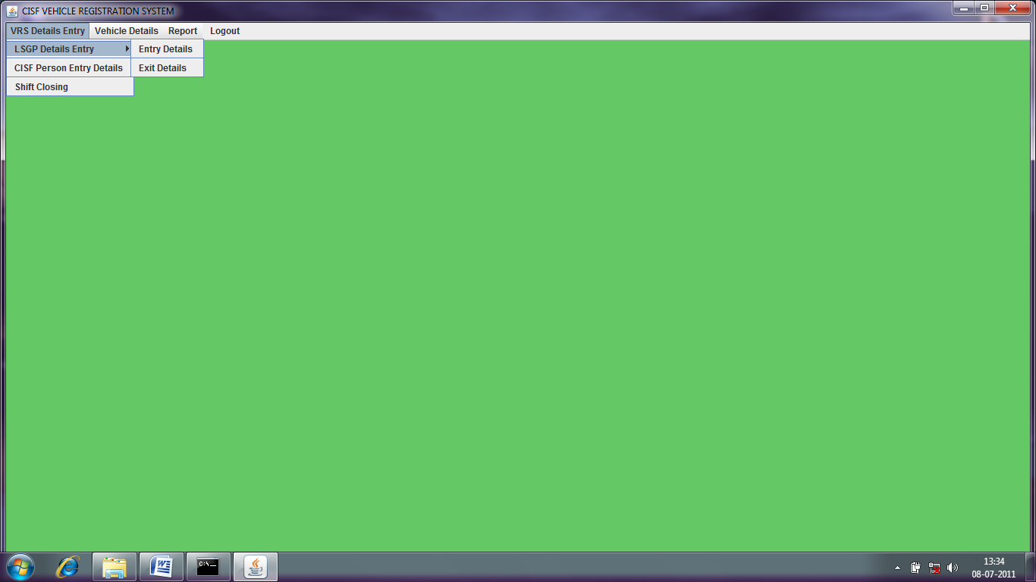

3.1 Menu Items:

The common menu items for all active windows in the application described as below:

Menu Option | Item | Key | Description
Action | Save | Alt+S | Save the Record
Action | Display | Alt+D | Display the Record
Action | Update | Alt+U | Modifications of the Record
Action | Exit | Alt+X | Exit from Screen

4. FUNCTIONAL REQUIREMENTS

The functional requirements have been divided into various logical modules as follows:

- Vehicle Registration Details Entry Module.
- Vehicle Details Module.
- Reports.

The each and every module is illustrated in sections to follow under different section heads as follows

i) Description of the function
ii) Input to the function
Iii) Screen layout
iv) Processing
v) Output

In the input section, the following abbreviations have been used as per the following list:

M- Mandatory, O-Optional, P-Pop up list, E-Entry, D-Display

4.1 VEHICLE REGISTRATION DETAILS ENTRY

Vehicle Registration Details Entry module consists of following sub modules:

- LSGP Details Entry
- CISF Person Details Entry
- Shift Closing

4.1.1 LSGP DETAILS ENTRY

The function of this sub module is to store new information about vehicle registration while entering and/or exiting through BC Gate as well as maintains the existing vehicle registered information. LS_NO is the primary key of the CISF Master, which maintains the above information.

This sub module again consists of following two sections:

- Entry Details
- Exit details

4.1.1.1 Entry Details

The function of this sub module is to store new information about vehicle registration while entering into VSP through BC Gate as well as it maintains the existing vehicle registered information. LS_NO is the primary key of the CISF Master, which maintains the above information.

4.1.1.1.1 Description

This sub module handles all the details of a vehicle registration while entering into VSP to take finished products on behalf of the customers. For a new arrival of vehicle, it inserts a new record where as an existing vehicle registered record may be updated.

4.1.1.1.2 Input

FILE DESCRIPTION | DATA TYPE | SIZE |  |  | REMARKS
IN_SLNO | NUMBER | 5 | M | D
IN_DATE | DATE |  | M | D
IN_TIME | CHAR | 8 | M | D
LS_NO | CHAR | 10 | M | E
PARTY | CHAR | 30 | M | D
VEHICLE_NO | CHAR | 10 | M | D
VEHICLE_TYPE | CHAR | 2 | M | D
PERSON_IN_NO | NUMBER | 9 | M | E
PERSON_IC_NO | NUMBER | 9 | M | E
SHIFT_IN | CHAR | 1 | O | P | A, B, C
DO_NO | CHAR | 10 | M | D
MATERIAL | CHAR | 15 | M | D
LC-NO | CHAR | 15 | M | E
DRIVER | CHAR | 15 | M | E
DESTINATION | CHAR | 20 | M | D

4.1.1.1.3 Screen

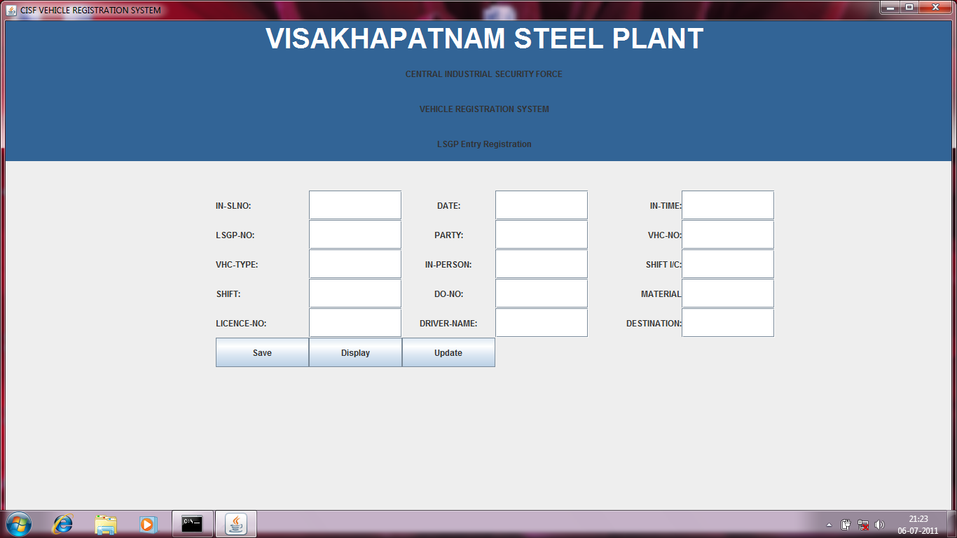

4.1.1.1.4 Process

4.1.1.1.4.1 Save

For a new entry, the user is required to enter the requisite data into the respective fields of the screen. This data will be automatically inserted into respective fields of the CISF-Master based on the LS_NO field.

Validations:

- Vehicle type should be Truck or Trailer.
- If Vehicle number is in black list then corresponding record will be set to close.
- If either LS_CANCEL or DO_CANCEL or both are true then corresponding record will be set to close.

4.1.1.1.4.2 Display

The user has to enter LSGP number then system will retrieve the information and displays on the screen.

4.1.1.1.4.3 Update

Updating of any record from a master table is not advisable but however it becomes necessary to update a record from the master occasionally. In the system only an authorized user can update a record. Selecting updating of a vehicle registered record, updates record from the CISF-Master table and the VHC_DETAILS-Master table based on the lsgp no.

4.1.1.1.5 Output

CISF master Table is Populated/Updated.

4.1.1.2 Exit Details

The function of this sub module is to store new information about vehicle registration while entering into VSP through BC Gate as well as it maintains the existing vehicle registered information. LS_NO is the primary key of the CISF Master, which maintains the above information.

4.1.1.2.1 Description

This sub module handles all the details of a vehicle registration while entering into VSP to take finished products on behalf of the customers. For a new arrival of vehicle, it inserts a new record where as an existing vehicle registered record may be updated.

4.1.1.2.2 Input

FILE DESCRIPTION | DATA TYPE | SIZE |  |  | REMARKS
LS_NO | CHAR | 10 | M | E
IN_SLNO | NUMBER | 5 | M | D
OUT_SLNO | NUMBER | 5 | M | D
IN_DATE | DATE |  | M | D
OUT_DATE | DATE |  | M | D
IN_TIME | CHAR | 8 | M | D
OUT_TIME | CHAR | 8 | M | D
VEHICLE_NO | CHAR | 10 | M | D
VEHICLE_TYPE | CHAR | 2 | M | D
DO_NO | CHAR | 10 | M | D
MATERIAL | CHAR | 15 | M | D
PERSON_IN_NO | NUMBER | 9 | M | D
SHIFT_IN | CHAR | 1 | O | P | A, B, C
PERSON_OUT_NO | NUMBER | 9 | M | E
SHIFT_OUT | CHAR | 1 | O | P | A, B, C
PERSON_IC_NO | NUMBER | 9 | M | D
PARTY | CHAR | 30 | M | D
DC_NO | CHAR | 10 | M | D
OUT_QTY | NUMBER | 5,3 | M | D
CUSTOMER | CHAR | 40 | M | E
DESTINATION | CHAR | 20 | M | D
LC_NO | CHAR | 15 | M | D
DRIVER | CHAR | 15 | M | D
REMARK | CHAR | 25 | M | D

4.1.1.2.3 Screen

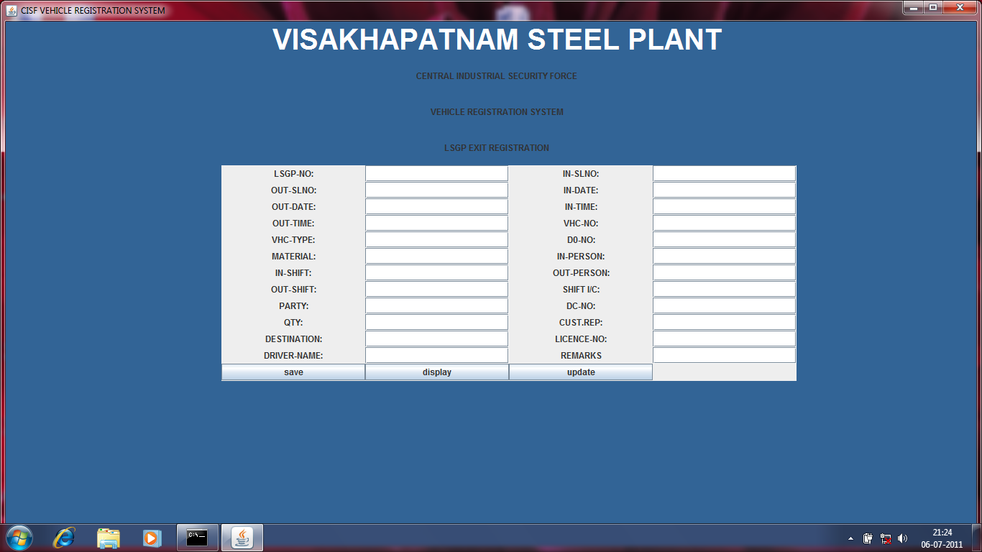

4.1.1.2.4 Process

4.1.1.2.4.1 Save

For a new entry, the user is required to enter the requisite data into the respective fields of the screen. This data will be automatically inserted into respective fields of the CISF-Master based on the LS_NO field.

Validations:

- Vehicle type should be Truck or Trailer.
- If Vehicle number is in black list then corresponding record will be set to close.
- If either LS_CANCEL or DO_CANCEL or both are true then corresponding record will be set to close.

4.1.1.2.4.2 Display

The user has to enter LSGP number then system will retrieve the information and displays on the screen.

4.1.1.2.4.3 Update

Updating of any record from a master table is not advisable but however it becomes necessary to update a record from the master occasionally. In the system only an authorized user can update a record. Selecting updating of a vehicle registered record, updates record from the CISF-Master table and the VHC_DETAILS-Master table based on the LSGP_NO.

4.1.1.2.5 Output

CISF master Table is Populated/Updated.

4.1.2 CISF PERSON DETAILS ENTRY

The function of this sub module is to store new CISF employee information as well as maintain the existing CISF employee information. CISF_PERSON_NO is the primary key of CISF_PERSON-Master.

4.1.2.1 Description

This sub module handles all the details of a CISF employee. For a new CISF employee, it inserts a new record where as an existing employee record may be updated.

4.1.2.2 Input

FILE DESCRIPTION | DATA TYPE | SIZE |  |  | REMARKS
CISF_PERSON_NO | NUMBER | 9 | M | E
CISF_PERSON_NAME | CHAR | 16 | M | E

4.1.2.3 Screen

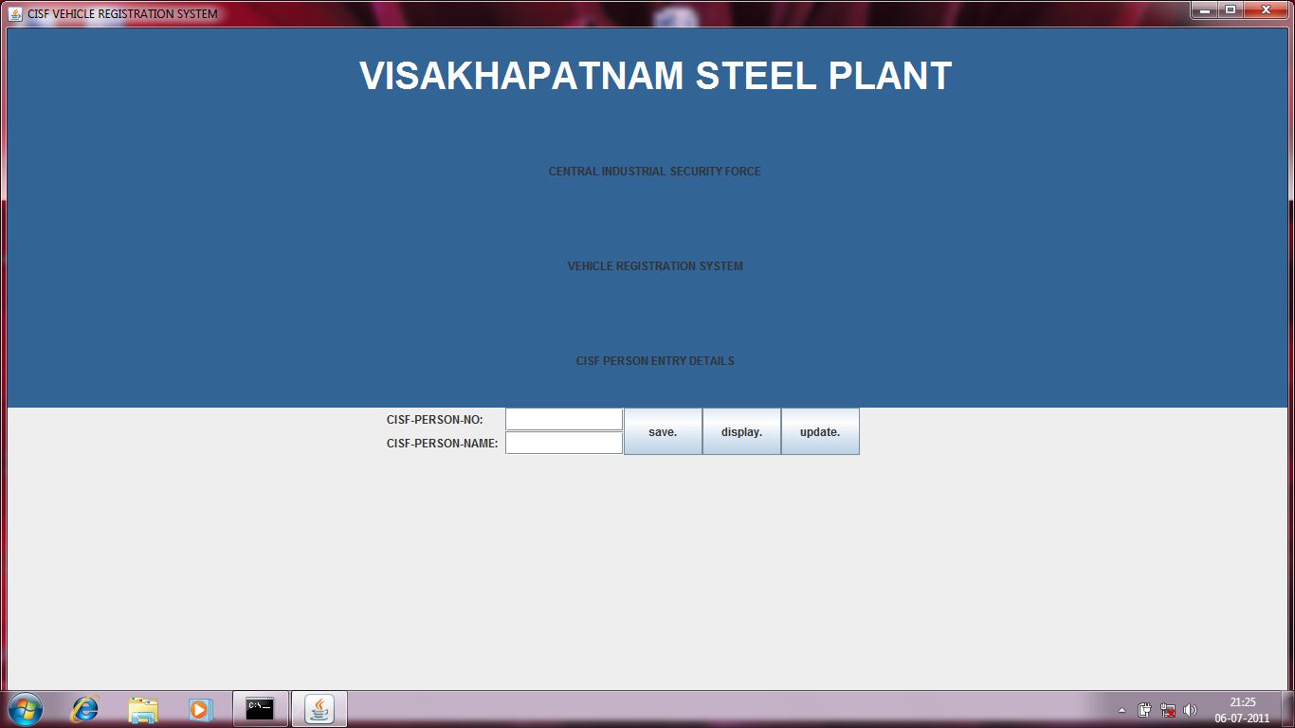

4.1.2.4 Process

4.1.2.4.1 Save

For a new entry, the user is required to enter the requisite data into the respective fields of the screen. This data will be automatically inserted into respective fields of the CISF_PERSON-Master based on the CISF_PERSON_NO field.

4.1.2.4.2 Display
The user has to enter employee number then system will retrieve the information and displays on the screen.

4.1.2.4.3 Update

Updating of any record from a master table is not advisable but however it becomes necessary to update a record from the master occasionally. In the system only an authorized user can update a record. Selecting updating of a CISF employer record, updates record from the CISF_PERSON-Master Table based on the CISF-employee no.

4.1.2.5 Output

CISF_PERSON master table is Populated/Updated.

4.1.3 SHIFT CLOSING

The function of this sub module is to delete the information that exists in the temporary cisf-person database for maintaining shift-wise cisf-employee details, when the present shift time up. After completion of this job the temporary cisf-person database must be empty. And then it is filled by the new information about cisf-employee of the respective shift while vehicles are entering and/or exiting through BC Gate into/from VSP.

4.2 VEHICLE DETAILS MODULE

Vehicle Details module consists of following sub modules: -

- Vehicle Tracking Details
- Black Listing Of Vehicles

4.2.1 Vehicle Tracking Details

The function of this sub module is to display the existing information about registered vehicle details while entered and/or exit through BC Gate as well as maintains the existing registered vehicle details information like vehicle entered date and time, DO date and time, vehicle out going date and time etc. VHC_NO is the primary key of the VHC_DETAILS Master, which maintains the above information.

4.2.1.1 Description

This sub module handles all the details of a registered vehicle details while entering into VSP to take finished products on behalf of the customers and/or exiting with carrying materials through BC Gate. The existing registered vehicle details updating is possible if necessary.

4.2.1.2 Input

FILE DESCRIPTION | DATA TYPE | SIZE |  |  | REMARKS
VEHICLE_NO | CHAR | 10 | M | E
LS_NO | CHAR | 10 | M | D
IN_DATE | DATE |  | M | D
IN_TIME | CHAR | 8 | M | D
LS_DATE | DATE |  | M | D
LS_TIME | CHAR | 8 | M | D
TARE_DATE | DATE |  | M | D
TARE_TIME | CHAR | 8 | M | D
YARD_IN_DATE | DATE |  | M | D
YARD_IN_TIME | CHAR | 8 | M | D

YARD_OUT_DATE | DATE |  | M | D
YARD_OUT_TIME | CHAR | 8 | M | D
GROSS_DATE | DATE |  | M | D
GROSS_TIME | CHAR | 8 | M | D
DC_DATE | DATE |  | M | D
DC_TIME | CHAR | 8 | M | D
OUT_DATE | DATE |  | M | D
OUT_TIME | CHAR | 8 | M | D

4.2.1.3 Screen

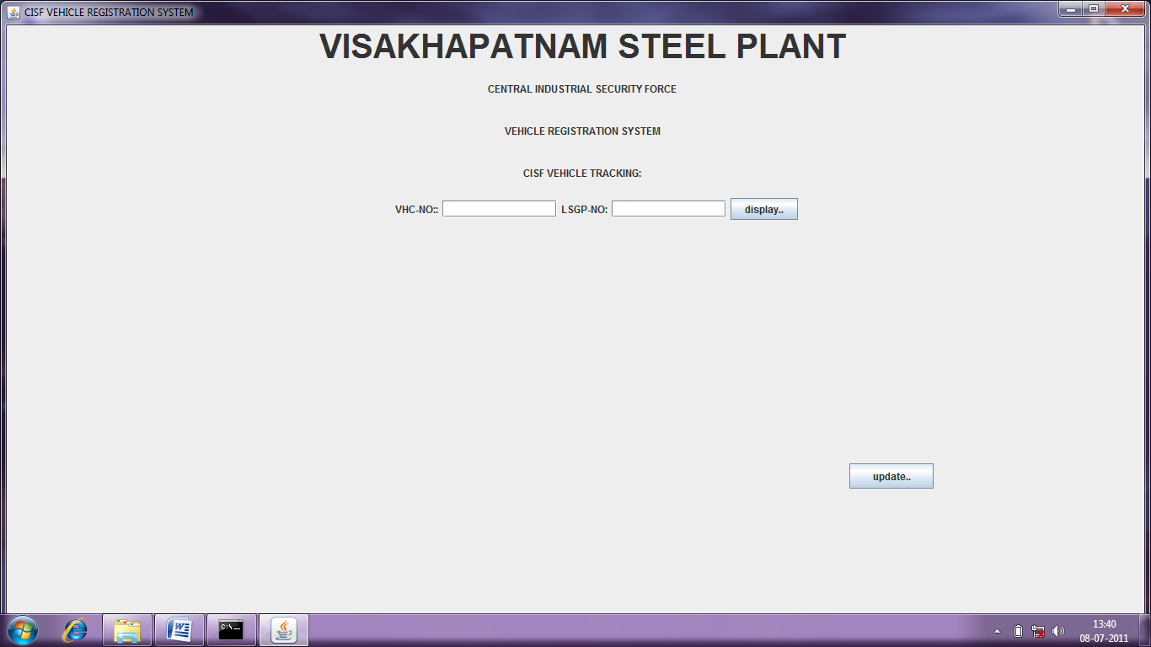

4.2.1.4 Process

4.2.1.4.1 Display

The user has to enter Vehicle number then system will retrieve the information and displays on the screen.

4.2.1.4.2 Update

Updating of any record from a master table is not advisable but however it becomes necessary to update a record from the master occasionally. In the system only an authorized user can update a record. Selecting updating of a registered vehicle details record, updates record from the VHC_DETAILS-Master table and CISF-Master table based on the vehicle number.

4.2.1.5 Output

VHC_DETAILS master Table is Populated/Updated.

4.2.2 Black Listing Of Vehicles

The function of this sub module is to store the vehicle number that comes under black list. That means, which try to do forgery of the documents those are comes under the black list and not allowed to enter into VSP as well as it maintains the existing registered vehicle details information. VEHICLE_NO is the primary key of the VHC_DETAILS-Master table, which maintained the above information.

4.2.2.1 Description

This sub module handles all the details of a registered vehicle details with the information whether particular vehicle is black listed or not. If the arrived vehicle produces forgery of the documents then the black_list_status of the particular record becomes yes. Which means, that vehicle comes under black list.

4.2.2.2 Input

FILE DESCRIPTION | DATA TYPE | SIZE |  |  | REMARKS
VEHICLE_NO | CHAR | 10 | M | E

4.2.2.3 Screen

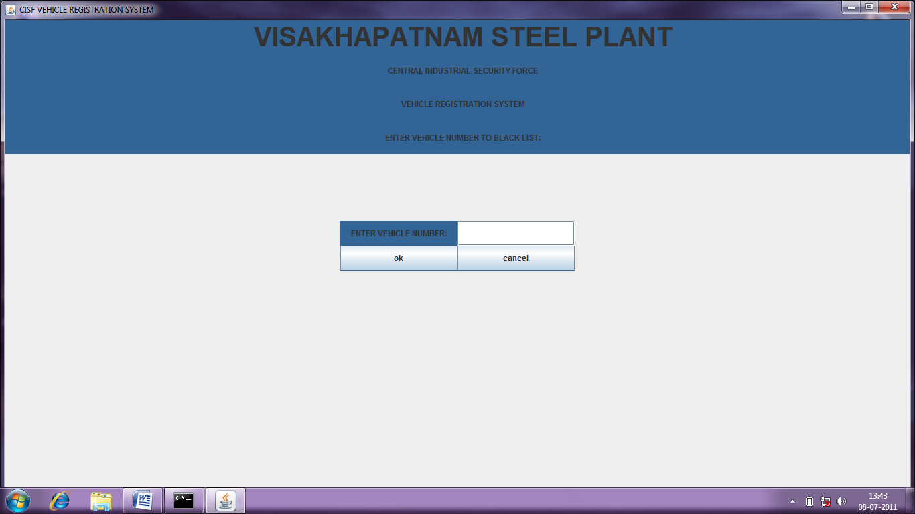

4.2.2.4 Process

The user has to enter Vehicle number then systems will updates the BLACK_LIST_STATUS field to yes in the VHC_DETAILS-Master and then displays message as “Record Processed Successfully”.

4.2.2.5 Output

VHC_DETAILS Master table is updated.

4.3 REPORTS

4.3.1 Description

The reports are generated and presented in report formats. Five different Reports are generated as mentioned below:

- Daily Report
- Shift Summary In Report
- Shift Summary Out Report
- Black Listing Of Vehicles Report
- Delay Report

4.3.2 Input

The input to the reports is the corresponding tables included at annexure I.

4.3.3 Process

Accept from and to dates. Based on selection, the corresponding Data base tables are accessed to generate the report.

4.3.4 Output

Report formats as per Annexure II.

5 Data Stores

As per Annexure - I

6. Resource Requirements

6.1 Hardware

- PENTIUM 4, 1.5 GHz, 512 MB RAM NODES
- PRINTER
- 10/100 BASE-T ETHERNET 16 PORT UTP HUB

6.2. Software

- WINDOWS 2000 SERVER
- ORACLE 9i
- VISUAL BASIC 6.0

7. Security

7.1 Database Security

The system will validate the authorized users from the Database and allow entry into the system. The Database user code and encrypted password ensures the security of the Data in the Database.

The CISF Personnel will be authorized to have full access to the application Database. The database access has two level securities. Users will have the access to all the functions of VRS except updating of records. Where as updating of database records lies with the section in-charge.

ANNEXURE – I

CISF-MASTER TABLE

Name Null? Type
------------------------------- -------------- --------
LS_NO NOT NULL CHAR(10)
IN_SLNO NOT NULL NUMBER(5)
OUT_SLNO NOT NULL NUMBER(5)
IN_DATE DATE
IN_TIME CHAR(8)
VEHICLE_NO NOT NULL CHAR(10)
VEHICLE_TYPE CHAR(2)
DO_NO NOT NULL CHAR(10)
MATERIAL CHAR(15)
DESTINATION CHAR(20)
PERSON_IN_NO NOT NULL NUMBER(9)
PERSON_IN_NAME CHAR(16)
OUT_DO_NO NOT NULL CHAR(10)
OUT_QTY NUMBER(8,3)
OUT_TIME CHAR(8)
PARTY CHAR(30)
PERSON_OUT_NO NOT NULL NUMBER(9)
DC_NO NOT NULL CHAR(10)
OUT_PERSON_NAME CHAR(16)
PERSON_IC_NO NOT NULL NUMBER(9)
PERSON_IC_NAME CHAR(16)
REMARK CHAR(25)
SHIFT_IN CHAR(1)
SHIFT_OUT CHAR(1)
LS_TYPE CHAR(1)
OUT_DATE DATE
DO_DATE DATE
DC_DATE DATE
LS_DATE DATE
LS_CANCEL CHAR(1)
DO_CANCEL CHAR(1)
MANUAL CHAR(1)
LC_NO CHAR(15)
DRIVER CHAR(15)
TARE_DATE DATE
TARE_TIME CHAR(8)
GROSS_DATE DATE
GROSS_TIME CHAR(8)
CUSTOMER CHAR(40)

CISF_INT TABLE

Name Null? Type
------------------------------- -------------- -----------
LS_NO NOT NULL CHAR(10)

LS_DT NOT NULL DATE
RECORD_TYPE NOT NULL CHAR(2)
LS_CANCEL CHAR(1)
PROD_CD NOT NULL CHAR(15)
PROD_DESC NOT NULL CHAR(40)
CUST_CD NOT NULL CHAR(7)
CUST_NAME NOT NULL CHAR(40)
DO_NO NOT NULL CHAR(10)
DO_DATE DATE
SALES_TYPE NOT NULL CHAR(1)
TOT_DO_QTY NUMBER(8,3)
LS_QTY NUMBER(9,3)
VEHICLE_NO NOT NULL CHAR(10)
VEHICLE_TYPE CHAR(1)
CONTRACT_NO CHAR(8)
CONTRACT_DT DATE
LOADING_PT CHAR(10)
DC_NO CHAR(10)
DC_DT DATE
UNIT_CD CHAR(2)
WGMT_CARD_NO CHAR(8)
TR_WT NUMBER(7,3)
TR_WT_DATE DATE
TR_EMP_NO CHAR(6)
GR_WT NUMBER(7,3)
GR_WT_DATE DATE
GR_EMP_NO CHAR(6)
NET_WT NUMBER(7,3)
STATUS CHAR(2)
BSO_CD NOT NULL CHAR(3)
DESTINATION CHAR(20)
TC_NO CHAR(10)
TC_DT DATE

CISF_PERSON TABLE

Name Null? Type
------------------------------- --------------- --------
CISF_PERSON_NO NOT NULL NUMBER(9)
CISF_PERSON_NAME CHAR(16)

SERIAL_NO TABLE

Name Null? Type
------------------------------- ------------- ------
DESCR NOT NULL CHAR(3)
SL_NO NOT NULL NUMBER(5)

TEMP_PERSON TABLE

Name Null? Type
------------------------------- --------------- -- -------
PERSON_IN_NO NOT NULL NUMBER(9)
PERSON_IN_NAME CHAR(16)
PERSON_OUT_NO NOT NULL NUMBER(9)
PERSON_OUT_NAME CHAR(16)
PERSON_IC_NO NOT NULL NUMBER(9)
PERSON_IC_NAME CHAR(16)
SHIFT CHAR(1)

TEMP_CISF TABLE

Name Null? Type
------------------------------- --------------- -------
LS_NO NOT NULL CHAR(10)
LS_DATE DATE
PROD_DESC CHAR(40)
CUST_NAME CHAR(40)
DO_NO NOT NULL CHAR(10)
DO_DATE DATE
VEHICLE_NO NOT NULL CHAR(10)
VEHICLE_TYPE CHAR(2)
DC_NO NOT NULL CHAR(10)
DC_DATE DATE
PERSON_IN_NO NOT NULL NUMBER(9)
PERSON_OUT_NO NOT NULL NUMBER(9)
PERSON_IC_NO NOT NULL NUMBER(9)
YARD CHAR(40)
LS_QTY NUMBER(9,3)
DC_QTY NUMBER(9,3)
IN_OUT_FLAG CHAR(1)

VHC_DETAILS TABLE

Name Null? Type
------------------------------- --------------- -----------
VEHICLE_NO NOT NULL CHAR(10)
VEHICLE_TYPE CHAR(2)
IN_DATE DATE
IN_TIME CHAR(8)
LS_NO NOT NULL CHAR(10)
LS_DATE DATE
LS_TIME CHAR(8)
TARE_DATE DATE
TARE_TIME CHAR(8)
GROSS_DATE DATE
GROSS_TIME CHAR(8)
DC_DATE DATE
DC_TIME CHAR(8)
OUT_DATE DATE
OUT_TIME CHAR(8)
YARD_IN_DATE DATE
YARD_IN_TIME CHAR(8)
YARD_OUT_DATE DATE
YARD_OUT_TIME CHAR(8)
BLACK_LIST_STATUS CHAR(1)

