CSA1708-ARTIFICIAL INTERLLIGENCE
LAB EXPERIMENTS
Program 2: Python Program to solve 8 queen problem
AIM:
To write a Python program to solve the 8-Queens problem using the backtracking algorithm, and place 8 queens on an 8×8 chessboard such that no two queens attack each other
ALGORITHM:
- Start with an empty 8×8 chessboard.
- Place a queen in the first row.
- Check whether the selected column and diagonals are safe.
- If safe, place the queen and move to the next row.
- If no safe position is available, backtrack to the previous row.
- Repeat until all 8 queens are placed.
- Display the chessboard using Q for queen and . for empty spaces.

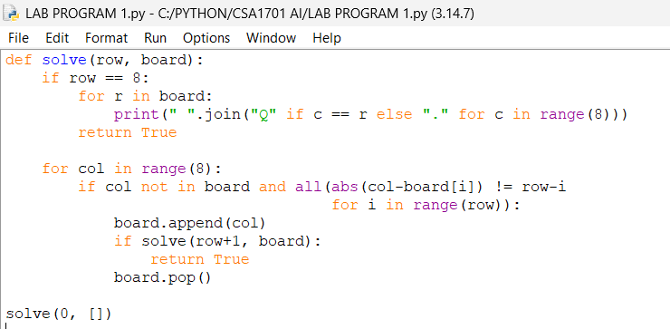
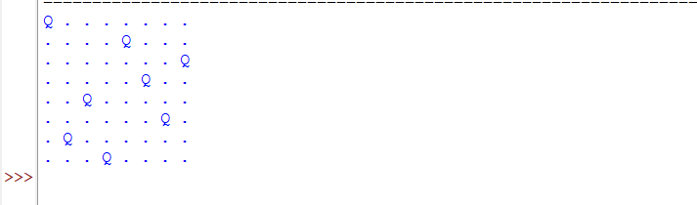
RESULT:
Thus, the 8 queen problem solved

