CSA1708-ARTIFICIAL INTELLIGENCE
LAB EXPERIMENTS
Program 1: Python Program to solve 8 Puzzle Problem
Aim
To develop a Python program that solves the 8-Puzzle Problem using a search algorithm (such as Breadth-First Search - BFS) to find the shortest sequence of moves from the initial state to the goal state

ALGORITHM
1. Represent the puzzle as a 3×3 matrix.
2. Define the goal state.
3. Locate the empty tile (0).
4. Generate all possible moves (up, down, left, right).
5. Use Breadth-First Search (BFS) to explore possible states.
6. Keep track of visited states to avoid repeated exploration.
7. If the goal state is reached, display the solution path.
8. If all possibilities are exhausted, report that no solution exists.

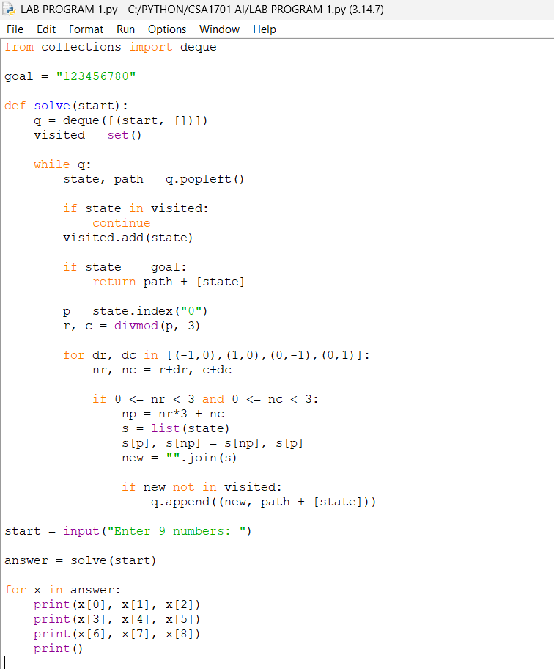

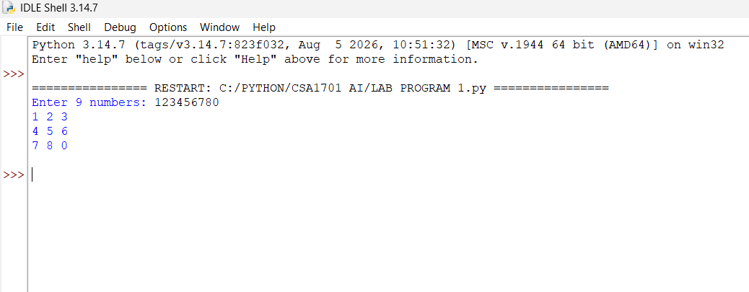

RESULT:
Thus, the 8-Puzzle Problem solved successfully using Python.

