CSA1708-ARTIFICIAL INTELLIGENCE
LAB EXPERIMENTS
Program 5: Pythom program to for Missionaries cannibal problem
Aim
To write a Python program to solve the Missionaries and Cannibals problem using the Breadth-First Search (BFS) algorithm.
Algorithm
- Start with 3 missionaries and 3 cannibals on the starting side.
- Represent each state as (M, C, B).
- Generate possible boat movements of missionaries and cannibals.
- Check that missionaries are never outnumbered by cannibals.
- Avoid already visited states.
- Continue until all missionaries and cannibals reach the opposite side.
- Display the sequence of states.
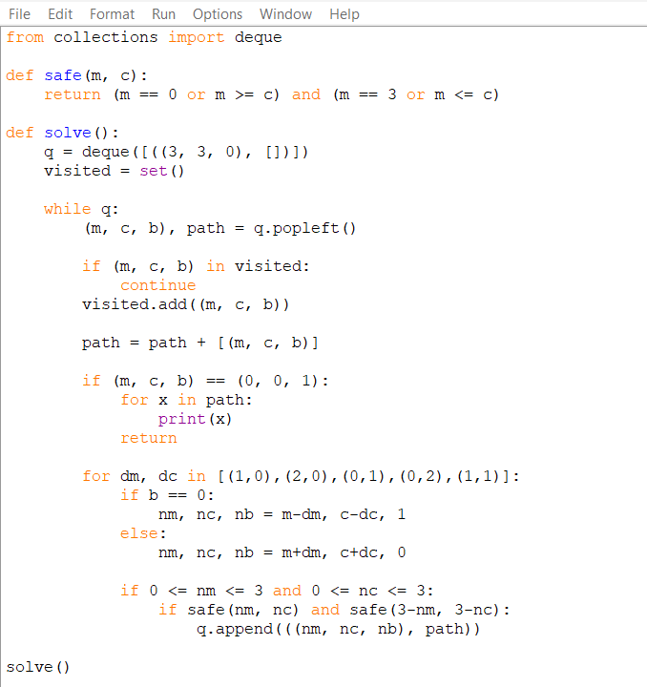
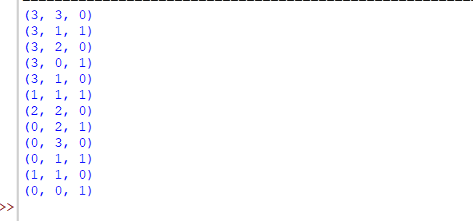
Result:
Thus, the Missionaries and Cannibals problem was successfully solved using Python and BFS, and a safe sequence of movements was obtained.

