B06502149 資工三 張琦琛

Description:

Implement 2 Laplacian Mask, Minimum Variance Laplacian, Laplacian of Gaussian, and Difference of Gaussian(inhibitory sigma=1, excitatory sigma=3, kernel size 11x11).

Please list the kernels and the thresholds(for zero crossing) you used.

Kernel:

Laplacian Mask 1:

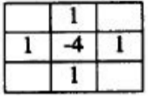

Laplacian Mask 2:

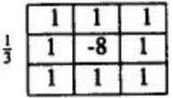

Minimum Variance Laplacian:

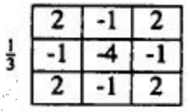

Laplacian of Gaussian:

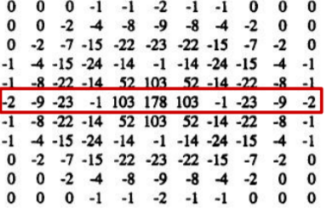

Difference of Gaussian:

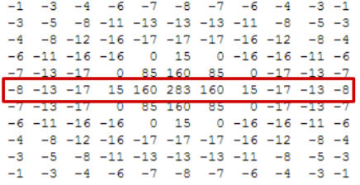

Result:

Laplacian_Mask1, threshold:15 Laplacian_Mask2, threshold:15

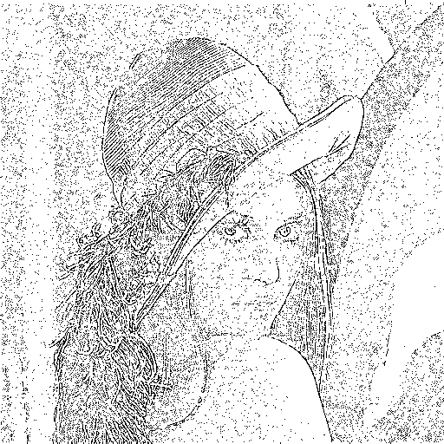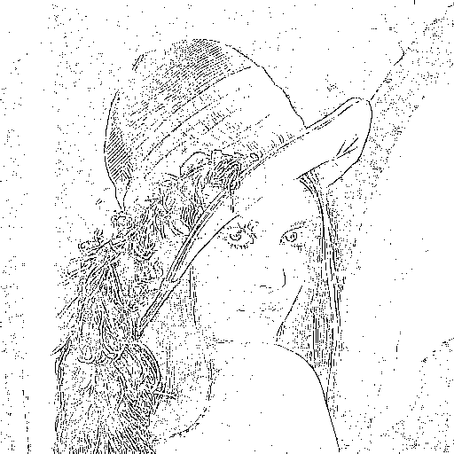

Minimum Variance Laplacian, threshold:20

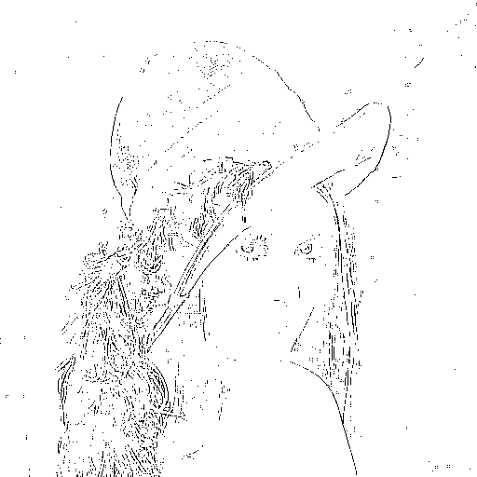

Laplacian of Gaussian, threshold:3000

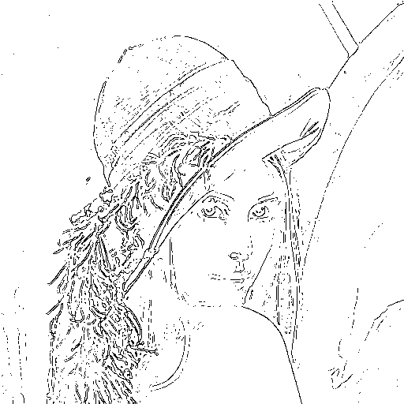

Difference of Gaussian, threshold:1

