B06502149 資工三 張琦琛

1. Binarized Lena.bmp with threshold 128.

Set pixel as black (0) if original pixel < threshold.

Set pixel as white (255) if original pixel >= threshold.

Code fragment:

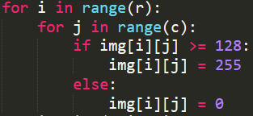

Result:

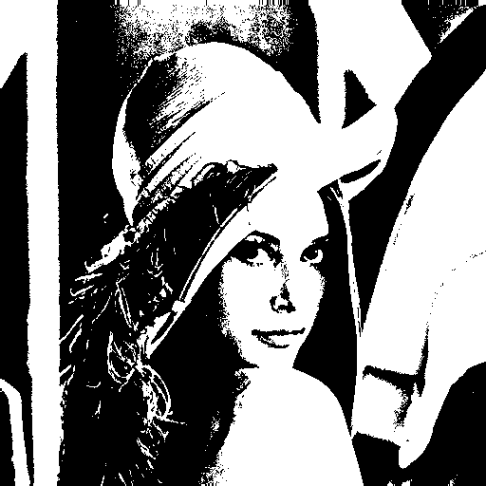

1. Histogram of lena’s Intensity.

Count every pixel’s intensity and save it in the intensity list x[256], and use matplotlib to generate histogram.

Code fragment:

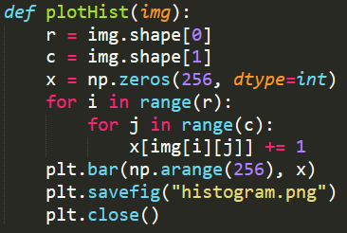

Result:

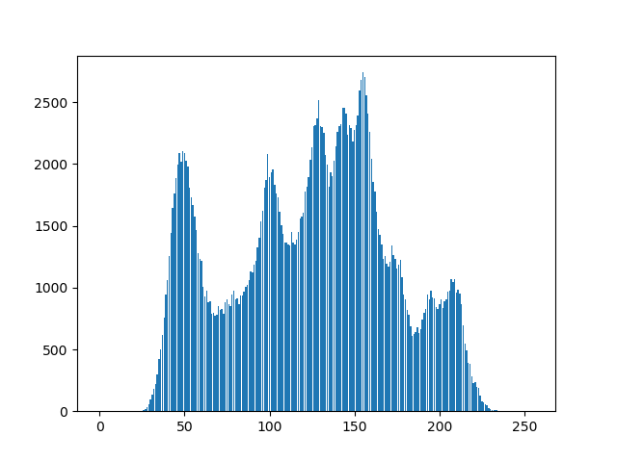

1. Draw the bounding box with the symbol “+” as centroid of the connected component, which the number of pixels >= 500.

I apply the iterative algorithm with 4-connected.

Step1. Initialize each pixel to a unique label

Step2. Interative on each pixel from top to down, left to right;

if the pixel’s label is larger than its 4-connected neighbor,

then change it’s label to the smallest one.

Step3. Interative on each pixel from down to top, right to left;

if the pixel’s label is larger than its 4-connected neighbor,

then change it’s label to the smallest one.

Step4. Repeat Step2 and Step3 until there’s no pixel been changed.

Code fragment:

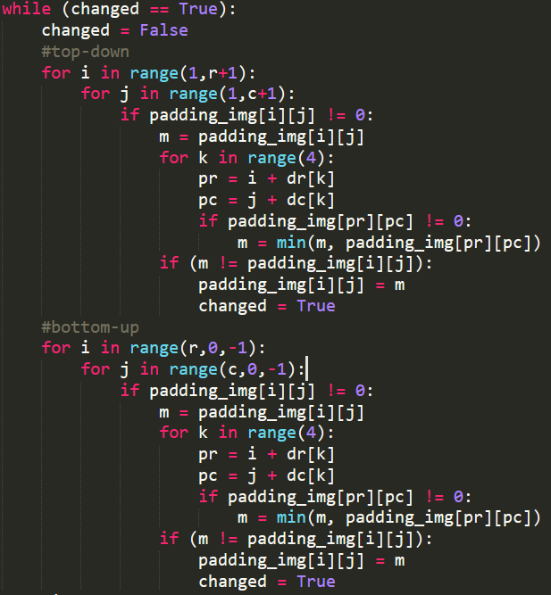

Result:

