B06502149 資工三 張琦琛

1. Original image and its histogram

Count every pixel’s intensity and save it in the intensity list x[256], and use matplotlib to generate histogram.

Code fragment:

The input image is the original lena.bmp, and K = 1

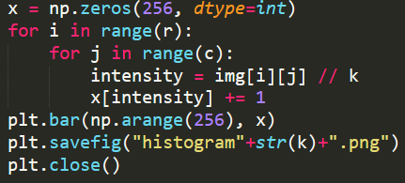

Result:

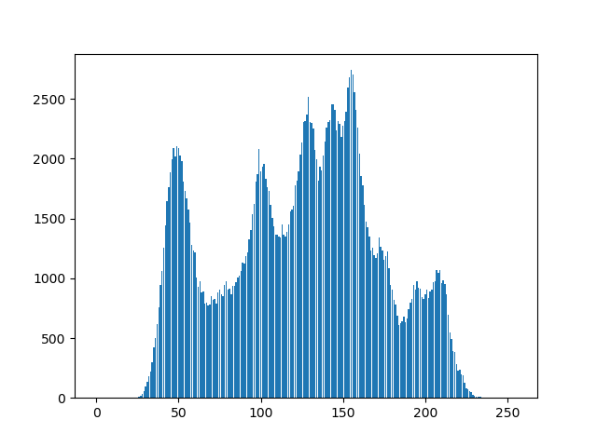

1. Image with intensity divided by 3 and its histogram

For the first part, we let the intensity of each pixel divided by 3; that is, img[i][j] = img[i][j] / 3.

Code fragment:

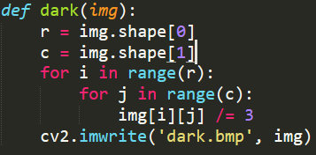

For the second part, we count every pixel’s intensity of the image after division and save it in the intensity list x[256], and use matplotlib to generate histogram.

Code fragment:

The input image is the original lena.bmp, and K = 3

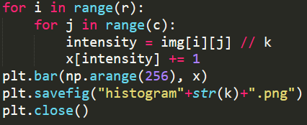

Result:



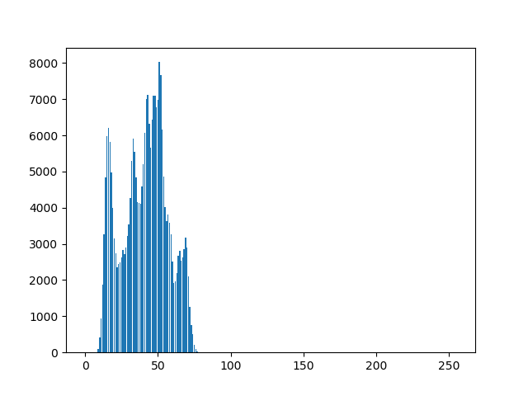

1. Image after applying histogram equalization to (b) and its histogram

We first calculate $s_{k}$,

$$s_{k}=255\sum_{j=0}^{k}{\frac{n_{j}}{n}} k=0, 1, …, 255$$

$n$ is the total number of pixels and $n_{j}$ denotes the total number of pixels with intensity $j$. Then, for each pixel in the image, we replace the original value with $s_{k}$; that is, if $I\left(i,j\right)=k$, then $I_{HE}\left(i, j\right)=s_{k}$.

Code fragment:

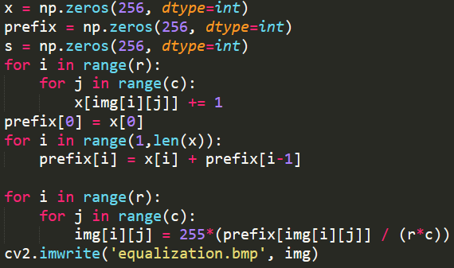

**Result:**

