B06502149 資工三 張琦琛

1. Dilation on binary image

Algorithm:



Code fragment:

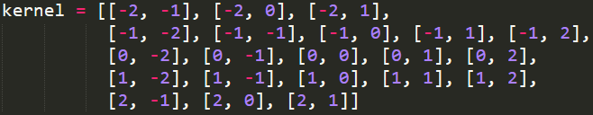

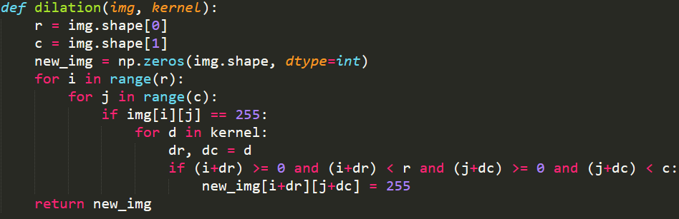

Result:



1. Erosion on binary image

Algorithm:



Code fragment:

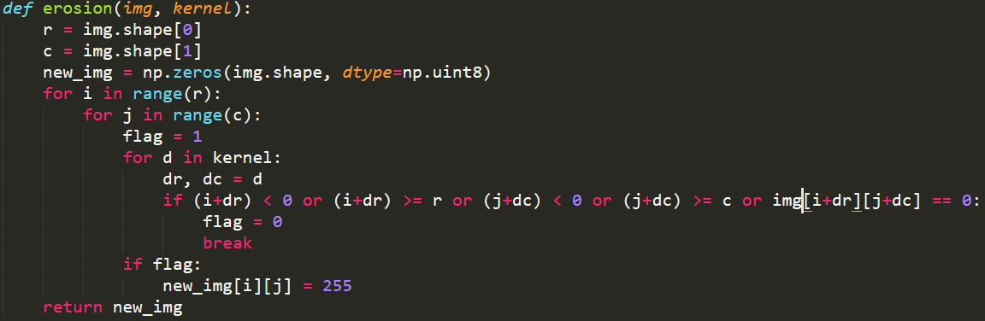

Result:

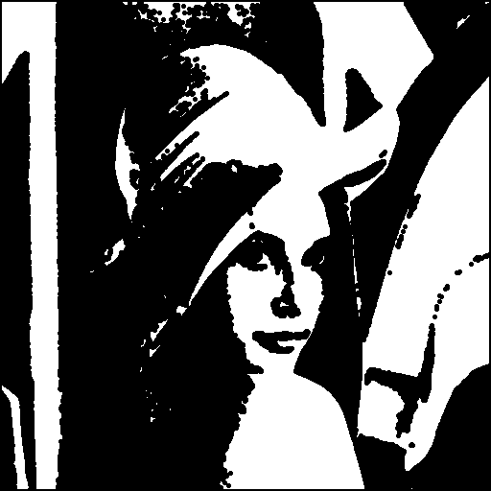

1. Opening on binary image

Algorithm:



Code fragment:



Result:



1. Closing on binary image

Algorithm:



Code fragment:



Result:

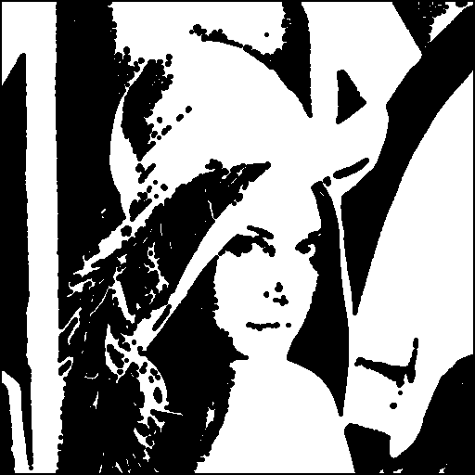

1. Hit and Miss on binary image

Algorithm:



Code fragment:

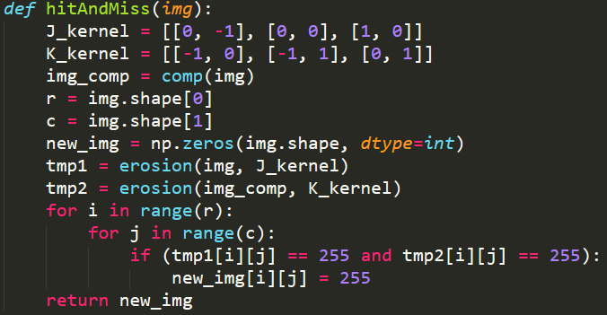

Result:

