B06502149 資工三 張琦琛

1. Dilation on gray-scale image

Algorithm:

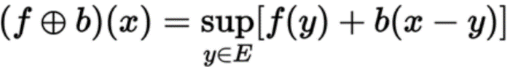

Code fragment:

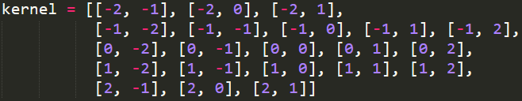

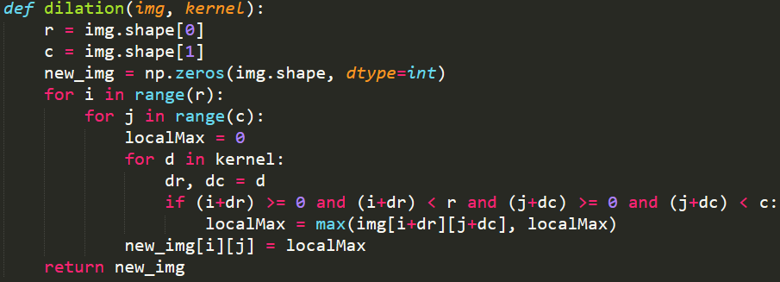

Result:



1. Erosion on gray-scale image

Algorithm:

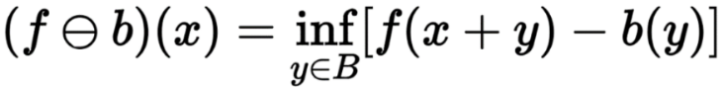

Code fragment:

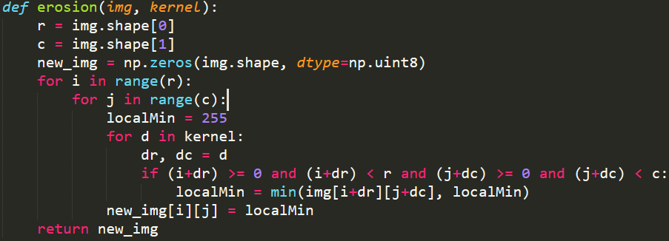

Result:



1. Opening on gray-scale image

Algorithm:

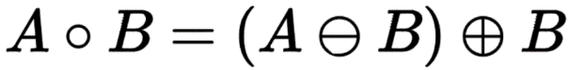

Code fragment:



Result:

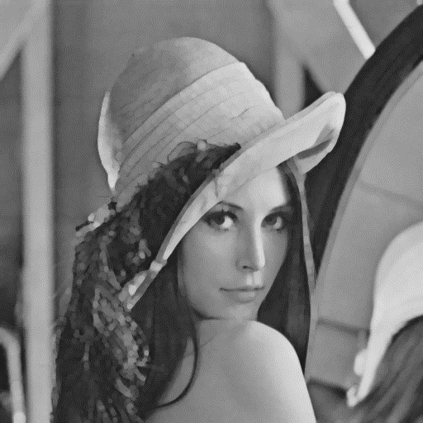

1. Closing on gray-scale image

Algorithm:

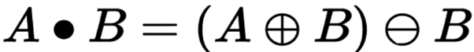

Code fragment:



Result:

