B06502149 資工三 張琦琛

Description:

1. Binarize lena.bmp with threshold 128
2. Down sampling lena.bmp from 512x512 to 64x64, and using 8x8 blocks as a unit, take the topmost-left pixel as the downsampled data.
3. Count the Yokoi connectivity number on a downsampled lena using 4-connected.

Algorithm:

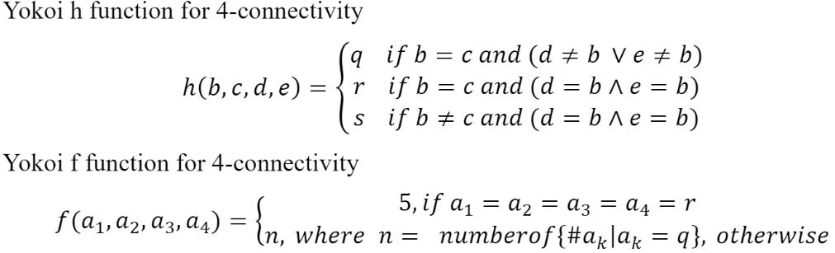

Code fragment:

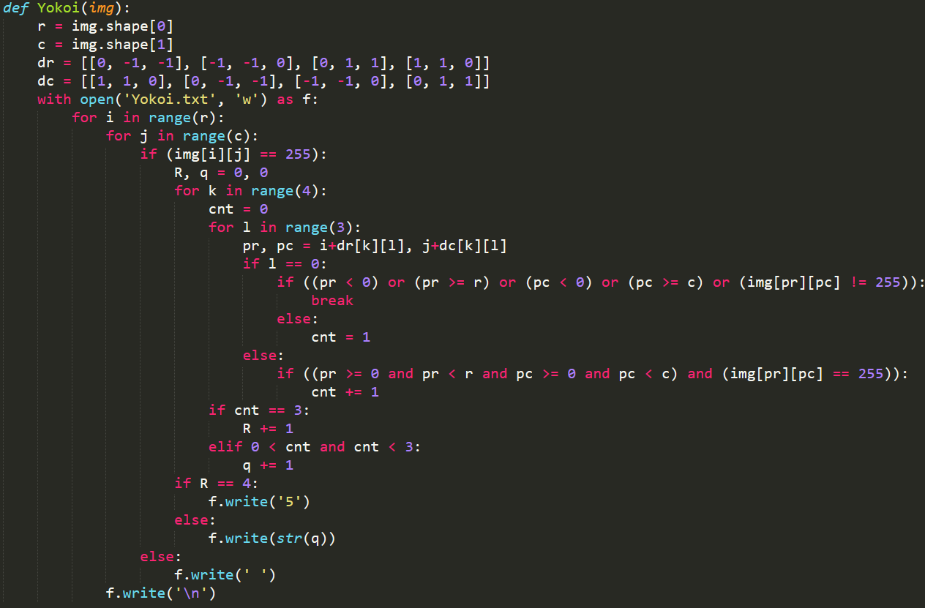

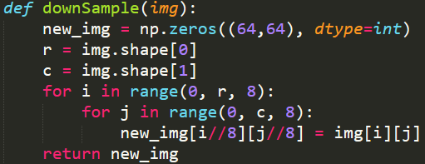

Result:

