B06502149 資工三 張琦琛

Description:

1. Binarize lena.bmp with threshold 128
2. Down sampling lena.bmp from 512x512 to 64x64, and using 8x8 blocks as a unit, take the topmost-left pixel as the downsampled data.
3. Creat marked image
4. Thinning
5. Iterate step 3 and step 4, 7 times.

Algorithm:

Pair relation operator

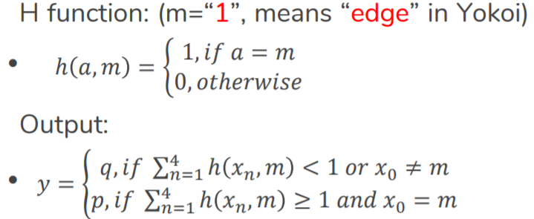

Thinning operator

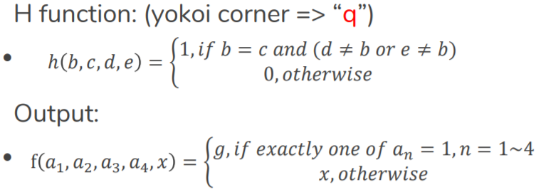

Result:

Thresholding and downsampling thinning after 7 iteration

