B06502149 資工三 張琦琛

1. Gaussian noise amplitude 10, SNR = 13.606



Box_3x3, SNR = 17.741 Box_5x5, SNR = 14.838



Median_3x3, SNR = 17.638 Median_5x5, SNR = 15.960



Open_then_close, SNR = 13.269 Close_then_open, SNR = 13.627



1. Gaussian noise amplitude 30, SNR = 4.155



Box_3x3, SNR = 12.613 Box_5x5, SNR = 13.267

Median_3x3, SNR = 11.097 Median_5x5, SNR = 12.842

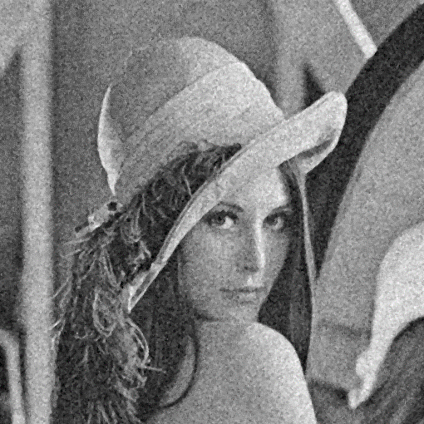

Open_then_close, SNR = 11.221 Close_then_open, SNR = 11.111

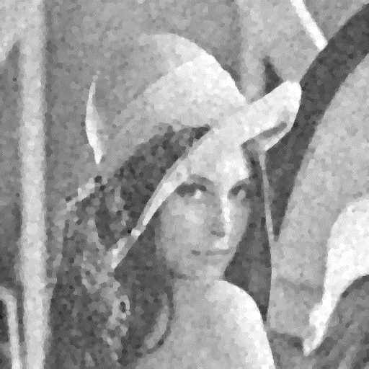

1. Salt and pepper noise probability = 0.05, SNR = 0.957

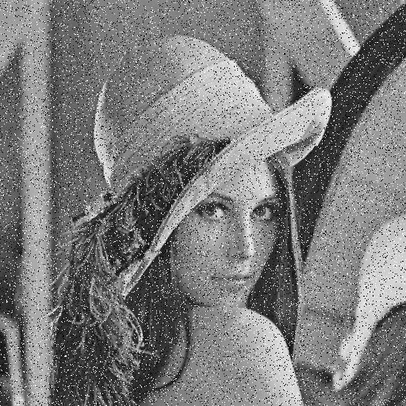

Box_3x3, SNR = 9.518 Box_5x5, SNR = 11.206



Median_3x3, SNR = 19.281 Median_5x5, SNR = 16.380

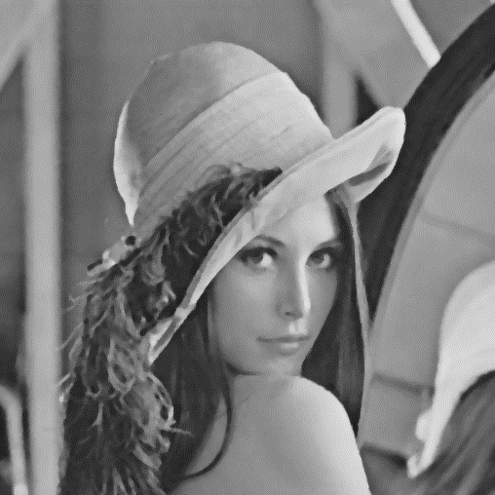

Open_then_close, SNR = 5.682 Close_then_open, SNR = 5.586

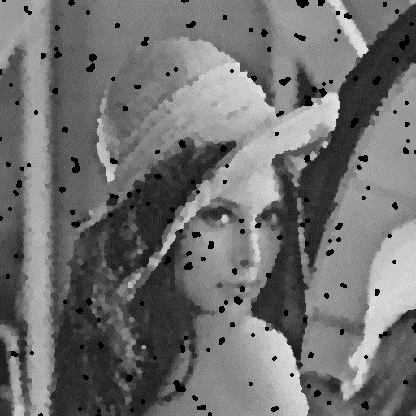

1. Salt and pepper noise probability = 0.1, SNR = -2.075



Box_3x3, SNR = 6.410 Box_5x5, SNR = 8.597

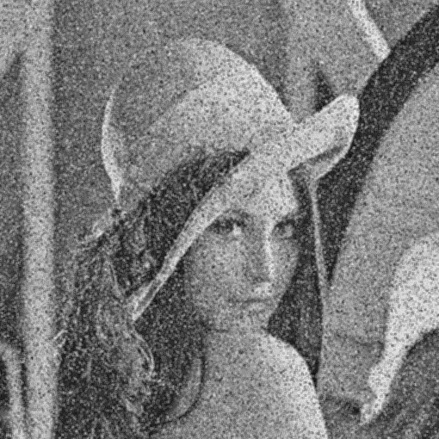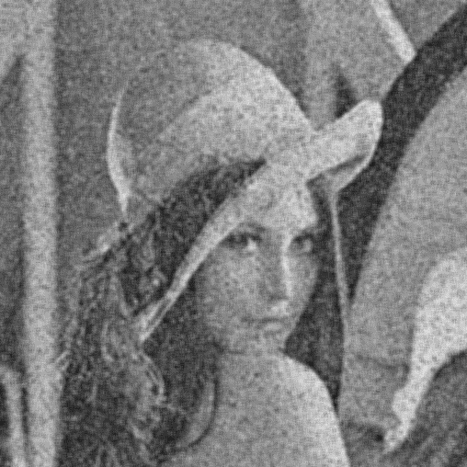

Median_3x3, SNR = 15.529 Median_5x5, SNR = 15.769



Open_then_close, SNR = -2.139 Close_then_open, SNR = -2.571

