B06502149 資工三 張琦琛

Description:

Implement following edge detectors with thresholds :

* + (a) Robert's Operator: 12
  + (b) Prewitt's Edge Detector: 24
  + (c) Sobel's Edge Detector: 38
  + (d) Frei and Chen's Gradient Operator: 30
  + (e) Kirsch's Compass Operator: 135
  + (f) Robinson's Compass Operator: 43
  + (g) Nevatia-Babu 5x5 Operator: 12500

Result:

Robert, threshold:12 Prewitt, threshold:24

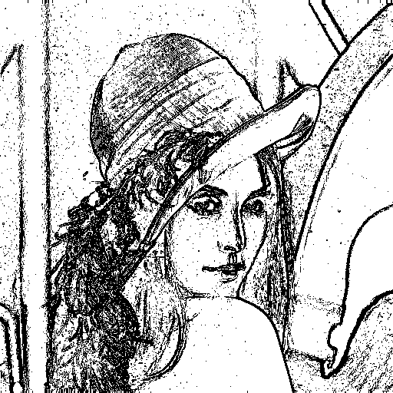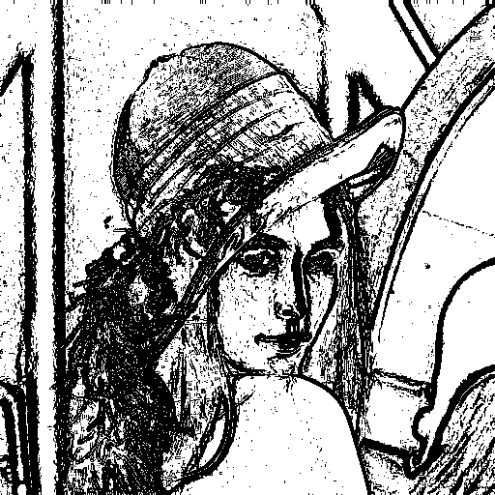

Sobel, threshold:38 Frei and Chen, threshold:30

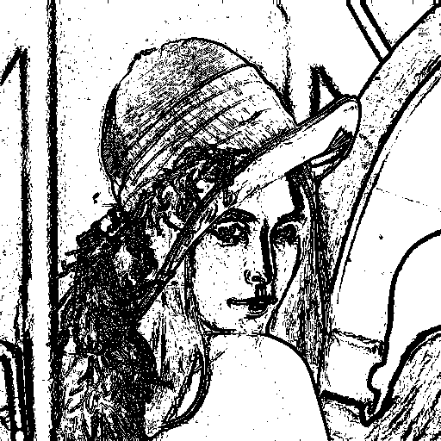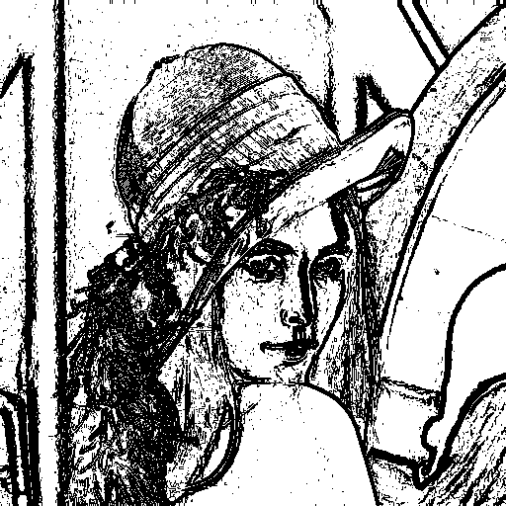

Kirsch, threshold:135 Robinsion, threshold:43

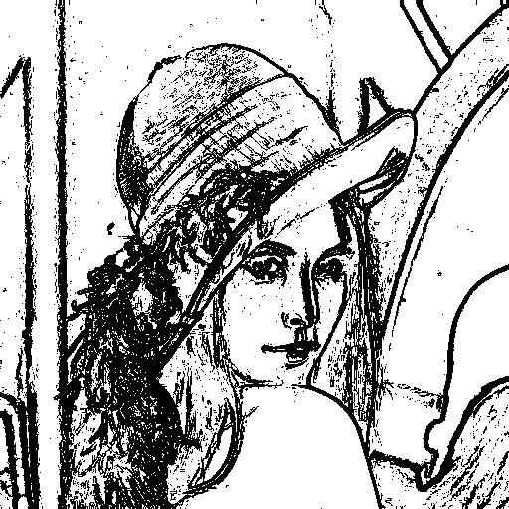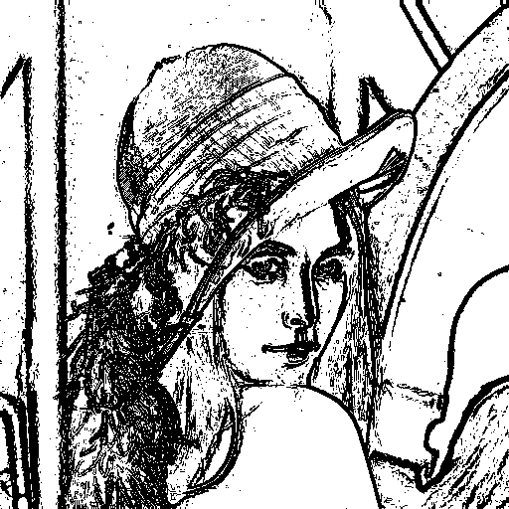

Nevatia-Babu, threshold:12500

