METHODOLOGY DIAGRAM

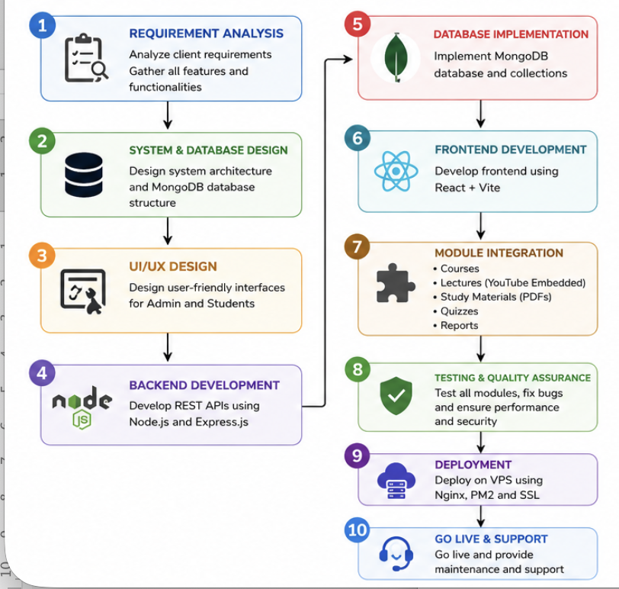

Phase 1: Requirement Analysis

First, we gather and analyze the client's requirements to understand the learning platform's objectives, target users, and required functionalities.

Activities:
- Understand institute requirements
- Identify admin and student roles
- Define course structure
- Define quiz and learning material requirements
- Estimate expected student capacity

Output:
- Software Requirement Specification (SRS)

Phase 2: System Design

The system architecture, database structure, and workflow are designed to ensure scalability, security, and ease of use.

Activities:
- Design LMS architecture
- Design MongoDB database
- Define user roles and permissions
- Create module structure

Output:
- System Architecture Diagram
- Database Design

Phase 3: UI/UX Design

User-friendly interfaces are designed for both administrators and students.

Activities:
- Admin Dashboard Design
- Student Dashboard Design
- Course Page Design
- Quiz Interface Design
- Responsive Mobile Layout

Output:
- Wireframes and User Interface Design

Phase 4: Development

The LMS platform is developed using modern web technologies.

Frontend Technologies
- React.js
- Vite
- Tailwind CSS

Backend Technologies

- Node.js
- Express.js

Database
- MongoDB

Modules Developed
- Authentication System
- Course Management
- Lecture Management
- Study Materials
- Quiz System

Output:
- Functional LMS Platform

Phase 5: Testing

The system is thoroughly tested to ensure reliability and performance.

Activities:
- Functional Testing
- User Authentication Testing
- Quiz Testing
- Performance Testing
- Security Testing

Output:
- Bug-Free System

Phase 6: Deployment

The completed LMS is deployed on the VPS server and made accessible online.

Server Environment
- Ubuntu VPS
- Nginx
- PM2
- MongoDB
- SSL Certificate

Output:
- Live LMS Website

Phase 7: Training & Support

The administrator is trained to manage courses, lectures, and quizzes effectively.

Activities:
- Admin Training
- Documentation
- Technical Support & Maintenance

Output:
- Fully Operational LMS Platform
SYSTEM ARCHITECTURE

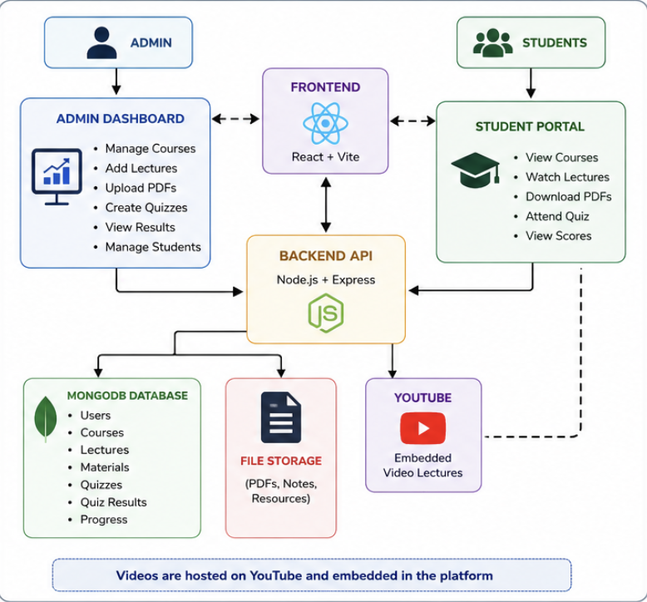

Presentation Layer (Frontend)

This is the interface used by Admins and Students.

Technology:
- React.js
- Vite
- Tailwind CSS

Functions:
- Login & Registration
- Course Dashboard
- Watch Lectures
- Attend Quizzes
- Download Study Materials
Application Layer (Backend)

This is the core business logic layer.

Technology:
- Node.js
- Express.js

Functions:
- User Authentication
- Course Management
- Quiz Evaluation
- Student Management
- API Handling
- Access Control

Data Layer (Database)

All LMS data is stored here.

Technology:
- MongoDB

Stores:
- Users
- Courses
- Lectures
- PDFs
- Quizzes

TECHNOLOGIES AND TOOLS USED

Frontend Technologies

Technology | Purpose
React.js | User Interface Development
Vite | Fast Frontend Build Tool
Tailwind CSS | Responsive UI Design
Axios | API Communication
React Router | Navigation and Routing

Backend Technologies

Technology | Purpose
Node.js | Server-Side Runtime Environment
Express.js | REST API Development
JWT | Authentication & Authorization
bcrypt.js | Password Encryption
Multer | File Upload Management

Database

Technology | Purpose
MongoDB | NoSQL Database
Mongoose | MongoDB Object Modeling

Security Technologies

Technology | Purpose
JWT Authentication | Secure Login
bcrypt.js | Password Hashing
Role-Based Access Control | Admin & Student Permissions
HTTPS/SSL | Secure Data Transmission

