CH TECH GIANT (OPC) PRIVATE LIMITED
Company Profile
About Us
CH TECH GIANT (OPC) PRIVATE LIMITED is a technology company specializing in innovative digital solutions for businesses and individuals. We focus on delivering high-quality software products, mobile applications, websites, and game development services.
Our mission is to help clients transform their ideas into successful digital products through modern technologies and industry best practices.

Company Information
Company Name: CH TECH GIANT (OPC) PRIVATE LIMITED
Location: Davanagere, Karnataka – 577001, India
Phone: +91 9980785020
Email: info@chtechgiant.com
Website: www.chtechgiant.com

Our Services
Mobile App Development
We develop Android and cross-platform mobile applications using modern frameworks and technologies.
Services include:
- Android App Development
- Flutter App Development
- Business Applications
- Utility Applications
- E-commerce Applications
- Educational Applications


Web Development
Professional website development solutions for businesses.
Services include:
- Business Websites
- Portfolio Websites
- E-commerce Stores
- Landing Pages
- Custom Web Applications
- Website Maintenance
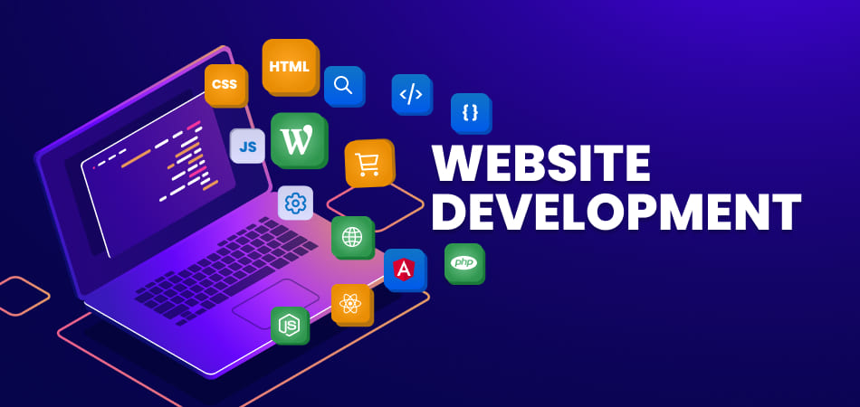

Software Development
Custom software solutions tailored to business requirements.
Services include:
- Desktop Applications
- Business Management Systems
- CRM Solutions
- ERP Solutions
- Automation Tools
- Cloud-Based Applications


Game Development
Development of engaging and interactive games.
Services include:
- Mobile Games
- 2D Games
- Casual Games
- Educational Games
- Game UI Design
- Game Publishing Support


Portfolio Highlights
Voice Calculator Application
A smart voice-enabled calculator application supporting multiple languages and speech recognition features.
CGPA & SGPA Calculator
Educational utility application designed for students to calculate academic performance quickly and accurately.
Invoice Generator
Professional invoice generation solution for freelancers and businesses.
File Converter
Multi-purpose file conversion platform supporting document, image, audio, video, and text conversions.
Sample Files Website
A platform that provides downloadable sample files in various formats including PDF, DOCX, XLSX, PPTX, TXT, CSV, and ZIP for testing and educational purposes.

Why Choose Us
- Professional Development Team
- Modern Technologies
- Affordable Pricing
- Fast Project Delivery
- Responsive Support
- Scalable Solutions
- Quality Assurance
- Client-Focused Approach

Technologies We Use
Frontend
- React.js
- HTML5
- CSS3
- JavaScript
- Bootstrap
Mobile
- Flutter
- Dart

Backend
- Node.js
- Express.js
Database
- MongoDB
- MySQL
Cloud & Deployment
- VPS Hosting
- Nginx
- Linux
- Vercel

Vision
To become a trusted technology partner for businesses worldwide by delivering innovative, reliable, and scalable digital solutions.
Contact Us
CH TECH GIANT (OPC) PRIVATE LIMITED
Phone: +91 9980785020
Email: info@chtechgiant.com
Website: www.chtechgiant.com

