Implementing Sentiment Analysis
and Named Entity Recognition
Two Mini-Projects on IMDB Reviews and CoNLL-2003
Week 3 Task: Natural Language Processing
YuvaIntern Internship Programme
Prepared by: Kammari Hari Charan

Table of Contents
1. Introduction 1
1.1 Objective 1
1.2 Why these two tasks belong together 1
1.3 What was built 1
1.4 Reproducibility and structure 1
2. Datasets and Justification 1
2.1 What the task needs 1
2.2 Datasets chosen 1
2.3 IMDB for sentiment analysis 1
2.4 CoNLL-2003 for NER 1
2.5 Why not a single dataset, and how the gap is bridged 1
3. Framework and Tools 1
3.1 Framework design 1
3.2 Tools and environment 1
4. Data Preparation and Preprocessing 1
4.1 Cleaning for the sentiment classifier 1
4.2 Preparing text for NER 1
4.3 Splits and leakage control 1
5. Project A: Sentiment Analysis 1
5.1 Problem formulation 1
5.2 Approach 1: lexicon-based scoring with VADER 1
5.3 Approach 2: machine learning with TF-IDF and a Linear SVM 1
5.4 Approach 3: pre-trained transformer (DistilBERT) 1
5.5 Evaluation protocol 1
5.6 Results 1
5.7 Error analysis 1
6. Project B: Named Entity Recognition 1
6.1 Problem formulation 1
6.2 Approach 1: rule-based tagger 1
6.3 Approach 2: statistical model (spaCy) 1
6.4 Approach 3: deep learning (BERT) 1
6.5 Evaluation protocol 1
6.6 Results on CoNLL-2003 1
6.7 Why NER must keep capitalisation 1
6.8 Domain probe: review-style sentences 1
6.9 NER applied to IMDB reviews 1
7. Integration: Entity-Level Sentiment 1
7.1 Method 1
7.2 Results 1
7.3 Limitations 1
8. Discussion of Results 1
8.1 Sentiment analysis 1
8.2 Named entity recognition 1
8.3 Trade-offs and best choice 1
9. Challenges and How They Were Addressed 1
10. Potential Improvements 1
11. Conclusion 1
Appendix A: Reproducibility 1
Appendix B: Core Code 1
Appendix C: Review-Style Probe Set 1
Appendix D: References 1

1. Introduction

1.1 Objective
This report documents two mini-projects built within one common framework: sentiment analysis, which decides how a piece of text feels, and named entity recognition (NER), which finds the people, organisations and places the text talks about. For each project the report describes data preparation, model selection, training or scoring, and evaluation, and it ends with a discussion of results, challenges and possible improvements.

1.2 Why these two tasks belong together
NER answers who or what a text is about and sentiment analysis answers how the author feels. Used together, they enable entity-level opinion mining, for example finding which actors or brands are most associated with positive reviews. This report therefore also joins the two projects in a final integration step (Section 7).

1.3 What was built
- Project A, sentiment analysis: three approaches compared on IMDB movie reviews: a lexicon method (VADER), a machine-learning classifier (TF-IDF with a Linear SVM) and a pre-trained transformer (DistilBERT).
- Project B, NER: three approaches compared on the gold-annotated CoNLL-2003 benchmark: a rule-based tagger, a statistical model (spaCy) and a deep-learning model (BERT). A small hand-annotated probe set measures how they cope with movie-review style sentences, and the models are applied to real IMDB reviews.
- Integration: entity-level sentiment, combining the entities found by NER with the sentiment of the reviews that mention them.

1.4 Reproducibility and structure
Everything was run in a single Google Colab notebook, available at https://github.com/haricharan-285/yuvaintern-nlp-tasks. Section 2 describes and justifies the datasets, Section 3 the framework and tools, Section 4 the preprocessing, Sections 5 and 6 the two projects, Section 7 the integration, Section 8 a discussion of results, Section 9 the challenges and Section 10 potential improvements.

2. Datasets and Justification

2.1 What the task needs
The task asks for a public dataset suitable for both sentiment analysis and NER. Evaluating both tasks properly with metrics such as accuracy and F1 requires two kinds of gold labels: a sentiment label for each text and entity annotations for the words in it. Public text collections rarely have both. Review corpora such as IMDB provide sentiment labels but no entity tags, while NER benchmarks such as CoNLL-2003 provide entity tags but no sentiment.

2.2 Datasets chosen
The solution adopted is a single text framework with one primary corpus and one benchmark: IMDB movie reviews are the common text (they carry gold sentiment labels and are full of named entities such as actors, directors, studios and places), and the NER systems are measured on CoNLL-2003, which has gold entity tags, and then applied to IMDB. A small hand-annotated probe set of review-style sentences connects the two.
Table 1: Datasets used and their roles
Dataset | Text type | Gold labels | Role in this report
IMDB Large Movie Review Dataset (Maas et al., 2011) | Movie reviews | Sentiment (positive / negative) | Train and evaluate the sentiment models; source text for applying NER and for the integration step
CoNLL-2003 English (Tjong Kim Sang & De Meulder, 2003) | News (Reuters) | Entities: PER, ORG, LOC, MISC in BIO format | Evaluate the NER systems against gold annotations
Review-style probe set (30 sentences, written for this report) | Movie-review sentences | Hand-annotated entities (PER, ORG, LOC, MISC) | Estimate how NER behaves on review language (domain shift)

2.3 IMDB for sentiment analysis
IMDB contains 50,000 English reviews, split officially into 25,000 for training and 25,000 for testing, with balanced positive and negative classes. It was explored in detail in Week 1 and used for classification in Week 2, so it allows direct comparison with earlier results. As in Week 2, duplicate reviews were removed and reviews appearing in both sets were dropped from the test set. After these checks the training set holds 24,904 reviews and the test set 24,678.

2.4 CoNLL-2003 for NER
CoNLL-2003 is the standard benchmark for English NER. It consists of newswire sentences, already split into tokens, annotated with four entity types in the BIO scheme: PER (person), ORG (organisation), LOC (location) and MISC (other, such as nationalities and event names). B- marks the first token of an entity, I- a continuation and O a token outside any entity. The standard test split has 3,453 sentences. In this work it was loaded from the Hugging Face copy lhoestq/conll2003, because the original loading script is no longer supported by recent versions of the datasets library. Licence and usage terms: The licence field on the Hugging Face dataset card is “other”: the text comes from the Reuters Corpus, whose stories are copyrighted by Reuters, so the CoNLL-2003 release distributes only the University of Antwerp annotations and use of the underlying Reuters Corpus is governed by the Reuters/NIST agreements, so the data should be used for research and educational purposes only.
Table 2: Gold entities in CoNLL-2003
Entity type | Train | Test
PER | 6,600 | 1,617
ORG | 6,321 | 1,661
LOC | 7,140 | 1,668
MISC | 3,438 | 702
Total | 23,499 | 5,648
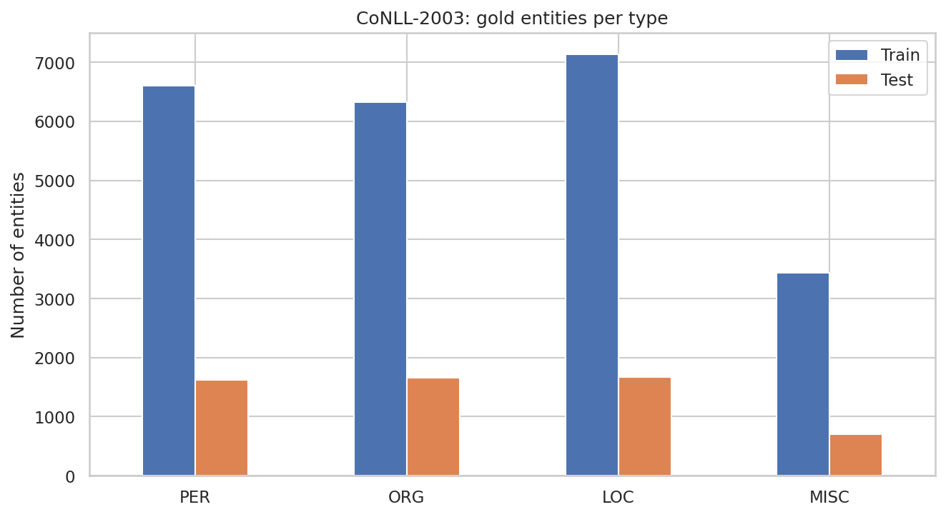
Figure 1: Gold entity counts per type in CoNLL-2003
In the test set, LOC (1,668) and ORG (1,661) are the most frequent types, closely followed by PER (1,617), while MISC is clearly the rarest with only 702 entities (about 12% of the 5,648 test entities); the training set shows the same pattern, with MISC at 3,438 of 23,499. MISC usually scores lower because it has far fewer training examples and is a mixed catch-all class (nationalities, events, titles of works) with no consistent surface pattern, unlike person names or place names.

2.5 Why not a single dataset, and how the gap is bridged
Using only IMDB for both tasks would leave the NER results without ground truth, so no honest F1-score could be computed. Using only CoNLL would leave the sentiment task without labels. The two-dataset design keeps both evaluations rigorous. The framework is still unified: the same text processing helpers, evaluation code and notebook serve both projects, and the final integration step applies both modules to the same IMDB reviews. The probe set partly closes the remaining gap by measuring NER on review language, although, being small and annotated by the author, it only gives indicative numbers.

3. Framework and Tools

3.1 Framework design
Both projects follow the same sequence of stages, shown below, so that the work is organised as one pipeline rather than two unrelated experiments.
Table 3: Shared framework, applied to each project
Stage | Project A: sentiment analysis | Project B: NER
1. Data | IMDB reviews with sentiment labels | CoNLL-2003 sentences with BIO tags; IMDB reviews for application
2. Preprocessing | Cleaning, normalisation, lemmatization (for the classifier) | Keep case and punctuation; tokenisation and BIO alignment
3. Models | VADER, TF-IDF + Linear SVM, DistilBERT | Rule-based tagger, spaCy, BERT
4. Scoring / decoding | Sentiment score and decision threshold | Tag sequence decoded into entity spans
5. Evaluation | Accuracy, precision, recall, F1, confusion matrix | Entity-level precision, recall and F1 (CoNLL scoring rules), per type
6. Integration | Sentiment score per review | Entities per review, linked to the review's sentiment

3.2 Tools and environment
Table 4: Libraries used
Library | Purpose
pandas, NumPy, Matplotlib, Seaborn | Data handling and visualisation
NLTK | Stopwords, lemmatizer, sentence splitting
scikit-learn | TF-IDF features, Linear SVM, classification metrics
vaderSentiment | Lexicon-based sentiment scoring
spaCy (en_core_web_sm) | Statistical NER model and tokenizer
Hugging Face transformers and PyTorch | DistilBERT sentiment model and BERT NER model
Custom scoring functions (CoNLL rules) | Entity-level NER precision, recall and F1
Hugging Face datasets | Loading IMDB and CoNLL-2003

The work was run on Google Colab with Python 3.13.15. A GPU (T4) was used, which mainly affects the speed of the transformer models. Random seeds are fixed at 42 and library versions are listed in Appendix A.

4. Data Preparation and Preprocessing
The two tasks need opposite kinds of preprocessing. A sentiment classifier benefits from normalisation, which shrinks the vocabulary and merges word forms. NER depends on exactly the information that normalisation removes: capitalisation, punctuation and word order.
Table 5: Preprocessing for each task and model
Task / model | Preprocessing | Reason
Sentiment: TF-IDF + SVM | HTML and URL removal, lowercasing, contraction expansion, punctuation and digit removal, stopword removal keeping negations, lemmatization | The Week 2 “full” pipeline, which gave the best validation accuracy; a smaller vocabulary helps a bag-of-words model
Sentiment: VADER | HTML removal only | VADER uses capitalisation, punctuation (such as “!”) and negation words as signals
Sentiment: DistilBERT | HTML removal only; truncation to 512 tokens | The model has its own sub-word tokenizer and learns from full, natural text
NER: all systems | Case, punctuation and token order preserved; HTML removed from reviews; CoNLL already tokenised | Capitalisation is the main cue for proper nouns; lowercasing would destroy it (tested in Section 6.7)

4.1 Cleaning for the sentiment classifier
- HTML and URL removal: tags such as <br /> carry no sentiment (shown in Week 1).
- Lowercasing and contraction expansion: merge word variants and keep negation (“didn’t” becomes “did not”).
- Punctuation and digit removal, stopword removal: reduce noise. The stopword list keeps negations such as “not” and “no”.
- Lemmatization: reduces words to dictionary forms while keeping them readable.
Example of a review before and after cleaning:
Before: STAR RATING: ***** Saturday Night **** Friday Night *** Friday Morning ** Sunday Night * Monday Morning Former New Orleans homicide cop Jack Robideaux (Jean Claude Van Damme) is re-assigned to Columbus, a small but violent town in Mexico to help the police there with their efforts to stop a major …
After: star rating saturday night friday night friday morning sunday night monday morning former new orleans homicide cop jack robideaux jean claude van damme assigned columbus small violent town mexico help police effort stop major heroin smuggling operation town culprit turn ex military lead former comma…

4.2 Preparing text for NER
CoNLL-2003 is already tokenised and tagged, so no preparation is needed beyond converting the numeric tag ids to their names. For IMDB reviews, only HTML tags are removed. The three NER systems tokenise differently: the rule-based tagger and the CoNLL evaluation work on the given tokens; spaCy is fed pre-tokenised documents during evaluation so that its predictions line up one-to-one with the gold tags; and BERT splits words into sub-word pieces, so its prediction for the first sub-word of each word is used as the prediction for that word.

4.3 Splits and leakage control
- IMDB: official train/test split; duplicates and train/test overlap removed (as in Week 2). The VADER threshold is tuned on a 5,000-review subsample of the training set, never on the test set.
- Test samples: the transformer sentiment model is evaluated on a stratified sample of 2,000 test reviews (1,000 per class) to keep run time reasonable, and the other models are also reported on the full test set.
- CoNLL-2003: the official test split is used for all NER evaluation. The three NER systems are pre-trained and are not trained or tuned in this work.

5. Project A: Sentiment Analysis

5.1 Problem formulation
Given a movie review, predict whether its overall sentiment is positive (1) or negative (0). The gold label comes from the reviewer’s star rating (4 or lower is negative, 7 or higher is positive). Three families of method were implemented to compare how much each costs and how well it works.

5.2 Approach 1: lexicon-based scoring with VADER
VADER (Hutto & Gilbert, 2014) is a rule-based tool that needs no training. It contains a lexicon of words with human-rated sentiment intensity and rules that adjust scores for negation (“not good”), intensifiers (“very good”), capitalisation (“GOOD”) and punctuation (“good!!!”). The word scores are summed and normalised into a compound score between −1 and +1:
compound = x / sqrt(x^2 + 15), where x is the sum of the adjusted word scores.
Sentiment scoring rule. A review is classed as positive when its compound score is at least a threshold. VADER’s documentation suggests 0.05, but the best value for long reviews may differ, so the threshold was tuned on training data. A second variant scores each sentence separately and averages the sentence scores, which limits the dominance of a few strongly worded sentences in long reviews. Both variants were compared.

5.3 Approach 2: machine learning with TF-IDF and a Linear SVM
This approach learns from the 24,904 labelled training reviews. Feature extraction: the cleaned text is converted into TF-IDF vectors using unigrams and bigrams, with min_df = 5 and sublinear term frequency (Section 4 of the Week 2 report explains why). Algorithm: a Linear Support Vector Machine finds the maximum-margin hyperplane between positive and negative reviews. The regularisation parameter C = 0.3 and the feature set were chosen in Week 2 by 5-fold cross-validation, so they are reused here and the result can be checked against Week 2.

5.4 Approach 3: pre-trained transformer (DistilBERT)
DistilBERT (Sanh et al., 2019) is a smaller version of BERT (Devlin et al., 2019): a 6-layer transformer produced by knowledge distillation, which is about 40% smaller and 60% faster than BERT while keeping about 97% of its language-understanding performance. The checkpoint used, distilbert-base-uncased-finetuned-sst-2-english, was fine-tuned on the Stanford Sentiment Treebank (SST-2; Socher et al., 2013) of movie-review sentences. It is applied zero-shot: no training on IMDB is done. Reviews longer than 512 tokens are truncated, so only the beginning of a long review is read.
Table 6: Comparison of the sentiment approaches
Approach | Needs training data? | Strengths | Weaknesses | Cost
VADER (lexicon) | No | Instant, transparent, no training | Cannot learn domain vocabulary; fooled by sarcasm and plot summaries | Very low
TF-IDF + Linear SVM | Yes (labelled reviews) | Strong in-domain accuracy, fast, interpretable features | Bag of words ignores word order beyond bigrams | Low
DistilBERT (pre-trained) | No (zero-shot) | Understands context and word order | Slow, truncates long reviews, trained on short sentences | High

5.5 Evaluation protocol
Models are scored with accuracy, precision, recall and F1-score for the positive class, computed from the confusion matrix (formulas in the Week 2 report). All five variants are compared on the same stratified sample of 2,000 test reviews; VADER and the SVM are also reported on the full test set of 24,678 reviews.

5.6 Results

Tuning the VADER scoring rule
On the 5,000-review training subsample, whole-review scoring reached 0.6940 accuracy with the default threshold of 0 and 0.7052 with the tuned threshold of 0.5. Sentence-averaged scoring reached 0.7098 with threshold 0 and 0.7418 with its tuned threshold of 0.12.
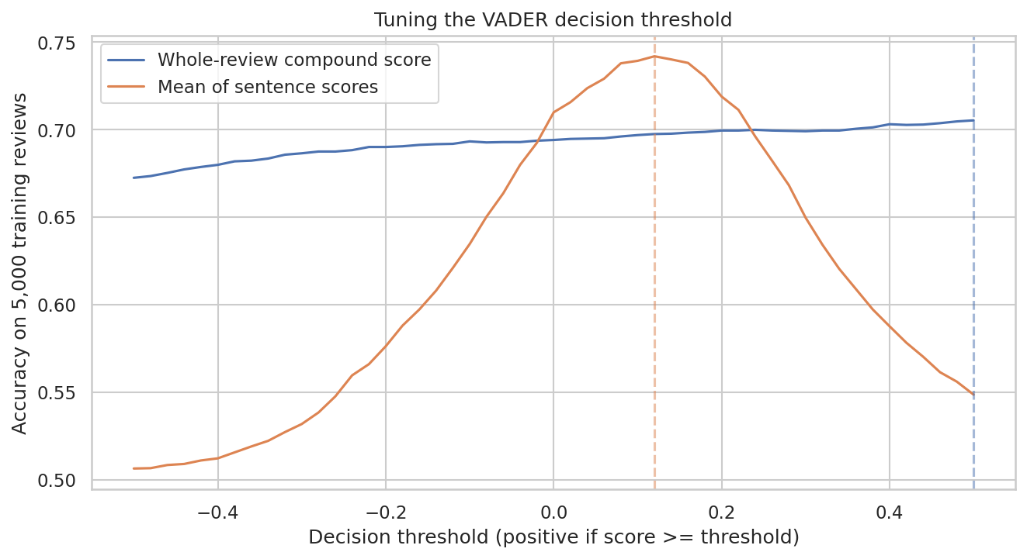
Figure 2: Accuracy of VADER as the decision threshold changes (training subsample)
For whole-review scoring the best threshold was 0.5 (at the upper edge of the search range), which raised accuracy only from 0.6940 to 0.7052 (+1.1 points), whereas sentence-averaged scoring peaked at 0.12 and gained 3.2 points (0.7098 to 0.7418). The curves differ because the compound score of a whole review is pushed towards the extremes by the many opinion words in a long text, so moving the threshold changes few decisions, while the mean of sentence scores is spread around zero and needs a small positive cut-off to correct VADER’s tendency to label reviews positive.

Comparison of all sentiment models
Table 7: Sentiment results on 2,000 test reviews
Model | Accuracy | Precision | Recall | F1
VADER (threshold 0, whole review) | 0.6865 | 0.6383 | 0.8610 | 0.7331
VADER (tuned threshold, whole review) | 0.7020 | 0.6637 | 0.8190 | 0.7332
VADER (tuned threshold, sentence average) | 0.7330 | 0.7500 | 0.6990 | 0.7236
TF-IDF + Linear SVM (trained on IMDB) | 0.8995 | 0.9007 | 0.8980 | 0.8993
DistilBERT SST-2 (pre-trained) | 0.8935 | 0.9053 | 0.8790 | 0.8919

Table 8: Sentiment results on the full test set
Model | Accuracy | Precision | Recall | F1
VADER (threshold 0, whole review) | 0.6997 | 0.6518 | 0.8649 | 0.7434
VADER (tuned threshold, whole review) | 0.7171 | 0.6806 | 0.8244 | 0.7456
VADER (tuned threshold, sentence average) | 0.7478 | 0.7707 | 0.7096 | 0.7389
TF-IDF + Linear SVM (trained on IMDB) | 0.8979 | 0.9004 | 0.8961 | 0.8983

The best model on the 2,000-review sample was TF-IDF + Linear SVM with an accuracy of 0.8995 and an F1 of 0.8993. On the full test set the SVM reached 0.8979, which is consistent with the 0.898 obtained in Week 2 because the SVM is the same pipeline as in Week 2 (same cleaning, TF-IDF with unigrams and bigrams, LinearSVC with C=0.3, trained on the same 24,904 reviews), so the full-test result of 0.8979 reproduces the earlier figure to within rounding (0.898).
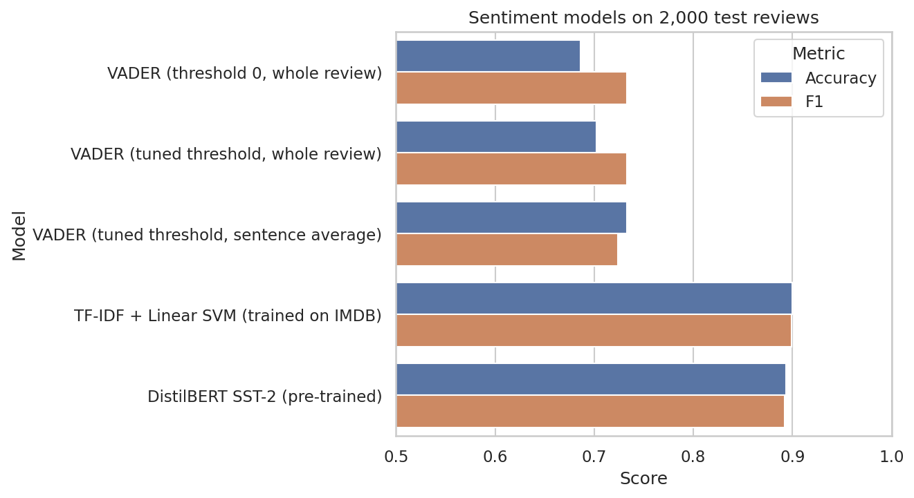
Figure 3: Accuracy and F1 of the sentiment models on 2,000 test reviews
The ranking on the 2,000-review sample is the SVM (accuracy 0.8995), DistilBERT (0.8935), then VADER with sentence averaging (0.7330), tuned whole-review VADER (0.7020) and default VADER (0.6865). The SVM and DistilBERT are only 0.6 points apart, but both are about 16 points above the best lexicon variant (0.8995 and 0.8935 against 0.7330), so learned models clearly beat the lexicon.
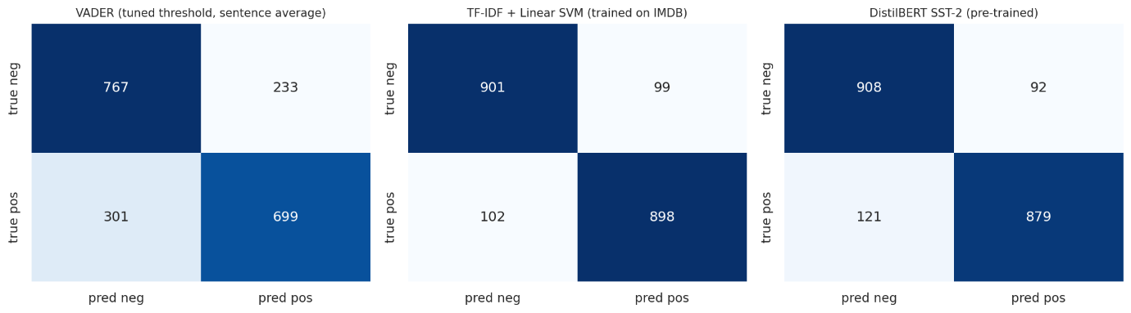
Figure 4: Confusion matrices of the best VADER variant, the SVM and DistilBERT
VADER favours the positive class: with the default threshold it finds 861 of the 1,000 positive reviews (recall 0.861) but its precision is only 0.638, which implies roughly 488 false positives against 139 false negatives. Tuning and sentence averaging reduce this imbalance (about 233 false positives and 301 false negatives for the sentence-average variant), while the SVM is almost balanced (about 99 false positives and 102 false negatives) and DistilBERT is slightly cautious (about 92 false positives and 121 false negatives, recall 0.879).

5.7 Error analysis
Of the 2,000 sampled reviews, both the SVM and DistilBERT were correct for 1,656, only DistilBERT for 131, only the SVM for 143 and neither for 70. Examples where they disagree:
DistilBERT right, SVM wrong (true: negative): “I wish I knew what to make of a movie like this. It seems to be divided into two parts -- action sequences and personal dramas ashore. It follows Ashton Kutcher through survival swimmer school, guided by Master Chief Kevin Costner…”
SVM right, DistilBERT wrong (true: positive): “I’m from Phoenix city and the first time i saw this movie and read the book it only confirmed the stories i had heard all of my life. i asked my grandfather about the mob and he told me that…”
The two models fail in different ways. The first DistilBERT-only example is a negative review that starts with a long plot description before the verdict, and the SVM, which counts words and bigrams, is probably distracted by neutral or mildly positive plot vocabulary while DistilBERT reads the whole sentence and picks up the negative tone. The SVM wins when the review is a personal story with little general sentiment language, and when sarcasm is used (the second SVM-only example, a negative review, praises “a healthy dose” of things and an “awesome casio keyboard soundtrack” ironically), where DistilBERT, trained on short SST-2 phrases, reads the positive words literally; long reviews that are cut at 512 tokens can also lose the verdict. Overall the 131 versus 143 split shows that the two models make largely different errors, which suggests that combining them would help.

6. Project B: Named Entity Recognition

6.1 Problem formulation
NER is a sequence-labelling task: every token receives a tag, and consecutive tags are decoded into entity spans. In the BIO scheme the sentence “Tom Hanks visited London” is tagged B-PER I-PER O B-LOC, which decodes to two entities, “Tom Hanks” (PER) and “London” (LOC). Three systems from three paradigms were implemented.

6.2 Approach 1: rule-based tagger
A hand-written tagger that needs no training data. Its rules are:
- Candidate detection: a run of consecutive capitalised tokens (excluding common function words) is a candidate entity; connectors such as “of”, “de” or “&” may join two capitalised words (for example “Bank of England”). A single capitalised word at the start of a sentence is ignored because it could be an ordinary word.
- Typing rules: a span found in a small gazetteer of countries and cities is LOC; a span containing an organisation keyword (such as “Inc”, “Bank”, “United”, “Studios”) is ORG; a span following a title (“Mr”, “Dr”, “President”) or consisting of two or three capitalised words is PER; an all-capital single token is ORG; anything else is MISC.
The approach is transparent and instantly adaptable, but it relies entirely on capitalisation and fixed lists, so it produces many false positives (any capitalised word) and cannot use context. It serves as a baseline that shows what the learned models add.

6.3 Approach 2: statistical model (spaCy)
spaCy’s en_core_web_sm is a compact pipeline whose NER component combines hashed word-feature embeddings with a convolutional encoder and a transition-based decision layer, trained on the OntoNotes 5 corpus (Honnibal et al., 2020). It is fast on a CPU and uses context within a window of surrounding words. Because it was trained on OntoNotes with 18 entity labels, its labels were mapped onto the four CoNLL types for evaluation.
Table 9: Mapping of spaCy (OntoNotes) labels to CoNLL types
spaCy label | CoNLL type
PERSON | PER
ORG | ORG
GPE (countries, cities), LOC, FAC (facilities) | LOC
NORP (nationalities, groups), EVENT, WORK_OF_ART, PRODUCT, LAW, LANGUAGE | MISC
DATE, TIME, MONEY, PERCENT, QUANTITY, CARDINAL, ORDINAL | O (no CoNLL equivalent, treated as outside)

6.4 Approach 3: deep learning (BERT)
The third system is dslim/bert-base-NER: a BERT-base-cased transformer (Devlin et al., 2019) with a token-classification layer, fine-tuned on CoNLL-2003. BERT reads the whole sentence at once, so every word’s representation depends on its full left and right context, which lets it separate, for example, “Jordan” the person from “Jordan” the country. Words are split into sub-word pieces by the WordPiece tokenizer and the prediction of the first piece of each word is used. Since it was fine-tuned on the CoNLL training data, its CoNLL test score represents an in-domain best case.
Table 10: Comparison of the NER approaches
Approach | Learns from data? | Strengths | Weaknesses | Cost
Rule-based | No | Transparent, instant, no training data | Depends on capitalisation and lists; no context | Very low
spaCy (statistical) | Yes (pre-trained on OntoNotes) | Fast, good general quality, easy to use | Different label set; limited context window | Low
BERT (deep learning) | Yes (fine-tuned on CoNLL) | Uses full-sentence context; highest accuracy | Heavy; best only on text similar to its training data | High

6.5 Evaluation protocol
NER is evaluated at the entity level using the standard CoNLL scoring rules, implemented in the notebook. A predicted entity counts as correct only if both its boundaries and its type match a gold entity exactly (strict matching). With TP, FP and FN counted over entities:
- Precision = TP / (TP + FP): of the entities predicted, how many are right.
- Recall = TP / (TP + FN): of the gold entities, how many were found.
- F1 = 2 × P × R / (P + R), computed overall (micro-averaged) and separately for each type.
Entity-level scoring is stricter than token-level accuracy: an entity “New York City” tagged as only “New York” is both a false positive and a false negative. Token-level accuracy would also be inflated by the large number of O tokens.

6.6 Results on CoNLL-2003
Table 11: NER results on the CoNLL-2003 test set (entity level)
System | Precision | Recall | F1
Rule-based | 0.4300 | 0.4219 | 0.4259
spaCy (statistical) | 0.6554 | 0.5446 | 0.5949
BERT (deep learning) | 0.9066 | 0.9193 | 0.9129

BERT is clearly the best system with an entity-level F1 of 0.9129, followed by spaCy (0.5949) and the rule-based tagger (0.4259), so BERT is 31.8 points above spaCy and 48.7 points above the rules. This gap should be read with care: BERT was fine-tuned on CoNLL-2003 itself, so its score is an in-domain best case, whereas spaCy was trained on OntoNotes with a different annotation style and label set that had to be mapped to the four CoNLL types, which lowers its strict-match score even when its predictions are reasonable. The rule-based tagger has low precision (0.4300), because every capitalised phrase becomes a candidate entity.
Table 12: F1 by entity type
Entity type | Rule-based | spaCy | BERT
PER | 0.5393 | 0.6456 | 0.9573
ORG | 0.2460 | 0.3594 | 0.8993
LOC | 0.6547 | 0.7488 | 0.9307
MISC | 0.2167 | 0.6140 | 0.8042
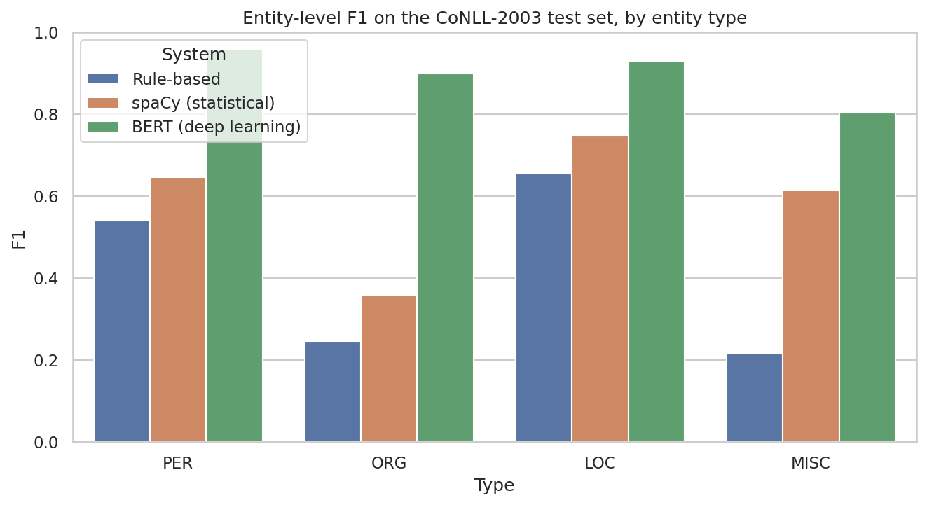
Figure 5: Entity-level F1 by entity type on the CoNLL-2003 test set
BERT is best on every type, with PER (0.9573) and LOC (0.9307) the easiest and MISC (0.8042) the hardest. spaCy is also strongest on LOC (0.7488) but weakest on ORG (0.3594), and the rule-based tagger is best on LOC (0.6547) and worst on MISC (0.2167) and ORG (0.2460). MISC is usually the lowest because it is a heterogeneous catch-all class with the fewest examples (702 in the test set) and no clear capitalisation or gazetteer pattern, while ORG is hard for spaCy because OntoNotes and CoNLL draw the boundary between organisations and places differently.
The token-level confusion tables show that the main confusions are between ORG, LOC and PER. spaCy labels 290 gold ORG tokens as LOC and 299 as PER, and 311 gold PER tokens as ORG, and it misses 641 ORG tokens completely (predicted as O) while adding 548 false ORG tokens from O; this is typical for sports teams named after cities (for example a football club named after its city) and for company names that look like surnames. BERT makes far fewer such mistakes, with the biggest remaining confusions being ORG as LOC (60) and LOC as ORG (76).

6.7 Why NER must keep capitalisation
To test the preprocessing decision, spaCy was run on the same CoNLL test set after converting all tokens to lowercase.
Table 13: Effect of lowercasing on spaCy
Input to spaCy | Entity F1
Original case | 0.5949
Lower-cased | 0.4446

Lowercasing reduced the F1 from 0.5949 to 0.4446 (a relative drop of 25.3%), which confirms that capitalisation is a key signal for NER and justifies keeping the text unnormalised for this task, even though the same normalisation helps sentiment classification.

6.8 Domain probe: review-style sentences
CoNLL is news text, whereas the target text is movie reviews. To estimate the effect of this domain shift, 30 review-style sentences containing 75 entities were written and annotated by hand (Appendix C). Film titles and nationalities are labelled MISC, actors and directors PER, studios ORG and places LOC. Two sentences contain no entities and test for false alarms. Because the set is small and written by the author, the results are only indicative. Two scores are reported: strict (boundaries and type) and boundaries only (type ignored), which separates the ability to find entities from the ability to label them.
Table 14: NER results on the review-style probe set
System | Precision (strict) | Recall (strict) | F1 (strict) | F1 (boundaries only)
Rule-based | 0.750 | 0.720 | 0.735 | 0.925
spaCy (statistical) | 0.691 | 0.627 | 0.657 | 0.923
BERT (deep learning) | 0.908 | 0.920 | 0.914 | 0.980

Boundary-only F1 is high for all three systems (0.925, 0.923 and 0.980), which means that entities are almost always found but often given the wrong type; the gap to strict F1 is largest for spaCy (0.923 against 0.657, a gap of 0.266), then the rule-based tagger (0.190) and BERT (0.066). The “right boundary, wrong type” lists show that film titles are the problem: spaCy typed Aladdin, Forrest Gump and Jaws as PER, Gladiator and Pulp Fiction as ORG, and Dilwale, La Dolce Vita and Pacific Rim as LOC (19 such errors in total, plus 9 entities missed completely, such as Inception, Parasite and Casablanca), while BERT had only 5 such errors (for example Pixar as PER, Ratatouille as PER and Shutter Island as LOC) and missed only Seven Samurai. Compared with CoNLL, BERT’s strict F1 stays about the same (0.914 against 0.913) and the rule-based and spaCy scores are higher than on CoNLL (0.735 and 0.657), but this is probably because the probe sentences are short, cleanly written and easy, and not because the models cope better with review language; with only 75 entities written by the author, these numbers are indicative only.

6.9 NER applied to IMDB reviews
spaCy was applied to a random sample of 5,000 test reviews, finding 60,358 entities. Here spaCy’s own OntoNotes labels are kept, since there is no gold standard to map against.
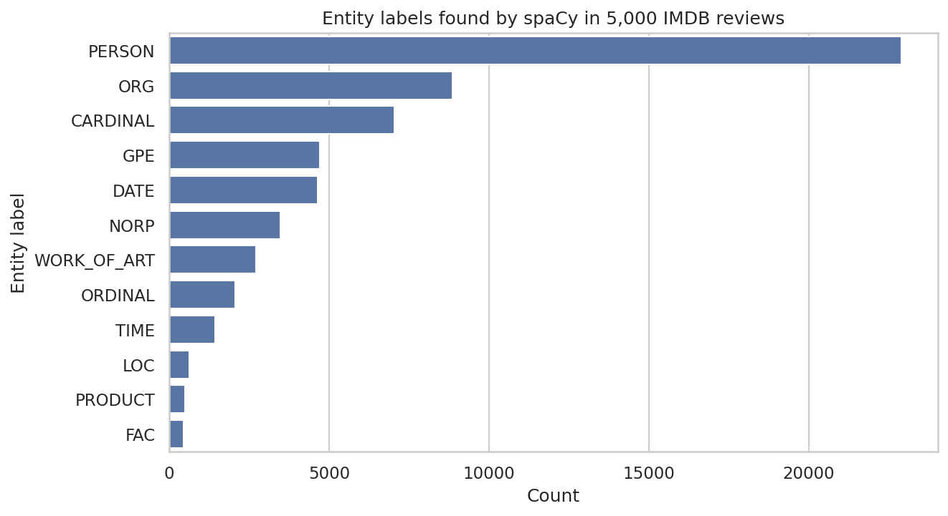
Figure 6: Most frequent entity labels found by spaCy in 5,000 IMDB reviews
PERSON is by far the most frequent label with 22,888 of the 60,358 entities (about 38%), followed by ORG (8,857), CARDINAL (7,036), GPE (4,707), DATE (4,641) and NORP (3,461). This is expected for movie reviews, which mostly talk about actors and directors, studios, places and years, and the numeric labels (CARDINAL, DATE, ORDINAL, TIME) mostly come from ratings, counts and release years. WORK_OF_ART is rarer than expected (2,715), because many film titles are tagged as PERSON or ORG instead.
Table 15: Most frequent entities by label in 5,000 IMDB reviews
Rank | PERSON | ORG | GPE | WORK_OF_ART
1 | gore (145) | Hitchcock (105) | Hollywood (357) | Batman (29)
2 | Oscar (92) | Disney (79) | America (116) | Bible (18)
3 | Shakespeare (62) | VHS (50) | US (89) | Star Trek (14)
4 | Jack (57) | BBC (49) | New York (73) | Love (13)
5 | Jason (55) | Ford (39) | London (61) | Hercules (12)

The top PERSON list is only partly correct: Shakespeare and Chaplin (45) are real people, but “gore” (145) is a common word (the horror-film element) and “Oscar” (92) is mostly the award, and many entries are single first names (Jack, Jason, Michael, Charlie) that cannot be linked to a specific person. The ORG column mixes real organisations (Disney, BBC, FBI, HBO) with directors mislabelled as organisations (Hitchcock, Fulci, Argento), with film names such as Batman, and with non-organisations such as VHS and CGI. In the WORK_OF_ART column Batman, Star Trek, Hamlet and Spider-Man are plausible, but Love and Yusuf look wrong, and GPE is the cleanest label, led by Hollywood (357), America, US, New York and London.

7. Integration: Entity-Level Sentiment

7.1 Method
The two projects were combined to answer the question “which people are associated with positive or negative reviews?” For each of the 5,000 reviews, spaCy found the people mentioned (only full names of two or more words were kept, to avoid ambiguous surnames) and the Linear SVM supplied a sentiment score for the review. For every person mentioned in at least 8 reviews, the mean SVM score and the share of truly positive reviews were calculated.

7.2 Results
64 people were mentioned in at least 8 reviews. The mean SVM score and the true share of positive reviews were correlated with a coefficient of 0.912, which shows that the predicted sentiment agrees closely with the gold labels at entity level.
Table 16: People most and least associated with positive reviews
Group | Person | Reviews | Mean SVM score | % positive
Most positive | Dustin Hoffman | 8 | 0.948 | 100%
Most positive | Martin Sheen | 8 | 0.880 | 100%
Most positive | Michelle Pfeiffer | 12 | 0.771 | 100%
Most negative | Chuck Norris | 18 | -0.883 | 5.6%
Most negative | Ed Wood | 16 | -0.868 | 12.5%
Most negative | Jim Carrey | 10 | -0.755 | 0%
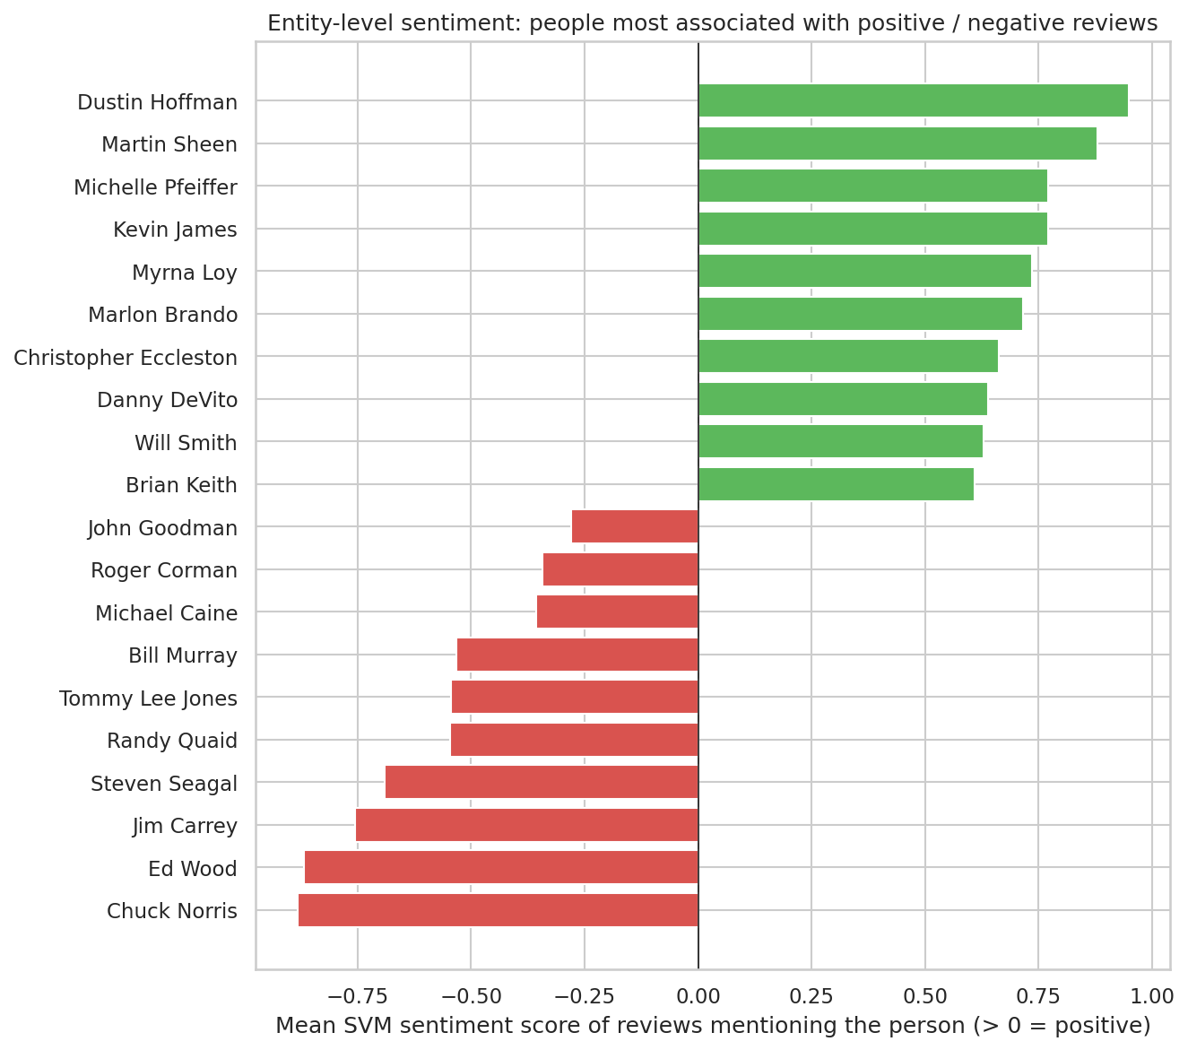
Figure 7: Entity-level sentiment: people most associated with positive and negative reviews
The most positive names are well-liked actors such as Dustin Hoffman (mean score 0.948), Martin Sheen (0.880) and Michelle Pfeiffer (0.771), and the most negative are Chuck Norris (-0.883), Ed Wood (-0.868) and Jim Carrey (-0.755), together with action actors such as Steven Seagal (-0.690) and cult B-movie names such as Roger Corman. The results look plausible: Ed Wood is known for “so bad it is good” films and Chuck Norris and Steven Seagal for low-rated action films, and Jim Carrey’s 0% share of positive reviews is consistent with his low mean score. The high correlation (0.912) shows that the SVM scores follow the true ratings, but the result describes the reviews in which a name appears, not opinions about the person.

7.3 Limitations
- The score is the sentiment of the whole review, not of the sentence about the person, so it shows association, not opinion about that person.
- Name variants (“Hitchcock” and “Alfred Hitchcock”) are counted as different entities, and no entity linking or coreference resolution is used.
- NER errors (for example film titles tagged as people) can enter the results.
- Only people mentioned in at least 8 sampled reviews are shown, so the results are limited to frequently discussed names.

8. Discussion of Results

8.1 Sentiment analysis
The SVM was the best sentiment model on both evaluation sets: it reached an accuracy of 0.8995 on the 2,000-review sample and 0.8979 on the full test set, ahead of DistilBERT (0.8935 on the sample) and far ahead of VADER, whose best variant (tuned threshold with sentence averaging) reached 0.7330 on the sample and 0.7478 on the full set. Tuning the threshold and averaging over sentences helped VADER by about 4.6 points over the default (0.6865 to 0.7330 on the sample), but it still stays about 16 points behind the learned models. The pre-trained DistilBERT, which never saw IMDB reviews, came within 0.6 points of the SVM that was trained on 24,904 in-domain reviews but did not beat it; the 131 versus 143 disagreements show that the two make different mistakes. This suggests that in-domain training data and general pre-trained knowledge are almost equally valuable here, and that DistilBERT would probably win if it were also fine-tuned on IMDB or not limited to 512 tokens.

8.2 Named entity recognition
On CoNLL-2003 the ranking is BERT (F1 0.9129), spaCy (0.5949) and the rule-based tagger (0.4259). The 31.8-point gap between the in-domain BERT and the out-of-domain spaCy is partly a difference in model quality and partly a difference in annotation style and label set, because BERT was fine-tuned on CoNLL itself while spaCy was trained on OntoNotes and had its labels mapped. On the 30-sentence review probe set BERT kept its strict F1 (0.914), but spaCy’s strict F1 was 0.266 below its boundary-only F1 (0.657 against 0.923), because it typed film titles as people, organisations or places. Lowercasing the input cut spaCy’s F1 from 0.5949 to 0.4446 (a relative drop of 25.3%), which confirms that capitalisation is the key signal for NER.

8.3 Trade-offs and best choice
Table 17: Best approach for each task, and why
Task | Best accuracy | Best for speed / simplicity | Recommended choice
Sentiment analysis | TF-IDF + Linear SVM | VADER (no training, instant) | TF-IDF + Linear SVM because it is almost as accurate as DistilBERT (0.8979 on the full test set against 0.8935 on the sample) but trains in about 16 seconds on a CPU, scores all 24,678 reviews quickly, has no 512-token limit and uses in-domain data
NER | BERT (dslim/bert-base-NER) | Rule-based / spaCy | BERT (dslim/bert-base-NER) because its F1 of 0.9129 is far above spaCy (0.5949) and the rules (0.4259) and it handles review-style text best, although it is heavier and spaCy is a reasonable choice if speed matters more than accuracy

A consistent pattern is that accuracy increases with model complexity and computational cost: lexicon and rule-based methods are instant but weak, classical machine learning and spaCy give a strong middle ground, and transformers give the best accuracy at the highest cost. The right choice depends on the amount of labelled data, the available compute and how much error is acceptable.

9. Challenges and How They Were Addressed
Table 18: Challenges and solutions
Challenge | Why it mattered | Solution
No dataset with gold labels for both tasks | Both tasks need ground truth to compute accuracy and F1 | Used IMDB for sentiment and CoNLL-2003 for NER evaluation, linked them through application to IMDB and a hand-annotated probe set
Opposite preprocessing needs | Lowercasing helps the classifier but destroys NER signals | Task-specific preprocessing; lowercasing ablation to prove the point
Dataset loading error | The original conll2003 loading script is no longer supported by recent datasets versions | Loaded a script-free copy (lhoestq/conll2003) with fallbacks. That copy has no label names attached to its tag column, which caused a second error (an AttributeError), so the standard CoNLL tag order was applied and checked against the published test statistics (1,617 PER, 1,661 ORG, 1,668 LOC and 702 MISC entities)
Different label sets | spaCy uses 18 OntoNotes labels, CoNLL has 4 types | Mapped spaCy labels to CoNLL types; dates, numbers and similar were treated as O
Sub-word alignment for BERT | BERT splits words into pieces, so predictions do not line up with the gold tokens | Used the first sub-word of each word as the word’s prediction
Domain shift (news to reviews) | Film titles and slang are rare in news training data | Measured it with the probe set and described the error types
Long reviews | DistilBERT reads at most 512 tokens | Truncated reviews; discussed as a limitation and as a reason for the SVM’s competitiveness
Threshold tuning without leaking the test set | Choosing VADER’s threshold on test data would inflate results | Tuned on a 5,000-review training subsample
Compute time of transformers | Running BERT and DistilBERT on every review is slow on CPU | Evaluated DistilBERT on a stratified 2,000-review sample; optional GPU
Entity-level sentiment is indirect | Review-level sentiment is not sentiment about a person; name variants split counts | Documented as limitations; proposed sentence-level and entity-linking improvements
All-capital headlines in CoNLL-2003 | Capitalisation is the main cue for names, so a headline written in capitals (for example “SOCCER - JAPAN GET LUCKY WIN”) makes every word look like a possible entity and all three systems made mistakes on it | Kept the official test set unchanged so the scores stay comparable, and used the example to explain the errors of the rule-based tagger, spaCy and BERT

The hardest part was that the two tasks need opposite preprocessing and that NER has no gold labels on the review text, so the results had to be built from two datasets and a small hand-made probe set. Several practical problems also appeared when running the notebook: the original CoNLL-2003 loading script no longer works with recent versions of the datasets library, the replacement copy had no label names (causing an AttributeError), and the spaCy model installation asked for a runtime restart. The NER results on IMDB taught me that a model can look good on its benchmark and still make odd mistakes on a new domain, since spaCy labelled “gore” as a person and directors such as Hitchcock as organisations, and that threshold tuning, evaluation on a held-out set and honest limitations matter as much as the choice of model.

10. Potential Improvements
Table 19: Possible improvements
Improvement | What it involves | Expected benefit
Fine-tune DistilBERT or BERT on IMDB | Train the transformer on the labelled reviews (needs a GPU) | Likely the highest sentiment accuracy; handles context and negation
Handle long reviews | Classify chunks or sentences and aggregate, instead of truncating | Uses the whole review
Domain-specific NER | Fine-tune on movie-domain annotations (for example the MIT Movie corpus) or annotate reviews with film, actor and director types | Fixes film-title errors and gives richer entity types
Sentence-level entity sentiment | Link each entity to the sentence or dependency phrase it appears in and score only that text, or use aspect-based sentiment analysis | True sentiment towards each entity
Entity linking and coreference | Merge name variants and pronouns and link names to a knowledge base such as Wikidata | Accurate entity counts
Larger or ensemble NER | Combine spaCy and BERT predictions, or use a larger transformer | Higher recall and precision
Gazetteers from film databases | Add lists of actors, directors and studios to the rule-based tagger and as features | Cheap gains for the rule-based system
Statistical significance testing | Use bootstrap confidence intervals or McNemar’s test to compare models | Shows whether small differences are real
Sarcasm and irony detection | Use context-aware models trained on sarcastic text | Fewer errors on ironic reviews

Given the results, the first two or three things to try would be fine-tuning DistilBERT on the IMDB training reviews, because it is the most direct way to combine the transformer's understanding of context with in-domain vocabulary; scoring the sentence around each person instead of the whole review, because that removes the main limitation of the entity-level analysis in Section 7; and adding movie-domain NER (fine-tuning on movie annotations or a film-title gazetteer), because film titles were the most common source of typing errors on review text.

11. Conclusion
This report implemented and compared three approaches each for sentiment analysis and named entity recognition within one framework, evaluated them with accuracy, precision, recall and F1, and combined them into an entity-level sentiment analysis of movie reviews.
The best sentiment model was the TF-IDF + Linear SVM with an accuracy of 0.8995 on the 2,000-review sample and 0.8979 on the full test set, just ahead of DistilBERT (0.8935) and far ahead of VADER (best 0.7478 on the full set). The best NER system was BERT with an entity-level F1 of 0.9129 on CoNLL-2003, compared with 0.5949 for spaCy and 0.4259 for the rule-based tagger. On review-style text BERT kept its strict F1 of 0.914 on the probe set, but spaCy fell from a boundary-only F1 of 0.923 to a strict F1 of 0.657 because film titles were given the wrong type. The most interesting finding of the entity-level analysis is that the 64 frequently mentioned people showed a strong correlation (0.912) between predicted and true sentiment, with names such as Dustin Hoffman at the positive end and Chuck Norris and Ed Wood at the negative end. Next I would fine-tune DistilBERT on IMDB, score the sentence around each person instead of the whole review, and add movie-domain NER.

Appendix A: Reproducibility
Notebook: https://github.com/haricharan-285/yuvaintern-nlp-tasks. Random seed: 42. Environment:
Table 20: Software environment
Library | Version
Python | 3.13.15
scikit-learn | 1.6.1
pandas / NumPy | 2.2.3 / 2.1.3
NLTK | 3.9.1
spaCy / model en_core_web_sm | 3.8.16 / 3.8.0
transformers / PyTorch | 5.18.0 / 2.11.0+cu130
Hugging Face datasets | 4.8.5
vaderSentiment | 3.3.2
Matplotlib / Seaborn | 3.10.0 / 0.13.2

Appendix B: Core Code
Entity decoding, entity-level evaluation and the VADER scoring rules used in the notebook:
def bio_to_spans(tokens, tags):
spans, start, typ = [], None, None
for i, tag in enumerate(list(tags) + ["O"]):
if tag == "O" or tag.startswith("B-") or (tag.startswith("I-") and tag[2:] != typ):
if start is not None:
spans.append((" ".join(tokens[start:i]), typ)); start, typ = None, None
if tag != "O":
start, typ = i, tag[2:]
return spans

# entity-level evaluation (strict boundaries and type)
# scores computed by entity_scores() in the notebook (CoNLL rules)
f1 = seq_f1(gold_tags, predicted_tags)

# VADER scoring rules
def vader_whole(t): return sia.polarity_scores(strip_html(t))["compound"]
def vader_sent(t):
sents = nltk.sent_tokenize(strip_html(t))
return np.mean([sia.polarity_scores(s)["compound"] for s in sents])
label = (score >= best_threshold) # threshold tuned on training data

Appendix C: Review-Style Probe Set
The 30 sentences below were written for this report and annotated by hand. PER = person, ORG = organisation, LOC = location, MISC = other (film titles, nationalities).
Table 21: Probe sentences and gold entities
# | Sentence | Gold entities
1 | Christopher Nolan directed Inception for Warner Bros in 2010. | Christopher Nolan (PER); Inception (MISC); Warner Bros (ORG)
2 | Tom Hanks gives a wonderful performance in Forrest Gump, which was shot mostly in Georgia. | Tom Hanks (PER); Forrest Gump (MISC); Georgia (LOC)
3 | I watched Parasite at a cinema in Seoul and loved every minute of it. | Parasite (MISC); Seoul (LOC)
4 | The Italian director Federico Fellini made La Dolce Vita in Rome. | Italian (MISC); Federico Fellini (PER); La Dolce Vita (MISC); Rome (LOC)
5 | Disney remade Aladdin with Will Smith, and the result is mediocre. | Disney (ORG); Aladdin (MISC); Will Smith (PER)
6 | Russell Crowe is magnificent in Gladiator, directed by Ridley Scott. | Russell Crowe (PER); Gladiator (MISC); Ridley Scott (PER)
7 | Netflix released Roma, a black-and-white drama set in Mexico City. | Netflix (ORG); Roma (MISC); Mexico City (LOC)
8 | Quentin Tarantino fans will enjoy Pulp Fiction, though the dialogue drags in the middle. | Quentin Tarantino (PER); Pulp Fiction (MISC)
9 | Shah Rukh Khan stars in Dilwale, a film shot partly in Iceland and Bulgaria. | Shah Rukh Khan (PER); Dilwale (MISC); Iceland (LOC); Bulgaria (LOC)
10 | Universal Pictures should have spent more money on the script of Waterworld. | Universal Pictures (ORG); Waterworld (MISC)
11 | Sean Connery was the best James Bond in my opinion. | Sean Connery (PER); James Bond (PER)
12 | Filmed in New Zealand, Lord of the Rings looks spectacular. | New Zealand (LOC); Lord of the Rings (MISC)
13 | Steven Spielberg made Jaws, and John Williams wrote an unforgettable score. | Steven Spielberg (PER); Jaws (MISC); John Williams (PER)
14 | Denzel Washington saved Flight from being a forgettable drama. | Denzel Washington (PER); Flight (MISC)
15 | Amazon Studios and BBC Films co-produced this slow burner set in London. | Amazon Studios (ORG); BBC Films (ORG); London (LOC)
16 | Brad Pitt is miscast as a German soldier in Inglourious Basterds. | Brad Pitt (PER); German (MISC); Inglourious Basterds (MISC)
17 | I rented Casablanca on the recommendation of a friend from Chicago. | Casablanca (MISC); Chicago (LOC)
18 | Hayao Miyazaki directed Spirited Away, the masterpiece that made Studio Ghibli famous. | Hayao Miyazaki (PER); Spirited Away (MISC); Studio Ghibli (ORG)
19 | Honestly, this was a waste of two hours, and the director should be ashamed. | (none)
20 | Martin Scorsese cast Leonardo DiCaprio in Shutter Island, filmed near Boston. | Martin Scorsese (PER); Leonardo DiCaprio (PER); Shutter Island (MISC); Boston (LOC)
21 | Sony and Marvel Studios made this film together, shot in Atlanta. | Sony (ORG); Marvel Studios (ORG); Atlanta (LOC)
22 | Judi Dench steals the show in Skyfall. | Judi Dench (PER); Skyfall (MISC)
23 | The soundtrack, composed by Hans Zimmer, is the only good thing about Armageddon. | Hans Zimmer (PER); Armageddon (MISC)
24 | Warner Bros keeps making sequels nobody asked for, like Gremlins 2. | Warner Bros (ORG); Gremlins 2 (MISC)
25 | I saw this at the Cannes festival and the French audience applauded for five minutes. | Cannes (LOC); French (MISC)
26 | Bruce Willis plays a cop in Los Angeles in Die Hard. | Bruce Willis (PER); Los Angeles (LOC); Die Hard (MISC)
27 | Pixar did it again with Ratatouille, a love letter to Paris. | Pixar (ORG); Ratatouille (MISC); Paris (LOC)
28 | Idris Elba is the only reason to watch Pacific Rim. | Idris Elba (PER); Pacific Rim (MISC)
29 | The pacing is terrible and the ending makes no sense at all. | (none)
30 | Akira Kurosawa influenced Hollywood with Seven Samurai. | Akira Kurosawa (PER); Hollywood (LOC); Seven Samurai (MISC)

Appendix D: References
- Maas, A. L., Daly, R. E., Pham, P. T., Huang, D., Ng, A. Y., & Potts, C. (2011). Learning Word Vectors for Sentiment Analysis. Proceedings of ACL, pp. 142–150.
- Tjong Kim Sang, E. F., & De Meulder, F. (2003). Introduction to the CoNLL-2003 Shared Task: Language-Independent Named Entity Recognition. Proceedings of CoNLL-2003.
- Ramshaw, L. A., & Marcus, M. P. (1995). Text Chunking using Transformation-Based Learning. Proceedings of the Third Workshop on Very Large Corpora.
- Hutto, C. J., & Gilbert, E. (2014). VADER: A Parsimonious Rule-based Model for Sentiment Analysis of Social Media Text. Proceedings of ICWSM.
- Devlin, J., Chang, M.-W., Lee, K., & Toutanova, K. (2019). BERT: Pre-training of Deep Bidirectional Transformers for Language Understanding. Proceedings of NAACL.
- Sanh, V., Debut, L., Chaumond, J., & Wolf, T. (2019). DistilBERT, a distilled version of BERT: smaller, faster, cheaper and lighter. arXiv:1910.01108.
- Socher, R., et al. (2013). Recursive Deep Models for Semantic Compositionality Over a Sentiment Treebank. Proceedings of EMNLP.
- Lample, G., Ballesteros, M., Subramanian, S., Kawakami, K., & Dyer, C. (2016). Neural Architectures for Named Entity Recognition. Proceedings of NAACL.
- Honnibal, M., Montani, I., Van Landeghem, S., & Boyd, A. (2020). spaCy: Industrial-strength Natural Language Processing in Python. Zenodo.
- Wolf, T., et al. (2020). Transformers: State-of-the-Art Natural Language Processing. Proceedings of EMNLP: System Demonstrations.
- Pedregosa, F., et al. (2011). Scikit-learn: Machine Learning in Python. Journal of Machine Learning Research, 12, 2825–2830.
- Joachims, T. (1998). Text Categorization with Support Vector Machines: Learning with Many Relevant Features. Proceedings of ECML.

