Exploratory Data Analysis & Preprocessing
of the IMDB Movie Review Dataset

Week 1 Task: Natural Language Processing
YuvaIntern Internship Programme
Prepared by: Kammari Hari Charan

Table of Contents
1. Introduction 3
1.1 Objective 3
1.2 Scope of this report 3
1.3 Reproducibility 3
2. Dataset Overview 4
2.1 Source and background 4
2.2 Structure of the dataset 4
2.3 Why this dataset was chosen 4
2.4 Dataset as analysed 4
3. Tools and Environment 6
4. Exploratory Analysis of the Raw Data 7
4.1 Missing, duplicate and noisy data 7
4.2 Review length distribution 7
4.3 Vocabulary and term frequency (raw) 8
5. Preprocessing Methodology 10
5.1 Removing HTML tags and URLs 10
5.2 Lowercasing 10
5.3 Expanding contractions 10
5.4 Removing punctuation, digits and symbols 11
5.5 Tokenization 11
5.6 Stopword removal (keeping negations) 11
5.7 Normalization: lemmatization versus stemming 12
5.8 Effect of each step on the vocabulary 12
5.9 Worked example 13
6. Analysis of the Cleaned Data 15
6.1 Effect of cleaning on review length 15
6.2 N-gram analysis 15
6.3 Distinctive terms per class 17
6.4 Sentiment distribution (VADER) 18
7. Challenges and Solutions 21
8. Insights for Future NLP Modelling 23
Recommendations 23
9. Conclusion 25
Appendix A: Preprocessing Code 25
Appendix B: References 26

1. Introduction

1.1 Objective
Real-world text is messy. Before any machine-learning model can learn from it, the text has to be explored, understood and cleaned. The objective of this task is to select a publicly available text dataset, perform a complete exploratory data analysis (EDA), and design and justify a text preprocessing pipeline covering cleaning, tokenization and normalization.

1.2 Scope of this report
This report documents the full process carried out on the IMDB movie review dataset. It covers:
- an overview of the dataset and its source (Section 2);
- the tools and environment used (Section 3);
- exploratory analysis of the raw data: data quality, review length, vocabulary and term frequency (Section 4);
- the step-by-step cleaning, tokenization and normalization methodology, with the reason for each choice (Section 5);
- analysis of the cleaned data: n-grams, word clouds, distinctive terms and sentiment distribution (Section 6);
- the challenges encountered and how they were addressed (Section 7);
- insights that can inform future NLP modelling (Section 8).

1.3 Reproducibility
All analysis was carried out in a single Python notebook on Google Colab. The notebook can be re-run from top to bottom to reproduce every number and figure in this report. Notebook link: https://colab.research.google.com/drive/1X4ctn6dJ5NEcbkbdh9TL9ZeqHUh3_TdJ?usp=sharing

2. Dataset Overview

2.1 Source and background
The dataset used is the Large Movie Review Dataset (IMDB), created by Maas et al. at Stanford University and introduced in the paper "Learning Word Vectors for Sentiment Analysis" (ACL 2011). It is a widely used benchmark for binary sentiment classification. It is publicly available from the Stanford AI Lab website and is also hosted on Hugging Face (stanfordnlp/imdb) and Kaggle. In this work it was loaded through the Hugging Face datasets library.
Usage terms: The Hugging Face dataset page lists the licence as "other", meaning no standard open-source licence is stated. The data was therefore used only for non-commercial, educational analysis as part of this internship task, and the original authors (Maas et al., 2011) are credited in the references.

2.2 Structure of the dataset
Table 1: Summary of the dataset
Attribute | Description
Total reviews | 50,000 (25,000 training + 25,000 test; both were combined for analysis)
Columns | text (the review) and label (the sentiment)
Labels | 0 = negative, 1 = positive
Label rule | Negative reviews have a rating of 4 or lower out of 10; positive reviews have 7 or higher. Neutral reviews are excluded.
Class balance (original) | 25,000 negative / 25,000 positive
Language | English
Raw format | Plain text containing some HTML markup (for example <br /> line breaks)

2.3 Why this dataset was chosen
- Realistic, noisy text: it contains HTML tags, inconsistent casing, contractions, slang and wide variation in length, so the cleaning decisions are real and worth documenting.
- Labelled data: the known labels allow sentiment distribution to be analysed and a rule-based sentiment tool to be checked against ground truth.
- Balanced classes: this keeps the analysis of class differences fair.
- Widely used benchmark: results can be compared with published work, and the data is freely accessible for reproducibility.

2.4 Dataset as analysed
After loading and adding a sentiment-name column, the combined dataset had 50,000 rows and 3 columns (text, label and sentiment). Removing exact duplicate reviews (Section 4.1) left 49,582 reviews, of which 24,698 were negative and 24,884 positive.
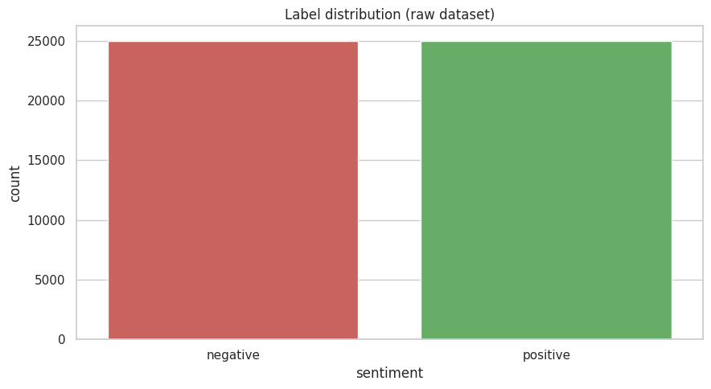
Figure 1: Label distribution of the dataset
After duplicate removal the dataset contains 24,698 negative and 24,884 positive reviews (49,582 in total). The classes remain almost perfectly balanced (about 49.8% negative and 50.2% positive), so no resampling is needed.

3. Tools and Environment
The work was done in Google Colab using Python. Table 2 lists the libraries and why each was used.
Table 2: Libraries used
Library | Purpose | Version
pandas, NumPy | Data loading, manipulation and numerical summaries | pandas 2.2.3, NumPy 2.1.3
Hugging Face datasets | Downloading the IMDB dataset | 4.8.5
Matplotlib, Seaborn | Visualisation | Seaborn 0.13.2, Matplotlib 3.10.0
NLTK | Stopword list, lemmatizer, stemmer, tokenizer comparison | 3.9.1
scikit-learn | CountVectorizer for n-grams; classification metrics | 1.6.1
WordCloud | Word clouds per sentiment class | 1.9.6
vaderSentiment | Rule-based sentiment scoring (VADER) | 3.3.2

Python version: 3.13.15. All random operations use a fixed seed where applicable so that results can be reproduced.

4. Exploratory Analysis of the Raw Data
This section describes the analysis done before any cleaning, in order to understand the data and find the problems the preprocessing pipeline needs to solve.

4.1 Missing, duplicate and noisy data

Procedure
Each review was checked for missing values, empty text, exact duplicates, HTML tags, URLs, non-ASCII characters and very short length (fewer than 10 words). Duplicates were also checked for conflicting labels, since the same text labelled both ways would indicate a labelling problem.

Findings
Table 3: Data quality assessment
Issue | Count | % of reviews | Treatment
Missing values | 0 | 0.00% | None needed
Empty / whitespace-only | 0 | 0.00% | None needed
Exact duplicate reviews | 418 | 0.84% | Removed (see below)
Contain HTML tags | 29,202 | 58.40% | Stripped in preprocessing
Contain URLs | 196 | 0.39% | Stripped in preprocessing
Contain non-ASCII characters | 4,660 | 9.32% | Not removed; the alphabetic filter splits accented words (see Section 7)
Very short (< 10 words) | 5 | 0.01% | Kept (still valid reviews)

Percentages in Table 3 are relative to the original 50,000 reviews. There were no missing or empty reviews. HTML tags were by far the most common form of noise, appearing in 29,202 reviews (58.4%), followed by non-ASCII characters in 4,660 reviews (9.3%) and URLs in 196 reviews (0.4%). Only 5 reviews had fewer than 10 words, so no review had to be dropped for being too short. Of the 50,000 reviews, 418 (0.84%) were exact duplicates. None of the duplicate groups carried conflicting labels, so the duplicates were simply removed, leaving 49,582 reviews (24,698 negative and 24,884 positive). Duplicates were removed because they would bias frequency statistics and could leak between train and test splits in later modelling.
Example of HTML noise in a raw review: “…I really had to see this for myself.<br /><br />The plot is centered around a young Swedish drama student…” (first review in the dataset, showing the <br /> line-break tags).

4.2 Review length distribution

Procedure
The number of characters and words in each review was computed, summarised with descriptive statistics and visualised with a histogram and a boxplot split by sentiment. Outliers were identified using the interquartile range (IQR) rule (values above Q3 + 1.5 × IQR).

Findings
Table 4: Review length statistics (raw text)
Statistic | Characters | Words
Mean | 1,310.6 | 231.4
Median | 971 | 173
Standard deviation | 990.8 | 171.5
Minimum | 32 | 4
Maximum | 13,704 | 2,470

The upper outlier fence was 514 words, and 3,661 reviews (7.4%) lie above it. The boxplots show that positive and negative reviews have very similar length distributions: the median is 174 words for negative reviews and 172 for positive reviews (means 229.6 and 233.1). The longest review is a positive one (2,470 words, against 1,522 for the longest negative review), which produces the highest outliers in the boxplot.
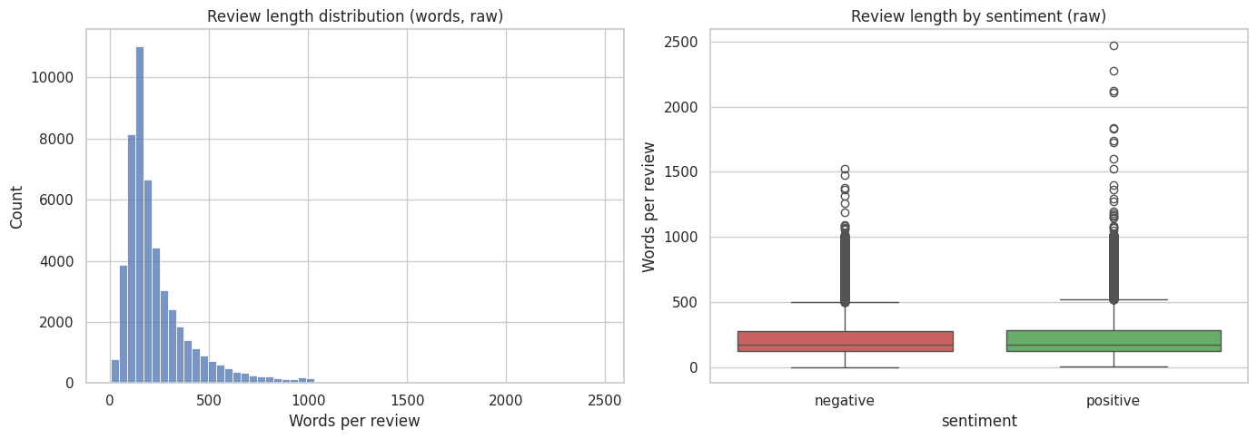
Figure 2: Distribution of review length (words) and length by sentiment, raw text
The distribution is strongly right-skewed: the mean (231.4 words) is well above the median (173 words), the middle 50% of reviews lie between 126 and 281 words, and the histogram peaks at roughly 150 words. A long tail reaches 2,470 words, while the shortest review has only 4 words. Both classes have a very similar spread and many high outliers (3,661 reviews exceed the 514-word fence), so review length alone does not separate positive from negative reviews.

4.3 Vocabulary and term frequency (raw)

Procedure
Raw text was lowercased and split into word tokens using a simple regular expression, with no other cleaning. Total tokens, vocabulary size (unique tokens) and the type-token ratio (unique tokens ÷ total tokens) were computed, and the 20 most frequent tokens were plotted.

Findings
The raw data contains 11,581,971 tokens and a vocabulary of 108,921 unique tokens, giving a type-token ratio of 0.0094.
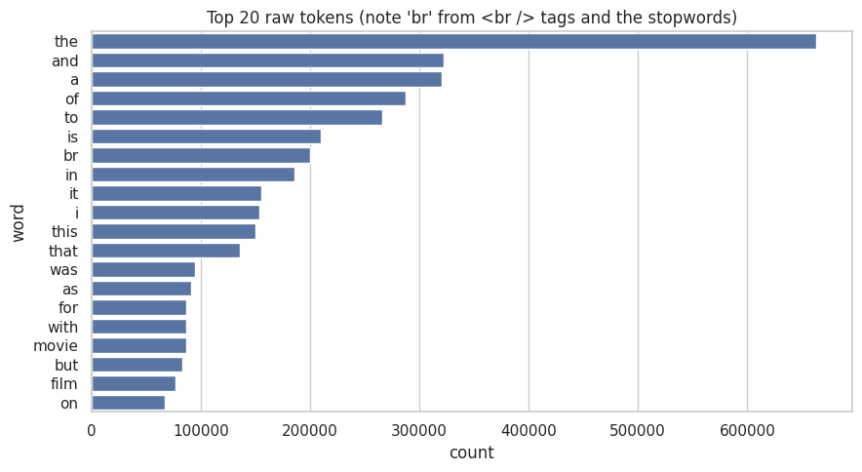
Figure 3: Top 20 most frequent tokens in the raw text
“the” is by far the most frequent token (about 660,000 occurrences), followed by “and”, “a”, “of”, “to” and “is”. The HTML artefact “br” ranks 7th with roughly 200,000 occurrences, purely because of the <br /> tags, which confirms that HTML must be stripped. Apart from “br” and the domain words “movie” and “film”, every one of the top 20 tokens is a function word, which justifies stopword removal.

5. Preprocessing Methodology
The preprocessing pipeline was built from small, single-purpose functions applied in a fixed order. After every step the vocabulary size was recorded, so that the effect of each decision can be measured. Table 5 summarises the pipeline; the subsections explain each step in detail.
Table 5: Summary of the preprocessing pipeline
Step | Technique | Main justification
1 | Remove HTML tags and URLs | Markup such as <br /> is a formatting artefact with no sentiment value
2 | Lowercase | Merges variants such as "Great" and "great" and shrinks the vocabulary
3 | Expand contractions | Turns "didn't" into "did not" so that negation survives later steps
4 | Remove punctuation, digits and symbols | Removes noise and leaves clean alphabetic tokens
5 | Tokenize | Splits text into the word units used for counting and modelling
6 | Remove stopwords (keeping negations) | Removes very frequent words that carry little meaning, but keeps "not", "no", "nor" and similar words that flip sentiment
7 | Lemmatize | Reduces words to dictionary forms while keeping them readable

5.1 Removing HTML tags and URLs
What it does: deletes anything between < and > and any web address, replacing it with a space.
Why: the raw reviews contain <br /> line-break tags and occasionally URLs. These are artefacts of how the data was collected, not part of what the reviewer said. Left in, br appears as one of the most frequent "words" (Figure 3) and would distort frequency analysis. A space is used as the replacement so that words on either side of a tag do not merge together.

5.2 Lowercasing
What it does: converts all text to lowercase.
Why: without it, "Good", "good" and "GOOD" would be counted as three different words. Lowercasing reduces vocabulary size and makes frequency counts more reliable. The trade-off is that emphasis conveyed by capital letters (for example "AWFUL") is lost. For this reason, the sentiment analysis in Section 6.4 is run on a version of the text that still keeps capitalisation and punctuation, because VADER uses them as signals.

5.3 Expanding contractions
What it does: rewrites forms such as "don't", "can't", "it's" and "they've" in expanded form ("do not", "can not", and so on).
Why: removing punctuation without handling contractions would turn "don't" into the fragments "don" and "t", and would silently destroy negation, which is one of the most important signals in sentiment. Expanding contractions first keeps "not" as a separate token. Possessive and "is" forms ending in 's are simply dropped because they carry no sentiment.

5.4 Removing punctuation, digits and symbols
What it does: keeps only the letters a–z and whitespace, and collapses repeated spaces.
Why: punctuation, digits (for example ratings such as "7/10") and symbols mostly add noise at the word-frequency level. This was done for the frequency-based analysis in this task. For tasks where emphasis matters, characters such as ! and ? could be kept as separate tokens.

5.5 Tokenization
What it does: splits the cleaned text into individual word tokens.
Why this choice: two approaches were compared on a messy sample sentence: simple whitespace splitting, and NLTK's word_tokenize. word_tokenize handles punctuation and contractions more intelligently on raw text (for example, it splits "didn't" into "did" and "n't"). However, by this stage the text has already been lowercased, contractions have been expanded and punctuation removed, so whitespace splitting gives the same tokens and is much faster on 50,000 reviews. Whitespace tokenization after cleaning was therefore chosen.
The two tokenizers were compared on a messy sample sentence: “I didn't like this movie... it's NOT worth $10! Check http://imdb.com <br /><br />Rating: 2/10”. Whitespace splitting leaves punctuation attached to words (“movie...”, “$10!”) and keeps HTML fragments such as “<br” inside tokens. NLTK's word_tokenize separates punctuation and splits “didn't” into “did” and “n't”, but it also breaks the URL and the HTML tags into many meaningless tokens. Either way, the text needs to be cleaned first, which is what the pipeline does.
Whitespace split : ['I', "didn't", 'like', 'this', 'movie...', "it's", 'NOT', 'worth', '$10!', 'Check', 'http://imdb.com', '<br', '/><br', '/>Rating:', '2/10']
NLTK word_tokenize: ['I', 'did', "n't", 'like', 'this', 'movie', '...', 'it', "'s", 'NOT', 'worth', '$', '10', '!', 'Check', 'http', ':', '//imdb.com', '<', 'br', '/', '>', '<', 'br', '/', '>', 'Rating', ':', '2/10']

5.6 Stopword removal (keeping negations)
What it does: removes very common words ("the", "is", "and"...) using NLTK's English stopword list, and drops single-letter tokens.
Why: these words dominate raw frequency counts (Figure 3) but say little about content. Important modification: NLTK's default list includes "not", "no" and "nor". Removing them would turn "not good" into "good" and reverse the meaning of the review, so a set of negation words (no, nor, not, never, neither, none, nothing, nowhere, hardly, barely) was explicitly kept.
Words such as "movie" and "film" are very frequent in this domain but were not removed from the pipeline, because they may be useful in some tasks. They were excluded only from the word-cloud visualisation (Section 6.2) to make it more informative.

5.7 Normalization: lemmatization versus stemming
What it does: reduces each word to a base form. Two techniques were compared: the Porter stemmer, which chops off suffixes by rule, and the WordNet lemmatizer, which maps words to dictionary forms.
Why lemmatization was chosen: stemming produces non-words (for example "studies" becomes "studi") that are hard to interpret in word clouds and n-gram plots. Lemmatization keeps real, readable words. Stemming reduces the vocabulary more aggressively, so the trade-off is interpretability versus compression. For an exploratory task where results must be explained, readability was preferred.
Table 6: Lemmatization versus stemming on example words
Word | Lemma | Stem
movies | movie | movi
characters | character | charact
studies | study | studi
acting | acting | act
terribly | terribly | terribl
beautifully | beautifully | beauti

5.8 Effect of each step on the vocabulary
Table 7: Vocabulary size and average review length after each step
Step | Vocabulary size | Avg words / review
0. Raw text | 438,729 | 231.4
1. + HTML / URL removal | 412,373 | 229.1
2. + Lowercasing | 365,227 | 229.1
3. + Contraction expansion | 353,754 | 231.2
4. + Punctuation / digit removal | 100,346 | 231.9
5. + Stopword removal (keep negations) | 100,181 | 121.2
6a. + Lemmatization (chosen) | 90,746 | 121.2
6b. + Stemming (alternative) | 69,723 | 121.2
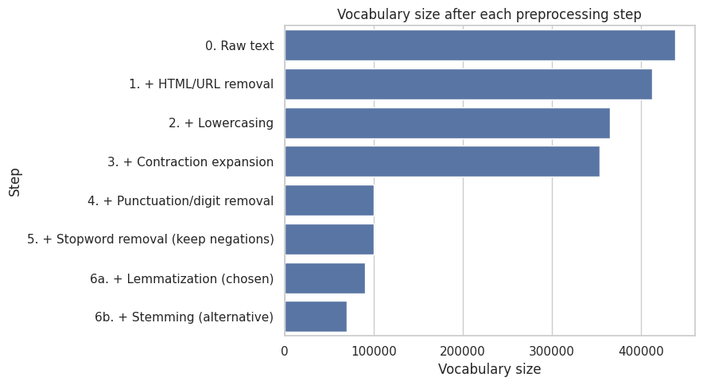
Figure 4: Vocabulary size after each preprocessing step
The largest single drop comes from removing punctuation and digits, which cut the vocabulary from 353,754 to 100,346 (a 71.6% reduction in one step), because variants such as “movie”, “movie.” and “movie,” collapse into a single word. HTML/URL removal (438,729 to 412,373), lowercasing (to 365,227) and contraction expansion (to 353,754) each trim the vocabulary more modestly. Stopword removal barely changes the vocabulary (100,346 to 100,181) because stopwords are only a few distinct words, but it almost halves the average review length from 231.9 to 121.2 words, since they are extremely frequent. Lemmatization reduces the vocabulary a further 9.4% to 90,746, while stemming would reduce it 30.4% to 69,723, which compresses more but produces non-words. Overall, the pipeline shrinks the vocabulary by 79% (438,729 to 90,746). Note that the raw vocabulary counts case variants and punctuation-attached forms as separate words, which is why it is so large.

5.9 Worked example
The following review shows the effect of the full pipeline.
Raw: This film was probably inspired by Godard's Masculin, féminin and I urge you to see that film instead.<br /><br />The film has two strong elements and those are, (1) the realistic acting (2) the impressive, undeservedly good, photo. Apart from that, what strikes me most is the endless stream of silliness. Lena Nyman has to be most annoying actress…
After HTML/URL removal: This film was probably inspired by Godard's Masculin, féminin and I urge you to see that film instead. The film has two strong elements and those are, (1) the realistic acting (2) the impressive, undeservedly good, photo. Apart from that, what strikes me most is the endless stream of silliness. Lena Nyman has to be most annoying actress in the wor…
After lowercasing, contraction expansion and punctuation removal: this film was probably inspired by godard masculin f minin and i urge you to see that film instead the film has two strong elements and those are the realistic acting the impressive undeservedly good photo apart from that what strikes me most is the endless stream of silliness lena nyman has to be most annoying actress in the world she acts so stup…
After stopword removal (negations kept): film probably inspired godard masculin minin urge see film instead film two strong elements realistic acting impressive undeservedly good photo apart strikes endless stream silliness lena nyman annoying actress world acts stupid nudity film unattractive comparing godard film intellectuality replaced stupidity without going far subject would say…
After lemmatization (final): film probably inspired godard masculin minin urge see film instead film two strong element realistic acting impressive undeservedly good photo apart strike endless stream silliness lena nyman annoying actress world act stupid nudity film unattractive comparing godard film intellectuality replaced stupidity without going far subject would say follow…

6. Analysis of the Cleaned Data

6.1 Effect of cleaning on review length
The number of words per review was recomputed after cleaning. The mean review length changed from 231.4 to 121.2 words and the median from 173 to 90 words.
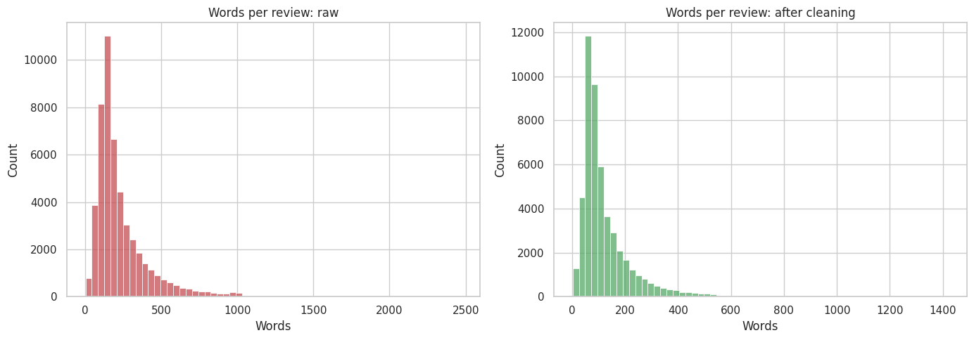
Figure 5: Words per review before and after cleaning
Both distributions are right-skewed, but cleaning shifts the whole distribution to the left: the mean falls from 231.4 to 121.2 words and the median from 173 to 90 (both about 48% shorter), the standard deviation from 171.5 to 91.3, and the longest review from 2,470 to 1,420 words. The shift is almost entirely caused by stopword removal, which alone cut the average length from 231.9 to 121.2 words per review (Table 7), because function words make up roughly half of every review.

6.2 N-gram analysis

Procedure
Unigrams, bigrams and trigrams were counted separately for positive and negative reviews using scikit-learn's CountVectorizer, ignoring n-grams that appear in fewer than 5 reviews (min_df = 5) to remove rare noise. The 15 most frequent n-grams per class were plotted. Word clouds were also generated for each class.

Findings
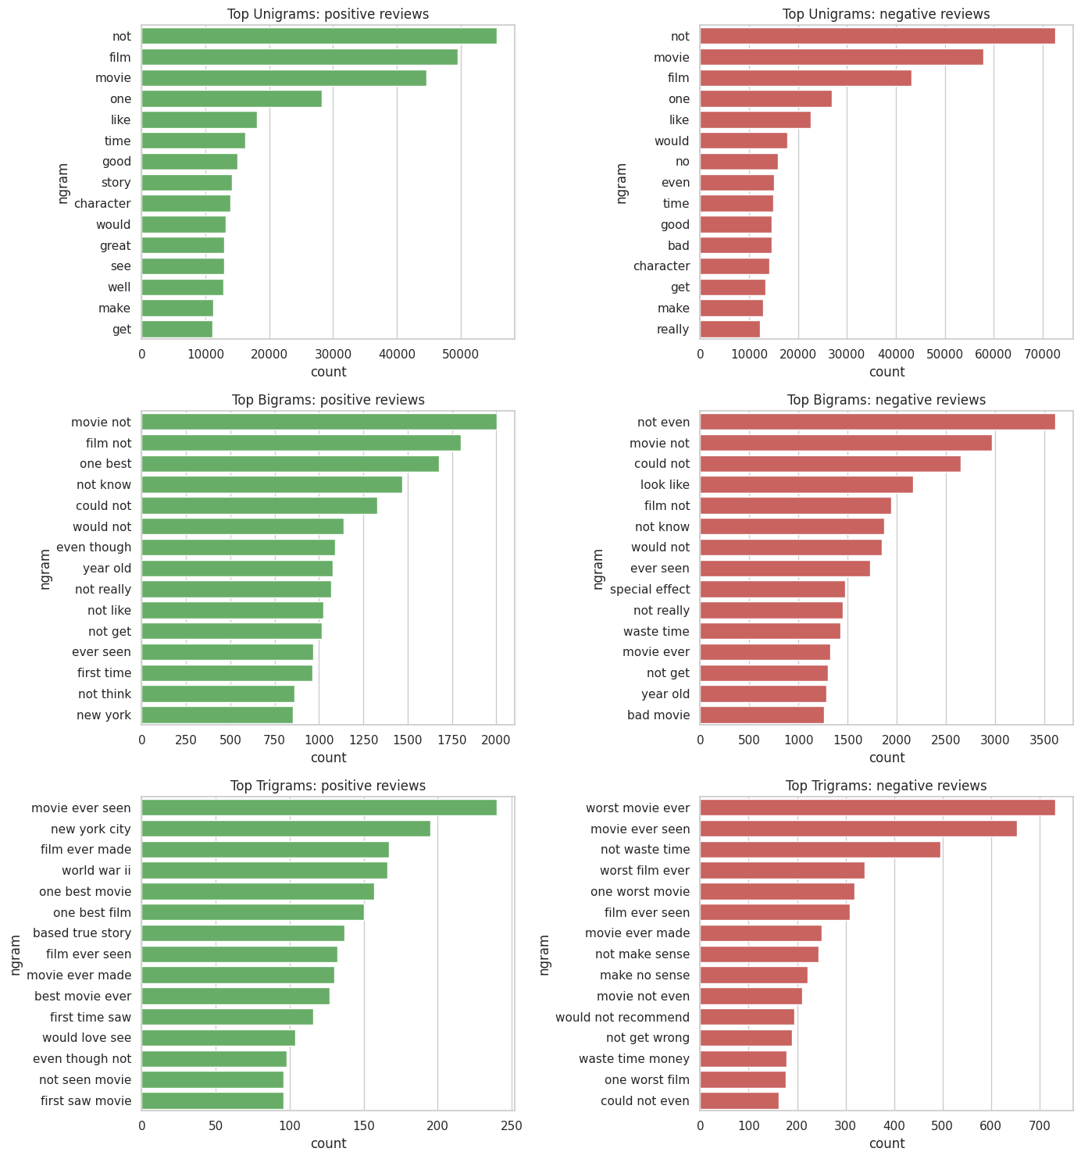
Figure 6: Top unigrams, bigrams and trigrams by sentiment class
The unigrams are very similar in both classes (“not”, “film”, “movie”, “one”, “like”, “time” and “good” dominate), so single words are weak discriminators. Bigrams and trigrams are far more informative: negative reviews are marked by phrases such as “worst movie ever”, “waste time”, “would not recommend”, “not make sense” and “could not even”, while positive reviews feature “one best”, “best movie ever” and “based true story”, plus topical phrases such as “new york city” and “world war ii”. Because negations were kept, “not” is the most frequent unigram in both classes and appears in many bigrams, and “movie ever seen” appears in both classes because it is used for both praise and criticism.
Table 8: Top bigrams with and without stopword removal
Rank | With stopwords | Stopwords removed
1 | of the (76,826) | movie not (4,967)
2 | in the (50,120) | not even (4,461)
3 | this movie (31,293) | could not (3,980)
4 | the film (26,774) | film not (3,741)
5 | and the (26,515) | not know (3,341)

With stopwords kept, the most frequent bigrams are dominated by function-word pairs such as "of the" (76,826 occurrences) and "in the" (50,120), which say nothing about the content of a review. After stopword removal the top bigrams, for example "not even" (4,461) and "could not" (3,980), reflect content and negation, so this version is more informative. One side effect is that deleting words creates artificial pairs: "movie not" and "film not" appear as top bigrams because the words between them (such as "was") were removed. The counts are also much lower, since the most frequent pairs were mostly made of stopwords.
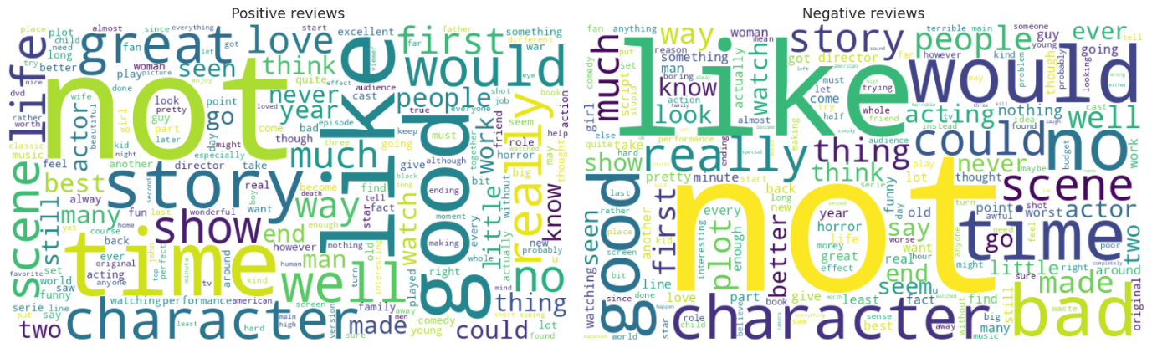
Figure 7: Word clouds for positive and negative reviews
In both clouds “not” is the largest word, because negations were deliberately kept, and many general words (like, would, good, story, time, character) appear in both. The positive cloud also features words such as great, love, best, well and life, while the negative cloud features bad, no, could, really and worst. The large overlap shows that sentiment is carried by combinations of words and negations rather than by a few individual words.

6.3 Distinctive terms per class
To find words that separate the classes, the log-ratio of each word's relative frequency in positive versus negative reviews was calculated for words that appear at least 100 times. Large positive values mean a word is characteristic of positive reviews, and large negative values mean it is characteristic of negative reviews.
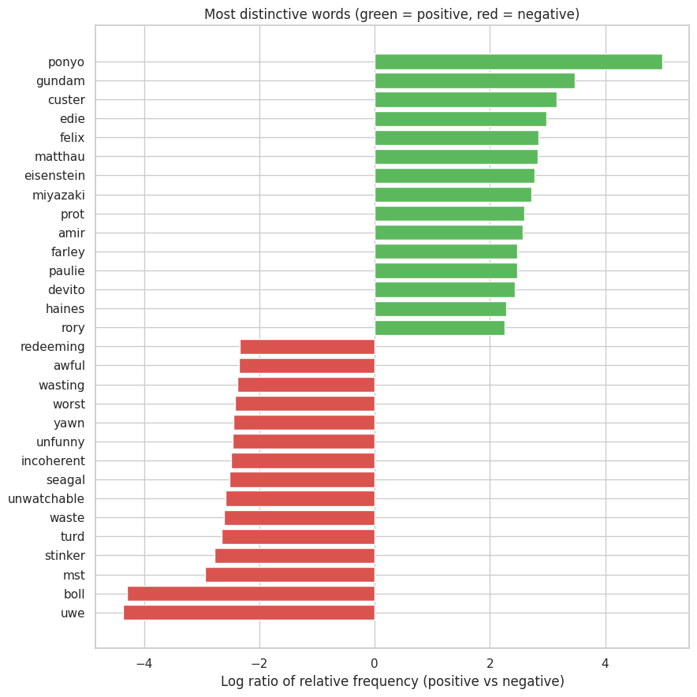
Figure 8: Most distinctive words per sentiment class
The strongest positive terms are mostly names and titles (“ponyo”, “gundam”, “miyazaki”, “custer”, “eisenstein”), pointing to well-loved anime and classic films, whereas the strongest negative terms are explicit evaluations (“awful”, “worst”, “waste”, “wasting”, “unwatchable”, “incoherent”, “unfunny”, “stinker”, “redeeming”), together with names tied to poorly rated films (“uwe”, “boll”, “seagal” and probably “mst”). This was surprising: the positive side is dominated by rare, film-specific words rather than sentiment words, so a higher frequency threshold than 100 would favour more general terms.

6.4 Sentiment distribution (VADER)

Procedure
Sentiment was scored with VADER, a rule-based sentiment analyser that uses a lexicon together with rules for negation, punctuation and capitalisation. It returns a compound score between −1 (most negative) and +1 (most positive). Reviews with a compound score of 0 or higher were predicted as positive, otherwise negative. Because VADER uses capitalisation and punctuation, it was applied to the text after HTML and URL removal only, not to the fully normalised text. The predictions were compared with the true labels.

Findings
Table 9: VADER performance against the true labels
Class | Precision | Recall | F1-score | Support
Negative | 0.79 | 0.53 | 0.64 | 24,698
Positive | 0.65 | 0.86 | 0.74 | 24,884
Overall accuracy | - | - | 0.70 | 49,582

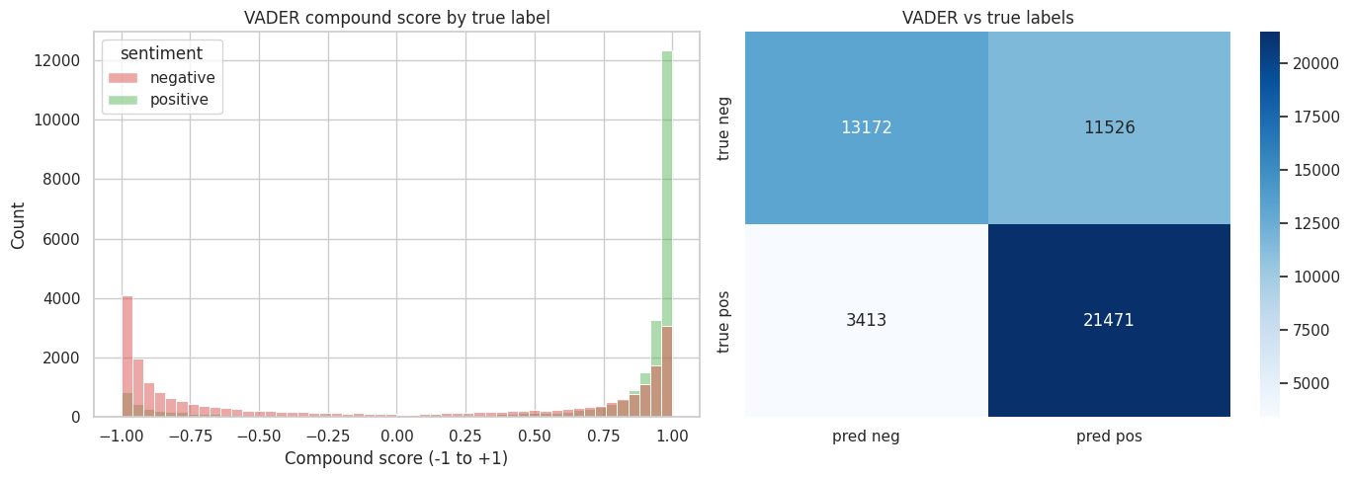
Figure 9: VADER compound score distribution and confusion matrix
The VADER scores are strongly bimodal, with most reviews scored close to −1 or +1. Positive reviews are concentrated at the high end, but many negative reviews also receive scores near +1, so the two distributions overlap heavily on the positive side. The confusion matrix confirms this: VADER correctly labelled 21,471 of 24,884 positive reviews (recall 0.86) but only 13,172 of 24,698 negative reviews (recall 0.53); 11,526 negative reviews were wrongly predicted as positive compared with 3,413 positive reviews predicted as negative, giving 69.9% overall accuracy.
VADER disagreed with the true label for 14,939 reviews (30.1%). Examples of disagreement are shown below.
Example 1 (true: negative, VADER score: 0.90): “When someone remakes a classic movie, the remake is always unfavorably compared to the original. Also, there's a chance that the remake is so radically different that it is just too unfamiliar to audiences. Well, the 1973 TV version of ‘Double Indemnity’ has almost identical scenes and dialogue as the 1944 original…”
Example 2 (true: negative, VADER score: 1.00): “I cannot say that Aag is the worst Bollywood film ever made, because I haven't seen every Bollywood film, but my imagination tells me that it could well be. This film seems like an attempt at artistic suicide on behalf of the director, and I for one be believe he has been successful in his mission…”
In Example 2 the reviewer uses sarcasm and hedged wording: the negative verdict (“the worst… film ever made”, “artistic suicide”) is wrapped in phrases such as “I cannot say that…” and “successful in his mission”, which a lexicon-based tool scores as positive. In Example 1 the reviewer spends most of the text describing the plot and comparing it with the original, so the positive-sounding words in the description appear to outweigh the criticism. Long reviews also push the compound score towards the extremes (0.90 and 1.00 here). These examples show that VADER misses sarcasm, hedging and context, which explains why most of its errors are negative reviews predicted as positive.

7. Challenges and Solutions
Table 10 lists the main challenges met while exploring and cleaning the data and how each was handled.
Table 10: Challenges and solutions
Challenge | Why it matters | Solution / mitigation
HTML markup and URLs inside the text | br appeared as a frequent word and inflated the vocabulary | Removed with regular expressions, replacing each tag with a space so neighbouring words did not merge
Duplicate reviews | Bias frequency counts and can leak between train and test sets | Detected with exact-match comparison and removed; labels of duplicates were checked for conflicts
Default stopword list removes negations | "not good" would become "good", reversing the sentiment | Built a custom stopword set that keeps negation words
Contractions and apostrophes | Stripping punctuation breaks "don't" into meaningless fragments | Expanded contractions before removing punctuation
Lemmatizer limitations | WordNet lemmatizer treats every word as a noun by default, so some verb forms (for example "running") are left unchanged | Accepted for this exploratory task; part-of-speech-aware lemmatization (for example with spaCy) is a clear next improvement
Sarcasm and mixed-sentiment reviews | A rule-based tool such as VADER cannot understand context, so such reviews are misclassified | Analysed the disagreements to identify failure patterns; contextual models are recommended for modelling
Long tail of rare words and typos | A very large vocabulary with many words appearing once increases sparsity and memory use | Used a minimum document frequency in n-gram analysis; recommend vocabulary capping for modelling
Processing time on 50,000 reviews | Some steps (stopword removal, lemmatization, VADER) take minutes to run | Used efficient tokenization after cleaning and built the pipeline from vectorised pandas operations
Accented characters split words | Removing every character outside a–z turns “féminin” into “f” and “minin”, and the single letter is then dropped (visible in the worked example in Section 5.9) | Accepted for this English-language task because non-ASCII characters are rare; a better fix is to normalise accents (for example mapping é to e with Python's unicodedata) before removing punctuation
Dataset loading error | The short Hugging Face identifier “imdb” raised an HfUriError because newer versions of the library require the full namespace/name form | Switched to the full identifier stanfordnlp/imdb, after which the dataset loaded correctly

The hardest part of this task was designing a preprocessing pipeline that cleans the text without destroying its meaning. The default stopword list would have deleted "not" and "no", reversing the sentiment of many reviews, so I built a custom list that keeps negations and expanded contractions before removing punctuation. I also met real problems while running the notebook: loading the dataset failed with an HfUriError because the short name "imdb" is no longer accepted, which I fixed by using the full identifier "stanfordnlp/imdb". Later, the worked example showed that my alphabetic filter split the accented word "féminin" into "f" and "minin", which taught me to inspect intermediate outputs instead of trusting the pipeline blindly. It was also my first time using Google Colab and notebooks, and I learned that running cells in order and checking each output makes errors much easier to find. Finally, I was surprised that VADER reached only about 70% accuracy, which showed me the limits of rule-based sentiment analysis on long, sarcastic reviews.

8. Insights for Future NLP Modelling
The exploratory analysis points to the following recommendations for future modelling work on this dataset.
Table 11: Statistics supporting the modelling recommendations
Statistic | Value
Median review length (cleaned, tokens) | 90
90th percentile length | 239
95th percentile length | 313
99th percentile length | 474
Vocabulary size after cleaning | 90,746
Coverage of top 5,000 words | 85.0%
Coverage of top 10,000 words | 91.9%
Words appearing only once | 35,557 (39.2% of vocabulary)

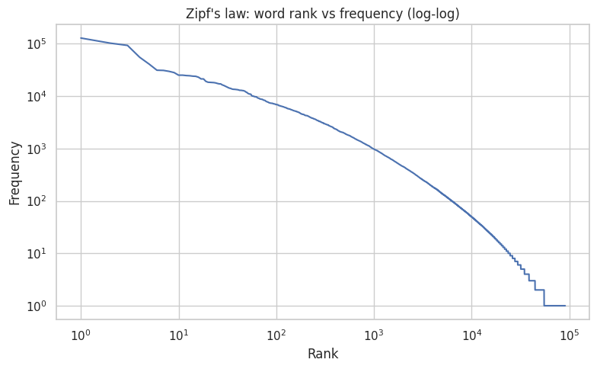
Figure 10: Zipf plot: word rank versus frequency (log-log)

The plot is roughly a straight line in the middle, as Zipf's law predicts: a handful of words occur more than 100,000 times, the word at rank 1,000 occurs about 1,000 times, and beyond rank 10,000 words occur fewer than about 50 times each. The long tail at the right consists of tens of thousands of words that appear only once or twice. With a final vocabulary of 90,746 words, most of the vocabulary is therefore rare, which is why a frequency cut-off is useful for modelling.

Recommendations
- Sequence length: truncate or pad reviews to about 313 tokens (the 95th percentile), which keeps almost all of the content of most reviews while limiting padding.
- Vocabulary size: cap the vocabulary at roughly 10,000 words, which covers 91.9% of all tokens, or use a minimum frequency threshold, because the long tail is mostly rare words and typos.
- Class balance: the classes are balanced, so accuracy is a fair evaluation metric and no resampling is needed.
- Baseline model: TF-IDF features with logistic regression is a strong, interpretable baseline, given the clearly separable distinctive words found in Section 6.3.
- Advanced models: contextual models such as transformers are likely to handle negation, sarcasm and mixed sentiment better than bag-of-words or rule-based methods, which matters because these are exactly where VADER failed.
- Preprocessing for modelling: keep negation words; consider keeping punctuation such as ! and ? as features; and consider part-of-speech-aware lemmatization.
- Expected failure cases: sarcasm, reviews that mix praise and criticism, and very long reviews that exceed the sequence-length cut-off.

9. Conclusion
This report documented an end-to-end exploratory analysis and preprocessing workflow on 49,582 IMDB movie reviews. The raw data was assessed for missing values, duplicates and noise; HTML markup and duplicates were removed; and a seven-step pipeline of cleaning, tokenization and normalization was designed with each choice justified and measured. The cleaned data was then analysed through n-grams, distinctive terms and sentiment scoring.
The step that shrank the vocabulary most was removing punctuation and digits, while the choice to keep negations was the most important for preserving sentiment. The n-gram analysis showed that single words are weak signals but phrases such as “worst movie ever” and “would not recommend” clearly separate the classes. VADER reached only about 70% accuracy, mainly because it labels many negative reviews as positive when they contain sarcasm or hedged wording. Next steps would be accent normalisation, part-of-speech-aware lemmatization, a TF-IDF baseline and a transformer-based model.

Appendix A: Preprocessing Code
The core preprocessing functions used in the notebook are reproduced below. The complete notebook is available at https://colab.research.google.com/drive/1X4ctn6dJ5NEcbkbdh9TL9ZeqHUh3_TdJ?usp=sharing.
NEGATIONS = {"no", "nor", "not", "never", "neither", "none",
"nothing", "nowhere", "hardly", "barely"}
STOP = set(stopwords.words("english")) - NEGATIONS

def strip_html(t):
return re.sub(r"<[^>]+>", " ", t)

def strip_urls(t):
return re.sub(r"http\S+|www\.\S+", " ", t)

def expand_contractions(t):
t = t.replace("\u2019", "'")
for pat, rep in CONTRACTIONS:
t = re.sub(pat, rep, t)
return t

def keep_alpha(t):
t = re.sub(r"[^a-z\s]", " ", t)
return re.sub(r"\s+", " ", t).strip()

def remove_stop(t):
return " ".join(w for w in t.split() if w not in STOP and len(w) > 1)

def lemmatize(t):
return " ".join(lemmatizer.lemmatize(w) for w in t.split())

# Order: strip_html -> strip_urls -> lower -> expand_contractions
# -> keep_alpha -> remove_stop -> lemmatize

Appendix B: References
- Maas, A. L., Daly, R. E., Pham, P. T., Huang, D., Ng, A. Y., & Potts, C. (2011). Learning Word Vectors for Sentiment Analysis. Proceedings of the 49th Annual Meeting of the Association for Computational Linguistics (ACL), pp. 142–150.
- Hutto, C. J., & Gilbert, E. (2014). VADER: A Parsimonious Rule-based Model for Sentiment Analysis of Social Media Text. Proceedings of the 8th International Conference on Weblogs and Social Media (ICWSM).
- Bird, S., Klein, E., & Loper, E. (2009). Natural Language Processing with Python. O'Reilly Media.
- Pedregosa, F., et al. (2011). Scikit-learn: Machine Learning in Python. Journal of Machine Learning Research, 12, 2825–2830.
- Stanford AI Lab. Large Movie Review Dataset v1.0. https://ai.stanford.edu/~amaas/data/sentiment/

