Language Trends in American Presidential Speech
Week 4 Task: Language Trends
YuvaIntern Internship Programme
Prepared by: Kammari Hari Charan

Contents
1. Executive summary
2. Introduction and objectives
3. Data selection and description
4. Methodology
5. Results
6. Discussion
7. Recommendations for further research
8. Reproducibility
9. Conclusion

1. Executive summary
This report investigates how the language of American presidents has changed over time. It applies a reproducible text-mining pipeline, covering cleaning, tokenisation, lemmatisation, frequency analysis, statistical trend detection, change-point detection, topic modelling (NMF and LDA), K-means and time-constrained hierarchical clustering, readability and style measures, and collocation analysis, to two public corpora from the NLTK library: 65 State of the Union (SOTU) addresses from 1945 to 2006 and 60 Inaugural addresses from 1789 to 2025.
Headline findings
- Vocabulary shifts are large and statistically robust. Of 192 frequent words tested, 90 show a significant monotonic trend over time (FDR q < 0.05): 41 rising and 49 falling. Words such as child, reform, america, job, woman and family rise, while expenditure, fiscal, farm, labor and resource fall.
- Events leave measurable marks. “Terrorist” jumps from 0.86 to 59.8 occurrences per 10,000 words at 2001 (p = 0.001, 88% of variance explained by a single step). “Communist” drops from 11.6 to 1.5 at 1970 (p = 0.001).
- Ten coherent topics describe the SOTU corpus. NMF with k = 10 gave the best coherence (NPMI = 0.232). Education/family (T3, ρ = +0.76) and national identity (T10, ρ = +0.58) rise most; federal programmes (T2, ρ = −0.69) and prices, wages and farming (T9, ρ = −0.65) fall most.
- Five language eras emerge from time-constrained clustering: 1945–1969, 1970–1974, 1975–1992, 1993–2000 and 2001–2006, which line up with the Cold War, Nixon, the Reagan–Bush period, Clinton and the post-9/11 period.
- Presidential style has become simpler and more personal. Inaugural addresses fell from a Flesch-Kincaid grade of 18.4 to 10.5 and from 37.4 to 21.1 words per sentence, while first-person plural pronouns (we/us/our) rose from 20.1 to 54.8 per 1,000 words.
The report also documents limitations, chiefly the small number of speeches, the SOTU corpus ending in 2006, weak cluster separation (silhouette ≈ 0.04), and the fact that written and spoken versions of speeches are not distinguished, and proposes concrete next steps for further research.

2. Introduction and objectives

2.1 Background
Political language is a record of what societies worry about and how leaders choose to address them. Presidential speeches are an unusually good source for studying this, since they are delivered regularly, are archived in full, and cover several generations of political and economic change. Quantifying the change, rather than reading each speech by hand, allows patterns to be detected that no single reader could see.

2.2 Research questions
- Which words and themes have become more or less prominent over time, and are these changes statistically significant?
- Can specific historical events be linked to abrupt shifts in vocabulary?
- What latent topics structure the State of the Union addresses, and how does their prevalence evolve?
- Does the corpus divide naturally into distinct “language eras”?
- How have the style and complexity of presidential speech (sentence length, readability, pronoun use) changed?
- How does the meaning context (collocates) of key terms such as “security” or “freedom” change?

2.3 Task requirements addressed
The project brief asks for an investigation of a linguistic trend using topic modelling, clustering or trend detection on public text data, a reproducible pipeline covering tokenisation, frequency analysis and topic modelling, visualisation of the evolution of language, and a critical discussion of implications, limitations and future work. Section 4 maps each of these requirements to the methods used, and Sections 5 to 7 present results, discussion and recommendations.

3. Data selection and description

3.1 Why presidential speeches
Two corpora distributed with NLTK were chosen because they are public, free of licensing concerns, cleanly dated and long enough to support quantitative analysis. The State of the Union addresses are the primary corpus for topic and trend analysis because they are long, policy-rich and delivered every year. The Inaugural addresses are a second, much longer time series (more than 200 years) and are used for the style analysis, where the longer span is an advantage.
Table 1. Corpus summary after cleaning
Corpus | Speeches | Years | Presidents | Total words | Median words
State of the Union | 65 | 1945–2006 | 11 | 347,813 | 4,923
Inaugural | 60 | 1789–2025 | 36 | 141,073 | 2,122

Speech length varies by more than an order of magnitude across the two corpora (Figure 1), which is why all frequency statistics in this report are normalised per 10,000 content words or per 1,000 words rather than reported as raw counts.
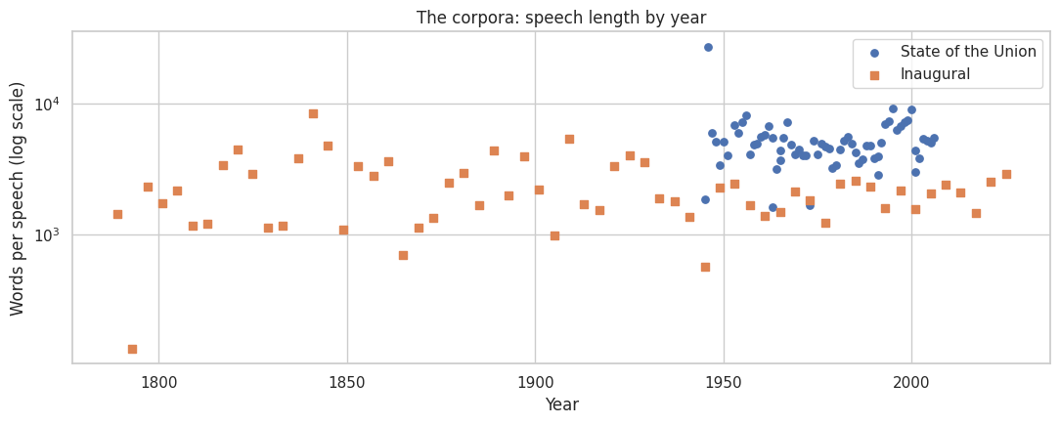
Figure 1. Speech length by year for both corpora (log scale).

3.2 Data cleaning
The raw files contain archive artefacts that would distort frequency and topic results. A dedicated cleaning function removes the following: title and date headers; editors’ end notes and footnotes (only when they appear in the final 20% of the file); bracketed notes such as “[Applause]”; stage directions in parentheses; “THE PRESIDENT:” speaker labels; garbled apostrophes; typographic quotes (normalised to ASCII); and any remaining non-ASCII characters. Whitespace is then collapsed so each speech is a single clean string.

4. Methodology
The pipeline runs in eight phases. For each method, this section states what was done and why it was chosen over alternatives.

4.1 Segmentation into passages
Each SOTU address is long and covers many subjects, so assigning one topic per speech would be meaningless. Speeches were therefore split into consecutive passages of six sentences (sentence-tokenised with NLTK Punkt; fragments under three words discarded; a final chunk of fewer than three sentences merged into the previous one). This produced 2,866 passages averaging about 122 words, a length that suits bag-of-words topic models. Topic results are then aggregated back to the speech and year level, with each speech weighted equally so that long speeches do not dominate.

4.2 Tokenisation, stop-word removal and lemmatisation
Text was lower-cased and tokenised into alphabetic tokens. Two token streams are produced. “Raw tokens” keep all words and are used for style measures, where function words matter (pronouns, word length). “Content tokens” remove English stop-words plus a custom list of 36 uninformative words (e.g. shall, upon, would, one, new, year), drop words under three letters, and lemmatise with the WordNet lemmatiser so that “taxes” and “tax” count together. This yields 163,216 content tokens and 10,435 distinct lemmas for the SOTU corpus.
Rationale: lemmatisation rather than stemming was chosen because it keeps real, readable words in topic labels. The custom stop-list removes high-frequency presidential filler that otherwise appears in every topic.

4.3 Frequency analysis and keyword tracking
Frequencies were converted to rates per 10,000 content words so speeches of different lengths are comparable. Twenty-seven theme words were grouped into four families (security and conflict, economy, society, values and identity) and plotted as 5-speech rolling means with key historical dates marked (Korean War 1950, Vietnam escalation 1965, end of the Cold War 1991, 9/11 2001).

4.4 Statistical trend detection
To avoid cherry-picking keywords, every word that appears in at least 15 speeches with 150 or more occurrences (192 words) was tested for a monotonic trend using the Spearman rank correlation between year and rate. The Benjamini–Hochberg procedure controls the false discovery rate at 5%. Rationale: Spearman’s ρ makes no normality assumption, is robust to the highly skewed word-rate distributions seen here, and detects any consistent rise or fall, not only linear ones. FDR correction is essential when testing nearly 200 hypotheses.

4.5 Change-point detection
For words suspected to respond to a specific event, a two-segment mean model finds the year that best splits the series (minimum sum of squared errors, at least five speeches per segment). Significance is assessed with a permutation test (1,000 shuffles): the share of variance explained by the best step is compared with the same quantity on shuffled series. Rationale: this is a transparent, assumption-light alternative to parametric change-point packages, and the permutation test properly accounts for having searched over all candidate split points.

4.6 Distinctive vocabulary by decade
Frequent words in a decade are often just frequent words overall. To find words that characterise a decade, the “Fightin’ Words” log-odds ratio with an informative Dirichlet prior (α₀ = 500) was computed for each decade against all others, ranked by z-score. The prior shrinks estimates for rare words, so the lists favour reliably distinctive terms.

4.7 Topic modelling (NMF and LDA)
Two algorithms were compared. NMF was fitted to a TF-IDF matrix (sublinear term frequency, max_df = 0.4, min_df = 8; 2,784-word vocabulary) with NNDSVD initialisation. LDA (batch variational Bayes) was fitted to the raw count matrix with the same vocabulary. Both were run for k = 4, 6, 8, 10, 12, 15 and 20 topics. Models were compared with NPMI coherence, computed from binary co-occurrence of each topic’s top-10 words across passages, which correlates better with human judgement than perplexity. The best (algorithm, k) pair was chosen automatically.
Rationale: NMF typically gives sharper topics on short passages, while LDA gives a probabilistic interpretation; comparing both on the same objective measure avoids relying on a single method. Each passage’s topic weights were normalised to proportions, and topic prevalence by year, five-year period and decade was computed as the mean over passages, then over speeches.

4.8 Clustering of passages and discovery of language eras
For passage-level clustering, the TF-IDF matrix was reduced to 100 dimensions with truncated SVD (22.9% of variance retained), L2-normalised, and clustered with K-means (10 initialisations, k from 4 to 14, selected by silhouette score on a 2,000-passage sample). Agreement with the topic model was measured with the adjusted Rand index (ARI). A t-SNE map visualises the structure.
To find eras, whole speeches (TF-IDF, 15 SVD components) were clustered with Ward-linkage agglomerative clustering constrained by a chain connectivity matrix, so that a speech may only merge with its temporal neighbours. Rationale: the constraint guarantees that each cluster is a contiguous period, which is what an “era” means, and gives interpretable boundaries. Five eras were chosen for interpretability and compared with the silhouette table.

4.9 Style and complexity measures
For each speech in both corpora the following were computed: mean sentence length, mean word length, Flesch–Kincaid grade level (with a rule-based syllable counter), lexical diversity as MATTR (moving-average type–token ratio, window 500, which unlike plain type–token ratio is not biased by speech length), and rates per 1,000 words of first-person plural (we/us/our/ours/ourselves) and singular (I/me/my/mine/myself) pronouns. Each measure was correlated with year (Spearman) and compared between the early and late halves of each corpus.

4.10 Semantic context shift (collocation analysis)
To see how the meaning of a word changes, passages were grouped by era and, for four target words (security, freedom, government, economy), the words that co-occur in the same passage more often than chance were ranked using a t-score, with at least five co-occurrences and at least 10 passages containing the target.

4.11 Mapping of the project requirements to methods
Table 2. Brief requirements and where they are met
Requirement | Where addressed
Identify trend and select public dataset | Section 3 (NLTK State of the Union and Inaugural corpora)
Tokenisation, frequency analysis, topic modelling | Sections 4.2, 4.3, 4.7
Clustering and trend detection | Sections 4.4, 4.5, 4.8
Visualisation of evolution over time | Figures 2 to 12
Critical analysis, limitations, future work | Sections 6 and 7
Reproducibility | Section 8

5. Results

5.1 Overall vocabulary
The most frequent content words (Figure 2) are dominated by the vocabulary of governing: government, nation, world, people, program, congress and so on. These words appear in nearly every era, which is why they carry little information about change; the trend analysis that follows therefore focuses on rates relative to time.
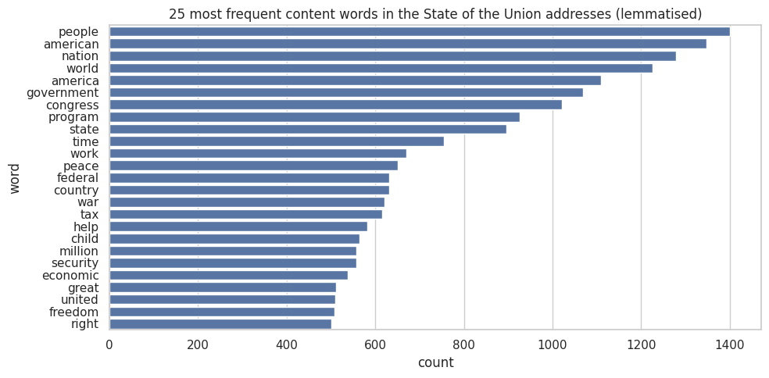
Figure 2. The 25 most frequent lemmatised content words in the State of the Union addresses.

5.2 Keyword trends
Figure 3 tracks selected keywords by theme. Security words such as soviet, communist and nuclear peak during the Cold War and decline after 1991; “terrorist” is nearly absent until 2001 and then dominates. Economic vocabulary shifts from fiscal and inflation concerns in the 1970s and 1980s towards jobs and trade later. Social words such as child, family and health rise steadily from the 1980s onward. Words of identity (america, freedom, god) grow in the late period.
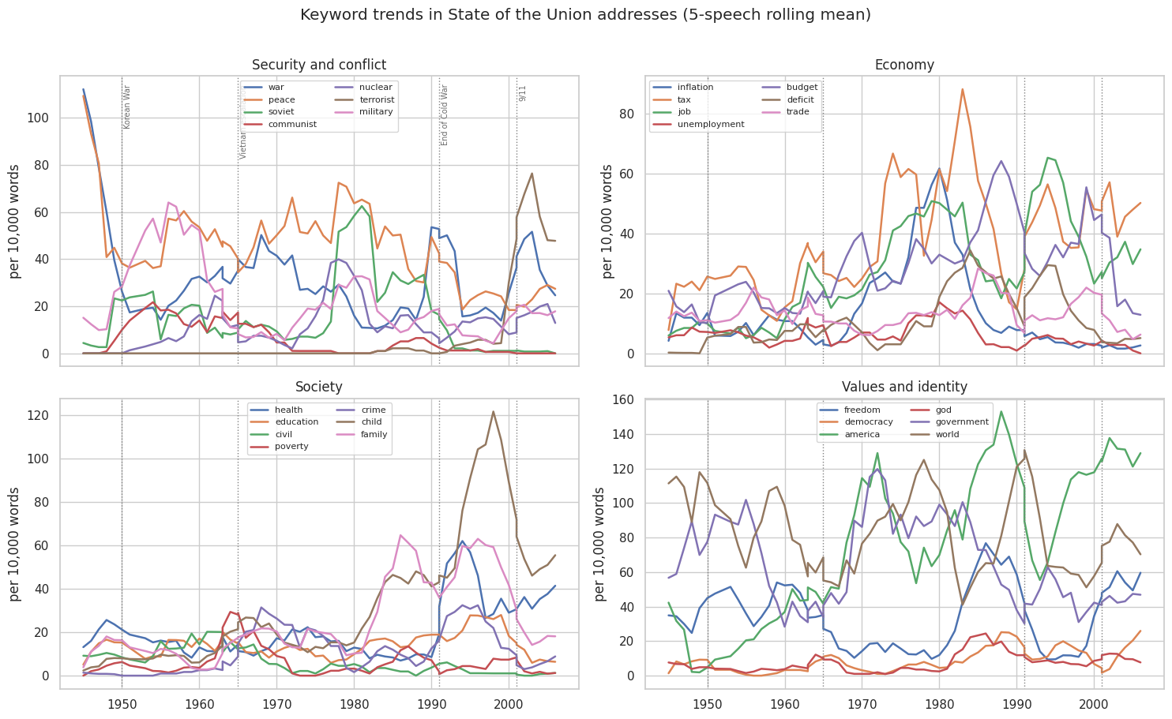
Figure 3. Keyword trends by theme (5-speech rolling mean, per 10,000 content words). Dotted lines mark historical events.

5.3 Rising and falling words
The all-vocabulary trend test found 90 of 192 words with a significant trend (41 rising, 49 falling; Figure 4, Table 3). The strongest risers are child (ρ = 0.79), reform (0.70), america (0.69), tonight (0.68), american (0.62) and day, work, woman, job, ask, family and century. The strongest fallers are present (−0.68), labor (−0.66), expenditure (−0.59), full, development, farm, increased, resource, fiscal, purpose, power, program, price, strength and necessary. Taken together, the vocabulary moves from the language of administration, production and public finance towards a more direct, personal and people-centred vocabulary.
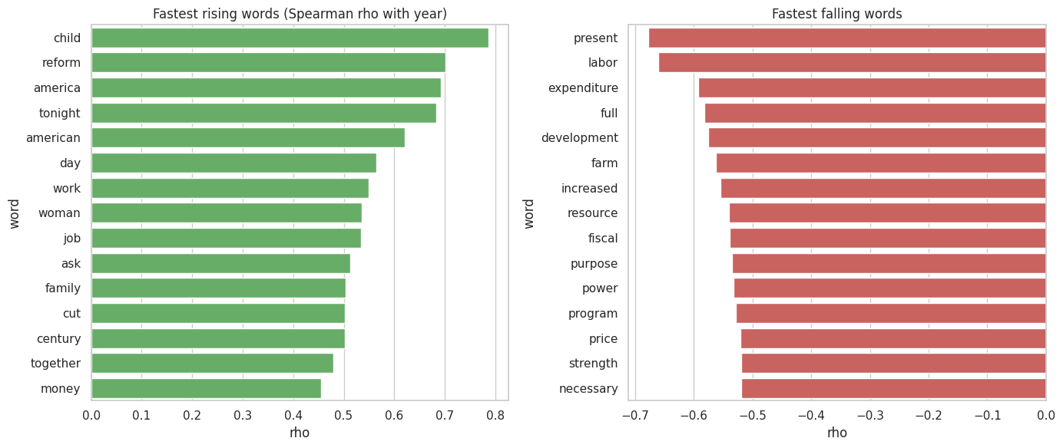
Figure 4. Words with the strongest rising (left) and falling (right) trends, by Spearman ρ with year.
Table 3. Top 10 rising and falling words (all q-values < 0.05)
Rising word | ρ | Falling word | ρ
child | 0.787 | present | −0.677
reform | 0.701 | labor | −0.661
america | 0.692 | expenditure | −0.593
tonight | 0.683 | full | −0.582
american | 0.621 | development | −0.576
day | 0.565 | farm | −0.562
work | 0.549 | increased | −0.554
woman | 0.536 | resource | −0.540
job | 0.534 | fiscal | −0.539
ask | 0.513 | purpose | −0.535

5.4 Event-linked change points
Table 4. Change-point results for four event-related words
Word | Change year | Mean before | Mean after | Variance explained | p (permutation)
terrorist | 2001 | 0.86 | 59.79 | 88.4% | 0.001
communist | 1970 | 11.59 | 1.53 | 36.5% | 0.001
inflation | 1985 | 19.17 | 4.22 | 14.1% | 0.057
soviet | 1992 | 19.80 | 1.30 | 6.9% | 0.353

The results (Figure 5, Table 4) separate sharp event-driven shifts from gradual decay. “Terrorist” is the clearest: a single step at 2001 explains 88% of its variance. “Communist” declines abruptly around 1970 (p = 0.001), well before the end of the Cold War, suggesting the word fell out of presidential use as détente began. “Inflation” shows a step in 1985 that is close to but not at significance (p = 0.057). “Soviet” is not significant under a single-step model (p = 0.353) because its usage rises and falls gradually rather than jumping; a step model is the wrong shape for it, which is a useful reminder that a non-significant result here does not mean there was no change.
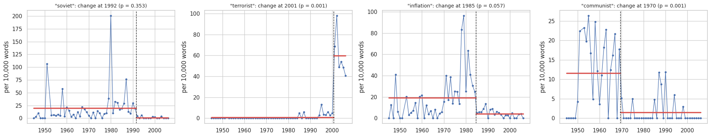
Figure 5. Best single change point (red steps) for four words, with permutation-test p-values.

5.5 Distinctive vocabulary by decade
Table 5 lists the top distinctive words per decade. The 1940s are dominated by wartime finance (dollar, war, fiscal, expenditure, production, housing). The 1950s focus on military and development (military, strength, free, defense). The 1960s use the language of aspiration and cities (nation, seek, men, city, hope, progress). The 1970s turn to energy and inflation. The 1980s are defined by soviet, spending, deficit and growth. The 1990s bring child, work, care, community, cut and century. The 2000s are marked by america, child, ask, weapon, woman and tonight.
Table 5. Top 5 distinctive words per decade (log-odds with informative prior)
Decade | Distinctive words
1940s | dollar, war, fiscal, expenditure, million
1950s | military, strength, free, economic, defense
1960s | nation, seek, men, city, effort
1970s | energy, inflation, goal, federal, union
1980s | soviet, spending, america, deficit, rate
1990s | child, work, care, community, cut
2000s | america, child, ask, weapon, woman

5.6 Topic modelling
NMF outperformed LDA on NPMI coherence at every value of k (Figure 6, Table 6). NMF coherence peaked at k = 10 (0.2323), whereas LDA’s best was 0.1377 at k = 15. NMF with 10 topics was therefore selected.
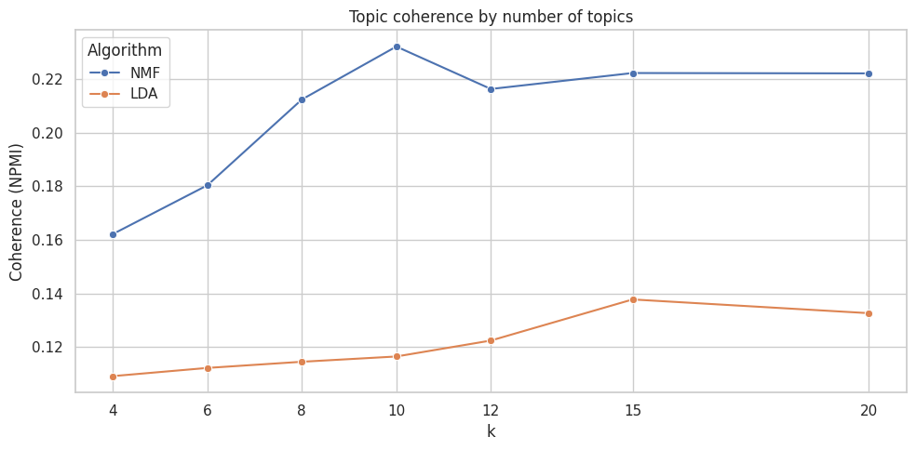
Figure 6. NPMI topic coherence for NMF and LDA at different numbers of topics.
Table 6. Topic coherence (NPMI) by number of topics
k | 4 | 6 | 8 | 10 | 12 | 15 | 20
NMF | 0.162 | 0.180 | 0.213 | 0.232 | 0.216 | 0.222 | 0.222
LDA | 0.109 | 0.112 | 0.114 | 0.116 | 0.122 | 0.138 | 0.133

Table 7 lists the ten topics with the labels derived from their top words, their overall share of the corpus, and the decade in which each peaked.
Table 7. The ten NMF topics
Topic | Interpretation and top words | Share | Peak
T1 | International relations: world, peace, nation, united, free, freedom, trade | 13.0% | 1950s
T2 | Federal programmes: federal, government, program, local, state, legislation, resource | 11.7% | 1950s
T3 | Education and family: child, school, parent, teacher, education, student | 8.5% | 1990s
T4 | Taxes and budget: tax, cut, budget, spending, rate, deficit, percent | 8.6% | 1980s
T5 | Address formalities: president, congress, member, speaker, union, tonight | 10.2% | 1970s
T6 | Defence: defense, force, military, nuclear, weapon, soviet, security | 9.9% | 2000s
T7 | Public finance: dollar, fiscal, expenditure, billion, million, appropriation | 4.6% | 1940s
T8 | Health care: health, care, insurance, medical, coverage, medicare | 6.2% | 1990s
T9 | Prices and labour: price, wage, farm, production, labor, farmer, employment | 9.0% | 1940s
T10 | National identity: america, american, god, people, together, bless, hope | 18.4% | 2000s

Representative passages confirm the labels: the most typical T6 passage (2003, Bush) discusses Iraqi chemical-weapon munitions, the T4 exemplar (1978, Carter) discusses $17 billion in income-tax cuts, the T7 exemplar (1946, Truman) the wartime federal budget, and the T3 exemplar (1996, Clinton) school character education.

Topic evolution
Figures 7 and 8 show how topic shares evolve. In the early decades, public finance (T7), prices and labour (T9) and federal programmes (T2) account for a large share; by the 1990s and 2000s, education and family (T3), health care (T8) and national identity (T10) dominate, with defence (T6) re-emerging in the 2000s.
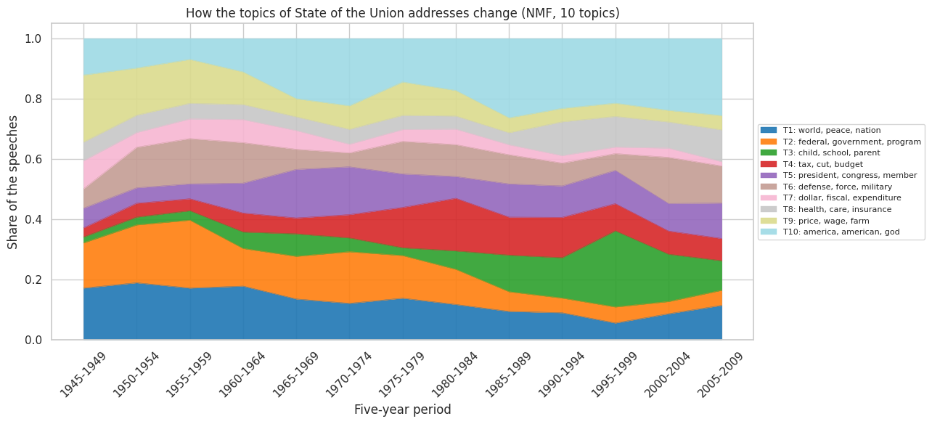
Figure 7. Topic shares by five-year period (stacked area).
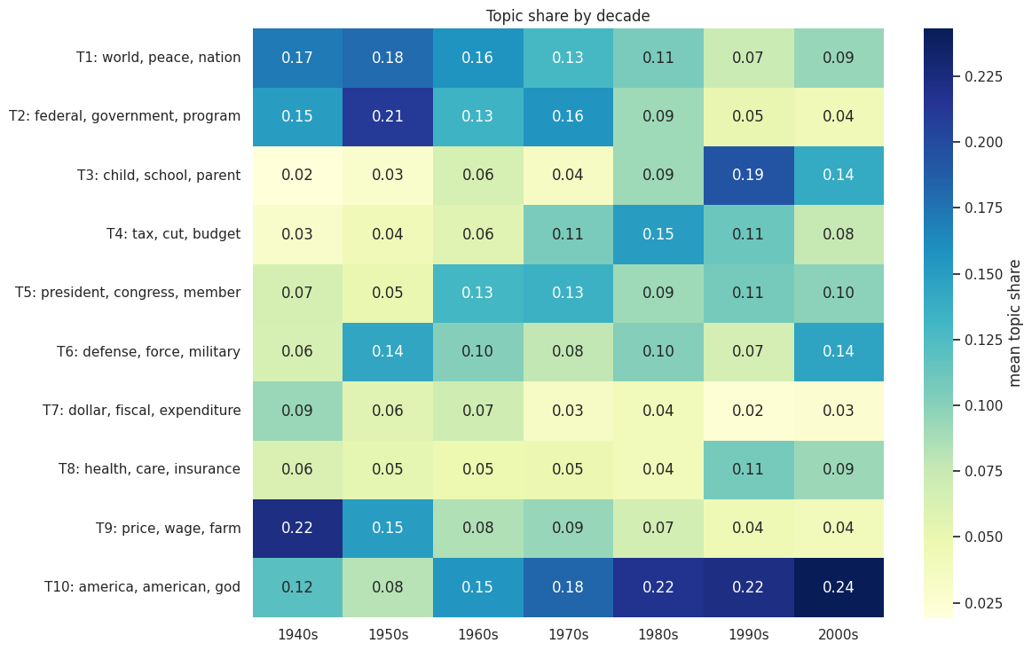
Figure 8. Mean topic share by decade.
Table 8. Topic trends over time (Spearman ρ of topic share with year)
Topic | ρ | Direction | Significant (q < 0.05)
T3 child, school, parent | +0.757 | Rising | Yes
T10 america, american, god | +0.579 | Rising | Yes
T4 tax, cut, budget | +0.499 | Rising | Yes
T5 president, congress, member | +0.327 | Rising | Yes (q = 0.010)
T8 health, care, insurance | +0.316 | Rising | Yes (q = 0.012)
T6 defense, force, military | +0.008 | Flat (peaks in the 1950s–60s and 2000s) | No (q = 0.95)
T7 dollar, fiscal, expenditure | −0.512 | Falling | Yes
T1 world, peace, nation | −0.548 | Falling | Yes
T9 price, wage, farm | −0.647 | Falling | Yes
T2 federal, government, program | −0.693 | Falling | Yes

Nine of ten topics have significant trends. The defence topic (T6) has no net trend (ρ = 0.008) not because defence disappeared but because it is high in two separate periods (Cold War and post-9/11). A rank correlation with year cannot capture such a U-shaped pattern, so Figures 7 and 8 should be read alongside Table 8.

5.7 Clustering of passages
K-means on the SVD-reduced TF-IDF space found its best silhouette at k = 14 (0.042), and the curve rises almost monotonically from 0.031 at k = 4 (Table 9 and Figure 9). Silhouette values this low indicate that passages form a continuum of overlapping themes rather than well-separated groups, which is expected for political prose. The clusters are nonetheless interpretable and agree strongly with the topic model (adjusted Rand index 0.556).
Table 9. The 14 K-means clusters
Cluster | Passages | Top terms | Median year
C1 | 88 | dollar, expenditure, fiscal, billion, million, estimated | 1946
C2 | 138 | president, congress, member, speaker, union, tonight | 1974
C3 | 195 | price, labor, farm, production, wage, farmer | 1950
C4 | 151 | budget, spending, deficit, federal, cut, tax | 1986
C5 | 112 | school, child, teacher, student, education, college | 1996
C6 | 133 | health, care, social, insurance, security, medical | 1994
C7 | 157 | tax, rate, income, percent, job, business, inflation | 1981
C8 | 343 | federal, program, government, congress, state, energy | 1961
C9 | 441 | world, peace, nation, united, free, freedom, trade, soviet | 1966
C10 | 100 | terrorist, iraq, weapon, saddam, terror, regime | 2003
C11 | 171 | defense, military, force, nuclear, security, missile | 1960
C12 | 492 | american, america, people, freedom, god, nation | 1984
C13 | 86 | crime, drug, law, police, enforcement, gun | 1992
C14 | 259 | child, work, family, welfare, community, help | 1996

Two clusters stand out for their precise temporal signature: C10 (terrorism and Iraq, median year 2003) and C13 (crime and drugs, median 1992). Others, such as C1 (public finance, median 1946) and C5 (education, 1996), tie directly to the topic model’s T7 and T3.
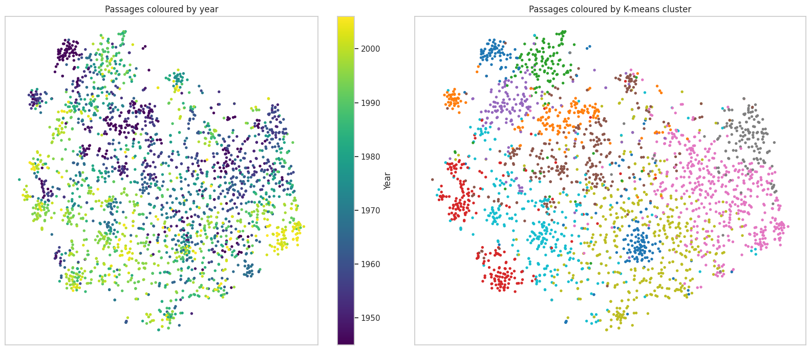
Figure 9. T-SNE map of the passages, coloured by year (left) and by K-means cluster (right).
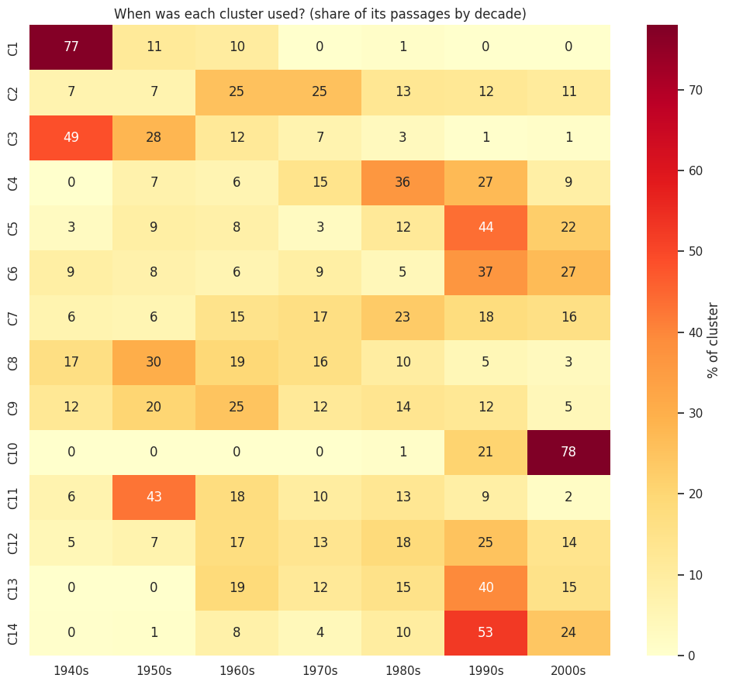
Figure 10. Share of each cluster’s passages falling in each decade.

5.8 Language eras
Constrained hierarchical clustering of whole speeches produced five contiguous eras (Table 10). The silhouette score increased with more eras (0.150 at 3 to 0.258 at 8), so no single number is obviously best; five were chosen because they correspond to recognisable political periods and keep each era large enough to analyse.
Table 10. Language eras of the State of the Union
Era | Years | Speeches | Presidents
E1 | 1945–1969 | 26 | Truman, Eisenhower, Kennedy, Johnson
E2 | 1970–1974 | 5 | Nixon
E3 | 1975–1992 | 19 | Ford, Carter, Reagan, Bush
E4 | 1993–2000 | 8 | Clinton
E5 | 2001–2006 | 7 | G. W. Bush

Several boundaries coincide with changes of administration, which shows that an individual president’s vocabulary is itself a strong signal. This is both a finding (language tracks political regimes) and a caveat (era boundaries cannot be separated from presidential idiolect). The Nixon era forms its own cluster of five consecutive speeches.
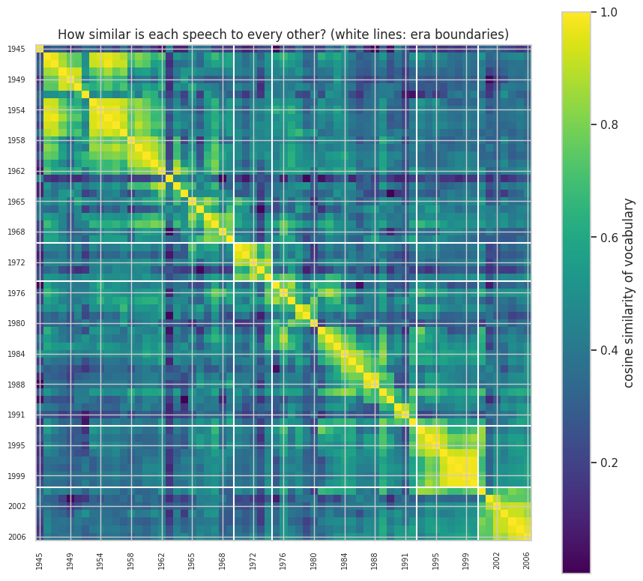
Figure 11. Pairwise cosine similarity of SOTU speeches by vocabulary. White lines mark era boundaries.

5.9 Style and complexity
Both corpora show that presidential speech has become shorter in sentence and word length and easier to read, but the effect is far stronger in the Inaugural addresses, which cover 236 years (Figure 12, Table 11).
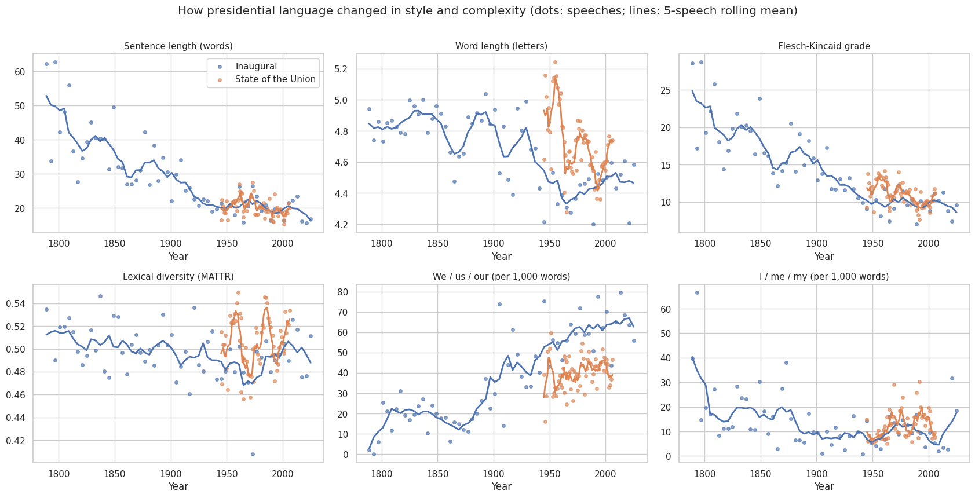
Figure 12. Style and complexity measures by year for both corpora (dots: speeches; lines: 5-speech rolling mean).
Table 11. Style trends (Spearman ρ with year; early vs late half of each corpus)
Corpus | Measure | ρ | Early | Late
Inaugural | Sentence length (words) | −0.872 | 37.4 | 21.1
Inaugural | Word length (letters) | −0.656 | 4.83 | 4.52
Inaugural | Flesch-Kincaid grade | −0.889 | 18.4 | 10.5
Inaugural | Lexical diversity (MATTR) | −0.303 | 0.504 | 0.490
Inaugural | We/us/our per 1,000 | +0.831 | 20.1 | 54.8
Inaugural | I/me/my per 1,000 | −0.437 | 17.9 | 9.5
SOTU | Sentence length (words) | −0.364 | 21.4 | 19.2
SOTU | Word length (letters) | −0.471 | 4.79 | 4.63
SOTU | Flesch-Kincaid grade | −0.520 | 11.8 | 10.2
SOTU | Lexical diversity (MATTR) | +0.052 (n.s.) | 0.501 | 0.510
SOTU | We/us/our per 1,000 | +0.251 | 37.5 | 42.7
SOTU | I/me/my per 1,000 | +0.386 | 11.4 | 13.7

- Simpler: Inaugural sentences shrank from about 37 to 21 words and the reading grade level fell from 18.4 to 10.5. The SOTU change is smaller (11.8 to 10.2) because the SOTU starts later, when speeches were already more conversational.
- More inclusive: “we/us/our” almost triples in inaugurals (20 to 55 per 1,000 words), consistent with a shift from formal statements about “the government” to appeals to a shared national “we”.
- Diverging use of “I”: in inaugurals “I” falls (ρ = −0.44) but in SOTU it rises (ρ = +0.39), reflecting a modern president who personally reports and asks (“I ask you to…”).
- Lexical diversity barely changes (ρ = −0.30 in inaugurals, not significant in SOTU), so the simplification is in syntax and word length, not in the breadth of vocabulary.

5.10 Shifting context of key terms
Collocation analysis (Table 12) shows how the meaning of a word shifts even if its frequency does not. “Security” co-occurs with military, defense and strength in 1945–1969, with soviet and peace in 1975–1992, with social, surplus and medicare in 1993–2000, and with social, retirement, homeland and benefit in 2001–2006: it moves from national defence to welfare and then homeland defence. “Freedom” is tied to communism and world peace in the Cold War era and to terror, ally and cause after 2001. “Government” is consistently paired with federal and local, and later with cut and bureaucracy in the 1990s. “Economy” moves from wage and price (1945–1969) to jobs, inflation and recession (1975–1992), to global, export and opportunity (1993–2000).
Table 12. Top collocates of four target words by era (selected)
Target | Era | Top collocates
security | 1945–1969 | social, military, health, defense, strength
security | 1975–1992 | social, national, soviet, defense, peace
security | 1993–2000 | social, surplus, medicare, debt, peace
security | 2001–2006 | social, retirement, homeland, benefit, worker
freedom | 1945–1969 | world, free, peace, ideal, communism
freedom | 1975–1992 | peace, america, world, democracy, hope
freedom | 2001–2006 | friend, democracy, ally, terror, cause
government | 1945–1969 | federal, local, business, private, executive
government | 1993–2000 | federal, cut, bureaucracy, problem, smaller
economy | 1945–1969 | growth, enterprise, wage, growing, price
economy | 1975–1992 | growth, job, inflation, rate, tax, recession
economy | 1993–2000 | global, world, century, opportunity, growth

The 1970–1974 era is omitted from this table because it has too few passages containing the target words to be analysed reliably.

6. Discussion

6.1 Interpretation and implications
Across independent methods (word trends, topics, clusters, eras and style), the same story emerges. Presidential language moved from administration to engagement: from the vocabulary of budgets, production, prices and federal programmes in the 1940s and 1950s towards a vocabulary about children, families, health and the nation itself. The idea of the President as a manager of the state gave way to the President as a communicator who addresses the audience directly (“tonight”, “ask”, “together”, “we”). This convergence of methods increases confidence that the trend is real and not an artefact of any single technique.
Events matter, but unevenly. Sudden shocks such as 9/11 produce an almost perfect step change in vocabulary, whereas the end of the Cold War produces a gradual decay. The “communist” change point at 1970 is notable because it comes two decades before the Soviet collapse, so the language of conflict changed before the events usually associated with it.
For practitioners, these methods could be applied to monitoring political communication, tracking brand or product vocabulary, analysing customer feedback over time, or studying how new terminology spreads in a scientific field.

6.2 Challenges faced
- Data quality. The raw archive files contain headers, footnotes, stage directions and encoding errors that distorted early results; a custom cleaning step was required. Even so, a few header fragments survive in passages (for example, the most representative passage for topic T5 is a speech header), which is why T5 is best read as a “procedural formalities” topic rather than a policy theme.
- Choosing the number of topics and clusters. Coherence and silhouette are imperfect guides. Silhouette kept rising up to the largest k tested (14), and era silhouette rose with every added era, so interpretability had to be used alongside the metrics.
- Multiple testing. Testing 192 words would give about 10 false positives at the 5% level without correction, so FDR control was used.
- Normalising for speech length. Raw counts would have overstated the vocabulary of long speeches; rates per 10,000 words, equal weighting of speeches and MATTR for diversity address this.
- Interpreting weak structure. The low silhouette (0.04) showed that clusters are not sharply separated, so the clusters should be read as soft groupings.

6.3 Limitations
- Sample size. Only 65 SOTU speeches and 11 presidents, so era and decade results can reflect an individual speaker. Era boundaries often align with changes of president, so period effects and speaker effects cannot be separated.
- Time coverage. The NLTK SOTU corpus ends in 2006, so the last two decades, including the pandemic, social media, and recent polarisation, are not represented.
- Written vs. spoken text. The corpora do not consistently distinguish delivered speech from the written message (early SOTU messages were written documents), which affects the sentence length and “I/we” analysis.
- Bag-of-words assumption. NMF, LDA and TF-IDF ignore word order and context, so negation, irony and phrases (“war on drugs”) are not captured.
- Lemmatiser and syllable counter. WordNet lemmatisation without part-of-speech tags leaves some forms unmerged; the readability formula uses a heuristic syllable counter, so absolute grade levels are approximate even though trends are reliable.
- Step-model assumption. The change-point test assumes a single abrupt change per word; gradual or multiple changes (such as “soviet”) are not well detected.
- Correlation, not causation. Associating a vocabulary shift with an event does not prove the event caused it.

7. Recommendations for further research
- Extend the time span. Add SOTU addresses after 2006 (from the American Presidency Project) to cover recent decades and test whether the identity and “we” trends continue.
- Add contextual embeddings. Use BERTopic or Sentence-BERT embeddings with HDBSCAN to capture meaning, phrases and word order; compare topics with the NMF results.
- Track semantic change with diachronic embeddings. Train word2vec or use aligned embeddings per era to measure the drift in meaning of “security”, “freedom” and “government” more precisely than collocates.
- Use dynamic topic models. Fit a dynamic topic model or structural topic model so that topics themselves evolve rather than only their prevalence, and include covariates such as party and president.
- Separate speaker from period. Use mixed-effects models with president as a random effect to estimate how much of each trend is a real period effect rather than individual style.
- Improve change-point analysis. Use multiple-change-point methods (PELT or Bayesian online detection) and event-study designs with control words.
- Add sentiment and framing. Combine the topic and style findings with sentiment or emotion lexicons to test whether rhetoric has become more positive or more emotionally charged.
- Add validation with human judgement. Have annotators rate topic coherence and label eras, and report agreement with the automatic results.
- Compare with other genres. Apply the same pipeline to Congressional records, party platforms or news to see whether presidential language leads or follows the broader public discourse.

8. Reproducibility
The entire analysis is contained in a single Jupyter notebook that runs top to bottom and writes all figures (PNG, 150 dpi) and tables (CSV) to an “outputs” folder, which the final cell archives as week4_outputs.zip. Every random process uses the fixed seed 42 (NumPy, NMF, LDA, K-means, SVD, t-SNE, permutation tests).

8.1 Step-by-step pipeline
Table 13. Pipeline phases and outputs
Phase | Description | Main outputs
0 | Setup: imports, NLTK downloads, seed, plot style | —
1 | Load and clean State of the Union and Inaugural corpora | Corpus summary table; Figure 1
2 | Passage segmentation; tokenisation; stop-words; lemmatisation | Top words table; Figure 2
3 | Keyword rates; Spearman trends with FDR; change points; distinctive words by decade | Figures 3 to 5; word-trend, change-point and decade tables
4 | NMF and LDA topic models; coherence; topic prevalence and trends | Figures 6 to 8; topic tables
5 | SVD + K-means clustering; t-SNE; constrained hierarchical clustering of eras | Figures 9 to 11; cluster and era tables
6 | Style and complexity metrics | Figure 12; style tables
7 | Collocations by era | Collocate table
8 | Summary of key numbers; export archive | week4_outputs.zip

8.2 Software environment
Python 3.13.16; NumPy 2.1.3; pandas 2.2.3; SciPy 1.16.3; scikit-learn 1.6.1; NLTK 3.9.1; Matplotlib 3.10.0; seaborn 0.13.2. Data are downloaded programmatically from NLTK (state_union, inaugural, punkt, stopwords, wordnet).

8.3 Key parameters
Table 14. Key parameters used
Parameter | Value
Passage length | 6 sentences (≈ 122 words)
Content-word filter | ≥ 3 letters, stop-words and 36 custom words removed, WordNet lemmas
Trend-test vocabulary | ≥ 15 speeches and ≥ 150 occurrences (192 words); FDR q < 0.05
Change-point test | Minimum segment 5 speeches; 1,000 permutations
Log-odds prior | α₀ = 500
Topic-model vocabulary | max_df = 0.4; min_df = 8; 2,784 words
Topic numbers tried | 4, 6, 8, 10, 12, 15, 20 (NMF and LDA)
K-means | SVD 100 components; k = 4 to 14; 10 initialisations
Eras | Ward linkage with temporal chain connectivity; 15 SVD components; 5 eras
MATTR | Window 500, step 25
Random seed | 42

9. Conclusion
Using a transparent and fully reproducible pipeline, this project shows that American presidential language has changed systematically over the last eight decades: toward children, families, health and national identity; away from budgets, farming and federal administration; toward shorter sentences, simpler words and a more inclusive “we”. Major events such as 9/11 leave sharp traces, while others, like the Cold War, fade gradually. Topic models, clustering, eras and style measures all point in the same direction. The analysis has clear limits, mainly the small number of speeches and the 2006 cut-off, and the recommendations in Section 7 outline how to address them.
Data sources: NLTK corpora “state_union” and “inaugural” (public domain U.S. presidential speeches).

