Designing and Implementing a
Text Classification Strategy
Sentiment Classification of IMDB Movie Reviews
Week 2 Task: Natural Language Processing
YuvaIntern Internship Programme
Prepared by: Kammari Hari Charan

Table of Contents
1. Introduction and Problem Statement 4
1.1 Problem statement 4
1.2 Why this problem matters 4
1.3 Success criteria 4
1.4 Scope and assumptions 4
1.5 Structure of this report 4
2. Overall Strategy 5
2.1 Pipeline overview 5
2.2 Guiding principles 5
3. Dataset and Data Preparation 6
3.1 Dataset 6
3.2 Data checks before modelling 6
3.3 Text preparation 6
3.4 Splitting strategy 7
4. Feature Extraction 8
4.1 Bag-of-Words (counts) 8
4.2 TF-IDF 8
4.3 N-grams 8
4.4 Embeddings and transformers (not used) 8
4.5 Feature sets compared 8
5. Algorithm Selection 10
5.1 Multinomial Naive Bayes 10
5.2 Logistic Regression 10
5.3 Linear Support Vector Machine 10
5.4 Neural network (MLP) 10
5.5 Comparison of the algorithms 10
5.6 Why these choices 11
6. Training Procedure and Experiments 12
6.1 Experimental design 12
6.2 E1: Does heavy cleaning help? 12
6.3 E2: Feature extraction × algorithm comparison 12
6.4 E3: Hyperparameter tuning with cross-validation 13
6.5 Model selection 14
7. Evaluation Framework 15
7.1 Metrics 15
7.2 Validation techniques 15
7.3 Baselines 15
7.4 Results on the test set 16
7.5 Error analysis 17
7.6 Does more data help? 20
8. Challenges and How They Are Addressed 21
9. Proposed Enhancements for Future Iterations 23
10. Conclusion 24
Appendix A: Reproducibility 24
Appendix B: Core Pipeline Code 24
Appendix C: References 25

1. Introduction and Problem Statement

1.1 Problem statement
The task is to design, build and evaluate a text classifier: a model that reads a piece of text and assigns it to one of several predefined categories. In this report the text is a movie review and the categories are positive and negative sentiment. Formally:
- Input: the raw text of one English movie review.
- Output: a label, 1 (positive) or 0 (negative), and ideally a confidence score.
- Goal: learn the mapping from labelled examples so that it generalises to reviews the model has never seen.

1.2 Why this problem matters
Automatic sentiment classification lets organisations monitor thousands of reviews, social media posts or support messages without reading each one, for example to track customer satisfaction or detect complaints early. It is also a standard testbed for the whole text-classification workflow: the same pipeline of data preparation, feature extraction, model selection and evaluation applies to spam detection, topic labelling and intent detection.

1.3 Success criteria
- The classifier must clearly beat two baselines: a majority-class predictor (50% accuracy on balanced data) and the rule-based VADER sentiment tool, which reached about 70% accuracy on this dataset in my Week 1 analysis.
- A target of at least 85% accuracy on the held-out test set, with precision and recall both reasonably balanced across the two classes.
- Every design decision must be justified and every reported number must be reproducible.

1.4 Scope and assumptions
- The task is binary and single-label: each review belongs to exactly one class.
- Only classical machine-learning methods (Naive Bayes, Logistic Regression, Linear SVM, a small neural network) are implemented. Transformer models are discussed as future enhancements.
- Review labels, derived by the dataset authors from star ratings, are assumed to be correct.

1.5 Structure of this report
Section 2 outlines the overall strategy. Sections 3 to 5 cover data preparation, feature extraction and algorithm selection. Section 6 describes training and experiments, Section 7 the evaluation framework and results, Section 8 the challenges and how they are addressed, and Section 9 proposed enhancements. The complete, re-runnable notebook is available at https://github.com/haricharan-285/yuvaintern-nlp-tasks

2. Overall Strategy

2.1 Pipeline overview
The strategy has a planning part (deciding what to do and why) and an execution part (carrying it out and measuring the result). Table 1 shows both for every stage of the pipeline.
Table 1: Classification pipeline, planning versus execution
Stage | Planning (decision and rationale) | Execution (what was run)
1. Data | Choose a reliable public labelled dataset; protect the test set | Loaded IMDB (25,000 train / 25,000 test); removed duplicates and train–test overlap
2. Text preparation | Decide how much cleaning helps a classifier, not just an analyst | Built a light and a full cleaning version and compared them
3. Splitting | Separate data for learning, tuning and final testing | 80/20 stratified train/validation split; test set locked
4. Features | Convert text to numbers: counts, TF-IDF, n-grams | Compared Bag-of-Words, TF-IDF unigrams, TF-IDF with bigrams
5. Algorithms | Pick models suited to sparse, high-dimensional text | Naive Bayes, Logistic Regression, Linear SVM, and a small neural network
6. Tuning | Choose hyperparameters without touching the test set | Grid search with 5-fold stratified cross-validation
7. Evaluation | Define metrics and baselines before seeing results | Accuracy, precision, recall, F1, ROC-AUC, confusion matrix on the test set, compared with the baselines
8. Analysis | Understand failures to guide improvement | Error analysis, accuracy by review length, influential features, learning curve

2.2 Guiding principles
- Start simple. Strong, simple baselines (majority class, VADER, Naive Bayes) show how much each added complexity really buys.
- Prevent data leakage. The data is split before any step that learns from it, and vectorizers are fitted inside cross-validation folds, so no information from validation or test data reaches training.
- Use the test set once. All choices are made on the validation set and cross-validation. The test set is used only for the final report.
- Change one thing at a time. Feature sets and algorithms are compared in a controlled grid so differences can be attributed to a single cause.
- Make it reproducible. Fixed random seeds, recorded library versions and a notebook that runs top to bottom.

3. Dataset and Data Preparation

3.1 Dataset
The experiments use the IMDB Large Movie Review Dataset (Maas et al., 2011), loaded from the Hugging Face repository stanfordnlp/imdb. It contains 50,000 English reviews, split officially into 25,000 for training and 25,000 for testing, with equal numbers of positive and negative reviews. A review is labelled negative if its rating is 4 out of 10 or lower and positive if it is 7 or higher; neutral reviews are excluded. The same dataset was explored in detail in Week 1, which makes it possible to reuse the insights and to compare against the VADER baseline. Licence: the Hugging Face page lists the licence as “other”, so the data was used only for non-commercial, educational analysis.
Why this dataset: it is a well-known benchmark, it is labelled, the classes are balanced (so accuracy is a meaningful metric), and it contains realistic noise such as HTML tags, contractions, sarcasm and very long reviews.

3.2 Data checks before modelling
Before any modelling, duplicate reviews were removed within each set, and the training and test sets were checked for reviews appearing in both, because a model that has seen a test review during training would score unfairly well.
Table 2: Dataset sizes before and after checks
Check | Train | Test
Raw reviews | 25,000 | 25,000
After removing duplicates inside each set | 24,904 | 24801
Reviews found in both train and test | 123 | —
Final reviews used | 24,904 | 24,678

Removing duplicates left 24,904 of the 25,000 training reviews (96 duplicates) and 24,801 of the 25,000 test reviews (199 duplicates). A further 123 test reviews also appeared in the training set and were removed from the test set, leaving 24,678. In total 96 + 199 + 123 = 418 reviews were removed, which matches the 418 duplicates found when the 50,000 reviews were analysed as one set in Week 1, and the two sets still add up to 49,582 reviews.

3.3 Text preparation
Week 1 produced a full cleaning pipeline for exploration. For classification, however, heavy cleaning is not guaranteed to help, because the model learns from whatever signals remain, including stopwords and word forms. Two versions of the text were therefore prepared and compared experimentally (Section 6.2):
- Light: remove HTML tags and URLs, lowercase, and expand contractions (“didn’t” becomes “did not”). Stopwords, word forms and numbers are kept.
- Full: the Week 1 pipeline, which adds removal of punctuation and digits, stopword removal while keeping negations (“not”, “no”, “never”), and lemmatization.
These steps process each review independently and learn nothing from the data, so they can safely be applied to all reviews before splitting without causing leakage. Negation handling was kept in both versions because a phrase such as “not good” must not collapse into “good”.

3.4 Splitting strategy
The official training set was divided into 80% training and 20% validation using a stratified split, which preserves the 50/50 class balance in each part. The official test set was locked and used only once, at the end. The data is split before fitting any vectorizer, because a vectorizer learns the vocabulary and the inverse-document-frequency weights from its input; if it learned them from validation or test text, information would leak and the scores would be optimistic.
Table 3: Data splits
Split | Purpose | Reviews | Negative | Positive
Train | Fit the models | 19,923 | 9,946 | 9,977
Validation | Choose features and models | 4,981 | 2,486 | 2,495
Test (locked) | Final, one-time evaluation | 24,678 | 12,266 | 12,412
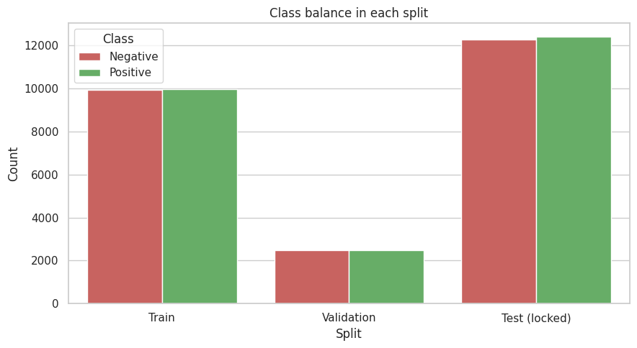
Figure 1: Class balance in the training, validation and test splits
The classes are almost perfectly balanced in every split: the training set has 9,946 negative and 9,977 positive reviews, the validation set 2,486 and 2,495, and the test set 12,266 and 12,412. Stratification therefore preserved the 50/50 balance, which makes accuracy a fair metric and means no resampling is needed.

4. Feature Extraction
Machine-learning algorithms work with numbers, not text, so every review must be converted into a numeric feature vector. The choice of representation largely determines what the classifier can learn.

4.1 Bag-of-Words (counts)
Bag-of-Words builds a vocabulary of all words in the training data and represents each review as a vector whose entries are the number of times each word occurs. It is simple and fast, and works surprisingly well for sentiment, but it ignores word order and treats very common words as just as important as rare, informative ones.

4.2 TF-IDF
TF-IDF (term frequency–inverse document frequency) re-weights the counts so that words which are frequent in a review but rare across the collection receive higher weight:
tf-idf(t, d) = tf(t, d) × idf(t), with idf(t) = log(N / df(t))
where tf(t, d) is how often term *t* occurs in review *d*, N is the number of reviews and df(t) is the number of reviews containing *t* (scikit-learn uses a smoothed version of this formula). Two further options were used: sublinear term frequency (1 + log tf), so that a word repeated ten times is not ten times as important, and L2 normalisation of each vector, so that long and short reviews are comparable. Words appearing in fewer than 5 reviews were dropped (min_df = 5) to remove typos and one-off names, which, as Week 1 showed, make up most of the vocabulary.

4.3 N-grams
Unigrams (single words) cannot capture phrases. Bigrams (two-word sequences) recover local context such as “not good”, “waste time” or “highly recommend”, which Week 1 showed to be far more informative than single words. The cost is a much larger feature space, which is limited by min_df.

4.4 Embeddings and transformers (not used)
Dense representations such as word2vec, GloVe or contextual transformer embeddings capture word meaning and context, and can handle words never seen in training. They are more powerful but heavier to run, so they are treated as an enhancement in Section 9.

4.5 Feature sets compared
Table 4: Feature representations used in the experiments
Feature set | Description | Strengths | Weaknesses
BoW (unigram counts) | Word counts, min_df = 5 | Simple, fast, strong baseline | Ignores word order; frequent words dominate
TF-IDF (unigrams) | Weighted counts, sublinear tf, L2 norm | Down-weights common words; robust to length | Still ignores word order
TF-IDF (uni + bigrams) | As above plus two-word phrases | Captures negation and short phrases | Larger feature space; more memory and time

5. Algorithm Selection
Text vectors are high-dimensional and sparse (tens of thousands of features, most of them zero for any review). Linear models and Naive Bayes are well matched to this setting, so they form the core of the study.

5.1 Multinomial Naive Bayes
Naive Bayes applies Bayes’ theorem and assumes that words are independent given the class: P(class | review) ∝ P(class) × P(word1 | class) × P(word2 | class) × …. Training only requires counting words per class, so it is extremely fast and works with little data. The independence assumption is clearly false for language, which limits accuracy, but it makes a hard-to-beat quick baseline. A smoothing parameter alpha prevents unseen words from producing zero probabilities and was tuned.

5.2 Logistic Regression
Logistic Regression computes a weighted sum of the features and passes it through the sigmoid function to give a probability: P(positive | x) = 1 / (1 + e^-(w·x + b)). It is trained by minimising log-loss with regularisation, controlled by C (larger C means weaker regularisation, which risks overfitting). It gives calibrated probabilities and its coefficients are directly interpretable: each word has a weight showing how strongly it pushes the prediction towards positive or negative.

5.3 Linear Support Vector Machine
A linear SVM finds the separating hyperplane with the largest margin between the two classes, controlled by the same kind of parameter C that trades margin width against training errors. It is particularly effective for sparse, high-dimensional text, as shown by Joachims (1998), and is usually among the most accurate classical text classifiers. It does not give probabilities directly, but its decision score can be used for ROC analysis.

5.4 Neural network (MLP)
A small multi-layer perceptron (one hidden layer of 64 units) was trained on 20,000 TF-IDF unigram features to test whether a non-linear model adds value over linear ones. It can learn feature interactions, but it is slower, needs early stopping to avoid overfitting, and is much harder to interpret.

5.5 Comparison of the algorithms
Table 5: Algorithms considered
Algorithm | Core idea | Strengths | Weaknesses | Tuned
Naive Bayes | Class-conditional word probabilities | Very fast; works with little data | Independence assumption; weaker accuracy | alpha
Logistic Regression | Linear score through a sigmoid | Interpretable; gives probabilities | Linear boundary only | C
Linear SVM | Maximum-margin hyperplane | Excellent on sparse text; robust | No native probabilities | C
Neural network (MLP) | Hidden layer of non-linear units | Can model interactions | Slow; less interpretable; overfits easily | Fixed size

5.6 Why these choices
Together these four cover a range of complexity, from the simplest probabilistic model to a non-linear network, while all remaining cheap enough to run many comparisons on a free Google Colab session. Deep transformer models were deliberately left out of the experiments, since they need GPU resources and the goal of this task is to understand and justify the design of a classical pipeline, with transformers as the natural next step.

6. Training Procedure and Experiments

6.1 Experimental design
Four experiments were run in order, each one using the decisions of the previous one:
- E1: Preprocessing ablation. Does heavy cleaning help a classifier?
- E2: Feature × algorithm grid. Which of the 3 feature sets and 3 algorithms work best, evaluated on the validation set?
- E3: Hyperparameter tuning. Tune each algorithm with 5-fold cross-validation and select the final model.
- E4: Final evaluation. Re-fit on the full training set and score once on the test set (Section 7).
All models are scikit-learn Pipeline objects (vectorizer followed by classifier), so the vectorizer is always fitted on training data only. The random seed was fixed to 42.

6.2 E1: Does heavy cleaning help?
TF-IDF (unigrams + bigrams) with Logistic Regression was trained on both text versions and scored on the validation set.
Table 6: Preprocessing ablation (validation accuracy)
Text version | Validation accuracy
Light (HTML/URL removal, lowercase, contractions; stopwords kept) | 0.8904
Full Week 1 pipeline (+ punctuation, stopword removal, lemmatization) | 0.8944

The full Week 1 pipeline gave a validation accuracy of 0.8944, slightly higher than the light version (0.8904), a gain of 0.4 percentage points. Lowercasing, lemmatization and stopword removal give the model a smaller and more consistent vocabulary (the Week 1 analysis showed the vocabulary shrinking by about 79%), which helps a little. The difference is small, however, and smaller than the typical fold-to-fold variation seen in Section 6.4 (a standard deviation of about 0.008), so heavy cleaning is helpful here but not essential. The full version was therefore used in all later experiments.

6.3 E2: Feature extraction × algorithm comparison
Each combination was trained on the training portion and evaluated on the validation set with default hyperparameters. A majority-class predictor is included as the floor.
Table 7: Validation results for all feature and algorithm combinations
Features | Model | Accuracy | Precision | Recall | F1
— | Majority-class baseline | 0.5009 | 0.5009 | 1.0000 | 0.6675
BoW (unigram) | Naive Bayes | 0.8498 | 0.8662 | 0.8281 | 0.8467
BoW (unigram) | Logistic Regression | 0.8707 | 0.8660 | 0.8778 | 0.8718
BoW (unigram) | Linear SVM | 0.8458 | 0.8423 | 0.8517 | 0.8470
TF-IDF (unigram) | Naive Bayes | 0.8649 | 0.8743 | 0.8529 | 0.8635
TF-IDF (unigram) | Logistic Regression | 0.8910 | 0.8792 | 0.9070 | 0.8929
TF-IDF (unigram) | Linear SVM | 0.8838 | 0.8760 | 0.8946 | 0.8852
TF-IDF (uni + bigram) | Naive Bayes | 0.8846 | 0.8834 | 0.8866 | 0.8850
TF-IDF (uni + bigram) | Logistic Regression | 0.8944 | 0.8826 | 0.9102 | 0.8962
TF-IDF (uni + bigram) | Linear SVM | 0.9004 | 0.8909 | 0.9130 | 0.9018
TF-IDF (20k unigrams) | Neural network (MLP) | 0.8988 | 0.8863 | 0.9154 | 0.9006
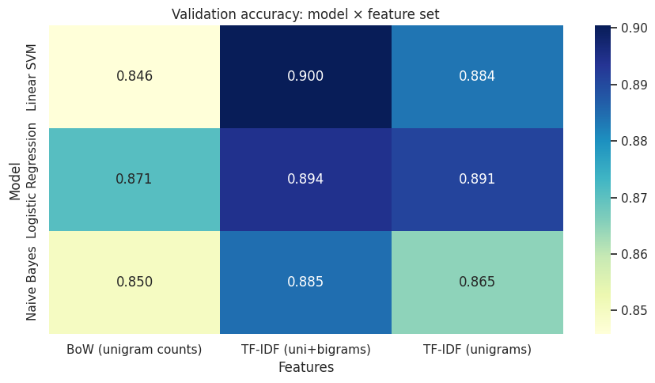
Figure 2: Validation accuracy for every model and feature set
TF-IDF with unigrams and bigrams was the best feature set for all three algorithms (0.885 for Naive Bayes, 0.894 for Logistic Regression and 0.900 for Linear SVM), and TF-IDF beat plain word counts for every model, by 1.5 points for Naive Bayes, 2.0 for Logistic Regression and 3.8 for the SVM. Adding bigrams to TF-IDF gained a further 2.0 points for Naive Bayes, 1.6 for the SVM and only 0.3 for Logistic Regression. The best combination was Linear SVM with TF-IDF unigrams and bigrams (0.900), while the SVM on raw counts was the weakest (0.846); every model is far above the 50% majority baseline.

6.4 E3: Hyperparameter tuning with cross-validation
Each algorithm was tuned on the training portion with stratified 5-fold cross-validation on TF-IDF (unigrams + bigrams). In k-fold cross-validation the training data is split into 5 parts; each part is used once as a validation fold while the model is trained on the other four, and the 5 scores are averaged. This gives a more reliable estimate than a single split, together with a standard deviation that shows how stable the model is. The vectorizer sits inside the pipeline, so it is re-fitted in every fold.
Table 8: Tuning results (5-fold cross-validation)
Model | Best parameters | CV accuracy (mean) | CV accuracy (std) | Validation accuracy
Naive Bayes | alpha = 0.3 | 0.8819 | 0.0038 | 0.8822
Logistic Regression | C = 10 | 0.8965 | 0.0080 | 0.9010
Linear SVM | C = 0.3 | 0.8973 | 0.0083 | 0.9034
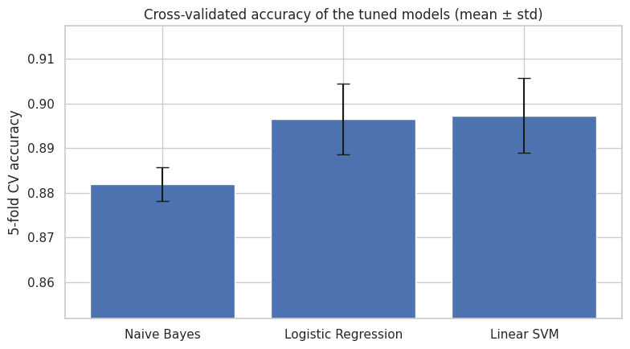
Figure 3: Cross-validated accuracy of the tuned models (mean ± standard deviation)
Linear SVM (0.8973) and Logistic Regression (0.8965) have almost identical mean cross-validation accuracy, and both are clearly ahead of Naive Bayes (0.8819). The error bars of the SVM and Logistic Regression overlap almost completely, so the 0.0008 difference between them is far smaller than the fold-to-fold variation (standard deviations of 0.0083 and 0.0080), whereas Naive Bayes has the smallest spread (0.0038) but is clearly lower on average. A standard deviation below one percentage point for every model shows that the estimates are stable across folds.

6.5 Model selection
The final model was selected by its mean cross-validation accuracy, not by test performance, so that the test set stays an unbiased judge. The selected model is Linear SVM with C = 0.3, using the full text version and TF-IDF with unigrams and bigrams. This fits the theory in Section 5: a linear maximum-margin classifier is well suited to sparse, high-dimensional TF-IDF vectors, and its mean cross-validation accuracy was essentially tied with Logistic Regression (the difference is far smaller than the error bars), so the choice between the two is not clear-cut, and the SVM was selected for its marginally higher mean. One caution is that the best value of C for Logistic Regression (10) is the largest value in the searched grid, so a wider grid might improve it slightly; this is listed as an enhancement in Section 9.

7. Evaluation Framework

7.1 Metrics
Evaluation is based on the confusion matrix, which counts true positives (TP), true negatives (TN), false positives (FP, negative reviews predicted positive) and false negatives (FN, positive reviews predicted negative). All other metrics are derived from it.
Table 9: Evaluation metrics
Metric | Formula | What it answers | When it matters
Accuracy | (TP + TN) / total | How often is the prediction right? | Balanced classes, as here
Precision | TP / (TP + FP) | Of the reviews predicted positive, how many really are? | When false alarms are costly
Recall | TP / (TP + FN) | Of all truly positive reviews, how many were found? | When missing a case is costly
F1-score | 2 × P × R / (P + R) | Single balance of precision and recall | Imbalanced classes
ROC-AUC | Area under the TPR/FPR curve | How well does the score rank positives above negatives, at any threshold? | Threshold-independent comparison

Because the IMDB classes are balanced, accuracy is a fair headline metric, but precision, recall and F1 are reported for both classes so that a model biased towards one class would be detected. For a different application, such as detecting complaints, recall on the negative class would deserve more weight.

7.2 Validation techniques
- Hold-out validation: a stratified 20% validation set for comparing features and models.
- Stratified 5-fold cross-validation: for tuning and for a stable estimate with a standard deviation.
- Locked test set: used once, after all decisions are made, to estimate performance on unseen data.
- Leakage controls: duplicate and overlap removal, splitting before vectorizing, and vectorizers inside the cross-validation pipeline.

7.3 Baselines
- Majority-class predictor: always predicts the most frequent class, giving about 50% accuracy. Any useful model must beat this.
- VADER: a rule-based sentiment lexicon needing no training. Scoring the test set with it shows the benefit of learning from labelled data.

7.4 Results on the test set
The tuned models were re-fitted on the full training set (train + validation) and evaluated once on the test set.
Table 10: Test-set results
Model | Accuracy | Precision | Recall | F1 | ROC-AUC
Logistic Regression (tuned) | 0.896 | 0.900 | 0.892 | 0.896 | 0.961
Linear SVM (tuned) | 0.898 | 0.900 | 0.896 | 0.898 | 0.962
Naive Bayes (tuned) | 0.865 | 0.883 | 0.844 | 0.863 | 0.941
Majority-class baseline | 0.503 | 0.503 | 1.000 | 0.669 | 0.500
VADER (rule-based baseline) | 0.700 | 0.652 | 0.865 | 0.743 | 0.787

The selected Linear SVM reached 0.898 accuracy on the test set (precision 0.900, recall 0.896, F1 0.898), an improvement of 19.8 percentage points over VADER (0.700) and 39.5 over the majority baseline (0.503). It meets the 85% target set in Section 1.3. The validation (0.903), cross-validation (0.897) and test (0.898) accuracies are close, which indicates the model is not overfitted. Logistic Regression is a very close second (0.896), while the tuned Naive Bayes is clearly weaker (0.865).
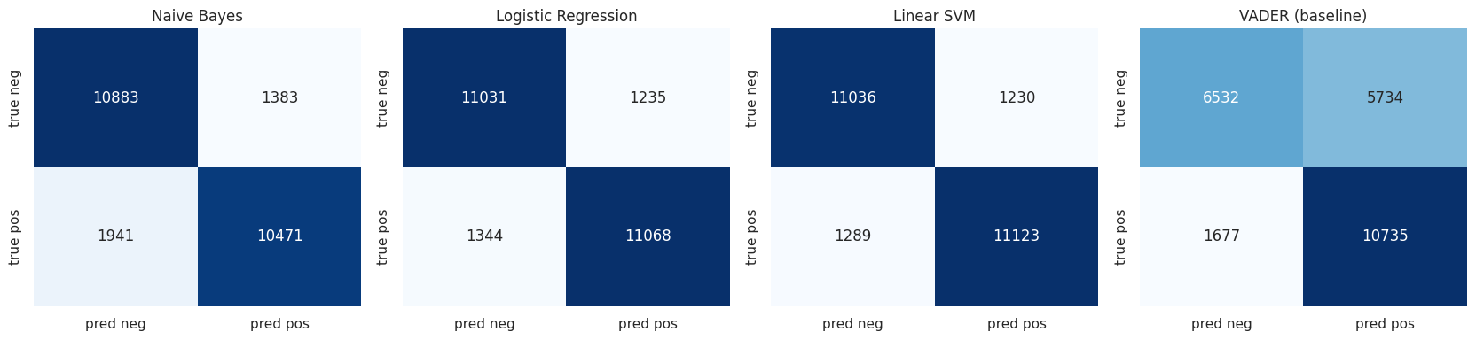
Figure 4: Test-set confusion matrices of the three tuned models and VADER
The selected Linear SVM correctly classified 11,036 negative and 11,123 positive reviews, with 1,230 false positives and 1,289 false negatives, so its errors are almost evenly split between the two classes. Logistic Regression behaves almost identically, whereas Naive Bayes makes more false negatives (1,941) than false positives (1,383). VADER is strongly biased towards the positive class: it wrongly labels 5,734 of the 12,266 negative reviews as positive (46.7%), against only 1,677 false negatives.
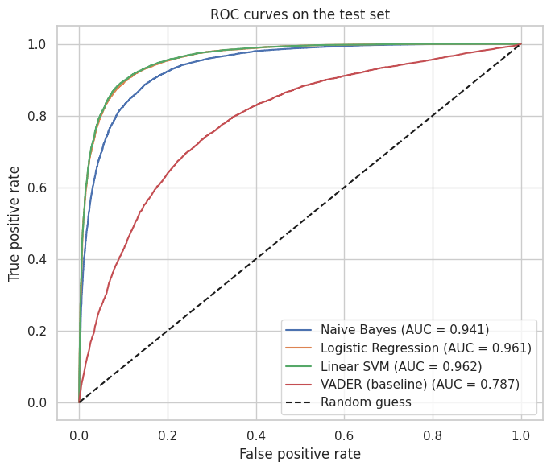
Figure 5: ROC curves on the test set
The ROC-AUC is 0.962 for Linear SVM and 0.961 for Logistic Regression (their curves are almost indistinguishable), 0.941 for Naive Bayes and only 0.787 for VADER. All trained models lie far above the diagonal of random guessing, and the gap between them and VADER shows how much is gained by learning from labelled data.

7.5 Error analysis
What the model learned. The largest Logistic Regression coefficients show which words and phrases drive the predictions.
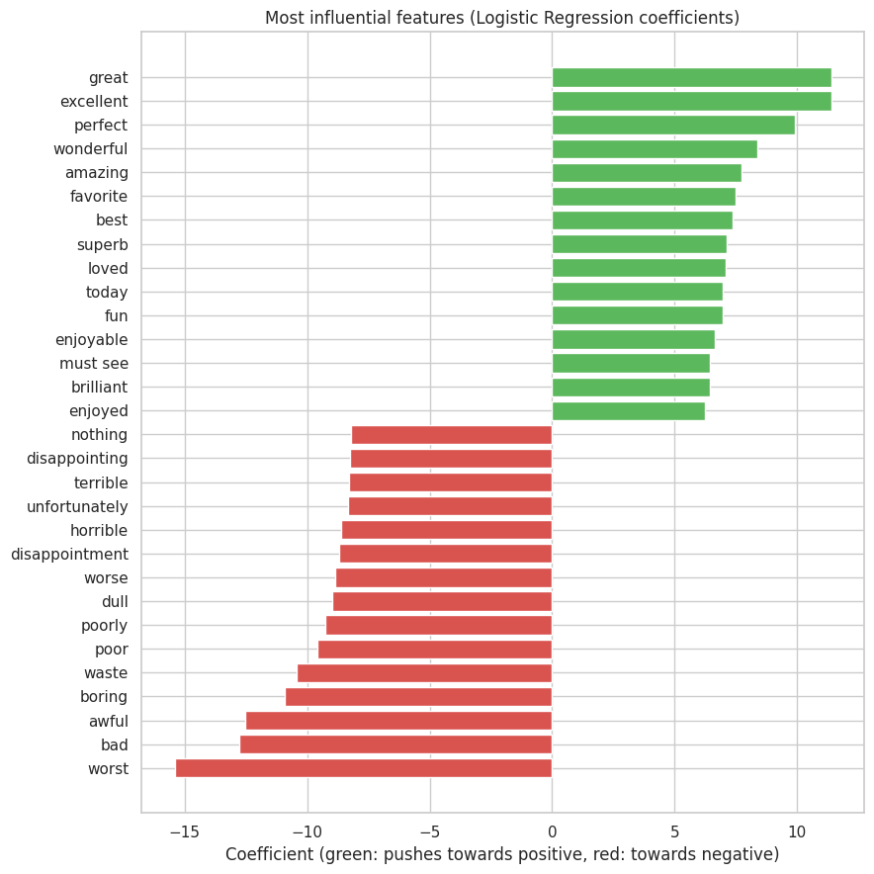
Figure 6: Most influential features (Logistic Regression coefficients)
The strongest positive features are “great”, “excellent”, “perfect”, “wonderful” and “amazing”, and the strongest negative ones are “worst”, “bad”, “awful”, “boring” and “waste”, which is exactly what we would expect from sentiment vocabulary. The model also uses the bigram “must see” as a positive signal and “unfortunately”, “disappointing” and “nothing” as negative ones. Slightly surprising is “today” among the positive features, probably from phrases such as a film that still holds up today.
Where the model fails. The selected model made 2,519 errors on 24,678 test reviews (10.2%): 1,289 false negatives and 1,230 false positives. Two typical misclassified reviews are shown below.
Example 1 (true: negative, model score: 0.38): "Like the previous commentator on this film, I too found myself in tears at times during this movie. Sometimes one wonders how a film of such awe-inspiring awfulness comes…"
Example 2 (true: positive, model score: -1.23): "Simon Wests pg-13 thriller about a babysitter who gets disturbing prank calls while sitting at a mansion is neither original nor exciting enough to be called a good film…"
These two examples show the main limits of a bag-of-words classifier. In Example 1 the reviewer is sarcastic: phrases such as "in tears" and "awe-inspiring" sound positive, and the model, which only sees word and bigram counts, cannot recognise the irony; its low score of 0.38 shows it was not confident either. In Example 2 the visible opening is clearly critical ("neither original nor exciting"), and the model scored it strongly negative (-1.23), which is a reasonable reading of that text, yet the review is labelled positive. Possibly the reviewer criticises the film at first and recommends it later, which a model that treats the whole review as one bag of words cannot follow, or the rating behind the label is borderline. Both cases match the challenges listed in Section 8 (sarcasm, and mixed or ambiguous sentiment) and are the reason context-aware models are proposed in Section 9.
Table 11: Test accuracy by review length
Length bucket | Reviews | Accuracy
< 100 words | 3,096 | 0.9028
100–200 words | 11,627 | 0.9005
200–400 words | 6,863 | 0.8928
> 400 words | 3,092 | 0.8949
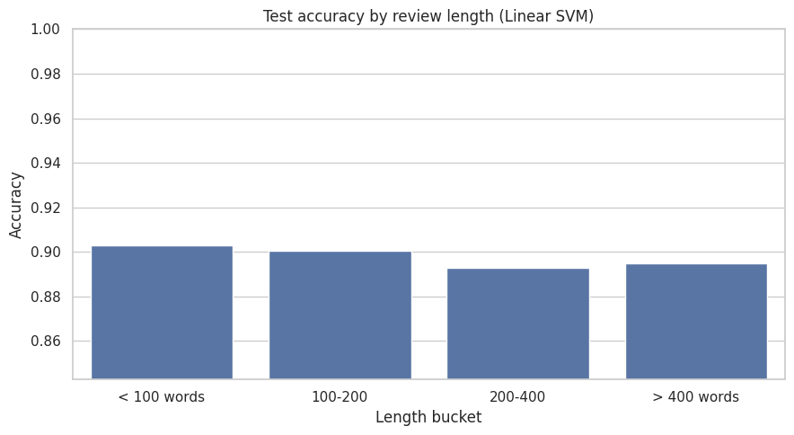
Figure 7: Test accuracy by review length
Accuracy is fairly stable across review lengths: 0.9028 for reviews under 100 words, 0.9005 for 100–200 words, 0.8928 for 200–400 words and 0.8949 for reviews over 400 words. The shortest reviews are classified slightly better and the 200–400 word bucket slightly worse, which is plausible because longer reviews more often mix praise and criticism or retell the plot, diluting the sentiment. The whole range is only about one percentage point, so length is not a major weakness.

7.6 Does more data help?
To judge whether more labelled data would improve the model, it was trained on 10%, 25%, 50%, 75% and 100% of the training portion and scored on the validation set.
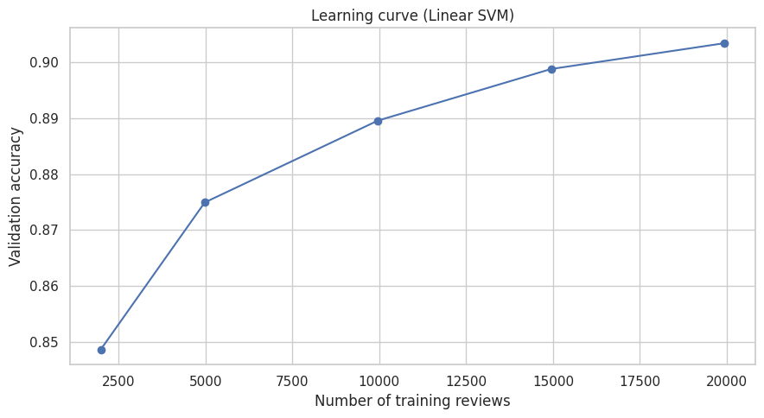
Figure 8: Learning curve of the selected model
Validation accuracy rises from about 0.85 with 2,000 training reviews to about 0.875 with 5,000, 0.89 with 10,000, 0.90 with 15,000 and 0.903 with the full 19,923 reviews. The curve is still increasing at 100% of the data but is flattening (roughly half a point gained between 15,000 and 20,000 reviews), so more labelled data would help only modestly, and a stronger model is likely to give larger gains.

8. Challenges and How They Are Addressed
Table 12 lists the main challenges for this classification task and the mitigation built into the strategy.
Table 12: Challenges and mitigation
Challenge | Why it matters | How it is addressed
Data leakage | Duplicates, train–test overlap or fitting a vectorizer on all data inflate scores | Removed duplicates and overlap; split before vectorizing; vectorizer inside the cross-validation pipeline; test set used once
Overfitting | Thousands of features against 20,000 training reviews let a model memorise noise | Regularisation (C, alpha), min_df, cross-validation, comparing validation, CV and test scores
Negation and word order | Bag-of-Words cannot tell “good” from “not good” | Kept negations when removing stopwords; added bigrams; transformers as a future step
Sarcasm and irony | The words say the opposite of the intent | Not solved by classical models; analysed in error analysis; contextual models proposed
Mixed or plot-heavy reviews | A review may praise one aspect and criticise another, or retell a plot with negative words | Documented through error analysis; sentence-level or aspect-based models proposed
High-dimensional sparse features | Large vocabularies are slow and noisy | Frequency threshold min_df = 5; linear models designed for sparse data
Very long or very short reviews | Little context in short reviews; sentiment diluted in long ones | L2-normalised, sublinear TF-IDF; accuracy analysed by review length
Class imbalance (other datasets) | Accuracy misleads when one class dominates | Not an issue here (balanced), but precision, recall and F1 are reported and class weights or resampling would be used
Domain shift | A model trained on movie reviews may fail on product reviews or tweets | Treated as a limitation; cross-domain testing proposed
Label noise | Labels come from rating thresholds, so a few reviews are mislabelled | Accepted as a performance ceiling; examined in misclassified examples
Computation time of cross-validated tuning | Tuning each model with 5-fold cross-validation took roughly 100 seconds (about 102 to 109 s per model), because every fold re-fits the vectorizer on bigram features. A larger grid would have multiplied this. | Kept each search grid small (three values per model), used min_df = 5 to limit the feature space, ran folds in parallel with n_jobs = -1, and used one fixed seed so runs are reproducible.

The hardest part of this task was making fair comparisons rather than just getting a high score. Because the final models were so close (Linear SVM 0.8973 and Logistic Regression 0.8965 in cross-validation, with a standard deviation of about 0.008), I learned that a tiny difference cannot be trusted without looking at the variation between folds, and that choosing the model by cross-validation rather than by test accuracy keeps the final test honest. I also learned that protecting against data leakage takes deliberate steps: the checks found 123 test reviews that also appeared in the training set, and fitting the vectorizer inside each fold mattered as much as the choice of algorithm. On the practical side, the tuning step was slow, and a Colab session reset meant re-running the notebook from the top, which showed me why fixed seeds and a notebook that runs end to end are important. Finally, the error analysis taught me that a model reaching about 90% accuracy still fails on sarcasm and mixed reviews, which cannot be fixed by tuning and points to context-aware models as the next step.

9. Proposed Enhancements for Future Iterations
Table 13: Possible improvements
Enhancement | What it involves | Expected benefit
Fine-tune a transformer (DistilBERT / BERT) | Fine-tune a pre-trained language model on the labelled reviews (needs a GPU) | Understands context, negation and some sarcasm; usually the largest accuracy gain
Pre-trained word embeddings | Use GloVe or fastText vectors as features for a neural network | Captures meaning and handles unseen words
Character n-grams | Add character-level features alongside words | Robust to typos and spelling variants
Part-of-speech-aware lemmatization | Lemmatize with POS tags instead of the noun default | Better normalisation of verbs and adjectives
Ensembling and stacking | Combine Naive Bayes, Logistic Regression and SVM predictions (for example NB-SVM) | Reduces individual model errors
Wider hyperparameter search | Randomised or Bayesian search over C, n-gram range and min_df | Small, cheap accuracy gains
Handling long reviews | Classify sentences or chunks and aggregate | Less dilution of sentiment in long reviews
Data augmentation | Back-translation or synonym replacement | Helps if more data is the bottleneck (see learning curve)
Threshold and probability calibration | Tune the decision threshold for the preferred precision/recall balance | Task-specific control of error types
Explainability | Use LIME or SHAP to explain individual predictions | Trust and easier debugging
Cross-domain evaluation | Test on product reviews or tweets | Measures real-world robustness

Based on the error analysis and the learning curve, I would try three things in this order. First, fine-tuning a transformer such as DistilBERT, because the remaining errors come from sarcasm, negation and mixed opinions that a bag-of-words model cannot represent, so this should give the largest gain. Second, a wider hyperparameter search and a simple ensemble, which are cheap and address the fact that the best C for Logistic Regression (10) sat at the edge of the searched grid. Adding more labelled data or augmentation would come last: the learning curve was still rising at 100% of the training data but had flattened to about half a percentage point per 5,000 reviews, so more data alone would give only modest improvement.

10. Conclusion
This report presented a complete plan and implementation for classifying IMDB movie reviews by sentiment. The pipeline moved from problem definition and leakage-safe data preparation, through TF-IDF feature extraction and a controlled comparison of Naive Bayes, Logistic Regression, a linear SVM and a small neural network, to tuning by cross-validation and a single final test.
The best model, selected by cross-validation, was a Linear SVM on TF-IDF unigram and bigram features, which reached 0.898 accuracy and a ROC-AUC of 0.962 on the untouched test set, almost 20 points above the rule-based VADER baseline (0.700) and far above the majority baseline (0.503). The comparison of feature sets showed that TF-IDF weighting mattered more than the choice of algorithm among the linear models, and that adding bigrams gave a further gain, especially for the SVM and Naive Bayes. The error analysis showed that errors are evenly split between false positives and false negatives and that accuracy varies by only about one point across review lengths. The learning curve is still rising slowly, so more data would help a little, but the most promising next step is a context-aware model such as a fine-tuned transformer, which can handle negation and sarcasm better than a bag-of-words approach.

Appendix A: Reproducibility
Notebook: https://github.com/haricharan-285/yuvaintern-nlp-tasks. Random seed: 42. Library versions:
Table 14: Software environment
Library | Version
Python | 3.13.15
scikit-learn | 1.6.1
pandas / NumPy | 2.2.3 / 2.1.3
NLTK | 3.9.1
Hugging Face datasets | 4.8.5
vaderSentiment | 3.3.2
Matplotlib / Seaborn | 3.10.0 / 0.13.2

Appendix B: Core Pipeline Code
The central scikit-learn pipeline and tuning procedure are shown below.
def tfidf12():
return TfidfVectorizer(ngram_range=(1, 2), min_df=5, sublinear_tf=True)

cv = StratifiedKFold(n_splits=5, shuffle=True, random_state=42)

grids = {
"Naive Bayes": (MultinomialNB(), {"clf__alpha": [0.1, 0.3, 1.0]}),
"Logistic Regression": (LogisticRegression(max_iter=1000), {"clf__C": [1, 3, 10]}),
"Linear SVM": (LinearSVC(), {"clf__C": [0.1, 0.3, 1.0]}),
}

for name, (est, grid) in grids.items():
pipe = Pipeline([("vec", tfidf12()), ("clf", est)])
gs = GridSearchCV(pipe, grid, cv=cv, scoring="accuracy", n_jobs=-1)
gs.fit(X_train, y_train) # vectorizer is re-fitted inside every fold

final = clone(best_pipeline).fit(X_full_train, y_full_train)
y_pred = final.predict(X_test) # test set used once, at the end

Appendix C: References
- Maas, A. L., Daly, R. E., Pham, P. T., Huang, D., Ng, A. Y., & Potts, C. (2011). Learning Word Vectors for Sentiment Analysis. Proceedings of ACL, pp. 142–150.
- Pang, B., Lee, L., & Vaithyanathan, S. (2002). Thumbs up? Sentiment Classification using Machine Learning Techniques. Proceedings of EMNLP.
- Joachims, T. (1998). Text Categorization with Support Vector Machines: Learning with Many Relevant Features. Proceedings of ECML.
- Manning, C. D., Raghavan, P., & Schütze, H. (2008). Introduction to Information Retrieval. Cambridge University Press.
- Salton, G., & Buckley, C. (1988). Term-weighting approaches in automatic text retrieval. Information Processing & Management, 24(5), 513–523.
- Hutto, C. J., & Gilbert, E. (2014). VADER: A Parsimonious Rule-based Model for Sentiment Analysis of Social Media Text. Proceedings of ICWSM.
- Pedregosa, F., et al. (2011). Scikit-learn: Machine Learning in Python. Journal of Machine Learning Research, 12, 2825–2830.
- Devlin, J., Chang, M.-W., Lee, K., & Toutanova, K. (2019). BERT: Pre-training of Deep Bidirectional Transformers for Language Understanding. Proceedings of NAACL.
- Sanh, V., Debut, L., Chaumond, J., & Wolf, T. (2019). DistilBERT, a distilled version of BERT. arXiv:1910.01108.

