Skill -2
Aim to recode the input of the terminal simulating the shell
it understands the inputs give and return the i/O commands. Also programm is capable of doing the shell command and executing them.
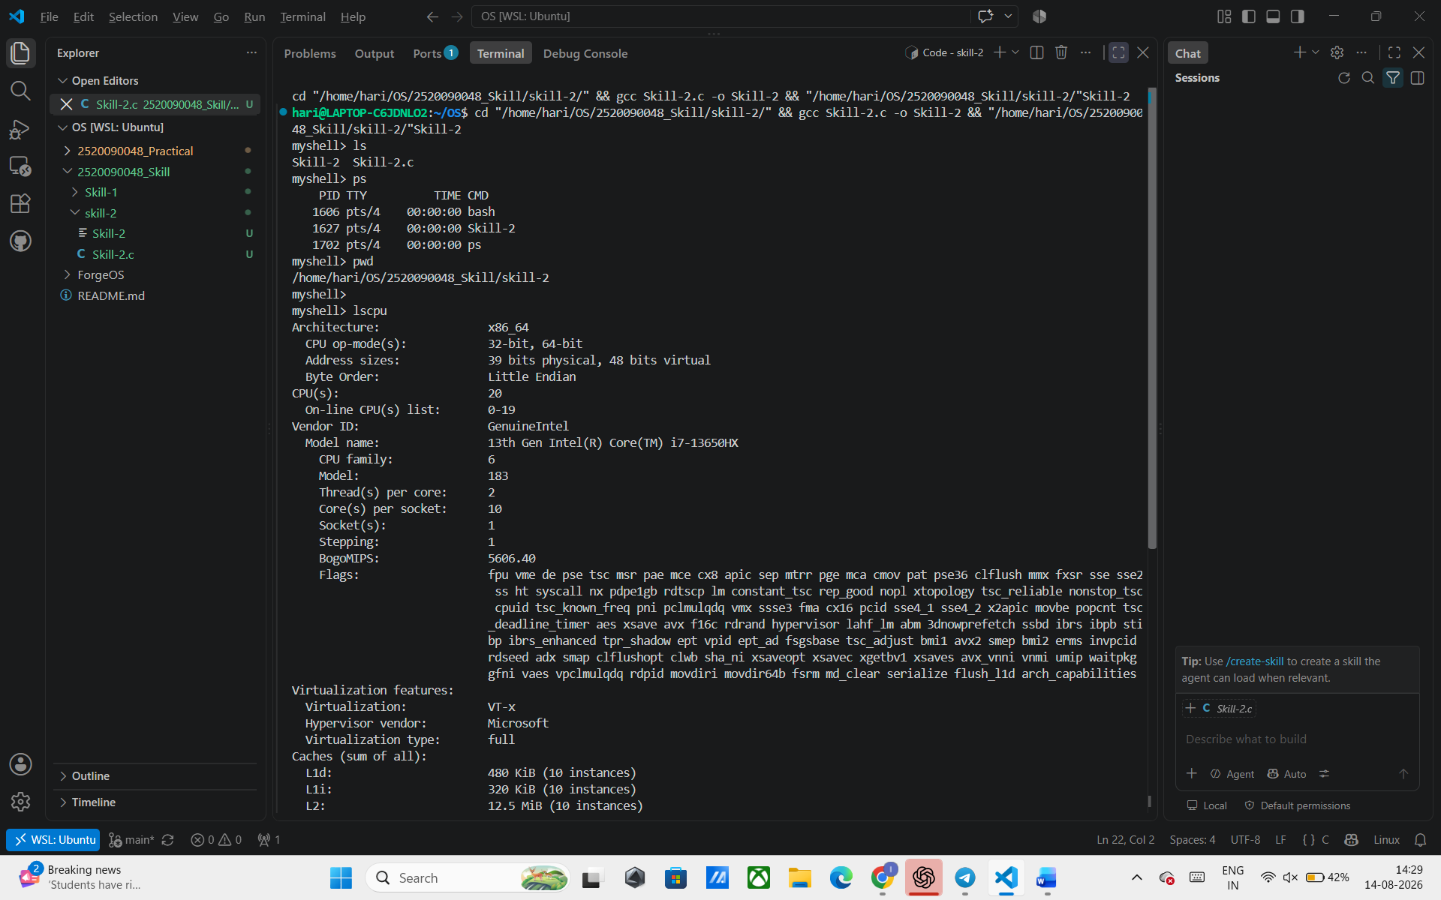

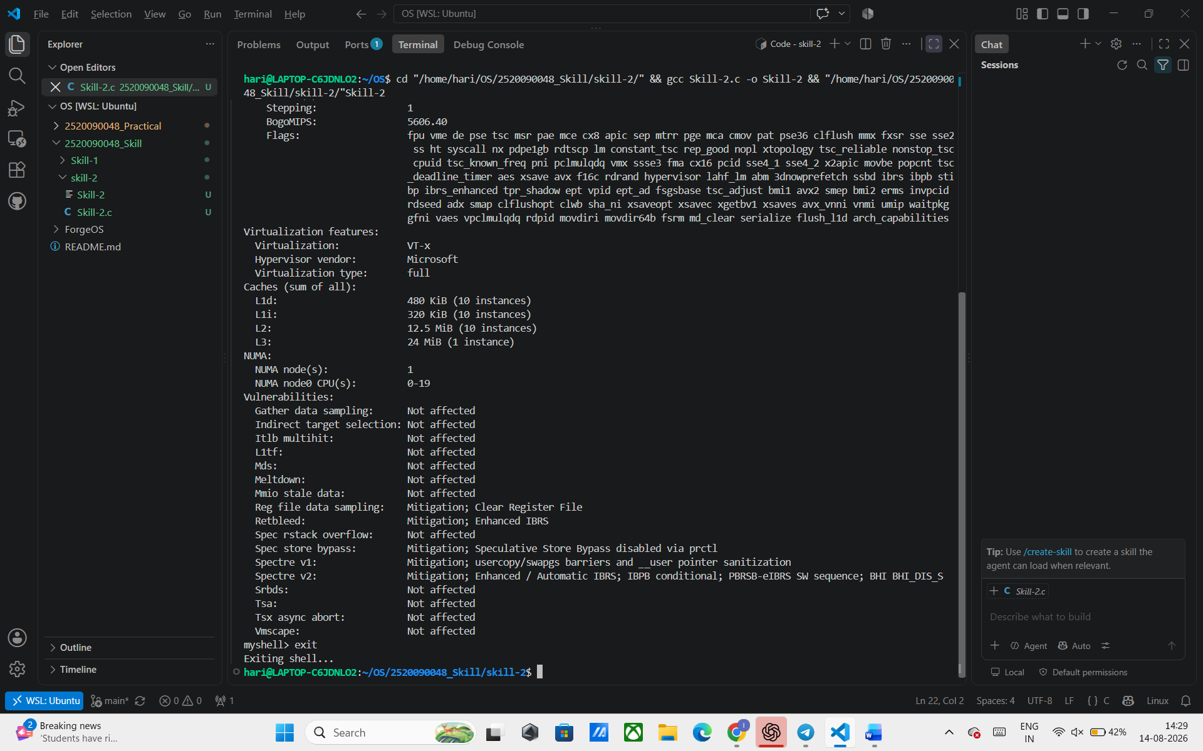
Second programm can do the text but not the commands
