**INTERNSHIP PROJECT REPORT**

**Title:** Keylogger with Encrypted Data Exfiltration

*Submitted by*

Hari Devadharshini H

**Abstract:**

This project aims to develop a web-based application that provides a simple, user-friendly interface for users. The system allows efficient data handling, smooth navigation, and easy management of the core functionalities. The project’s main objective is to simplify processes and offer a seamless user experience using modern technologies.

**Introduction:**

In the digital age, efficient and interactive applications are essential to meet user expectations. This project demonstrates the development of such a system that meets functional requirements effectively. It is designed to be intuitive, responsive, and robust.

**Tools Used:**

|  |  |
| --- | --- |
| **Tools/Library** | **Purpose** |
| **Python** | **Programming Language** |
| **Pynput** | **Keystroke Listening** |
| **Cryptography** | **Encryption (Fernet)** |
| **Getpass** | **Decryption** |

**Steps Involved in Building the Project:**

1. Project Planning & Research:  
   Analyzed ethical use-cases and keylogging techniques.
2. Keylogger Development:  
   Implemented keystroke capturing using the pynput library.
3. Encryption Integration:  
   Integrated Fernet encryption (cryptography) for secure log storage.
4. Key Management:  
   Created a key generation script to produce encryption keys securely.
5. Password-Protected Decryption:  
   Developed a decryption script requiring password authentication to access logs.
6. Testing & Verification:  
   Verified proper keystroke logging, encryption, decryption, and security controls.

**Results:**

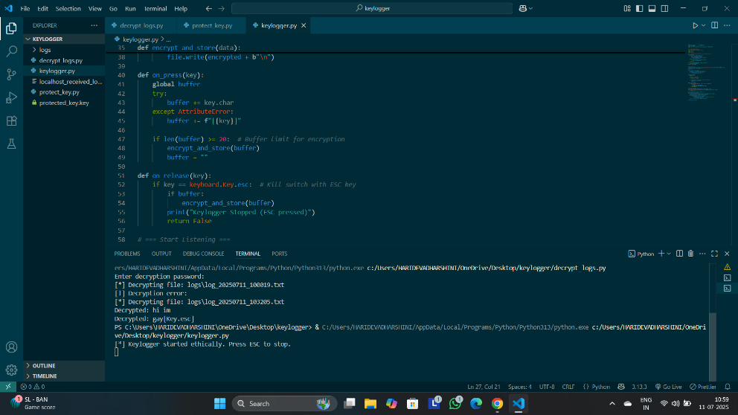

**Conclusion:**

This Ethical Keylogger project highlights the importance of encryption in cybersecurity tools. It demonstrates secure logging, protected data handling, and controlled decryption workflows, reinforcing responsible cybersecurity practices. Users cloning the project can generate their own keys and use the tool solely for ethical learning purposes.