NPALS Healthcare Data Analysis Report: Provider Distribution & Workforce Insights

1. Problem Objective:
This project delivers an end-to-end healthcare analytics solution using the National Post-Acute and Long-Term Care Study (NPALS) dataset, sourced from the U.S. Department of Health & Human Services. The analysis pipeline spans data cleaning and transformation in Microsoft Excel and Python through to interactive dashboard development in Power BI, producing a decision-ready intelligence layer over the U.S. post-acute and long-term care sector.
The project addresses the following analytical dimensions:
- Provider Landscape Assessment: Mapping the distribution and density of care providers across seven post-acute and long-term care settings, including nursing homes, hospices, home health agencies, and residential care communities
- Workforce Composition Analysis: Examining staffing levels, full-time equivalent employee counts, and nursing and social work workforce proportions across care settings to surface patterns in workforce intensity, role distribution, and sector-level staffing adequacy.
- Service Utilization Profiling: Quantifying participant, resident, and patient volumes including daily averages and annual totals, to assess demand trends, facility-level throughput, and the divergence between provider supply and patient utilization following the COVID-19 period.
- Operational Efficiency Benchmarking: Evaluating FTE hours per patient, resident, and participant as a proxy for care delivery efficiency, and benchmarking bed utilization and capacity stability across facility types to identify settings under strain or operating below optimal capacity.
The intended output is an interactive Power BI dashboard that enables healthcare administrators, policy analysts, and public health researchers to explore provider availability, workforce efficiency, and long-term care utilization trends supporting evidence-based planning and resource allocation decisions.
2. Data Sources:
• Sources: Data.gov (Catalog.data.gov) https://catalog.data.gov/dataset/dqs-national-post-acute-and-long-term-care-providers
• Domain: Healthcare Analytics

3. Problem Statement:
The United States post-acute and long-term care sector is navigating a period of significant structural pressure. Despite the availability of nationally representative survey data through the National Post-Acute and Long-Term Care Study (NPALS), there is a persistent gap between raw data availability and actionable insight. Provider counts, staffing levels, bed capacity, patient volumes, and efficiency ratios exist across seven distinct care settings - nursing homes, hospices, home health agencies, residential care communities, adult day services centres, inpatient rehabilitation facilities, and long-term care hospitals, but without structured analysis, these figures cannot reveal the geographic inequities, workforce imbalances, or utilization trends that decision-makers require.
Specifically, this project addresses the below core analytical problems:
Workforce Capacity and Staffing Adequacy: Variation in full-time equivalent employee counts and nursing workforce proportions across care types suggests that staffing models are not consistently aligned with care intensity. Without a structured view of workforce distribution relative to patient and resident volumes, it is difficult to identify settings at risk of understaffing or those carrying inefficient staffing overhead.
Operational Efficiency and Utilization Misalignment: In several care settings, provider supply has grown while patient volumes per facility have declined, pointing to potential underutilization, fragmented referral networks, or unmet demand-side barriers. Simultaneously, bed utilization trends and FTE-to-patient ratios indicate that capacity planning decisions are being made without adequate performance benchmarking.
Addressing these problems requires a rigorous, data-driven analytical framework that transforms NPALS survey data into a coherent intelligence layer one capable of supporting evidence-based planning, equitable resource allocation, and informed policy decisions across the continuum of post-acute and long-term care.
4. Tools & Technologies:
- Excel
- Python
- Power Query
- Power BI

5. Attributes:
The table below documents all 18 attributes present in the NPALS pre-processing dataset. Each entry specifies the attribute name, its data type as observed in the source file, and a detailed description of the attribute's meaning, role in the analytical framework, and relevance to the project objectives.
Attribute Name | Data Type | Description
SUBTOPIC | Text (String) | Name of the post-acute or long-term care provider type. Identifies the care setting being reported, such as Nursing home, Hospice, Home health agency, or Adult day services centre. Serves as the primary categorical dimension for all analyses.
SUBTOPIC_ID | Integer | Unique numeric identifier assigned to each SUBTOPIC value. Used as a foreign key for relational data modelling and for efficient filtering and joining across tables in Power BI.
CLASSIFICATION | Text (String) | High-level grouping that categorises how the data row is segmented. Takes one of three values: Total (national aggregate), Geographic Characteristic (breakdown by location type or region), or Other Characteristic (breakdown by operational or organisational attribute such as certification or ownership).
CLASSIFICATION_ID | Integer | Numeric identifier corresponding to each CLASSIFICATION category. Facilitates structured filtering and hierarchical drill-down in dashboard visuals.
GROUP | Text (String) | Mid-level segmentation dimension that defines the analytical grouping within a CLASSIFICATION. Examples include Metropolitan statistical area, Region, Type of ownership, Certification, and Chain affiliated. Provides the context for interpreting SUBGROUP-level breakdowns.
GROUP_ID | Integer | Numeric identifier for each GROUP value. Used in data modelling to maintain relational integrity and support ordered filtering.
GROUP_ORDER | Integer | Numeric value indicating the display sort order for GROUP categories within their parent CLASSIFICATION. Ensures consistent visual sequencing of groups in charts and tables.
SUBGROUP | Text (String) | Most granular segmentation level within the hierarchy. Represents specific segments such as Metropolitan, Metropolitan, Neither (rural), Northeast, Midwest, South, West, For-profit, Non-profit, Medicaid, Medicare, or participant-size bands (e.g. 1–25 participants). Used as the primary filter dimension for geographic and operational analyses.
SUBGROUP_ID | Integer | Unique numeric identifier for each SUBGROUP value. Enables relational joins to a dimension table and supports efficient slicer-driven filtering in Power BI.
SUBGROUP_ORDER | Integer | Numeric value defining the display sequence of SUBGROUP entries within their parent GROUP. Ensures logical ordering in visual outputs for example, presenting regional subgroups in geographic sequence rather than alphabetically.
ESTIMATE_TYPE | Text (String) | Descriptive label identifying what the ESTIMATE value measures. Includes metrics such as Number of providers, Number of beds (total and average), Number of employees, Number of participants/residents/patients (total, average, daily average, annual average), Percent of total providers (crude), Percent of providers (crude), Percent of nursing and social work FTE employees (crude), and Ratio of FTE hours per participant/resident/patient.
ESTIMATE_TYPE_ID | Integer | Numeric identifier for each ESTIMATE_TYPE. Used to link the fact table to the Estimate Type dimension table (sourced from Estimate_type_details.xlsx) for enriched benchmarking and reference comparisons.
TIME_PERIOD | Integer | Survey reference year for the data observation. Takes values 2020 or 2022, representing the two NPALS data collection cycles included in this dataset. Used as the primary time dimension for year-over-year trend analysis and comparative reporting.
TIME_PERIOD_ID | Integer | Numeric surrogate key for the TIME_PERIOD dimension. Takes value 1 for 2020 and 2 for 2022. Used in data modelling and DAX time-intelligence calculations.
ESTIMATE | Decimal (Float) | The primary quantitative measure for the row. Represents the survey-derived value corresponding to the ESTIMATE_TYPE for the given SUBTOPIC, SUBGROUP, and TIME_PERIOD combination. Depending on context, values may represent absolute counts (e.g. number of providers, beds, employees), averages, percentages, or FTE ratios. This is the main fact column used in all DAX aggregations and Power BI visuals.
STANDARD_ERROR | Decimal (Float) | The standard error associated with the ESTIMATE value. Quantifies the statistical precision of each survey estimate. Higher values indicate lower reliability. Used in coefficient of variation calculations and for identifying estimates that should be interpreted with caution in analysis.
ESTIMATE_LCI | Decimal (Float) | Lower bound of the 95% confidence interval for the ESTIMATE. Together with ESTIMATE_UCI, defines the range within which the true population value is expected to fall with 95% probability. Used in error bar visualisations and statistical significance testing between time periods.
ESTIMATE_UCI | Decimal (Float) | Upper bound of the 95% confidence interval for the ESTIMATE. Used alongside ESTIMATE_LCI to assess estimate precision and to determine whether year-over-year changes are statistically meaningful (non-overlapping confidence intervals indicate significant change).

6. Data Pre-Processing (Excel / Power Query / Power BI / Python):
Tasks Performed:
Data Cleaning & Transformation: Removed unwanted columns that were irrelevant to the analysis scope, applied Trim functions in Excel to eliminate leading and trailing whitespace from categorical fields, standardized text formats across provider type and classification columns, and ensured correct data types were assigned to all 18 attributes prior to loading into Power BI.
Python- Data Inspection & Validation: Loaded the raw NPALS dataset into Python using the pandas library to perform an initial structural audit before any transformation. Inspected dataset dimensions, column names, and data types using df.shape, df.dtypes, and df.info(). Examined unique values across categorical columns SUBTOPIC, CLASSIFICATION, GROUP, SUBGROUP, and ESTIMATE_TYPE using df[col].unique() and df[col].nunique() to identify inconsistencies, unexpected categories, and value distribution. Confirmed the dataset contains 608 rows across 18 columns spanning 7 provider types and 2 time periods (2020 and 2022).
Python- Missing Value Treatment: Identified missing values across all columns using df.isnull().sum() to quantify the extent of data gaps. Applied median imputation to the four core numeric columns ESTIMATE, STANDARD_ERROR, ESTIMATE_LCI, and ESTIMATE_UCI using column-wise median values calculated via df[col].median(). Median was selected over mean to avoid skew introduced by extreme values present in provider count and bed total estimates. Categorical columns with null or empty values SUBTOPIC, CLASSIFICATION, GROUP, SUBGROUP, and ESTIMATE_TYPE were flagged for downstream removal in Power Query rather than imputed, preserving data integrity for categorical analysis.
Python- Data Type Enforcement: Validated and explicitly cast column data types to align with their analytical roles. Identifier and ordering columns (SUBTOPIC_ID, CLASSIFICATION_ID, GROUP_ID, GROUP_ORDER, SUBGROUP_ID, SUBGROUP_ORDER, ESTIMATE_TYPE_ID, TIME_PERIOD_ID) were enforced as integer types. Numeric measure columns (ESTIMATE, STANDARD_ERROR, ESTIMATE_LCI, ESTIMATE_UCI) were cast as float64. Categorical label columns were confirmed as object (string) type. TIME_PERIOD was retained as integer to support year-based filtering and DAX time intelligence measures.
Python - Descriptive Statistics & Distribution Analysis: Generated summary statistics using df.describe() to examine the range, mean, median, and spread of all numeric columns. Analysed the distribution of ESTIMATE values across ESTIMATE_TYPE categories to understand metric-specific value ranges for example, provider counts ranged from 340 to 32,200 while FTE ratios ranged from 0.46 to 41.8. These distribution insights informed the Estimate Band thresholds used in feature engineering and supported the identification of outlier estimates flagged for cautious interpretation in the dashboard.
Python- Export of Cleaned Dataset: After completing all inspection, imputation, and type-casting steps, the cleaned and validated dataset was exported as a structured CSV file using df.to_csv(), producing the Data_Preprocessing.csv file used as the primary data source for all subsequent Power Query and Power BI transformations.
Handling Missing Values: Identified missing values in the four core numeric columns ESTIMATE, STANDARD_ERROR, ESTIMATE_LCI, and ESTIMATE_UCI and imputed them using median-based logic in Python to preserve the statistical distribution of each metric without introducing mean bias. Categorical columns (SUBTOPIC, CLASSIFICATION, GROUP, SUBGROUP, ESTIMATE_TYPE) were handled separately by removing rows with empty or null values during the Power Query transformation stage, ensuring only complete, valid records were loaded into the data model.
Power Query Transformations: Loaded the cleaned dataset into Power BI using Power Query, where additional transformation steps were applied including data type enforcement for all columns, removal of empty rows in categorical fields using the Remove Empty filter, and validation of column integrity before final load into the data model.
Calendar Table Creation: Created a separate date dimension table using TIME_PERIOD values (2020 and 2022) to establish a structured time axis within the data model, enabling time-based filtering, period-over-period comparisons, and support for time intelligence DAX measures across all visuals.
Time Intelligence: Implemented DAX measures including Year-over-Year (YoY) Change and YoY Percentage Change to quantify shifts in provider counts, workforce levels, and utilization metrics between the 2020 and 2022 survey cycles, supporting trend identification across all seven care settings.
Filtering & Sorting: Applied record-level filters to isolate Total classification rows for high-level KPIs and geographic or operational subgroup rows for drill-down analysis. Sorted GROUP_ORDER and SUBGROUP_ORDER columns to enforce consistent display sequencing across all dashboard visuals.

7. DAX Measures:
- Total Providers Calculates the sum of ESTIMATE filtered to the Number of providers estimate type, serving as the headline KPI measure across all provider-level visuals and cards.
- Average Estimate Computes the average ESTIMATE value across the current filter context, used in matrix tables and subgroup comparison visuals to surface mean metric values per care setting.
- YoY Change Measures the absolute difference in ESTIMATE between the 2022 and 2020 survey periods using VAR-based CALCULATE blocks, returning BLANK where a prior period value is unavailable to prevent misleading zero comparisons.
- YoY Percentage Change Expresses the year-over-year shift as a percentage of the 2020 baseline value, used in conditional formatting rules and trend indicator visuals to highlight care settings with significant growth or decline.
- Trend Direction Returns a categorical label of Increased, Decreased, or No Change based on the sign of YoY Change, enabling color-coded conditional formatting across bar charts and matrix visuals without requiring report-level calculated columns.
- CI Width Calculates the width of the 95% confidence interval as ESTIMATE_UCI minus ESTIMATE_LCI, surfaced in scatter visuals to identify estimate types or subgroups with lower statistical precision.
- Coefficient of Variation Divides STANDARD_ERROR by ESTIMATE and multiplies by 100 to produce a relative precision percentage, flagging records where estimate reliability falls below acceptable thresholds for analytical use.
- Subgroup Share % Computes each subgroup's ESTIMATE as a percentage of the Total subgroup ESTIMATE for the same provider type, estimate type, and time period using ALLEXCEPT to anchor the denominator correctly while respecting all other active filter context.
- FTE Ratio Filters to estimate types containing Ratio of FTE and returns the average value, providing a direct operational efficiency measure comparable across nursing homes, residential care communities, and adult day services centers.
- NH Bed Total A pinned measure filtering specifically to Nursing home and Number of beds total to return the national nursing home bed stock figure, used as a standalone KPI card on the provider capacity page.
8. Analysis and Visualizations (Power BI):
Page 1: Provider Overview
Visuals Used:
- KPI Cards (Total Providers, FTE Ratio, Average Estimate, Nursing Home Bed Total) headline summary measures giving an immediate national-level snapshot of provider count, workforce efficiency, average estimate value, and nursing home bed stock.
- Clustered Bar Chart (Sum of Estimate by SUBTOPIC) compares aggregate estimate values across all seven care settings side by side, highlighting scale differences between provider types.
- Treemap (Average Estimate by SUBTOPIC) sizes each tile proportionally by average estimate value per care setting, offering a quick proportional comparison across the sector.
- Waterfall Chart (YoY % Change by SUBTOPIC) shows positive and negative year-over-year percentage shifts between 2020 and 2022 per care setting, making growth and contraction immediately visible.
- Slicer (SUBTOPIC) filters all visuals and cards on the page to a selected care setting.
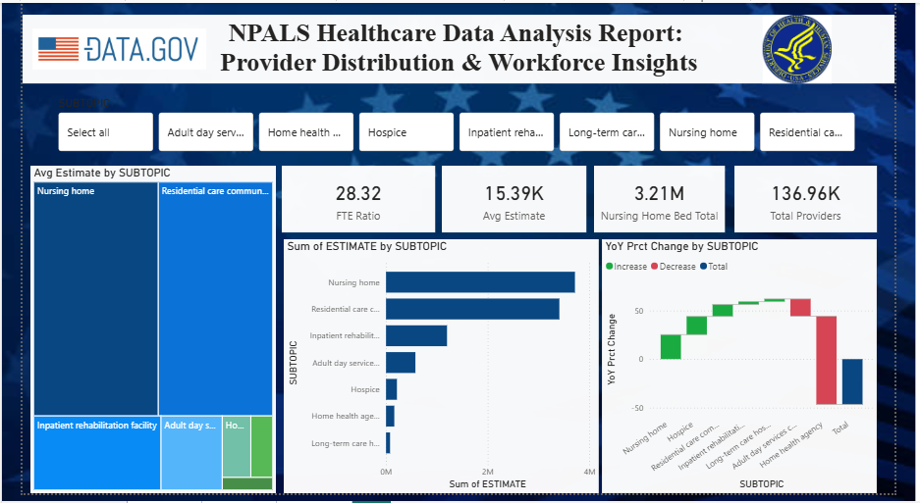
Page 2: Estimate Type and Data Quality Analysis
Visuals Used:
- Matrix Table (ESTIMATE_TYPE × SUBTOPIC YoY % Change) cross-tabulates all estimate types against all care settings with YoY Percentage Change as values, giving a comprehensive view of which metrics shifted most significantly between survey years.
- Scatter Chart (Sum of Estimate vs Sum of Standard Error by SUBTOPIC) plots estimate magnitude against statistical error per care setting, serving as a data reliability diagnostic to identify low-precision records.
- Slicer (SUBTOPIC) filters the matrix and scatter chart to a selected care setting.
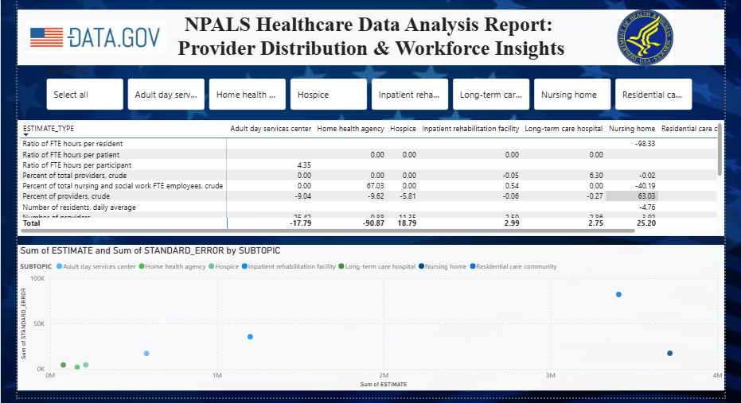
Page 3: Subgroup and Geographic Trend Analysis
Visuals Used:
- Donut Chart (YoY % Change by GROUP) displays the proportional distribution of year-over-year change across classification groups such as region, metropolitan area, and certification type.
- Ribbon Chart (YoY % Change by SUBGROUP) ranks subgroups (Metropolitan, Micropolitan, Northeast, South, etc.) by YoY % Change across time, showing how subgroup rankings shift between the two survey periods.
- Line Chart (YoY % Change by SUBGROUP_ORDER) plots the percentage change trend across ordered subgroup positions, enabling pattern detection across geographic and operational segments.
- Slicer (SUBTOPIC) filters all three visuals to a selected care setting.
Interactive Features:
- Slicers (SUBTOPIC across all three pages)
- Consistent Layout and Color Theme (Tidal theme with branded header and source images carried across all pages)
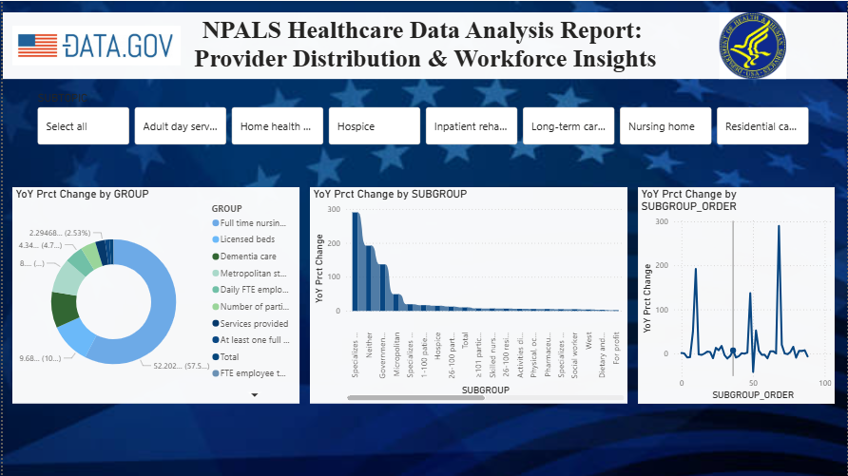
9. Insights & Conclusions: NPALS Post-Acute and Long-Term Care Analysis
Provider Distribution Analysis
- Residential care communities lead with 32,200 providers in 2022, followed by nursing homes (14,700) and home health agencies (11,500), indicating that community-based settings dominate provider count while institutional settings hold significantly larger per-facility capacity.
- Adult day services centers recorded the sharpest decline across all care types, dropping from 4,130 to 3,080 providers a 25.4% reduction between 2020 and 2022 reflecting the outsized disruption to congregate day programs during the post-pandemic period.
- Hospice providers grew 11.3% (5,200 to 5,790) and residential care communities grew 5.2% (30,600 to 32,200), indicating a structural shift in care preference toward home-based and community-level end-of-life and assisted living services.
- The South region consistently holds the largest provider share across most care types 54.6% of long-term care hospitals, 40.8% of home health agencies, and 35.9% of nursing homes while the Northeast maintains the smallest share across nearly all categories.
Workforce & Staffing Analysis
- Nursing homes employ the largest workforce at 470,400 employees in 2022, followed closely by residential care communities (455,900) and inpatient rehabilitation facilities (279,700), reflecting the high staffing demands of round-the-clock institutional care.
- Hospice workforce expanded from 90,500 to 108,400 employees a 19.8% increase consistent with its provider growth rate and indicating rising demand for end-of-life care services.
- Inpatient rehabilitation facilities and long-term care hospitals dedicate approximately 46% of their workforce to nursing and social work roles, nearly double the 25% share seen in adult day services and hospice, highlighting the higher clinical intensity of acute post-acute settings.
- Medicaid certification in adult day services grew from 72.1% to 74.4%, while Medicare certification remained completely flat at 41.8% across both survey years, indicating Medicaid as the dominant and growing funding pathway for community-based day programs.
Service Utilization Analysis
- Total adult day service participants declined from 294,000 to 239,100 (−18.7%), yet average participants per surviving facility increased from 71 to 78 revealing a consolidation effect where closures eliminated smaller, lower-volume centers and concentrated demand in larger programs.
- Nursing home daily average residents declined from 84 to 80 per facility, while residential care community daily average residents grew from 27 to 31 indicating a measurable shift in resident preference from large institutional settings toward smaller community-based residential environments.
- Home health agencies and hospice providers both saw per-facility patient volumes decline despite stable or growing provider counts 376 to 340 for home health (−9.6%) and 349 to 308 for hospice (−11.7%) pointing to possible market fragmentation, underutilization, or disrupted referral pipelines in the post-pandemic period.
- Inpatient rehabilitation facilities remained the most stable setting, with annual average patients nearly unchanged at 321 (2020) to 323 (2022), suggesting consistent and resilient demand for structured post-acute rehabilitation services.

Operational Efficiency Analysis
- Adult day services improved FTE efficiency from 0.46 to 0.48 hours per participant, indicating that surviving facilities deployed marginally more staff time per participant likely reflecting higher-acuity participants remaining in consolidated programs.
- Nursing home average bed count held steady at exactly 107 beds per facility across both years, and the 3% decline in total bed stock (1.63M to 1.58M) closely tracked the 3.9% facility closure rate confirming that closures were whole-facility shutdowns rather than capacity downsizing within continuing facilities.
- Residential care community total bed stock grew from 1.20 million to 1.31 million (+9.7%), driven by both new facility growth and a rise in average beds per facility from 39 to 41, signalling active capacity expansion in this segment.
- The YoY percentage change matrix reveals that no single care setting improved uniformly across all metrics gains in provider count or workforce were frequently offset by declines in per-facility utilization, underscoring the complexity of post-pandemic recovery across the long-term care sector.
Geographic & Access Analysis
- Metropolitan areas account for 89.1% of adult day services providers in 2022, up from 86.2% in 2020, while the rural share shrank from 4.4% to 3.9% indicating a widening urban concentration that raises equity concerns for rural populations dependent on community-based care.
- The West region overtook the South in hospice provider concentration, growing from 36.1% to 40.3% between 2020 and 2022, representing the most notable regional redistribution observed across any care type in the dataset.

10. Conclusion
- The NPALS Post-Acute and Long-Term Care Analysis (2020–2022) reveals a sector in active structural transition marked by the contraction of congregate and institutional care settings, the expansion of community-based and hospice services, and an uneven post-pandemic recovery across provider types.
- The analysis delivers clear, evidence-based insights into provider availability, workforce composition, service utilization, and operational efficiency across all seven care settings using key DAX measures and interactive Power BI visuals.
- Geographic findings highlight a persistent and widening urban-rural access gap, with metropolitan concentration increasing across most care types a critical signal for healthcare policy, resource allocation, and long-term care planning in underserved regions.
- These findings support data-driven decision-making for healthcare administrators, policy analysts, and public health researchers, and establish a replicable analytical framework for tracking long-term care sector performance across future NPALS survey cycles.

