**A**

**a**

**Identification of unknown bacteria by looking at its biochemical and phenotypical properties**

Muhamad Haries Ramdhani[1]

*1Department of Molecular Biology and Genetics, Gebze Technical University, Turkey*

Identification of unknown bacteria by looking at its biochemical and phenotypical properties have been around for centuries. Here I present the scientific report of the identification of our unknown bacteria (named X bacteria) by looking at its biochemical and phenotypical properties data gathered by a sequence of experiments that had been performed this whole semester in the MBG374 Lab. It is found that there is a high probability that the bacteria comes from the *Lactococcus* genus, specifically *Lactococcus lactis* because it has a 95.5% similarity to our unknown bacteria and the fact that it was used in one of the labs in the university before strengthens the hypothesis that our unknown bacteria is *Lactococcus lactis*.

**INTRODUCTION**

Bacteria are single-celled microorganisms, it's so tiny that it can only be seen by the help of microscope. Bacteria are classified and identified to distinguish one organism from another and to group similar organisms by criteria of interest to microbiologists or other scientists. The most important level of this type of classification is the species level [1]. As it was mentioned before bacteria are so tiny that even though it can be seen from microscope to understand about the bacteria better, other methods need to be performed. Using methods like microscopical, medical, serological and biochemical methods to classify bacteria are called bacterial identification.

Bacterial identification is necessary because of several things. Bacterial identification allows us to identify the disease, select suitable drugs, evaluate the treatment progress of a patient and for other industrial purposes. Unlike the other microorganisms, bacteria are easily traceable by simple staining methods and most of them are easy to be grown in different agar plates.

Since the beginning of the semester several identification methods were used to identify our bacteria of interest (called 'X' bacteria). To identify the shape and structure of the bacteria Gram[2], endospore[3], capsule[4] staining were performed. Several different agars/media were also used to identify the biochemical activity if the bacteria among these there were MSA [5], MacConkey Agar[6], Endo Agar[7], SS Agar[8] and Blood Agar[9]. Bacteria were also identified by the existence of the enzymes in their cell (biochemical activties), several tests were performed for this purpose among them there were oxidase[10], gelatinase[11], urease[12], nitrate reductase[13], decarboxylases[14], and amylase. In advance, sugar hydrolysis test[15] and IMViC test[15] were also performed to identify our X bacteria further.

**MATERIAL AND METHODS**

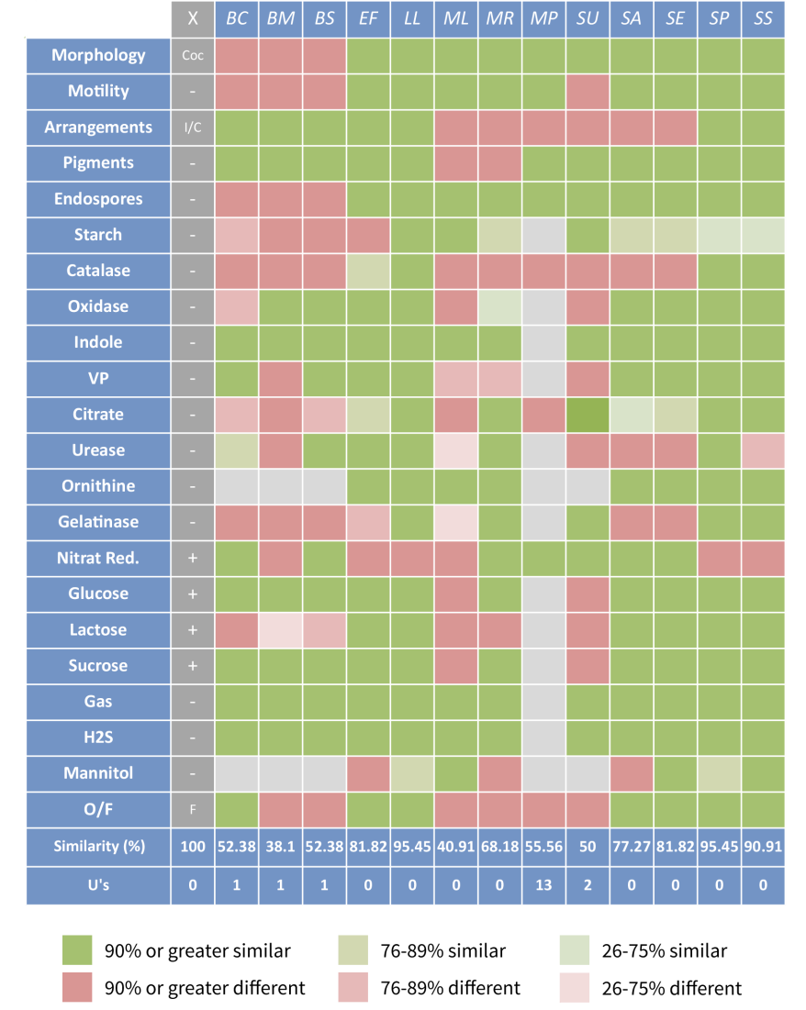During the spring semester all of the tests mentioned in the introduction part were performed. At the end of the semester the data of our X bacteria are collected. To identify the bacteria itself several classification methods were performed. The first method was to manually identify the bacteria using the table given by the lab. İnstructors, the other methods that were used were auto-classification/auto-identify methods found online (namely: bacteriaIdentifier etc.)

**a**

**Figure 1** Analysis of similarity of our unknown bacteria to 13 other Gram-positive bacteria using the Gram-positive bacteria identification table.The Gram-positive bacteria that were compared to our unknown bacteria are *Bacillus cereus* (BC), *Bacillus megaterium* (BM), *Bacillus subtilis* (BS), *Enterococcus faecalis* (EF), *Lactococcus lactis* (LL), *Micrococcus luteus* (ML), *Micrococcus roseus* (MR*), Mycobacterium phlei* (MP), *Sporosarcina ureae* (SU), *Staphylococcus aureus* (SA), *Staphylococcus epidermidis* (SE), *Streptococcus pyogenes* (SP), and *Streptococcus salivarius* (SS). (**a**) heatmap showing the similarity of the bacteria to our unknown bacteria. (**b**) Percentage of the similarity of the bacteria to our unknown bacteria. (**c**) The probability (%) of the bacteria are our X bacteria and the genus where they belong to.

**RESULTS AND DISCUSSION**

**Test results**

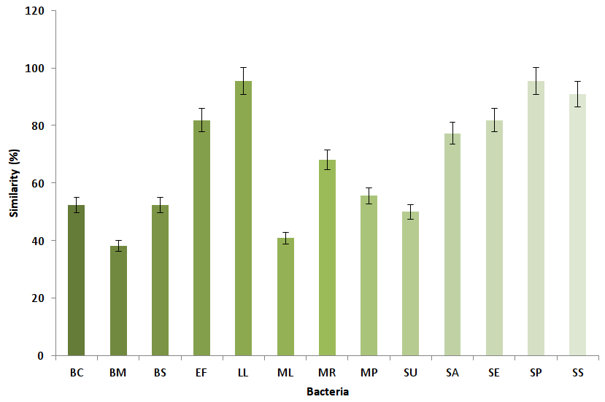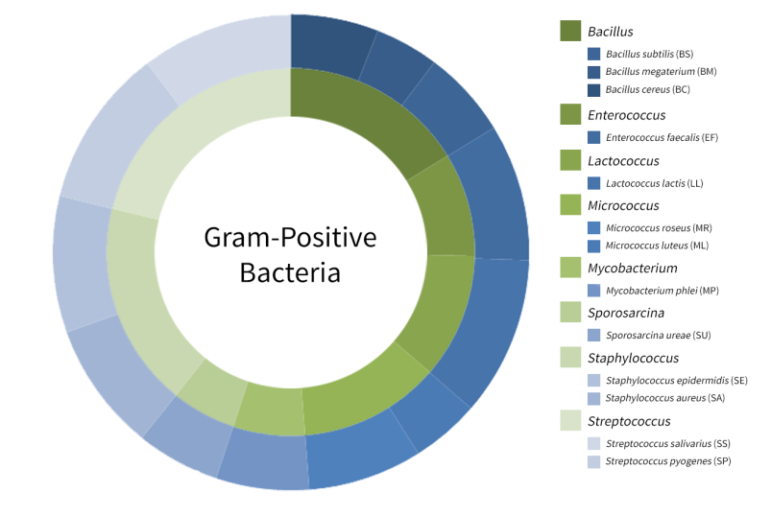**Gram staining**; this method was performed to observe the shape and the cell wall structure of the bacteria. Using this method we identified that our unknown bacteria are possessing a coccus shape (clustered/irregular) and is Gram-positive because it appeared purple at the end of the test.

**c**

**b**

**Endospore staining**; this method was performed to observe the existence of spore/endospore in the bacteria. Using this method we identified that our unknown bacteria don't have any spore/endospore because no endospores/spores were seen under the microscope.

**Capsule staining**; this method was performed to observe whether our unknown bacteria possess capsule or not. Using this method we identified that our unknown bacteria don't posses any capsule.

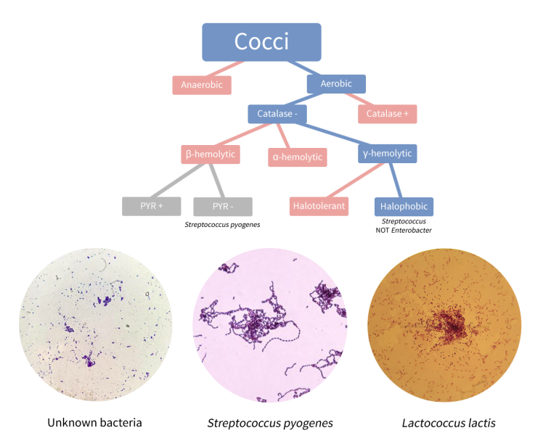**Hemolysis test (Blood Agar)**; this test was performed to observe the hemolytic activity of the bacteria. Using this test we identified that our unknown bacteria are γ-hemolytic bacteria because it doesn't have the ability to lyse the blood in the media (show no hemolytic activity).

**b**

**a**

**MSA (Mannitol Salt Agar) test**; this test was performed to understand whether our unknown bacteria are able to ferment mannitol or not and able to survive in high-level of salt or not. Using this test we identified that our unknown bacteria are unable to ferment the mannitol found in the media and also unable to resist the high-level of salt in the media, because no color change and no growth were observed in the media during the process.

**MacConkey Agar test**; this test was performed to understand whether our unknown bacteria are Gram-positive or Gram-negative because of the crystal violet and bile salts found in the media restrict the growth of Gram-positive bacteria so if there is no growth it tells us that the bacteria are Gram-positive. Using this test we identified that our unknown bacteria are Gram-positive bacteria because it was unable to grow and flourish in the media.

**Endo Agar test**; this test was performed to understand whether our unknown bacteria are Gram-positive or Gram-negative because of the basic fuchsin and anhydrous sodium sulfate found in the media restrict the growth of Gram positive bacteria so if there is no growth it tells us that the bacteria are Gram-negative. Using this test we identified that our unknown bacteria are Gram-positive bacteria because it was unable to grow and flourish in the media.

**SS Agar test**; this test was performed to understand whether our unknown bacteria are Gram-positive or Gram-negative because of the bile salts, sodium citrate and brilliant green found in the media restrict the growth of Gram-positive bacteria so if there is no growth it tells us that the bacteria are Gram-negative. Using this test we identified that our unknown bacteria are Gram-positive bacteria because it was unable to grow and flourish in the media.

**Carbohydrate utilization test**; this test was performed to understand whether our unknown bacteria can utilize different type of sugars (lactose, glucose and sucrose) or not. Using this test we identified that our unknown bacteria can utilize glucose, glucose and sucrose because all of the media where the bacteria are found turned yellow, which suggested that the bacteria can ferment the sugars thus the media acidified.

**Amylase (starch hydrolysis) test**; this test was performed to observe the amylase activity of our unknown bacteria. Using this test we identified that our unknown bacteria didn't have the amylase enzyme and didn't show the amylase activity because after pouring the 10% Lugol the area near colony still stayed dark-blue which means the bacteria can not hydrolyze the starch.

**TSI Agar test**; same as the carbohydrate utilization test, this test was performed to understand whether our unknown bacteria can utilize different type of sugars (lactose, glucose and sucrose) or not, as an extra this test was also used to observe whether gas and H2S were produced or not during fermentation of the sugar. Using this test we identified that our unknown bacteria can utilize sugar because the tube appeared to be A/A Gas which means that fermentation occurred in the tube.

**Gelatinase test**; this test was performed to observe the gelatinase activity of our unknown bacteria. Using this test we identified that our unknown bacteria are gelatinase negative because it couldn't hydrolyze the gelatin found in the medium (the medium stay solid after incubation)

**Urease test**; this test was performed to observe the urease activity of our unknown bacteria. Using this test we identified that our unknown bacteria are urease negative because the medium where it is found turned yellow even after incubation which means that it cannot hydrolyze the urea found in the medium.

**Nitrate reductase (nitrate reduction) test**; this test was performed to observe the nitrate reductase activity of our unknown bacteria. Using this test we identified that our unknown bacteria are nitrate reductase negative because after incubation no gas was observed in the Durham tube. After the addition Nitrate I (Sulphanilic acid) and Nitrate II (N,N-Dimethyl-1-napthylamine) no color change was observed and even after the addition of zinc (Zn2+) to the solution the color of the solution turned red which means that the bacteria cannot reduce the nitrate thus it is a nitrate reductase negative bacteria.

**Decarboxylase test**; this test was performed to observe the activity of different decarboxylases found in our unknown bacteria, namely lysine decarboxylase, arginine decarboxylase and ornithine decarboxylase. Using this test we identified that our unknown bacteria has only arginine decarboxylase but not lysine and ornithine decarboxylases, because only the tube where arginine was found turned purple.

**Catalase test**; this test was performed to observe the catalase activity of our unknown bacteria. Using this test we identified that our unknown bacteria are catalase negative because after the addition of 3% hydrogen peroxide to media no bubbles formed.

**Oxidase test**; this test was performed to observe the oxidase activity of our unknown bacteria. Using this test we identified that our unknown bacteria are oxidase negative because after the addition of oxidase reagent [N'-N'-N'-N'- tetramethyl *p*-phenyldiamine (1% w/v)] no color change was observed.

**Thioglycollate test**; this test was performed to identify our unknown bacteria by its use of oxygen. Using this test we identified that out unknown bacteria was facultative anaerobes because it appeared to spread all over the tube where it was found.

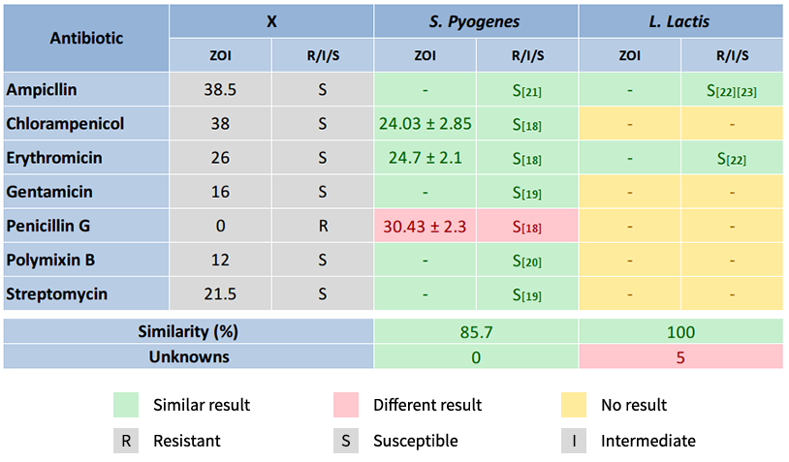**Indole (I in IMViC) test**; this test was performed to observe whether our unknown bacteria can convert tryptophan to indole or not. As additions this test can also be used to identify the motility of the bacteria and H2S production. Using this test we identified that our bacteria are indole negative and are not motile.

**Methyl red (M in IMViC) test**; this test was performed to distinguish bacteria regarding their glucose metabolism. Using this test we identified that our unknown bacteria are MR positive bacteria because after the addition of methyl red to the tube the color turned red, this tells us that the bacteria can metabolize the glucose and produce formic acid or lactic acid.

**Voges-Proskauer (V in IMViC) test**; this test was performed to distinguish bacteria regarding their glucose metabolism. Using this test we identified that our unknown bacteria are VP negative bacteria.

**Citrate (C in IMViC) test**; this test was performed to observe the citrase activity of our unknown bacteria. Using this test we identified that our unknown bacteria

**Bacterial Identification using Gram-positive bacteria identification table**

To perform the calculation of the Gram-positive bacteria found in the table with our unknown bacteria, 1 point is given to those having similarity with our unknown bacteria (-, +, [] or d) and 0 point is given to those which counter the result of our unknown bacteria (no similarity). In order to visualize the similarity clearly colors are given to each cells. Green if they share the same characteristic (scored 1 point) and red if they don't share the same characteristic (scored 0 point), the color gets lighter as the percent similarity gets lower (d has lighter color compared to d). The result of this analysis showed that *Lactococcus lactis* appeared to be the bacteria with the highest similarity to our unknown bacteria together with *Streptococcus pyogenes* both sharing 95.5% similarity. *Streptococcus salivarius* appeared as the second most similar to unknown bacteria both having 81.82% similarity. *Staphylococcus aureus* came as third with 77.27% similarity, its possibility to be our unknown bacteria is very low because we also used *Staphylococcus aureus* most of the time as our control during the experiment in the lab.

Another surprising result is the fact that *Lactococcus lactis* and *Streptococcus pyogenes* do not onlypossess the same similarity but they also lost points in the same box/cell in the table, namely; nitrate reduction test. Our X bateria appeared to be nitrate reductase positive while on the table it was shown that both *Lactobacillus lactis* and Streptococcus pyogenes are nitrate reductase negative. Further research on looking at the hemolytic activity of both *Lactococcus lactis* and *Streptococcus pyogenes* gave us information that *Lactococcus lactis* weakly hemolyzes (α-hemolytic)[16] while *Streptococcus pyogenes* can completely hemolyzes (β-hemolytic)[17], both of these results contradict our hemolysis test because our unknown bacteria appeared to be non-hemolytic (γ-hemolytic) thus further study is needed.

Out of all the genuses, bacteria from the genus *Lactococcus* has the most similarity to our unknown bacteria. Followed by the genus *Streptococcus* and *Staphylococcus*. Bacteria from the genus *Bacillus* has the least similarity to our unknown bacteria.

**Bacterial identification using Gram-positive decision tree**

To identify the ‘real’ identity of our unknown bacteria further, decision tree test was performed (the decision tree was given by the laboratory instructor at the end of the semester). Using the decision tree it was found that our unknown bacteria come from the genus *Streptococcus* and not *Enterobacter*, this result was actually a little bit off because if we compare this result with the previous method (*Bacterial Identification using Gram-positive bacteria identification table*) both of the methods give different results. From this decision tree, we can also learn the fact that *Streptococcus pyogenes* are having β-hemolytic activity while our unknown bacteria do not have any hemolytic activity (α-hemolytic), this result lowers the possibility that our unknonwn bacteria is *Streptococcus pyogenes*. Another possible reason why this method gives different result is because of the fact that this method only includes a little amount of tests while the table method includes the number of tests five times more than the decision tree. The fact that *Lactobacillus lactis* was not in the decision tree can also cause this difference.

**Comparison of antibiotic susceptibility between unknown bacteria, *Streptococcus pyogenes* and *Lactobacillus lactis***

To compare the antibiotic susceptibility between our unknown bacteria, *Streptococcus pyogenes* and *Lactobacillus lactis* data curated from several sources were collected[18-23]. It was a bit easier to curate/find the data of antibiotic susceptibility of *Streptococcus pyogenes* (7 out of 7 data were collected) unfortunately it was hard to find and collect the data for *Lactobacillus lactis* (2 out of 7 data were collected), out of seven antibiotics only two of them were found. The result for *Streptococcus pyogenes* is showing 85.7% similarity (6 out of 7) with the difference only for Penicillin G antibiotic (see Table X). Out of the two data for *Lactobacillus lactis*  both are similar with our unknown bacteria. The possible reason that causes the difference between the Penicillin G for our unknown bacteria and *Streptococcus pyogenes* is probably because of the strain difference, thus further study needs to be conducted.

**CONCLUSION**

**ACKNOWLEDGEMENTS**

My labmates Çisel Dikkulak, Büşra Çelik and Merve Sarıtaş. Lab instructor for our group Özlem Akkaya and other İnstructors who have been so helpful during the semester Tuğrul Doruk, Mine Gül Şeker, Zeynep Girgin Ersoy and Zeynep Demir Öksüz.

**REFERENCES**

[1] Baron EJ. Classification. In: Baron S, editor. Medical Microbiology. 4th edition. Galveston (TX): University of Texas Medical Branch at Galveston; 1996. Chapter 3.

[2] Bartholomew JW, Mittwer T. THE GRAM STAIN. Bacteriological Reviews. 1952;16(1):1-29.

[3] Lechtman MD, Bartholomew JW, Phillips A, Russo M. Rapid Methods of Staining Bacterial Spores at Room Temperature. Journal of Bacteriology. 1965;89(3):848-854.

[4] Gray PHH. STAINING BACTERIAL CAPSULES. Journal of Bacteriology. 1943;45(3):301-302.

[5] Patricia Shields, Anne Y. Tsang. 2006. Mannitol salt agar plates protocols.

[6] Mossel DAA, Mengerink WHJ, Scholts HH. USE OF A MODIFIED MacCONKEY AGAR MEDIUM FOR THE SELECTIVE GROWTH AND ENUMERATION OF ENTEROBACTERIACEAE. Journal of Bacteriology. 1962;84(2):381.

[7] Elizabeth F. Genung and Lucy E. Thompson. COLOR DIFFUSION IN ENDO AGAR. J Bacteriol. August 1927 14:2 139-156.

[8] Leifson, E. 1935. New culture media based on sodium desoxycholate for the isolation of intestinal pathogens and for the enumeration of colon bacilli in milk and water. J. Pathol. and Bacteriol. 40:581-599.

[9] Buxton, R. Blood agar plates and hemolysis protocols. 2005.

[10] Steel, K.J. The Oxidase Reaction as a Taxonomic Tool. J. gen. MicroMol. (1961), 25, 297-806.

[11] Whaley DN, Dowell VR, Wanderlinder LM, Lombard GL. Gelatin agar medium for detecting gelatinase production by anaerobic bacteria. Journal of Clinical Microbiology. 1982;16(2):224-229.

[12] Kato et al. UREASE TEST. Nihon Rinsho 51 (12), 3192-3195. 12 1993.

[13] Conn HJ, Breed RS. The Use of the Nitrate-Reduction Test in Characterizing Bacteria. Journal of Bacteriology. 1919;4(3):267-290.

[14] Brooker DC, Lund ME, Blazevic DJ. Rapid Test for Lysine Decarboxylase Activity in Enterobacteriaceae. Applied Microbiology. 1973;26(4):622-623.

[15] Clarke, P. H. & Cowan, S. Biochemical Methods for Bacteriology. 2). J. gen. Microbiol; 1952. 6, 187-19.

[16] Goyache J, Vela AI, Gibello A, et al. Lactococcus lactis subsp. lactis infection in waterfowl: first confirmation in animals. Emerging Infectious Diseases. 2001;7(5):884-886.

[17] "Streptococcus pyogenes - Pathogen Safety Data Sheets". Government of Canada, Public Health Agency of Canada.

[18] Camara M, Dieng A, Boye CSB. Antibiotic Susceptibility of Streptococcus Pyogenes Isolated from Respiratory Tract Infections in Dakar, Senegal. Microbiology Insights. 2013;6:71-75. doi:10.4137/MBI.S12996.

[19] Cattoir V. Mechanisms of Antibiotic Resistance. 2016 Feb 10. In: Ferretti JJ, Stevens DL, Fischetti VA, editors. Streptococcus pyogenes : Basic Biology to Clinical Manifestations.

[20] Port GC, Vega LA, Nylander AB, Caparon MG. Streptococcus pyogenes Polymyxin B-Resistant Mutants Display Enhanced ExPortal Integrity. Journal of Bacteriology.

[21] Ikebe T, Hirasawa K, Suzuki R, et al. Antimicrobial Susceptibility Survey of Streptococcus pyogenes Isolated in Japan from Patients with Severe Invasive Group A Streptococcal Infections. Antimicrobial Agents and Chemotherapy. 2005;49(2):788-790. doi:10.1128/AAC.49.2.788-790.2005.

[22] Elliott JA, Facklam RR. Antimicrobial susceptibilities of Lactococcus lactis and Lactococcus garvieae and a proposed method to discriminate between them. Journal of Clinical Microbiology. 1996;34(5):1296-1298.

[23] DʼAimmo M.R., Modesto M., Biavati B. Antibiotic resistance of lactic acid bacteria and Bifidobacterium spp. isolated from dairy and pharmaceutical products. Int. J. Food Microbiol. 2007;115:35–42. doi: 10.1016/j.ijfoodmicro.2006.10.003.