# NAAN MUDHALVAN PROJECT

# INTELLIGENT CUSTOMER RETENTION USING MACHINE LEARNING FOR ENHANCED PREDICTION OF TELECOM CUSTOMER CHURN

## BACHELOR OF SCIENCE IN COMPUTER SCIENCE

**TO THE**

THIRUVALLUVAR UNIVERSITY,SERKKADU,VELLORE-632115

## BY

## S. BHARATHI --- 35620U18004

## G. HARI --- 35620U18009

## R. SUGUMAR --- 35620U18045

## L. VINOTH --- 35620U18051

## 



**APRIL-2023**

## GOVERNMENT ARTS AND SCIENCE COLLEGE, ARAKKONAM-631051

**(AFFILIATED TO THIRUVALLUVAR UNIVERSITY)**

## GUIDED AND HEAD OF DEPARTMENT

**Dr. S. Selvakani**

|  |  |
| --- | --- |
| S.NO | CONTENT |
| 1. | INTRODUCTION |
| 2. | MILESTONE 1: Define Problem /Problem Understanding  * Specify The Business Problem  * Business Requirements  * Literature Survey  * Social Or Business Impact |
| 3. | MILESTONE 2: Data Collection & Preparation  * Collect The Dataset  * Importing The Libraries  * Read The Dataset  * Data Preparation  * Handling Missing Values  * Handling Categorical Values  * Label Encoding  * Splitting The Dataset into Dependent and Independent Variable  * OneHot Encoding  * Handling Imbalance Data |
| 4. | MILESTONE 3: Exploratory Data Analysis  * Descriptive Statistical  * Visual Analysis  * Univariate Analysis  * Bivariate Analysis  * Multivariate Analysis  * Splitting Data into And Test  * Scaling The Data |
| 5. | MILESTONE 4: Model Building  * Training The Model in Multiple Algorithms  * Logistic Regression Model  * Decision Tree Model  * Random Forest Model  * KNN Model  * SVM Model  * ANN Model  * Testing The Model |

|  |  |
| --- | --- |
| 6. | MILESTONE 5: Performance Testing & Hyperparameter Tuning  * Testing Model with Multiple Evaluation Metrics  * Compare The Model  * Comparing Model Accuracy Before & After Applying Hyperparameter Tuning |
| 7. | MILESTONE 6: Model Deployment  * Save The Best Model  * Integrate With Web Framework  * Build Python Code  * Run The Web Application |
| 8. | MILESTONE 7: Project Demonstration & Documentation  *Record Explanation Video for Project End to End Solution  *Project Documentation-Step by Step Project Development Procedure |

INTRODUCTION

Customer churn is often referred to as customer attrition, or customer defection which is the rate at which the customers are lost. Customer churn is a major problem and one of the most important concerns for large companies. Due to the direct effect on the revenues of the companies, especially in the telecom field, companies are seeking to develop means to predict potential customer to churn. Looking at churn, different reasons trigger customers to terminate their contracts, for example better price offers, more interesting packages, bad service experiences or change of customers’ personal situations.

Customer churn has become highly important for companies because of increasing competition among companies, increased importance of marketing strategies and conscious behaviour of customers in the recent years. Customers can easily trend toward alternative services. Companies must develop various strategies to prevent these possible trends, depending on the services they provide. During the estimation of possible churns, data from the previous churns might be used. An efficient churn predictive model benefits companies in many ways. Early identification of customers likely to leave may help to build cost effective ways in marketing strategies. Customer retention campaigns might be limited to selected customers but it should cover most of the customer. Incorrect predictions could result in a company losing profits because of the discounts offered to continuous subscribers.

Telecommunication industry always suffers from a very high churn rates when one industry offers a better plan than the previous there is a high possibility of the customer churning from the present due to a better plan in such a scenario it is very difficult to avoid losses but through prediction we can keep it to a minimal level.

Telecom companies often use customer churn as a key business metrics to predict the number of customers that will leave a telecom service provider. A machine learning model can be used to identity the probable churn customers and then makes the necessary business decisions.

# Milestone 1: Define Problem / Problem Understanding

## Activity 1: Specify the business problem

Refer Project Description

## Activity 2: Business requirements

The business requirements for a machine learning model to predict whether the customer will churn or not on customer information, to minimise the number of false positives (customer that predicted as loyal but churn) and false negatives (customer predicted to be churn which could have stayed loyal). Provide an explanation for the model's decision, for better decision making in order to gain more profitability.

## Activity 3: Literature Survey (Student Will Write)

As the data is increasing daily due to digitization in the banking sector, people want to apply for loans through the internet. Machine Learning (ML), as a typical method for information investigation, has gotten more consideration increasingly. Individuals of various businesses are utilising ML calculations to take care of the issues dependent on their industry information. Telecom companies often use customer churn as a key business metrics to

predict the number of customers that will leave a telecom service provider. A machine learning model can be used to identity the probable churn customers and then makes the necessary business decisions.

## Activity 4: Social or Business Impact.

Social Impact:- Proposed model can help improve the overall customer experience and service quality. Companies can also make better decisions about how to retain their customers.

Business Model/ Impact :- This product can generate revenue using a product based model, where the system can be sold as a product to the telecom companies. This product can also be used for subscription based model.

# Milestone 2: Data Collection & Preparation

ML depends heavily on data. It is the most crucial aspect that makes algorithm training possible. So this section allows you to download the required dataset.

## Activity 1: Collect the dataset

There are many popular open sources for collecting the data. Eg: kaggle.com, UCI repository, etc.

In this project we have used .csv data. This data is downloaded from kaggle.com. Please refer to the link given below to download the dataset.

Link: <https://www.kaggle.com/shrutimechlearn/churn-modelling>

As the dataset is downloaded. Let us read and understand the data properly with the help of some visualisation techniques and some analysing techniques.

**Note:** There are a number of techniques for understanding the data. But here we have used some of it. In an additional way, you can use multiple techniques.

## Activity 1.1: Importing the libraries

Import the necessary libraries as shown in the image.

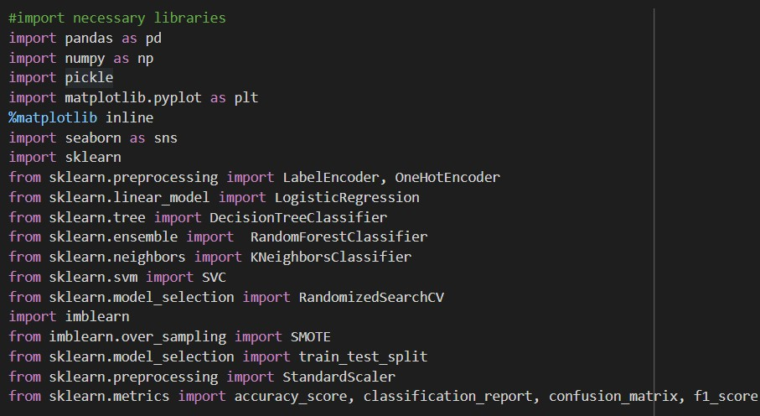

## Activity 1.2: Read the Dataset

Our dataset format might be in .csv, excel files, .txt, .json, etc. We can read the dataset with the help of pandas.

In pandas we have a function called read_csv() to read the dataset. As a parameter we have to give the directory of the csv file.

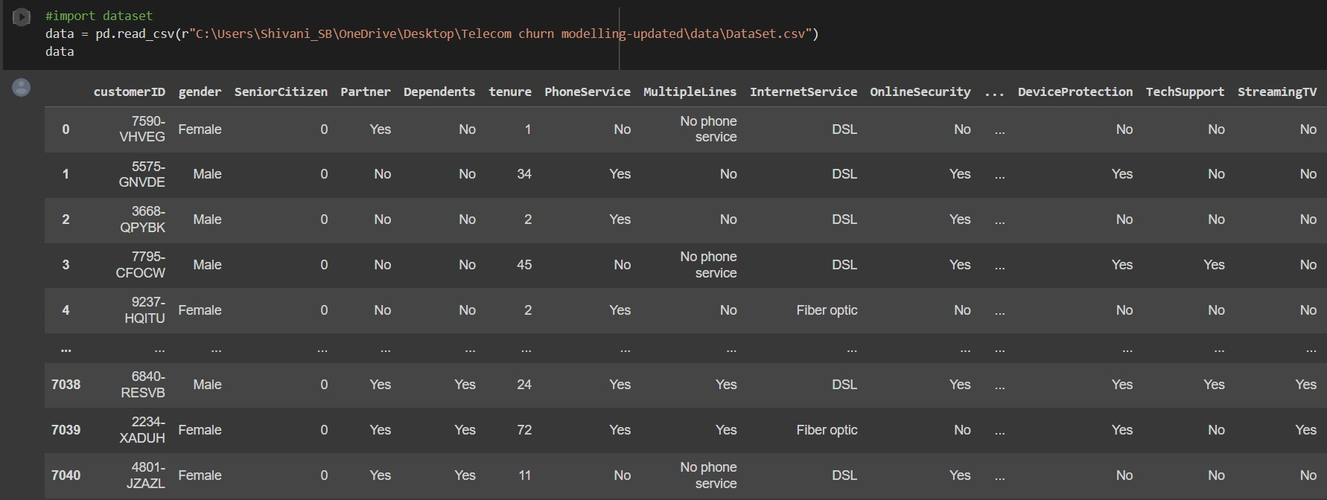

## Activity 2: Data Preparation

As we have understood how the data is, let's pre-process the collected data.

The download data set is not suitable for training the machine learning model as it might have so much randomness so we need to clean the dataset properly in order to fetch good results. This activity includes the following steps.

* + Handling missing values
  + Handling categorical data
  + Handling Imbalance Data

Note: These are the general steps of pre-processing the data before using it for machine learning. Depending on the condition of your dataset, you may or may not have to go through all these steps.

## Activity 2.1: Handling missing values

* + 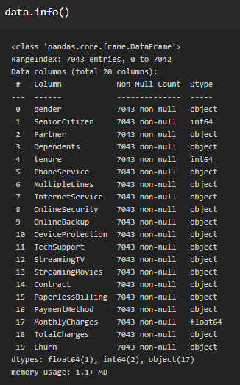Let’s find the shape of our dataset first. To find the shape of our data, the df.shape method is used. To find the data type, df.info() function is used.
    - For checking the null values, df.isnull() function is used. To sum those null values we use .sum() function. From the below image we found that there are no null values present in our dataset. So we can skip handling the missing values step.

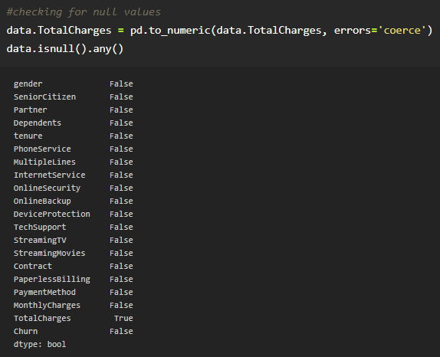

* + - 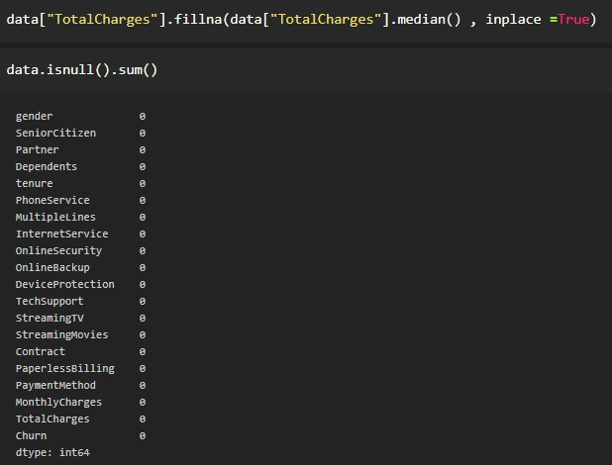From the above code of analysis, we can infer that column TotalCharges is having the missing values, we need to treat them in a required way.
    - We will fill in the missing values in the TotalCharges column by median as it’s a numercal column and then again we checked for null values to see if there is any null value left.

## Activity 2.2: Handling Categorical Values

As we can see our dataset has categorical data we must convert the categorical data to integer encoding or binary encoding.

To convert the categorical features into numerical features we use encoding techniques. There are several techniques but in our project we are using manual encoding with the help of list comprehension.

### Label Encoding.

Label Encoding refers to converting the labels into numeric form so as to convert it into the machine-readable form. Machine learning algorithms can then decide in a better way on how those labels must be operated. It is an important pre-processing step for the structured dataset in supervised learning.

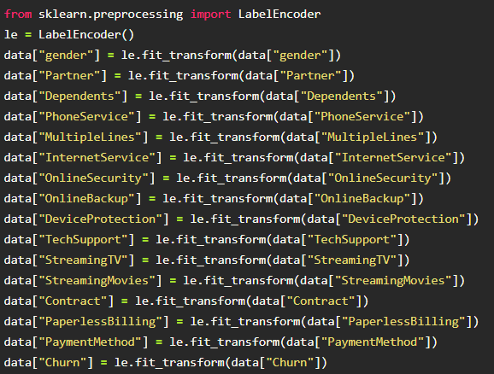

Data after label encoding

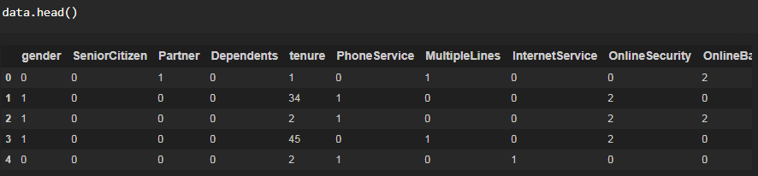All the data is converted into numerical values.

### Splitting the Dataset into Dependent and Independent variable

Let’s split our dataset into independent and dependent variables.

1. The independent variable in the dataset would be considered as 'x' and gender,SeniorCitizen,Partner,Dependents,tenure,PhoneService,MultipleLines,Inte rnetService,OnlineSecurity,OnlineBackup,DeviceProtection,TechSupport,Streamin gTV,StreamingMovies,Contract,PaperlessBilling,PaymentMethod,MonthlyCharges

,TotalCharges columns would be considered as independent variable.

1. The dependent variable in the dataset would be considered as 'y' and the 'Churn' column is considered as dependent variable.

Now we will split the data of independent variables,

From the above code **“:”** indicates that you are considering all the rows in the dataset and **“0:18”** indicates that you are considering columns 0 to 8 such as sex, job and purpose as input values and assigning them to variable x. In the same way in second line **“:”** indicates you are considering all the rows and **“18:19”** indicates that you are considering only last column as output value and assigning them to variable y.

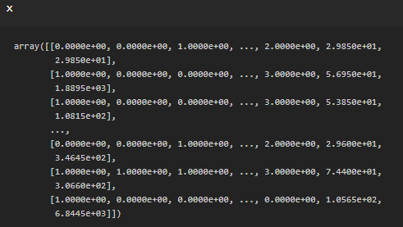After splitting we see the data as below x

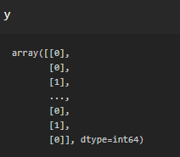Y

### OneHot Encoding

Sometimes in datasets, we encounter columns that contain numbers of no specific order of preference. The data in the column usually denotes a category or value of the category and also when the data in the column is label encoded. This confuses the machine learning model, to avoid this, the data in the column should be One Hot encoded.

One Hot Encoding –

It refers to splitting the column which contains numerical categorical data to many columns depending on the number of categories present in that column. Each column contains “0” or “1” corresponding to which column it has been placed.

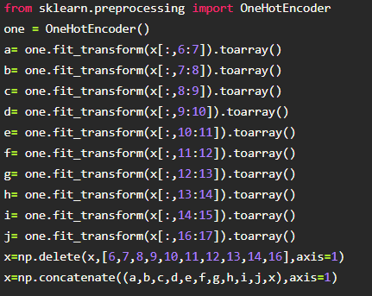

## Activity 2.3: Handling Imbalance Data

Data Balancing is one of the most important step, which need to be performed for classification models, because when we train our model on imbalanced dataset ,we will get biassed results, which means our model is able to predict only one class element

For Balancing the data we are using the SMOTE Method.

SMOTE: Synthetic minority over sampling technique, which will create new synthetic data points for under class as per the requirements given by us using KNN method.

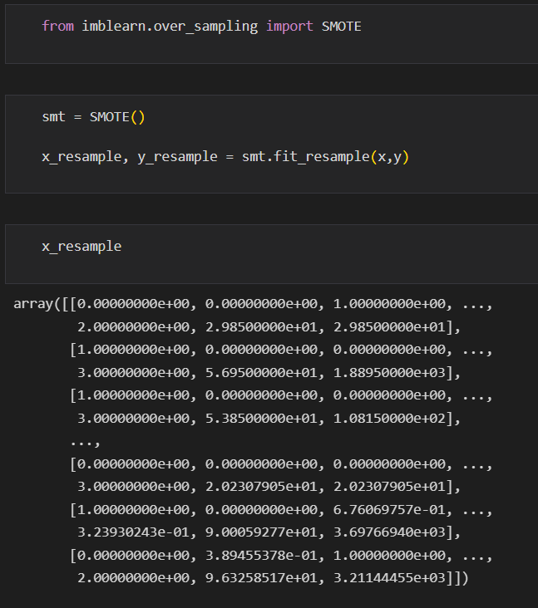

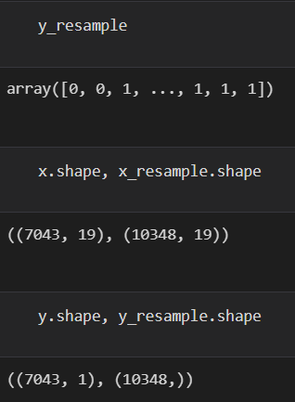

From the above picture, we can infer that ,previously our dataset had 492 class 1, and 192 class items, after applying smote technique on the dataset the size has been changed for minority class.

# Milestone 3: Exploratory Data Analysis

## Activity 1: Descriptive statistical

Descriptive analysis is to study the basic features of data with the statistical process. Here pandas has a worthy function called describe. With this describe function we can understand the unique, top and frequent values of categorical features. And we can find mean, std, min, max and percentile values of continuous features.

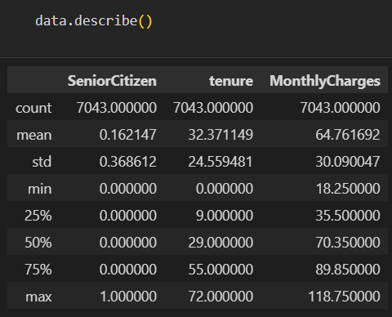

## Activity 2: Visual analysis

Visual analysis is the process of using visual representations, such as charts, plots, and graphs, to explore and understand data. It is a way to quickly identify patterns, trends, and outliers in the data, which can help to gain insights and make informed decisions.

## Activity 2.1: Univariate analysis

In simple words, univariate analysis is understanding the data with a single feature. Here we have displayed two different graphs such as distplot and countplot.

* The Seaborn package provides a wonderful function distplot. With the help of distplot, we can find the distribution of the feature. To make multiple graphs in a single plot, we use subplot.

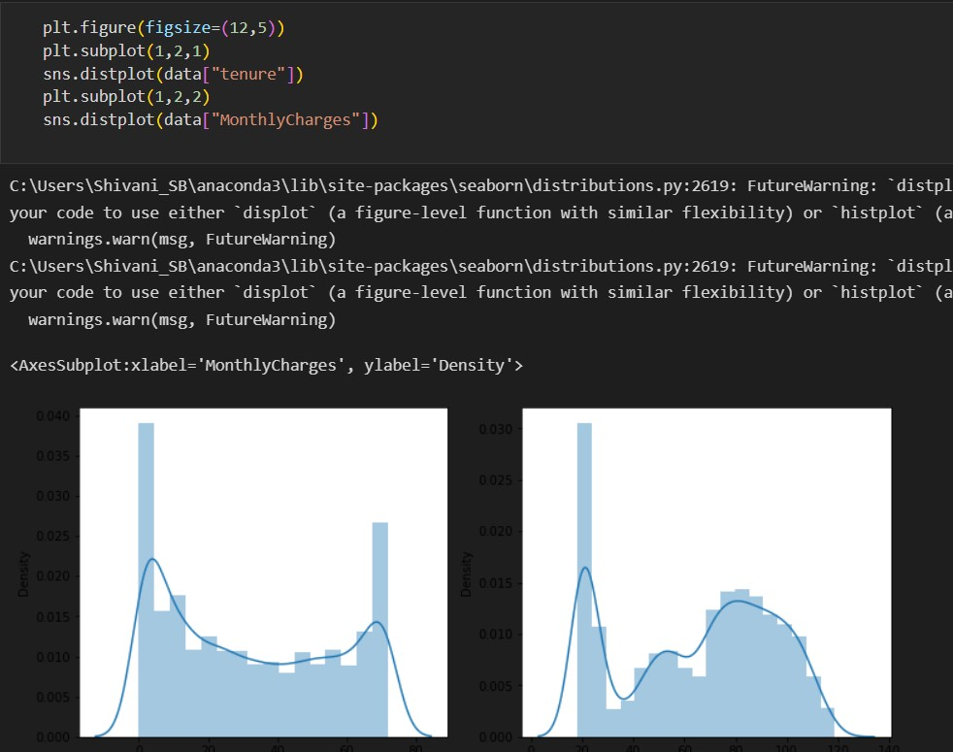

* In our dataset we have some categorical features. With the count plot function, we are going to count the unique category in those features. We have created a dummy data frame with categorical features. With for loop and subplot we have plotted this below graph.
* From the plot we came to know, Applicants income is skewed towards left side, where as credit history is categorical with 1.0 and 0.0

#### Countplot :-

A count plot can be thought of as a histogram across a categorical, instead of quantitative, variable. The basic API and options are identical to those for barplot() , so you can compare counts across nested variables.

From the graph we can infer that , gender and education is a categorical variables with 2 categories , from gender column we can infer that 0-category is having more weightage than category-1,while education with 0,it means no education is a underclass when compared with category -1, which means educated .

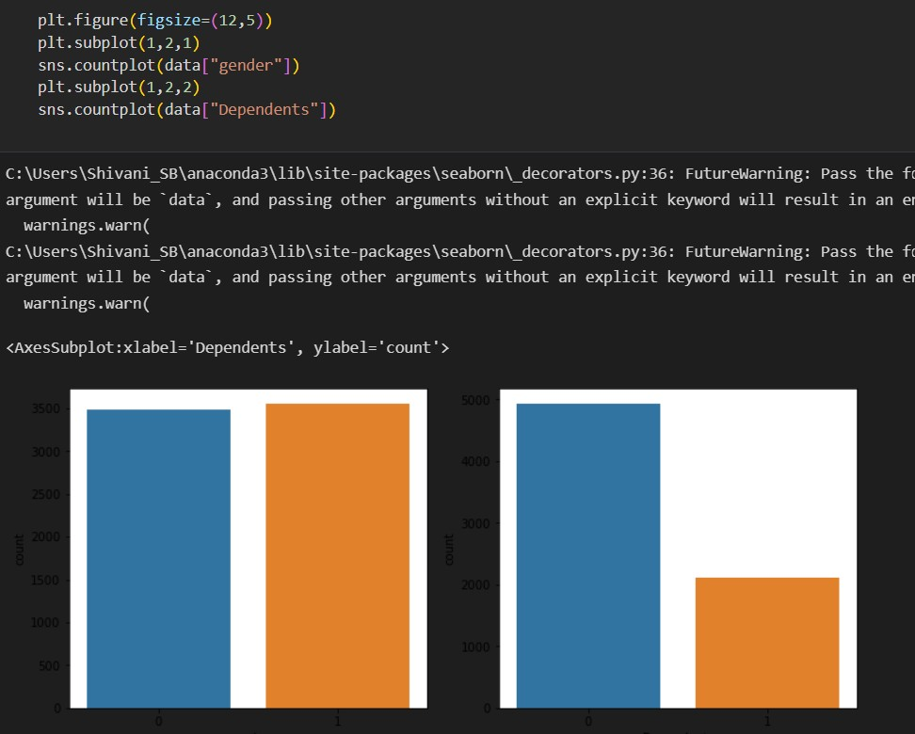

## Activity 2.2: Bivariate analysis

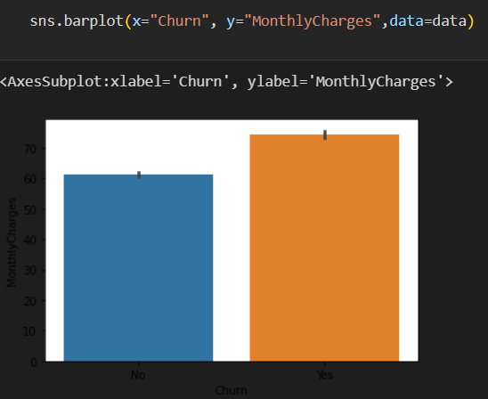

From the above graph we can infer the analysis such as

* Segmenting the gender column and married column based on bar graphs
* Segmenting the Education and Self-employed based on bar graphs ,for drawing insights such as educated people are employed.
* Loan amount term based on the property area of a person holding

## Activity 2.3: Multivariate analysis

In simple words, multivariate analysis is to find the relation between multiple features. Here we have used a swarm plot from the seaborn package.

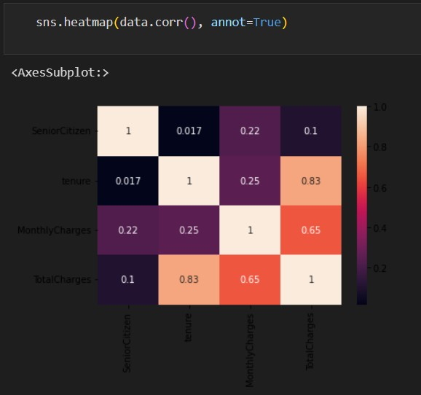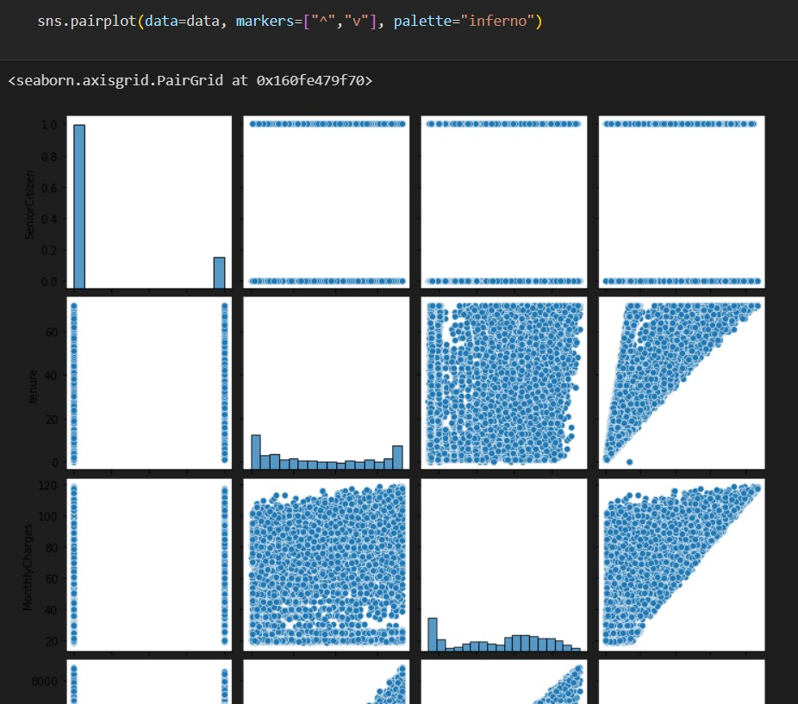

From the above graph we are plotting the relationship between the Gender, applicants income and loan status of the person.

Now, the code would be normalising the data by scaling it to have a similar range of values, and then splitting that data into a training set and a test set for training the model and testing its performance, respectively.

#### Splitting data into train and test

Now let’s split the Dataset into train and test sets

Changes: first split the dataset into x and y and then split the data set

Here x and y variables are created. On x variable, df is passed with dropping the target variable. And on y target variable is passed. For splitting training and testing data we are using the train_test_split() function from sklearn. As parameters, we are passing x, y, test_size, random_state.



#### Scaling the Data

Scaling is one the important process, we have to perform on the dataset, because of data measures in different ranges can leads to mislead in prediction

Models such as KNN, Logistic regression need scaled data, as they follow distance based method and Gradient Descent concept.

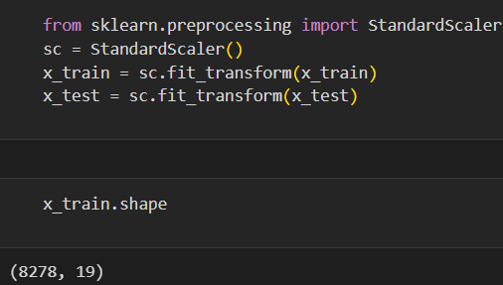

We will perform scaling only on the input values.Once the dataset is scaled, it will be converted into an array and we need to convert it back to a dataframe.

# Milestone 4: Model Building

## Activity 1: Training the model in multiple algorithms

Now our data is cleaned and it’s time to build the model. We can train our data on different algorithms. For this project we are applying four classification algorithms. The best model is saved based on its performance.

## Activity 1.2: Logistic Regression Model

Logistic regression estimates the probability of an event occurring, such as voted or didn’t vote, based on a given dataset of independent variables. Since the outcome is a probability, the dependent variable is bounded between 0 and 1. In logistic regression, a

logit transformation is applied on the odds—that is, the probability of success divided by the probability of failure.

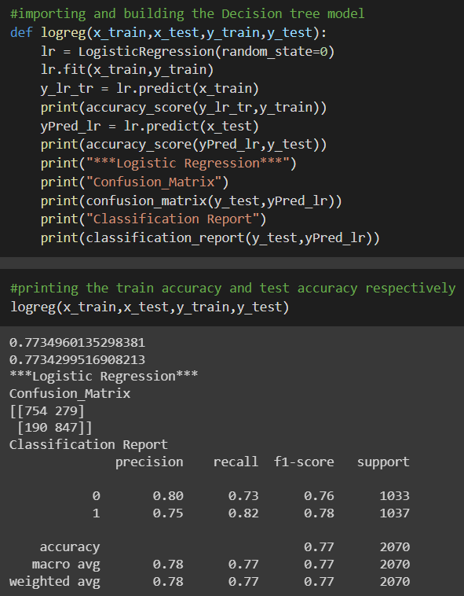

## Activity 1.2: Decision tree model

A function named decisionTree is created and train and test data are passed as the parameters. Inside the function, DecisionTreeClassifier algorithm is initialised and training data is passed to the model with the .fit() function. Test data is predicted with .predict() function and saved in a new variable. For evaluating the model, a confusion matrix and classification report is done.

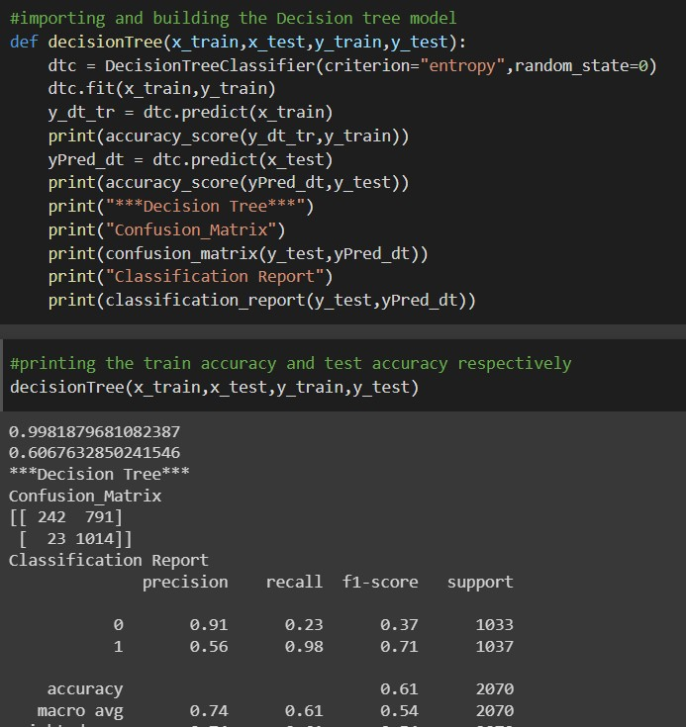

## Activity 1.3: Random forest model

A function named randomForest is created and train and test data are passed as the parameters. Inside the function, RandomForestClassifier algorithm is initialised and training data is passed to the model with .fit() function. Test data is predicted with .predict() function and saved in a new variable. For evaluating the model, a confusion matrix and classification report is done.

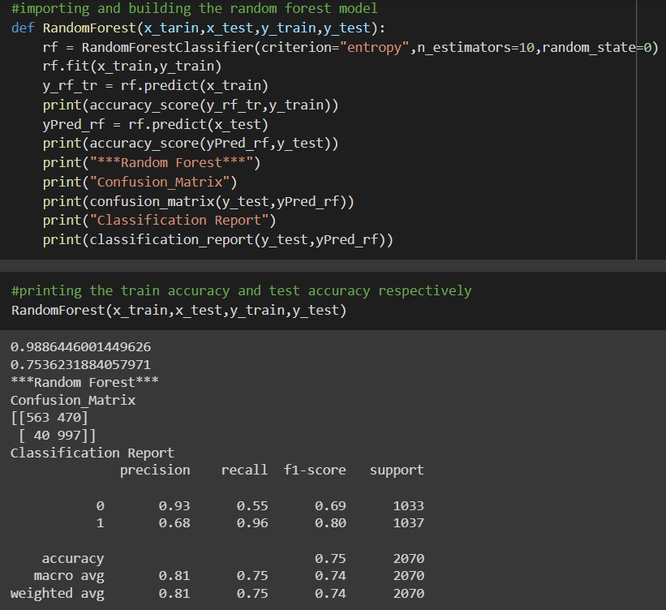

## Activity 1.3: KNN model

A function named KNN is created and train and test data are passed as the parameters. Inside the function, KNeighborsClassifier algorithm is initialised and training data is passed to the model with .fit() function. Test data is predicted with .predict() function and saved in new variable. For evaluating the model, confusion matrix and classification report is done.

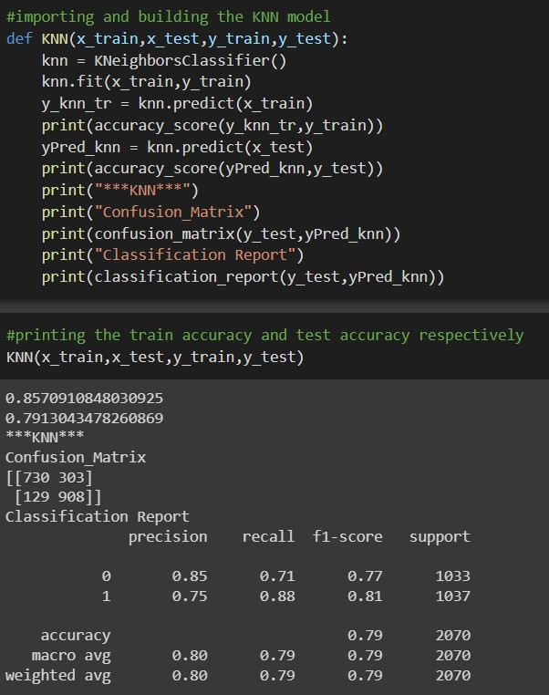

## Activity 1.4: SVM model

“Support Vector Machine” (SVM) is a supervised machine learning algorithm that can be used for both classification or regression challenges. However, it is mostly used in classification problems. In the SVM algorithm, we plot each data item as a point in n-dimensional space (where n is a number of features you have) with the value of each feature being the value of a particular coordinate.

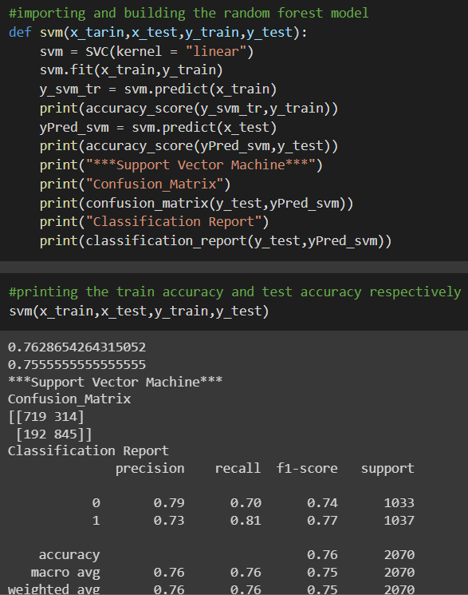

## Activity 1.5: ANN model

Building and training an Artificial Neural Network (ANN) using the Keras library with TensorFlow as the backend. The ANN is initialised as an instance of the Sequential class, which is a linear stack of layers. Then, the input layer and two hidden layers are added to the model using the Dense class, where the number of units and activation function are specified. The output layer is also added using the Dense class with a sigmoid activation function. The model is then compiled with the Adam optimizer, binary cross-entropy loss function, and accuracy metric. Finally, the model is fit to the training data with a batch size of 100, 20% validation split, and 100 epochs.

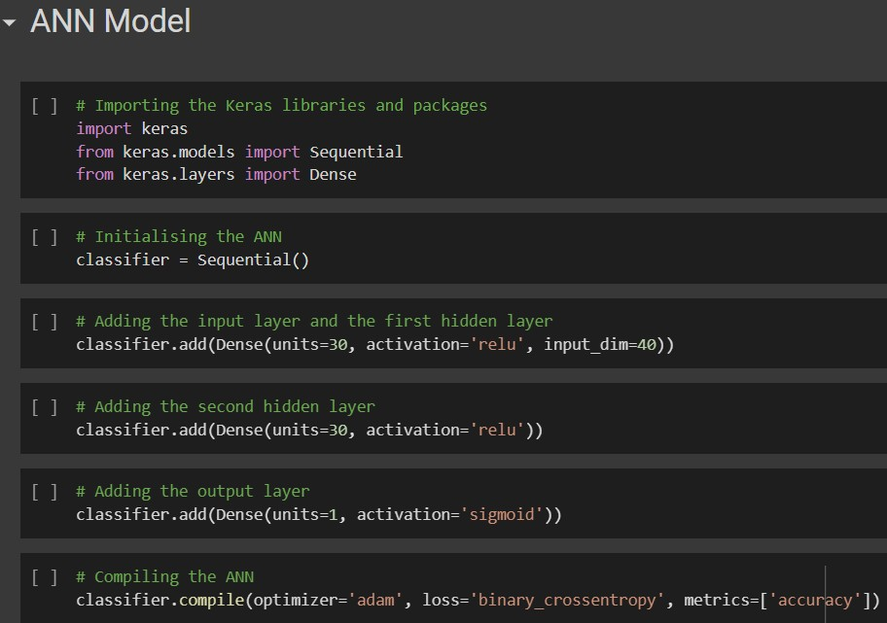

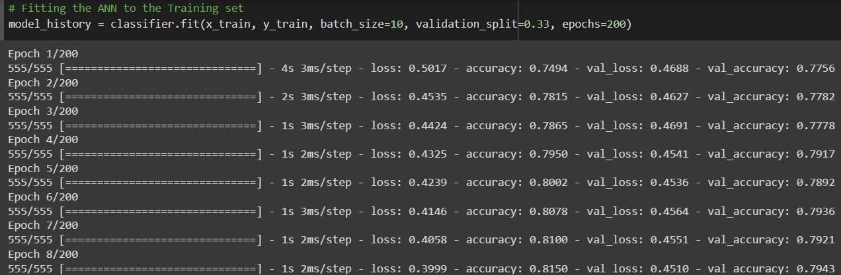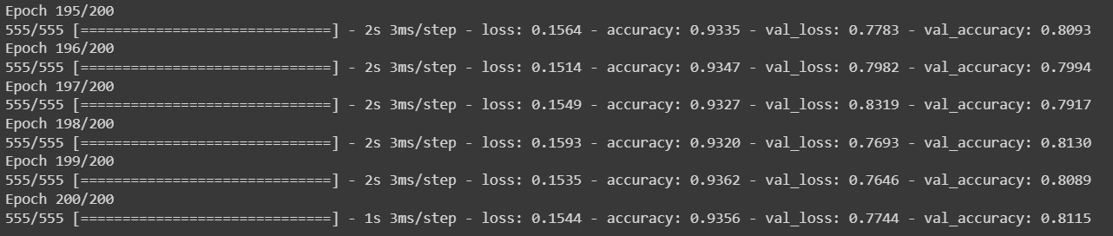

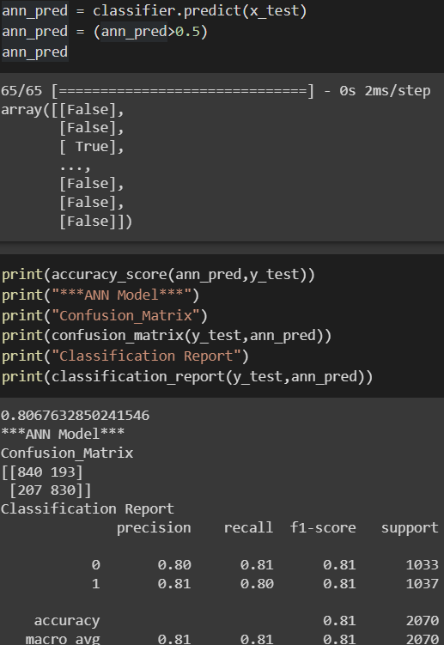

## Activity 2: Testing the model

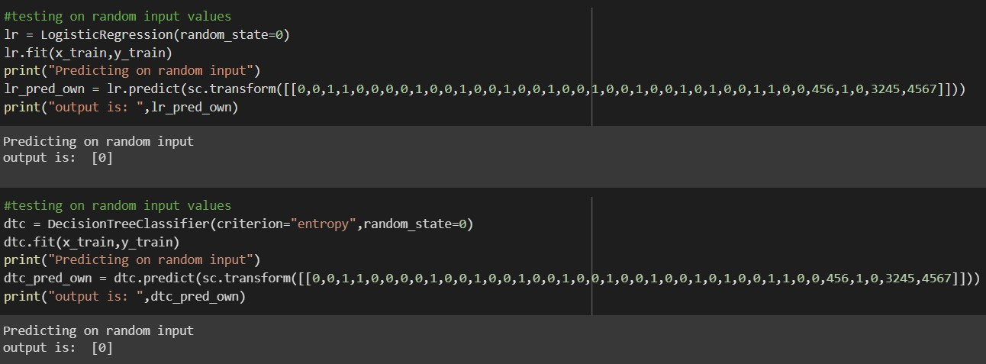

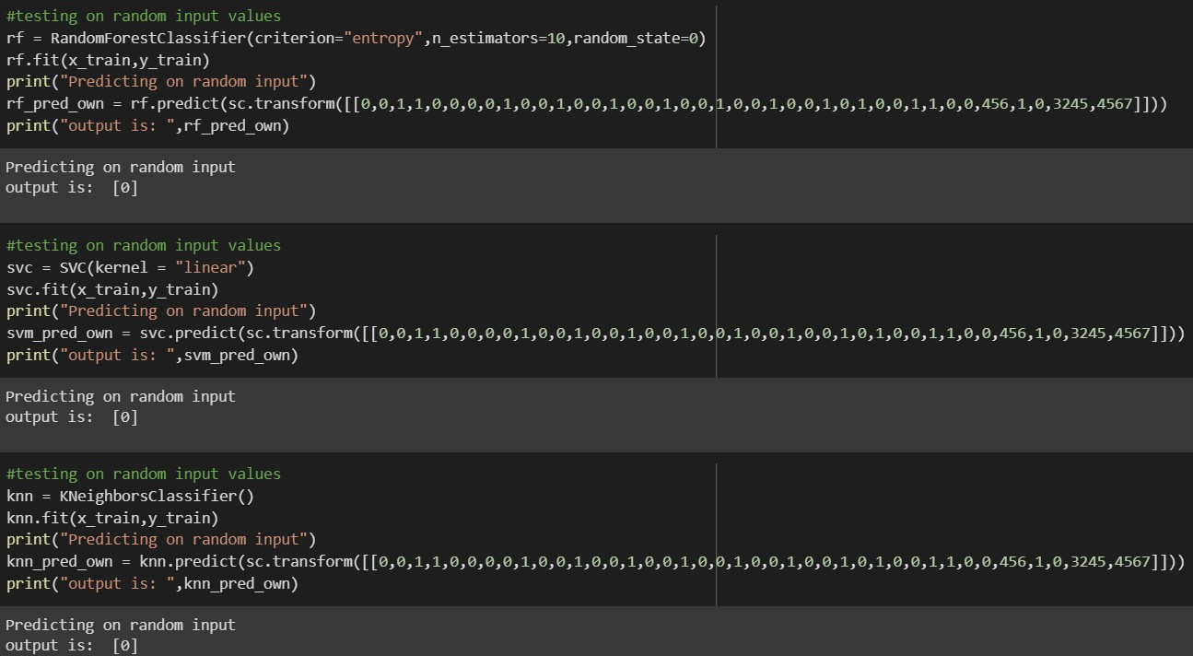

For ANN

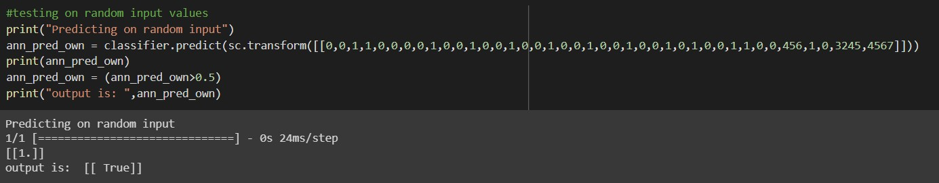

# Milestone 5: Performance Testing & Hyperparameter Tuning

## Activity 1: Testing model with multiple evaluation metrics

Multiple evaluation metrics means evaluating the model's performance on a test set using different performance measures. This can provide a more comprehensive understanding of the model's strengths and weaknesses. We are using evaluation metrics for classification tasks including accuracy, precision, recall, support and F1-score.

## Activity 1.1: Compare the model

For comparing the above four models, the compareModel function is defined.

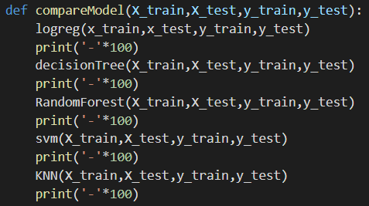

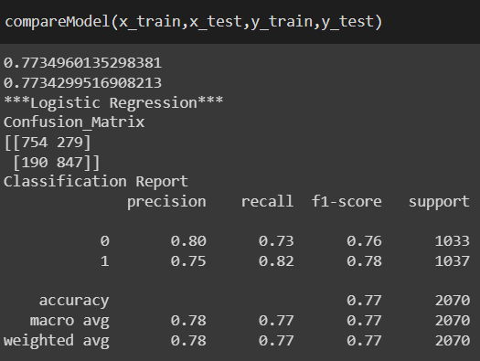

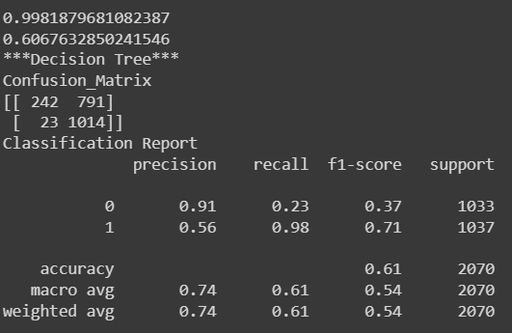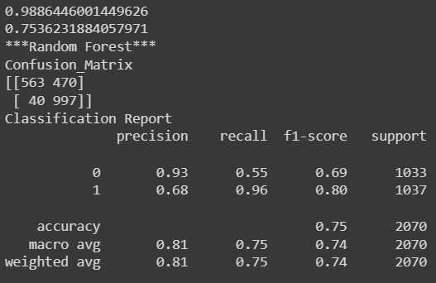

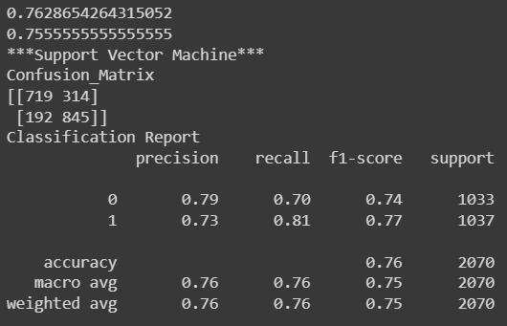

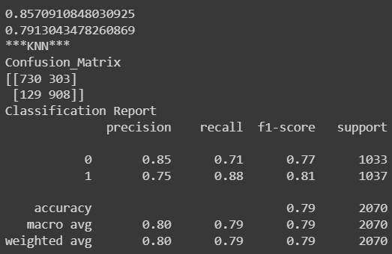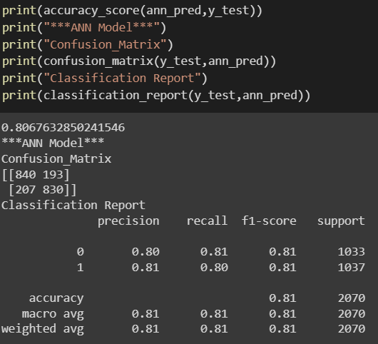

After calling the function, the results of models are displayed as output. From the five models Xgboost is performing well. From the below image, We can see the accuracy of the model. Xgboost is giving the accuracy of 93.39% with training data , 82.2% accuracy for the testing data.

## Activity 2: Comparing model accuracy before & after applying hyperparameter tuning

Evaluating performance of the model From sklearn, cross_val_score is used to evaluate the score of the model. On the parameters, we have given rf (model name), x, y, cv (as 5 folds).

**Note:** To understand cross validation, refer to this [link](https://towardsdatascience.com/cross-validation-explained-evaluating-estimator-performance-e51e5430ff85)

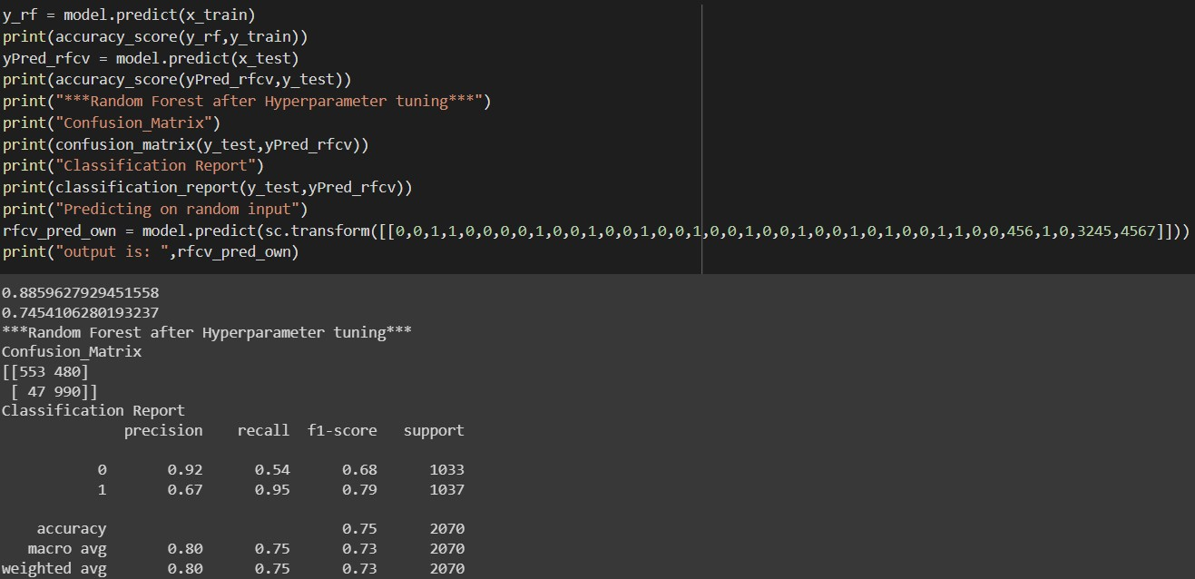

# Milestone 6: Model Deployment

## Activity 1:Save the best model

Saving the best model after comparing its performance using different evaluation metrics means selecting the model with the highest performance and saving its weights and configuration. This can be useful in avoiding the need to retrain the model every time it is needed and also to be able to use it in the future.



## Activity 2: Integrate with Web Framework

In this section, we will be building a web application that is integrated to the model we built. A UI is provided for the uses where he has to enter the values for predictions. The enter values are given to the saved model and prediction is showcased on the UI.

This section has the following tasks

* Building HTML Pages
* Building server side script
* Run the web application

## Activity 2.1: Building Html Pages:

For this project create two HTML files namely

* base.html
* index.html
* predyes.html
* predno.html

and save them in the templates folder.

## Activity 2.2: Build Python code:

Import the libraries

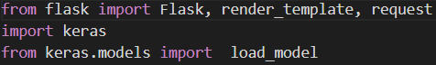

Load the saved model. Importing the flask module in the project is mandatory. An object of Flask class is our WSGI application. Flask constructor takes the name of the current module ( name ) as argument.



Render HTML page:

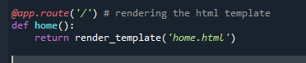

Here we will be using a declared constructor to route to the HTML page which we have created earlier.

In the above example, ‘/’ URL is bound with the home.html function. Hence, when the home page of the web server is opened in the browser, the html page will be rendered. Whenever you enter the values from the html page the values can be retrieved using POST Method.

Retrieves the value from UI:

Here we are routing our app to predict() function. This function retrieves all the values from the HTML page using Post request. That is stored in an array. This array is passed to the model.predict() function. This function returns the prediction. And this prediction value will be rendered to the text that we have mentioned in the submit.html page earlier.

Main Function:

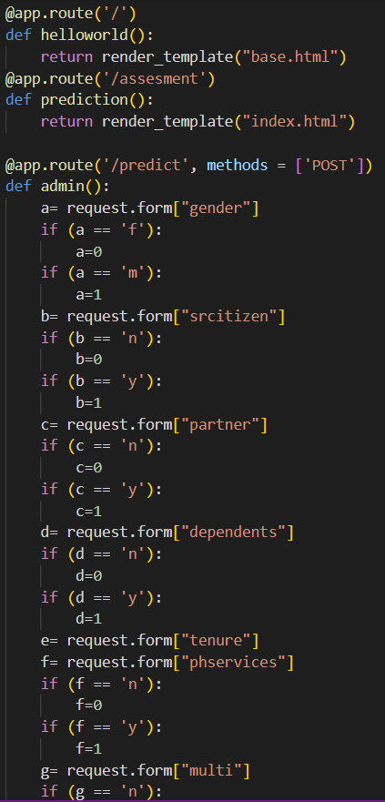 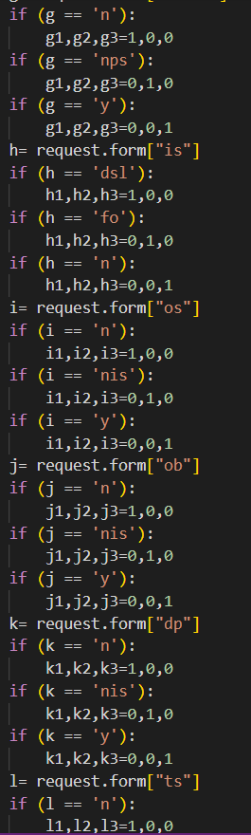

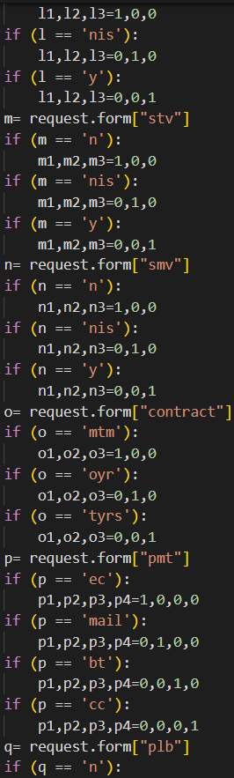

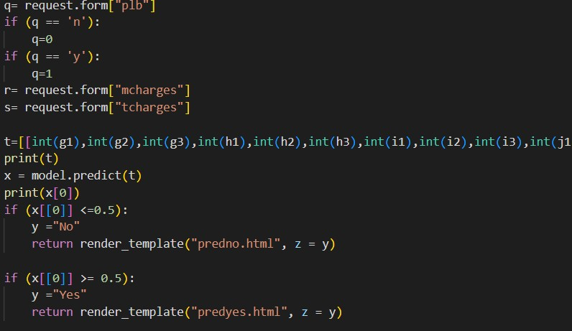

## Activity 2.3: Run the web application

* + Open anaconda prompt from the start menu
  + Navigate to the folder where your python script is.
  + Now type “python app.py” command
  + Navigate to the localhost where you can view your web page.
  + 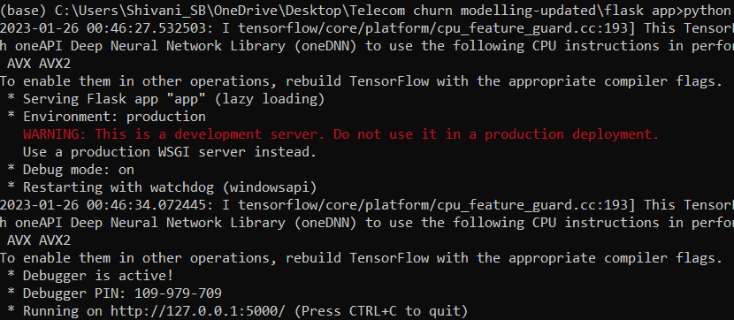Click on the predict button from the top left corner, enter the inputs, click on the submit button, and see the result/prediction on the web.

Now,Go the web browser and write the localhost url (http://127.0.0.1:5000) to get the below result

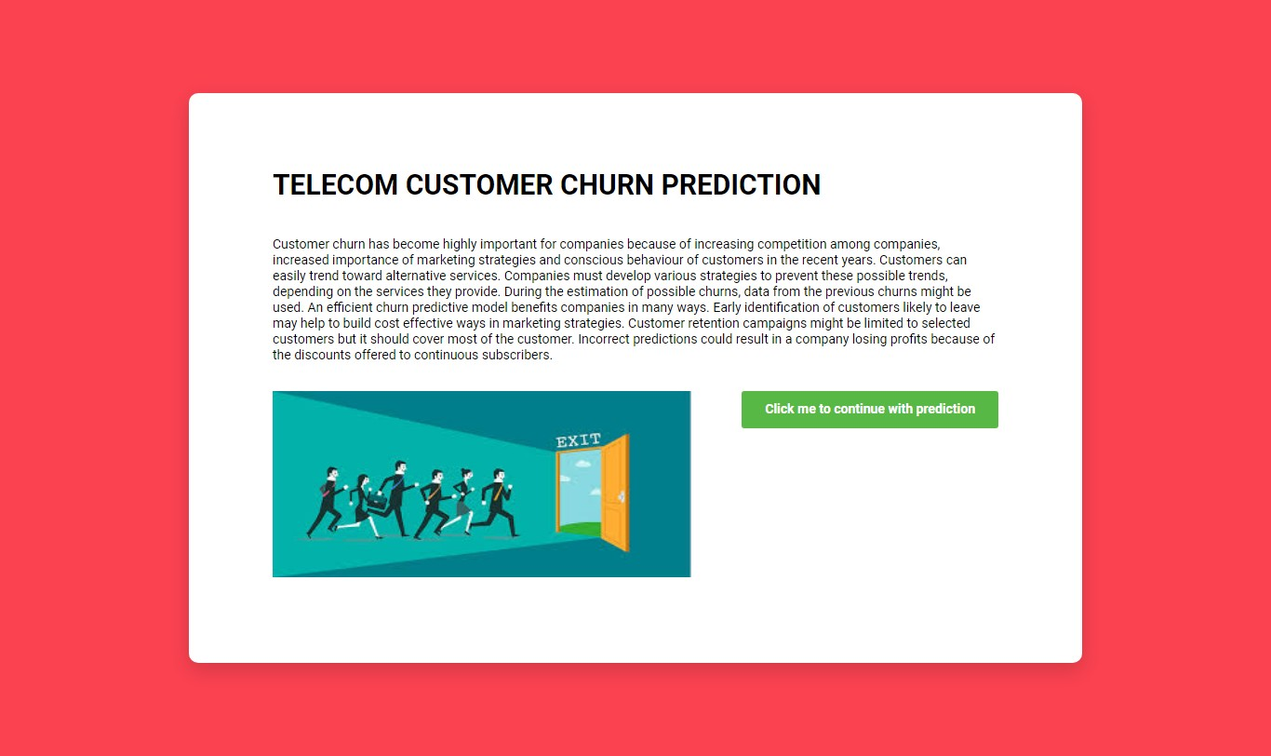

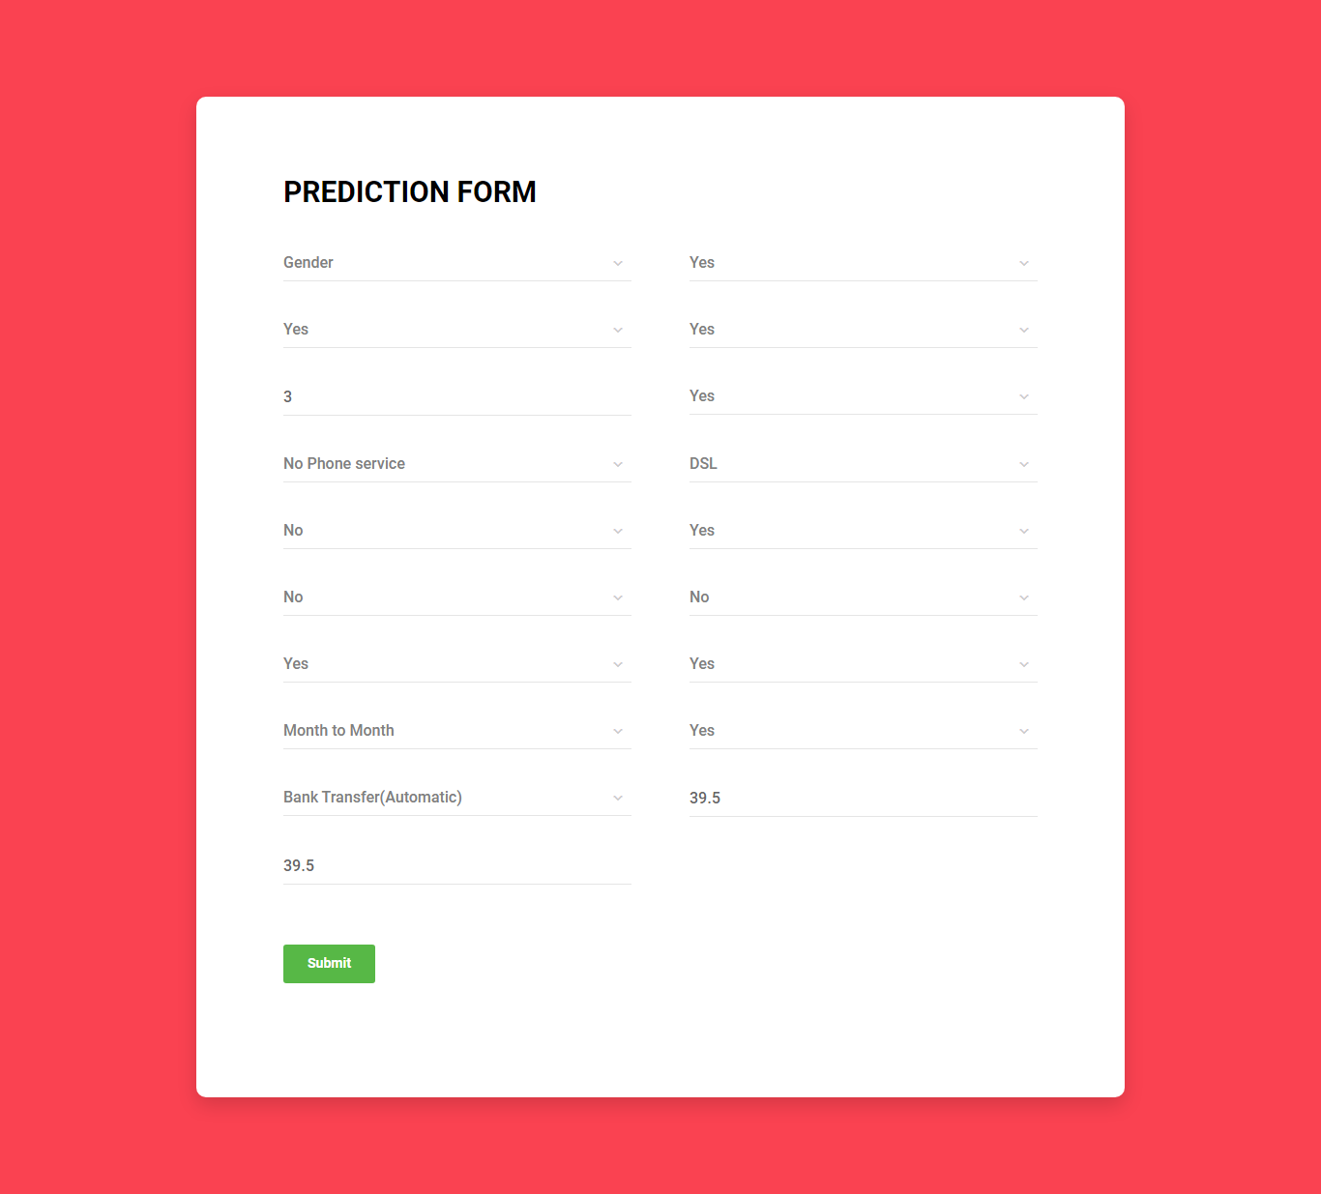

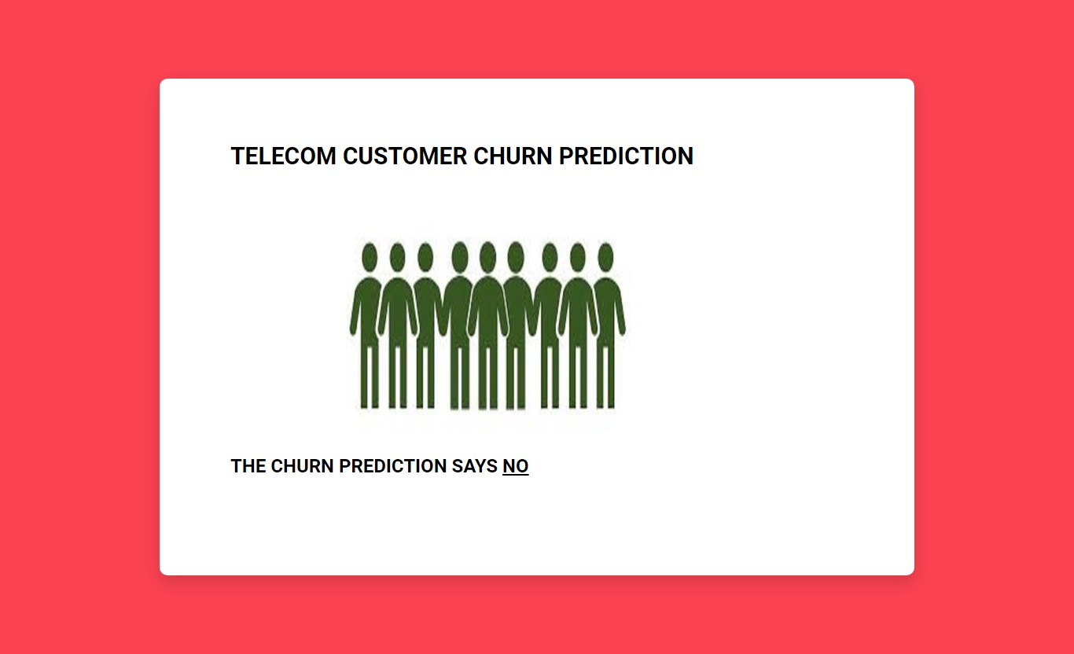

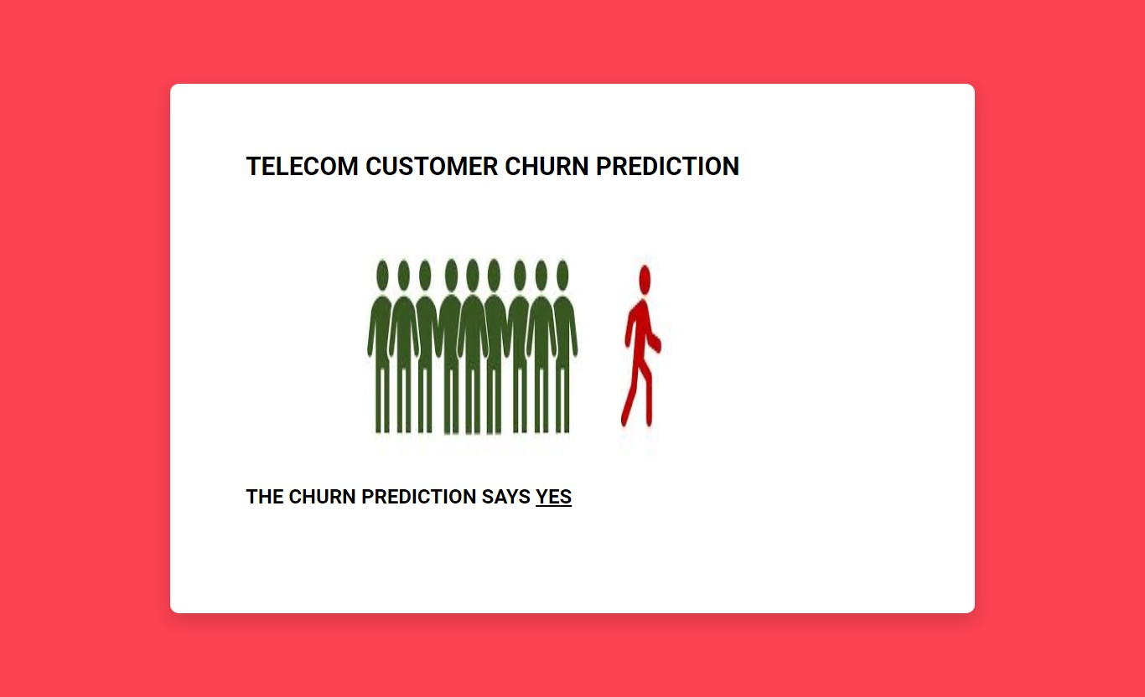

**Milestone 7: Project Demonstration & Documentation**

Below mentioned deliverables to be submitted along with other deliverables

## Activity 1:- Record explanation Video for project end to end solution

**Activity 2:- Project Documentation-Step by step project development procedure**

Create document as per the template provided