Climate change data analysis based on World Bank data.

10 major nations were chosen from around the world for analysis and visualization, and data from several climate change indicators, such as the ones listed below, were used to look for trends and patterns: Total greenhouse gas emissions (kt of CO2 equivalent), GDP (current US dollars), urban and rural populations, and CO2 emissions (kt).

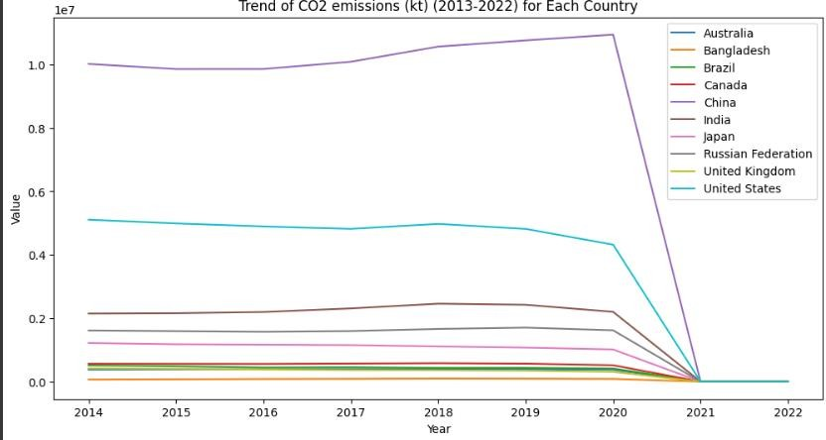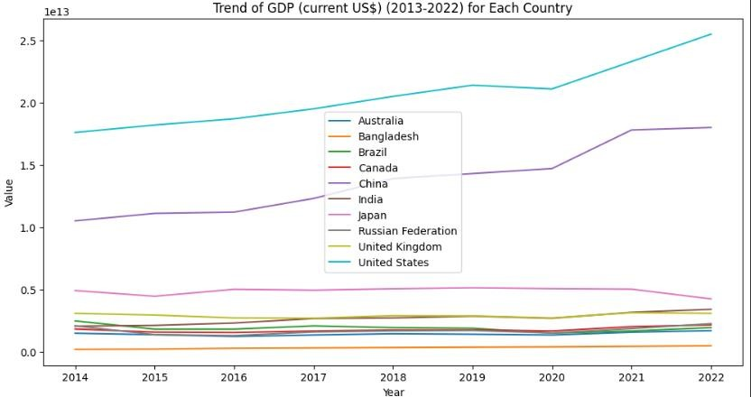The analysis found some correlations between the factors and causes behind them were investigated.

The line graphs above two major indicators that is the CO2 emissions and the GDP(in $US) are taken for all the 10 nations for the last 10 years to analyse the trend in both indicators and to compare it with each other. Here we can conclude that there is some relationship between both indicators as the more CO2 emissions the more GDP of that country compared to others.

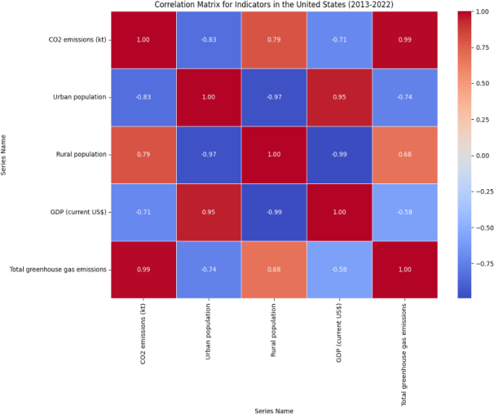

The correlation heatmap of last 10 years for United States shown above, concludes that there is a highly positive relation between GDP growth and the greenhouse and total emission of CO2.It also shows that Rural population has inverse relation to GDP of United States.

The Trend in line graphs of “Urban Population” and “CO2 emission” clearly depicts how there is a high upward trend over last 10 years in most 2 populous countries of world that is China and India. It also shows steady increase in terms of “GDP” of both the nations.

The below table depicts the rise in CO2 emissions for last 10 years by showing values for 2013, 2017 and 2020. The table gives clear indication that the Carbin dioxide emission has been highly increasing for all the nations.

|  |  |  |  |
| --- | --- | --- | --- |
| **Country** | **2013** | **2017** | **2020** |
| Australia | 388427.4 | 397149.4 | 378996.8 |
| Bangladesh | 62965.7 | 87658 | 85493.1 |
| Brazil | 486844.7 | 455684.8 | 414138.8 |
| Canada | 555742.4 | 568175.9 | 516873.7 |
| India | 1972429 | 2308804 | 2200836 |
| China | 9979128 | 10089273 | 10944686 |
| Japan | 1267376 | 1150835 | 1014065 |
| United  Kingdom | 453778.1 | 366844.1 | 308650.3 |
| United States | 5092097 | 4819365 | 4320533 |
| Russian Federation | 1632680 | 1594550 | 1618271 |

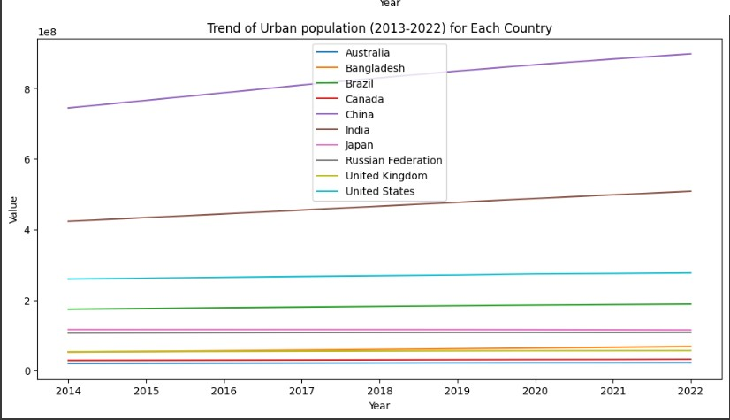 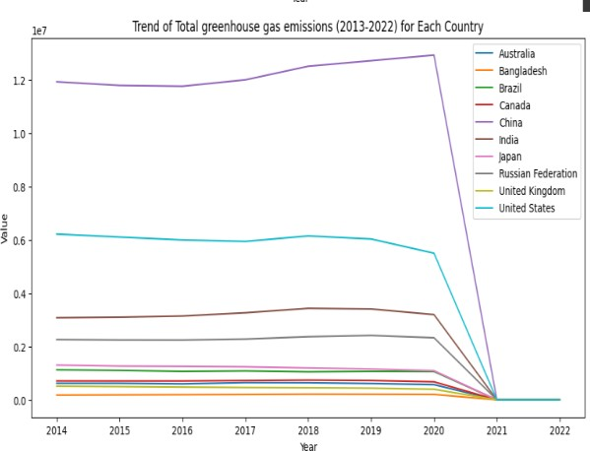

From the above line graph, it can be concluded that the trend of Urban population is significantly increasing in highly populous countries while it is almost constant in other major countries which have comparatively more stable population and GDP.

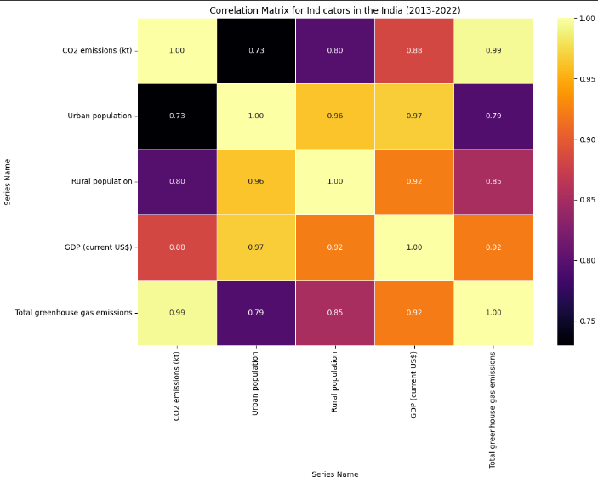

The heatmap for one of the topmost populous countries out of selected ten that is for India has been analysed and strongly indicates a high relationship between increase in Urban Population leading to increase in total GDP of the country. This increase is ultimately leading to increase in greenhouse gas emissions and the overall carbon emissions. Also, on interesting conclusion found from this heat map is that even the growth in Rural population along with the Urban population is contributing to GDP growth and higher greenhouse gas emissions and carbon dioxide emissions. Overall, the heatmap indicates that country is in state of extreme development and significant changes in terms of population and emissions.

The above line graph shows the trend of greenhouse gas emissions for each selected country over the period of last 10 years. This trend shows exactly similar trends of the carbon dioxide emissions as because the greenhouse gas emissions itself contribute towards the total CO2 emissions.

Now a stable population and emission country is selected to be analysed and to understand the correlation of different indicators.

Here a heatmap for Australia is shown below.

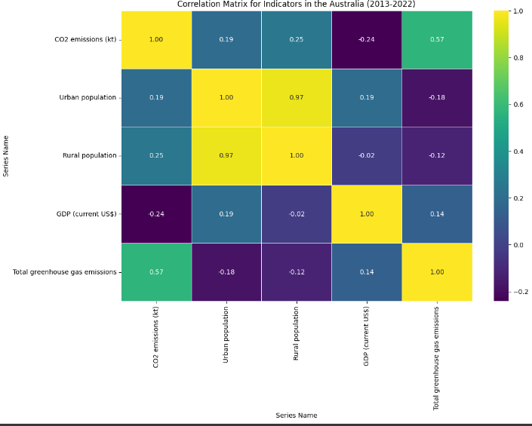

Here, there is strong correlation between the urban and rural population indicating that both urban and rural population have steadily increased over time. Also, there is no strong relation between Urban population and GDP and even between GDP and Carbon emissions. The reasons for this are because Australia has high amount forest area and much less overall population as compared to other major countries.