[[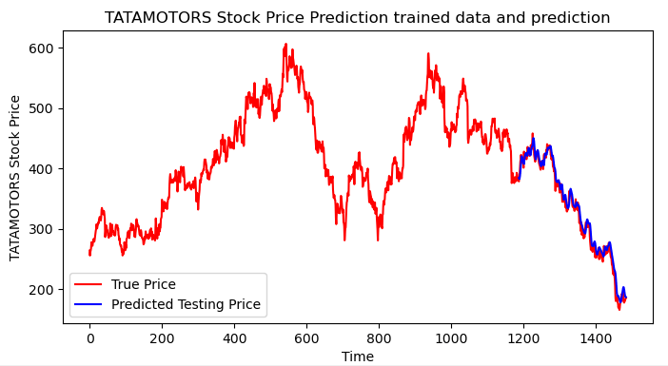](https://www.google.com/url?sa=i&url=https%3A%2F%2Fwww.researchgate.net%2Ffigure%2Fpredicted-testing-stock-price-The-Fig-3-is-drawn-from-original-dataset-also-shown-the_fig2_348390803&psig=AOvVaw3zWifxYa_yvM_GBomBtwzV&ust=1747061163525000&source=images&cd=vfe&opi=89978449&ved=2ahUKEwi7y9iR1JuNAxV2TmwGHVxLFYsQjRx6BAgAEBk)](https://www.google.com/url?sa=i&url=https%3A%2F%2Fwww.researchgate.net%2Ffigure%2Fpredicted-testing-stock-price-The-Fig-3-is-drawn-from-original-dataset-also-shown-the_fig2_348390803&psig=AOvVaw3zWifxYa_yvM_GBomBtwzV&ust=1747061163525000&source=images&cd=vfe&opi=89978449&ved=2ahUKEwi7y9iR1JuNAxV2TmwGHVxLFYsQjRx6BAgAEBk)