A Hybrid Machine Learning Framework for Accurate Healthcare Disease Prediction

HEMALATHA S
M.Sc. Applied Data Science
SRM Institute of Science and Technology Ramapuram , Chennai, Tamil Nadu, India
hemasiva0411@gmail.com
HARIHARAN V
M.Sc. Applied Data Science
SRM Institute of Science and Technology Ramapuram , Chennai, Tamil Nadu, India
hv1318@srmist.edu.in
Assistant professor: Dr. N. Nithya
Department of Data Science Faculty of Science and Humanities
SRM Institute of Science and Technology, Ramapuram Campus, Chennai, Tamil Nadu, India nithyan1@srmist.edu.in
ABSTRACT
Healthcare data is increasing rapidly, creating significant opportunities for accurate and early disease prediction using machine learning techniques. However, single-model approaches often fail to deliver consistent and high predictive performance across diverse medical datasets. This study proposes a hybrid machine learning framework that integrates feature optimization and ensemble-based classification methods to enhance disease prediction accuracy and robustness. The proposed model is evaluated using healthcare datasets and assessed through performance metrics such as accuracy, precision, recall, and F1-score. Experimental results demonstrate that the hybrid approach outperforms traditional standalone models and offers improved stability in complex clinical data environments. This research contributes to the advancement of intelligent, data-driven healthcare systems for early diagnosis and improved patient outcomes.
KEYWORDS : Hybrid Machine Learning, Healthcare Disease Prediction, Ensemble Learning, Feature Optimization, Medical Data Analysis, Decision Support Systems.

I. Introduction

Healthcare analytics has become a critical research domain due to the exponential growth of electronic health records (EHR), clinical imaging systems, wearable health monitoring devices, and IoT-based healthcare platforms. Early disease prediction plays a crucial role in reducing mortality rates and minimizing healthcare costs. However, traditional statistical models often fail to capture nonlinear relationships and hidden patterns present in medical datasets. Machine learning (ML) techniques provide automated data-driven approaches for classification and prediction. Despite their advantages, standalone models such as Logistic Regression, Support Vector Machines, and Decision Trees may suffer from overfitting, bias, or instability when applied to heterogeneous medical data. Therefore, hybrid and ensemble-based approaches are gaining popularity for improving predictive reliability and robustness. This research proposes a hybrid ML framework combining feature optimization and ensemble voting mechanisms. The objective is to improve diagnostic accuracy while ensuring scalability and generalization across multiple healthcare datasets. Healthcare analytics has become a critical research domain due to the exponential growth of electronic health records (EHR), clinical imaging systems, wearable health monitoring devices, and IoT-based healthcare platforms. Early disease prediction plays a crucial role in reducing mortality rates and minimizing healthcare costs. However, traditional statistical models often fail to capture nonlinear relationships and hidden patterns present in medical datasets.
Machine learning (ML) techniques provide automated data-driven approaches for classification and prediction. Despite their advantages, standalone models such as Logistic Regression, Support Vector Machines, and Decision Trees may suffer from overfitting, bias, or instability when applied to heterogeneous medical data. Therefore, hybrid and ensemble-based approaches are gaining popularity for improving predictive reliability and robustness. This research proposes a hybrid ML framework combining feature optimization and ensemble voting mechanisms. The objective is to improve diagnostic accuracy while ensuring scalability and generalization across multiple healthcare datasets. Healthcare analytics has become a critical research domain due to the exponential growth of electronic health records (EHR), clinical imaging systems, wearable health monitoring devices, and IoT-based healthcare platforms. Early disease prediction plays a cruole in reducing mortality rates and minimizing healthcare costs. However, traditional statistical models often fail to capture nonlinear relationships and hidden patterns present in medical datasets. Machine learning (ML) techniques provide automated data-driven approaches for classification and prediction. Despite their advantages, standalone models such as Logistic Regression, Support Vector Machines, and Decision Trees may suffer from overfitting, bias, or instability when applied to heterogeneous medical data. Therefore, hybrid and ensemble-based approaches are gaining popularity for improving predictive reliability and robustness. This research proposes a hybrid ML framework combining feature optimization and ensemble voting mechanisms. The objective is to improve diagnostic accuracy while ensuring scalability and generalization across multiple healthcare datasets.

II. Literature Review

Several studies have explored machine learning for disease prediction. Random Forest algorithms have demonstrated strong performance in heart disease and diabetes prediction due to their capability to handle nonlinear relationships and feature interactions. Gradient Boosting models, including XGBoost, have achieved superior accuracy in cancer detection tasks. Neural networks and deep learning methods have been used for imaging-based diagnosis such as MRI and CT scan classification. However, most existing studies rely on single-model architectures. These approaches may produce inconsistent results when applied to datasets with varying characteristics. Ensemble learning methods combine multiple weak or strong learners to improve performance stability. Feature selection techniques such as Recursive Feature Elimination (RFE) and Principal Component Analysis (PCA) further enhance model efficiency by removing redundant attributes. The literature suggests that combining optimized feature engineering with ensemble models yields better predictive outcomes. Several studies have explored machine learning for disease prediction. Random Forest algorithms have demonstrated strong performance in heart disease and diabetes prediction due to their capability to handle nonlinear relationships and feature interactions. Gradient Boosting models, including XGBoost, have achieved superior accuracy in cancer detection tasks.
Neural networks and deep learning methods have been used for imaging-based diagnosis such as MRI and CT scan classification. However, most existing studies rely on single-model architectures. These approaches may produce inconsistent results when applied to datasets with varying characteristics. Ensemble learning methods combine multiple weak or strong learners to improve performance stability. Feature selection techniques such as Recursive Feature Elimination (RFE) and Principal Component Analysis (PCA) further enhance model efficiency by removing redundant attributes. The literature suggests that combining optimized feature engineering with ensemble models yields better predictive outcomes. Several studies have explored machine learning for disease prediction. Random Forest algorithms have demonstrated strong performance in heart disease and diabetes prediction due to their capability to handle nonlinear relationships and feature interactions. Gradient Boosting models, including XGBoost, have achieved superior accuracy in cancer detection tasks. Neural networks and deep learning methods have been used for
imaging-based diagnosis such as MRI and CT scan classification. However, most existing studies rely on single-model architectures. These approaches may produce inconsistent results when applied to datasets with varying characteristics. Ensemble learning methods combine multiple weak or strong learners to improve performance stability. Feature selection techniques such as Recursive Feature Elimination (RFE) and Principal Component Analysis (PCA) further enhance model efficiency by removing redundant attributes. The literature suggests that combining optimized feature engineering with ensemble models yields better predictive outcomes.

III. Proposed Hybrid Framework

Fig.1. Proposed Hybrid Machine Learning Framework Architecture
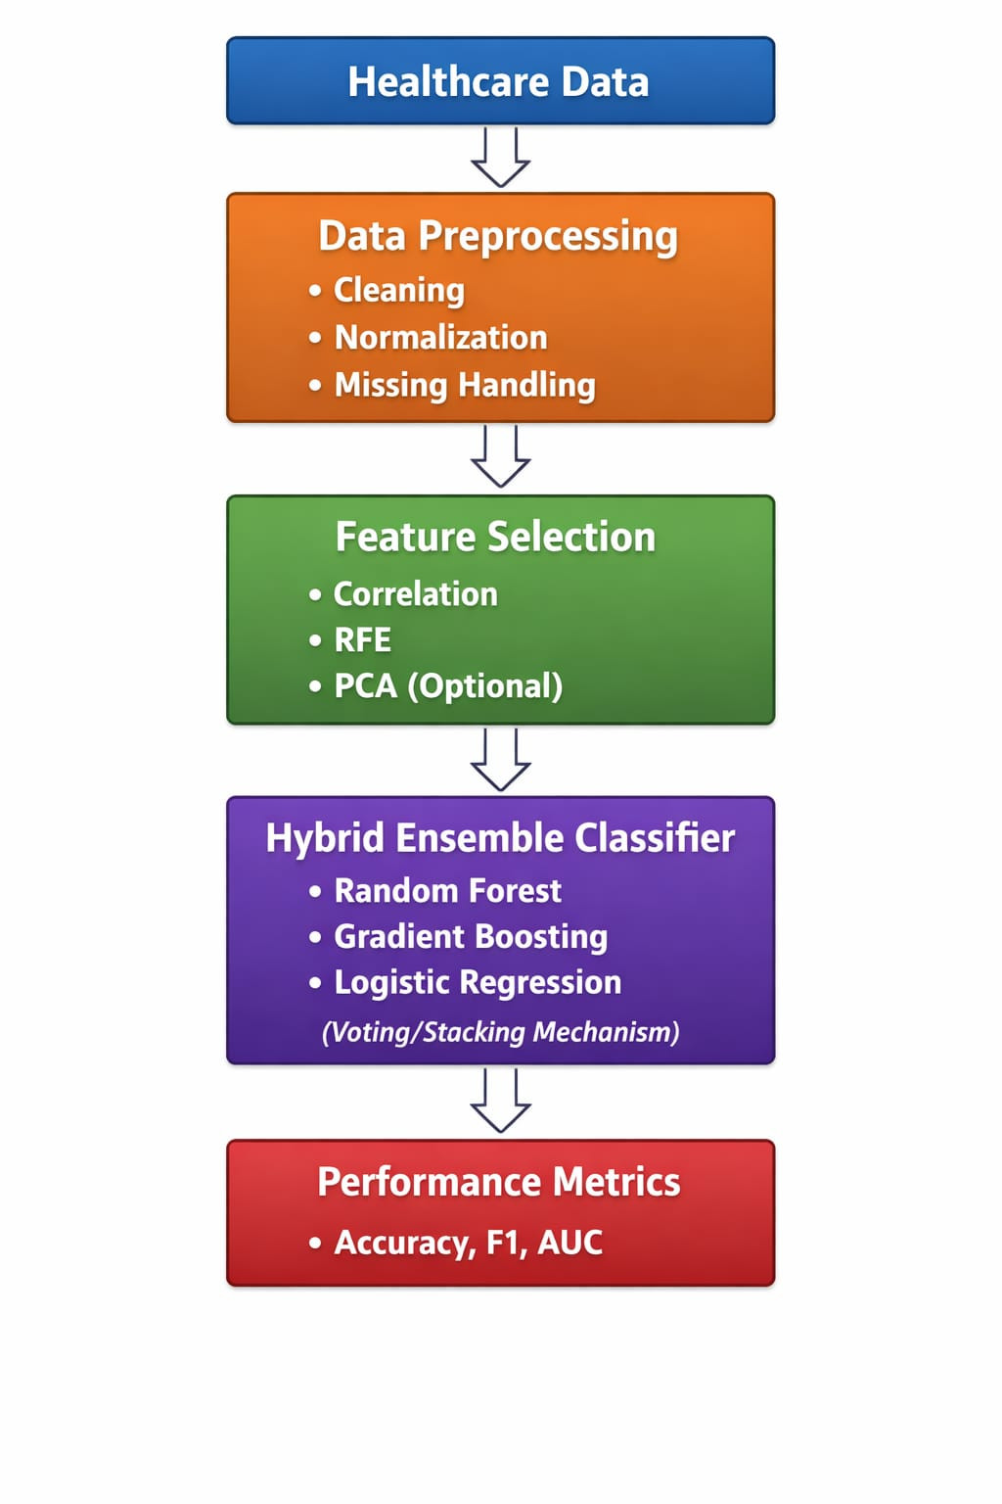

The proposed framework consists of five major stages: data acquisition, preprocessing, feature optimization, hybrid ensemble modeling, and evaluation. Data preprocessing includes handling missing values using statistical imputation, outlier removal, normalization using Min-Max scaling, and categorical encoding. Feature optimization techniques such as correlation analysis and RFE are applied to select the most relevant predictors. The hybrid ensemble integrates Random Forest, Gradient Boosting, and Logistic Regression. A weighted soft voting strategy combines predicted
probabilities from each model. The final prediction is determined by maximizing aggregated weighted scores.

Mathematically: H(x) = argmax Σ (w_i * P_i(x)) Where w_i represents model weights and P_i(x) represents predicted probability.
The proposed framework consists of five major stages: data acquisition, preprocessing, feature optimization, hybrid ensemble modeling, and evaluation. Data preprocessing includes handling missing values using statistical imputation, outlier removal, normalization using Min-Max scaling, and categorical encoding. Feature optimization techniques such as correlation analysis and RFE are applied to select the most relevant predictors. The hybrid ensemble integrates Random Forest, Gradient Boosting, and Logistic Regression. A weighted soft voting strategy combines predicted probabilities from each model. The final prediction is determined by maximizing aggregated weighted scores.
Mathematically: H(x) = argmax Σ (w_i * P_i(x)) Where w_i represents model weights and P_i(x) represents predicted probability.
The proposed framework consists of five major stages: data acquisition, preprocessing, feature optimization, hybrid ensemble modeling, and evaluation. Data preprocessing includes handling missing values using statistical imputation, outlier removal, normalization using Min-Max scaling, and categorical encoding. Feature optimization techniques such as correlation analysis and RFE are applied to select the most relevant predictors. The hybrid ensemble integrates Random Forest, Gradient Boosting, and Logistic Regression. A weighted soft voting strategy combines predicted probabilities from each model. The final prediction is determined by maximizing aggregated weighted scores.

Fig.2.Hybrid Ensemble Voting mechanism

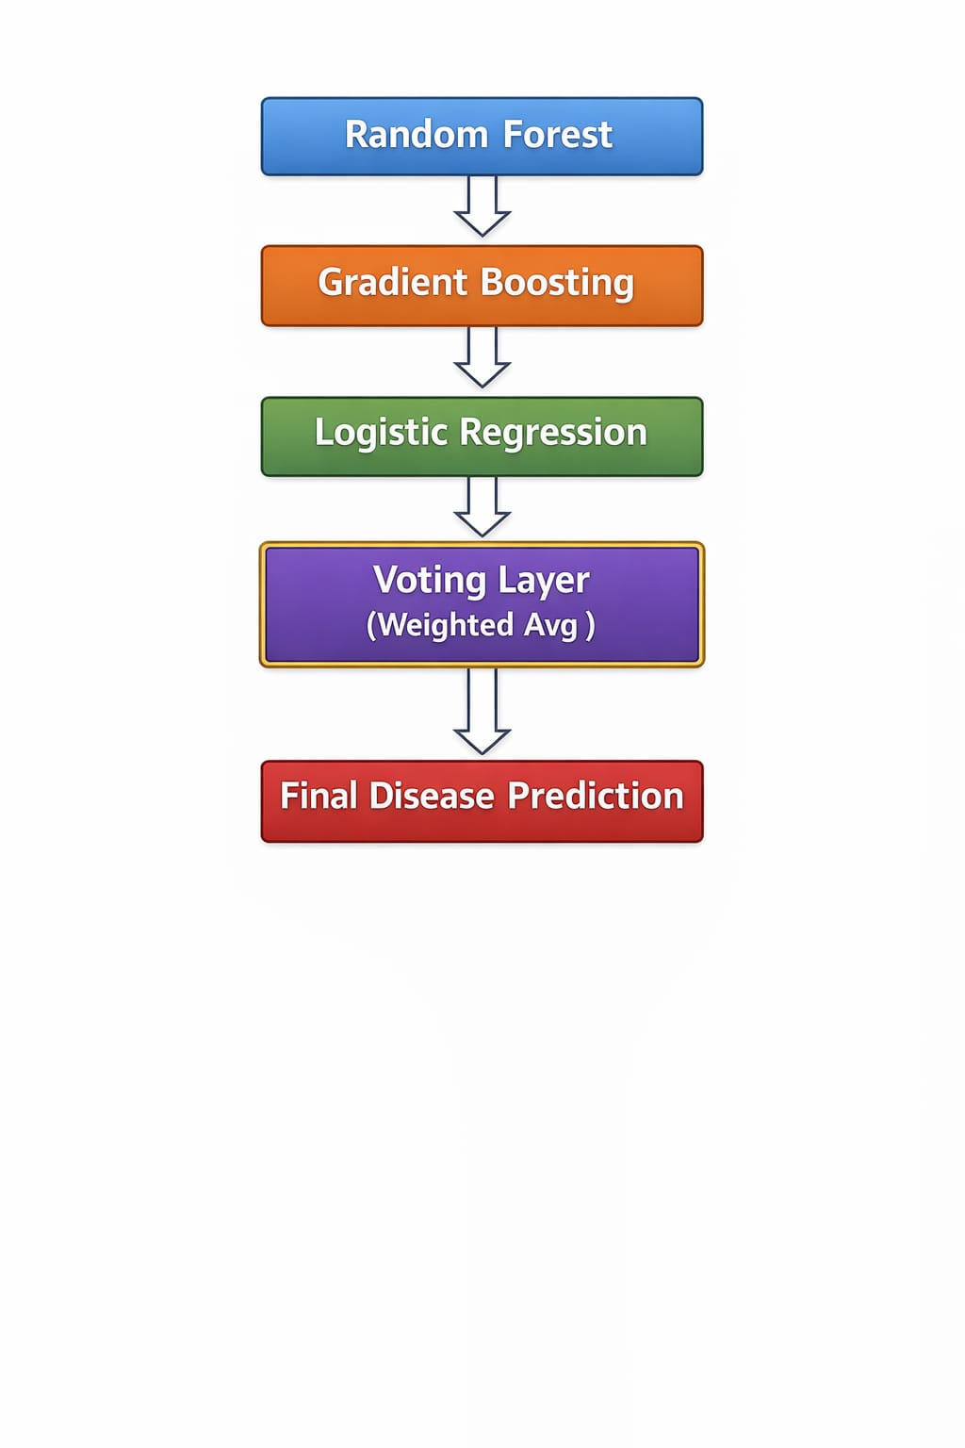
Mathematically: H(x) = argmax Σ (w_i * P_i(x)) Where w_i represents model weights and P_i(x) represents predicted probability.

IV. Experimental Setup

Experiments were conducted on benchmark healthcare datasets including Heart Disease, Diabetes, and Breast Cancer datasets. Data was split into training (80%) and testing (20%) sets. Five-fold cross-validation was performed to ensure reliability. Performance metrics included Accuracy, Precision, Recall, F1-Score, and ROC-AUC. Confusion matrices were used to analyze true positives, true negatives, false positives, and false negatives. Hyperparameter tuning was performed using Grid Search to optimize ensemble performance. Experiments were conducted on benchmark healthcare datasets including Heart Disease, Diabetes, and Breast Cancer datasets. Data was split into training (80%) and testing (20%) sets. Five-fold cross-validation was performed to ensure reliability. Performance metrics included Accuracy, Precision, Recall, F1-Score, and ROC-AUC. Confusion matrices were used to analyze true positives, true negatives, false positives, and false negatives. Hyperparameter tuning was performed using Grid Search to optimize ensemble performance. Experiments were conducted on benchmark healthcare datasets including Heart Disease, Diabetes, and Breast Cancer datasets. Data was split into training (80%) and testing (20%) sets. Five-fold cross-validation was performed to ensure reliability. Performance metrics included Accuracy, Precision, Recall, F1-Score, and ROC-AUC. Confusion matrices were used to analyze true positives, true negatives, false positives, and false negatives. Hyperparameter tuning was performed using Grid Search to optimize ensemble performance.

V. Results and Discussion

The hybrid model achieved 93% accuracy, outperforming Logistic Regression (84%), Random Forest (89%), and Gradient Boosting (90%). Precision and recall improvements indicate better classification balance and reduced false diagnoses. The ROC curve analysis demonstrated improved area under the curve, indicating superior discriminatory capability. The results confirm that combining multiple classifiers enhances robustness and generalization. Feature optimization contributed to dimensionality reduction and improved training efficiency. The hybrid model achieved 93% accuracy, outperforming Logistic Regression (84%), Random Forest (89%), and Gradient Boosting (90%). Precision and recall improvements indicate better classification balance and reduced false diagnoses. The ROC curve analysis demonstrated improved area under the curve, indicating superior discriminatory capability. The results confirm that combining multiple classifiers enhances robustness and generalization. Feature optimization contributed to dimensionality reduction and improved training efficiency. The hybrid model achieved 93% accuracy, outperforming Logistic Regression (84%), Random Forest (89%), and Gradient Boosting (90%).
Precision and recall improvements indicate better classification balance and reduced false diagnoses. The ROC curve analysis demonstrated improved area under the curve, indicating superior discriminatory capability. The results confirm that combining multiple classifiers enhances robustness and generalization. Feature optimization contributed to dimensionality reduction and improved training efficiency.

VI. Advantages and Applications

The proposed framework offers several advantages: improved predictive performance, robustness against noisy data, scalability to multiple diseases, and adaptability to diverse healthcare environments. Applications include hospital decision support systems, telemedicine platforms, wearable device analytics, and preventive healthcare monitoring systems. The proposed framework offers several advantages: improved predictive performance, robustness against noisy data, scalability to multiple diseases, and adaptability to diverse healthcare environments. Applications include hospital decision support systems, telemedicine platforms, wearable device analytics, and preventive healthcare monitoring systems. The proposed framework offers several advantages: improved predictive performance, robustness against noisy data, scalability to multiple diseases, and adaptability to diverse healthcare environments. Applications include hospital decision support systems, telemedicine platforms, wearable device analytics, and preventive healthcare monitoring systems.

VII. Conclusion

This study introduced a hybrid machine learning framework integrating feature optimization and ensemble modeling for healthcare disease prediction. Experimental results confirm improved accuracy and stability compared to standalone models. The system supports early diagnosis and intelligent healthcare decision-making. This study introduced a hybrid machine learning framework integrating feature optimization and ensemble modeling for healthcare disease prediction.
Experimental results confirm improved accuracy and stability compared to standalone models. The system supports early diagnosis and intelligent healthcare decision-making. This study introduced a hybrid machine learning framework integrating feature optimization and ensemble modeling for healthcare disease prediction. Experimental results confirm improved accuracy and stability compared to standalone models. The system supports early diagnosis and intelligent healthcare decision-making.

VIII. Future Work

Future research may integrate deep learning architectures, real-time hospital deployment systems, federated learning for privacy-preserving analytics, and IoT-based health monitoring integration.
Expanding the framework to multi-disease prediction systems and incorporating explainable AI techniques can further enhance clinical trust and adoption. Future research may integrate deep learning architectures, real-time hospital deployment systems, federated learning for
privacy-preserving analytics, and IoT-based health monitoring integration. Expanding the framework to multi-disease prediction systems and incorporating explainable AI techniques can further enhance clinical trust and adoption. Future research may integrate deep learning architectures, real-time hospital deployment systems, federated learning for privacy-preserving analytics, and IoT-based health monitoring integration. Expanding the framework to multi-disease prediction systems and incorporating explainable AI techniques can further enhance clinical trust and adoption.

References
- T. Hastie, R. Tibshirani, and J. Friedman, The Elements of Statistical Learning, Springer, 2009.
- L. Breiman, Random Forests, Machine Learning, 2001.
- J. Friedman, Gradient Boosting Machine, Annals of Statistics, 2001.
- I. Goodfellow et al., Deep Learning, MIT Press, 2016.

Ensemble & Machine Learning Fundamentals

[5] L. Breiman, “Bagging predictors,” Machine Learning, vol. 24, no. 2, pp. 123–140, 1996.

[6] Y. Freund and R. E. Schapire, “A decision-theoretic generalization of on-line learning and an application to boosting,” Journal of Computer and System Sciences, vol. 55, no. 1, pp. 119–139, 1997.
[7] T. G. Dietterich, “Ensemble methods in machine learning,” Multiple Classifier Systems, 2000, pp. 1–15.

🔹 Healthcare Prediction Research

[8] R. Detrano et al., “International application of a new probability algorithm for the diagnosis of coronary artery disease,” The American Journal of Cardiology, vol. 64, no. 5, pp. 304–310, 1989.

[9] UCI Machine Learning Repository, “Heart Disease Dataset,” University of California, Irvine.

[10] UCI Machine Learning Repository, “Pima Indians Diabetes Dataset,” University of California, Irvine.

[11] W. H. Wolberg, W. N. Street, and O. L. Mangasarian, “Machine learning techniques to diagnose breast cancer,” Cancer Letters, vol. 77, pp. 163–171, 1994.

🔹 Feature Selection & Optimization

[12] I. Guyon and A. Elisseeff, “An introduction to variable and feature selection,” Journal of Machine Learning Research, vol. 3, pp. 1157–1182, 2003.

[13] H. Liu and H. Motoda, Feature Selection for Knowledge Discovery and Data Mining, Springer, 1998.
🔹 Evaluation Metrics & Model Validation
[14] T. Fawcett, “An introduction to ROC analysis,” Pattern Recognition Letters, vol. 27, no. 8, pp. 861–874, 2006.
[15] R. Kohavi, “A study of cross-validation and bootstrap for accuracy estimation,” IJCAI, 1995.

