AN INTEGRATED BLOCKCHAIN AND CLOUD-BASED EXPLAINABLE AI FRAMEWORK FOR REDUCING BLACK BOX RISK IN DEEP LEARNING SYSTEMS

HEMALATHA S
M.Sc. Applied Data Science
SRM Institute of Science and Technology Ramapuram, Chennai, Tamil Nadu, India hemasiva0411@gmail.com

HARIHARAN V
M.Sc. Applied Data Science
SRM Institute of Science and Technology Ramapuram, Chennai, Tamil Nadu, India hv1318@srmist.edu.in

Assistant professor Dr. N. Nithya
Department of Data Science Faculty of Science and Humanities
SRM Institute of Science and Technology, Ramapuram Campus, Chennai, Tamil Nadu, India
nithyan1@srmist.edu.in

ABSTRACT

Deep Learning (DL) models have demonstrated superior predictive capabilities across domains such as healthcare analytics, financial fraud detection, and intelligent transportation systems. Despite their high accuracy, their inherent black box behavior limits interpretability, transparency, and regulatory compliance, thereby reducing stakeholder trust in AI-driven decisions. Addressing this limitation is critical for deploying AI in high-risk and mission-critical environments.

This paper proposes an integrated framework that combines Cloud Computing, Explainable Artificial Intelligence (XAI), and Blockchain technology to mitigate black box risk in deep learning systems. The cloud layer enables scalable data storage, distributed model training, and real-time inference. An Explainable AI module is incorporated to generate interpretable insights using feature attribution and model explanation techniques. To ensure transparency and integrity, a blockchain layer is introduced to record model predictions, explanations, and version updates in an immutable and auditable manner.

The proposed framework is evaluated using metrics such as predictive accuracy, explanation fidelity, computational latency, and system security robustness. Experimental analysis demonstrates that the integration of explainability and decentralized audit logging significantly enhances transparency and trust without degrading model performance. The framework provides a scalable and secure foundation for developing trustworthy AI systems suitable for real-world deployment.

KEYWORDS
Explainable AI, Deep Learning, Blockchain, Cloud Computing, Trustworthy AI,
Model Transparency, AI Auditing

INTRODUCTION

We are facing the day-to-day problem of AI fear because of the block box problem. It means deep learning system processing tack decision making process is not transparent.
It creates risk in critical systems such as:

- Autonomous Vehicles
- Healthcare diagnosis
- Financial trade detection

Solution:

We are create the framework for solve the black box problem with the help of technology and using
Some algorithms .It will reduce the black box problem ,security, data storage process ,create trust and belief it will show the decision making decision making and transparent.

RELATED WORK

The using technology like Deep learning, Cloude, Block chine, Explainable AI(XA)

- DEEP LEARNING:
The century greater data availability and in creasing computational power lead to increased successes of neural networks, and this area was reborn under the new label of “deep learning.” Although we are still far from the day that artificial intelligence (AI) is close to human performance, there are specific domains like image recognition, self-driving cars, and game playing, where AI has matched or exceeded human performance. It is also hard to predict what AI might be able to do in the future. The are using neural networks and Deep learning.
The use some concepts and algorithms :

- CNN (Convolutional Neural Network)
- DNN(Deep Neural Network)

- EXPLAINABLE AI (XAI) :
All this has led to the development of the Explainable Artificial Intelligence (XAI) discipline, which is the field of study that aims to make AI systems understandable to humans , as the notion of “black box”, problem it is make an huge role to solve this problem.
It can be concluded that an algorithm falls within the XAI discipline if it follows three principles: transparency, interpretability and explainability.
Transparency occurs if the processes that calculate the parameters of the models and produce the results can be described and justified. Interpretability describes the ability to understand the model and present how it makes decisions in a human-understandable way.
The use some concepts and algorithms :

- LIME (local interpretable Model-agnostic Explanations)
- SHAP (Shapley Additive Explanations)

- Blockchain:
A Blockchain is a technology began with introduction decentralized, distributed, and immutable it is an digital ledger that record truncation once recorded data can not be alter or deleted with out network consensus. It is mainly used for security .

- POW(Proof of Work)
- POS (proof of Stake)

- Cloude computing:
Cloud computing uses Internet technologies to offer elastic services. The term elastic computing refers to the ability to dynamically acquire computing resources and support a variable workload. A cloud service provider maintains a massive infrastructure to support elastic services. The resources used for these services can be metered and the users can be charged only for the resources they use. Maintenance and security are ensured by service providers. Economy of scale allows service providers to operate more efficiently due to specialization and centralization. Cloud computing is cost-effective due to resource multiplexing; lower costs for the service provider are passed on to the cloud users.
The use some concepts and algorithms :
- Resource scheduling
- Load balancing
- Distributed Processing

SYSTEM ARCHITECTURE

Figure 1.1

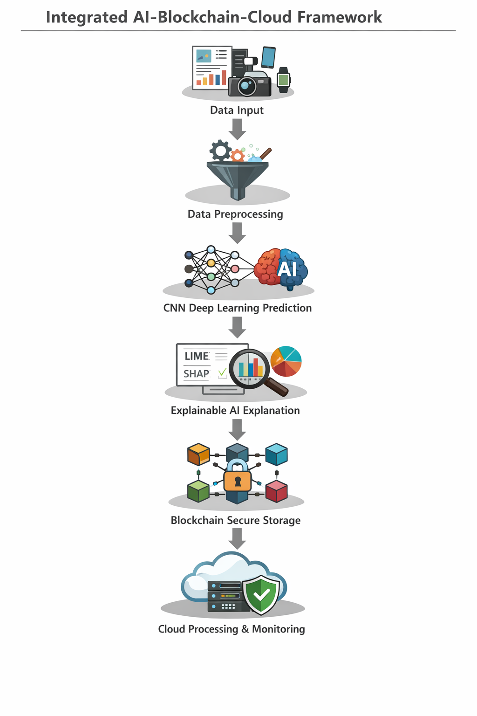

- Data Input:

It is use for collecting different form data source such as Sensors, Cameras,
IoT devices, Transaction data ,Medical images.

- Data Preprocessing:

Raw data cannot be used directly. It must be cleaned and prepared.
Main preprocessing tasks:
- Data cleaning
- Data normalization
- Feature extraction
- Removing noise

- CNN Deep Learning Prediction

This Convolutional Neural Networks use for analysis and detects patterns in the image and DNN concept used for finding hidden pattern
Example:
Figure 1.2 given below

4. Explainable AI Explanation
Deep learning models are often black boxes.
To understand the decision, we apply:
- Local Interpretable Model-Agnostic Explanations
- Shapley Additive Explanations
These methods explain:
which features influenced the prediction, why the model made the decision
Example: AI says Stop
Explanation:

- Traffic signal detected
- Pedestrian detected
- Road obstacle detected
Purpose:
Increase transparency and trust in AI systems.

5. Blockchain Secure Storage
After prediction and explanation, the data is stored in Blockchain.
Blockchain provides:
- Secure storage
- Tamper-proof records
- Distributed verification
Stored information:
- AI decision
- Explanation result
- Timestamp
Ensure data integrity and security.

6. Cloud Processing and Monitoring

The final stage uses Cloud Computing.

Cloud systems provide:
- Large storage capacity
- High processing power
- Real-time monitoring
- Scalable resources

Cloud tasks include:
- training AI models
- storing large datasets
- managing system operations

REAL TIME EXAMPLE :

Figer 1.2

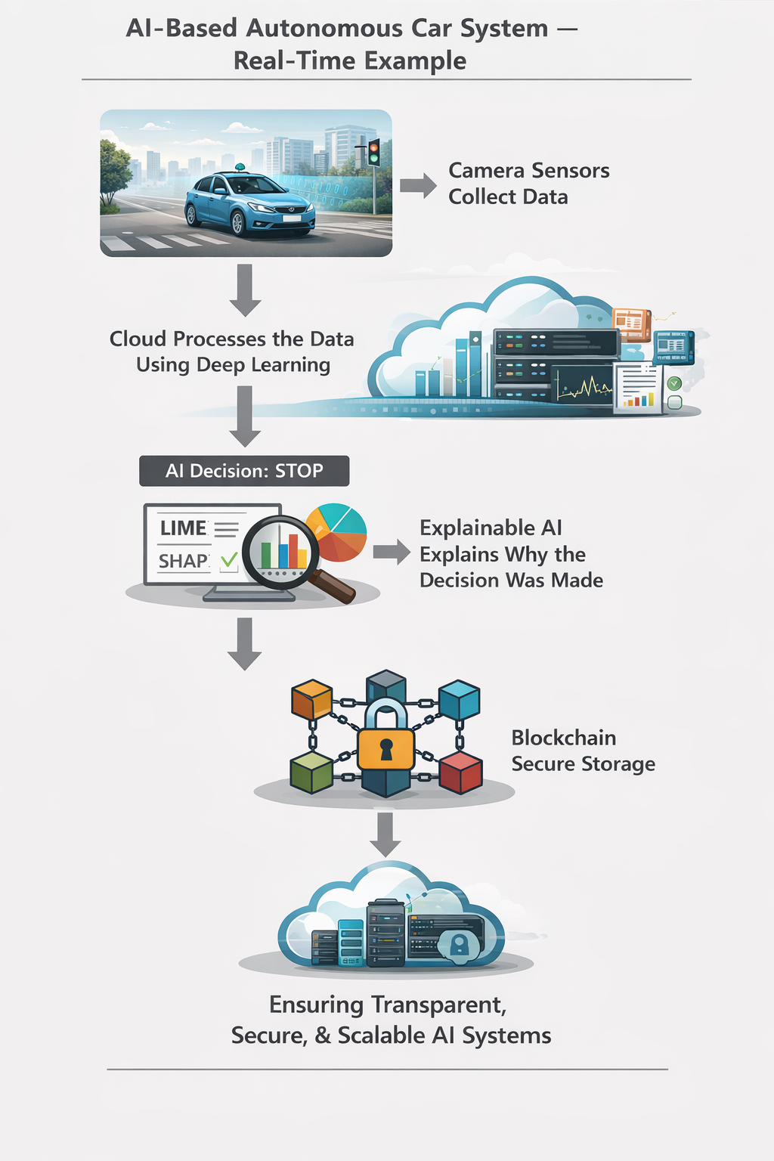

Algorithm formulas

  - Deep learning Algorithm

1. DNN(Deep Nural Network)

$Z=W. X+b$

$A=f\left(z\right)$

2. CNN(Convolutional Neural Networks)

$S\left(i,j\right)=\sum_{m}{\sum_{n}{X\left(i+m,j+n\right)K(m,n)}}$

- Explainable AI

  - LIME (Local interpretable Model-Agnostic Explanations)

$E(x)=arg\min_{g∈G}{L}(f,g,π\left.x\right)+∩(g)$

  - SHAP(shape Additive Explanations)

- Block Chain

    - POW(Proof of Work )

HASH(Block)< Target

    - POS(Proof of Stake)

RESULTS:

The proposed framework integrates Convolutional Neural Network, LIME, SHAP, Blockchain, and Cloud Computing to reduce the black-box problem in deep learning systems.
In summary, the framework provides accurate predictions, transparent AI decision explanations, secure storage of results using blockchain, and scalable real-time processing through cloud infrastructure. By combining these technologies, the system improves trust, security, and reliability in AI-based applications used in real-world industries.

REFERENCES

- Ian Goodfellow, Yoshua Bengio, and Aaron Courville (2016).
Deep Learning.
MIT Press.
(This book explains deep neural networks and modern AI models.)

- Marco Tulio Ribeiro, Sameer Singh, and Carlos Guestrin (2016).
“Why Should I Trust You? Explaining the Predictions of Any Classifier.”
Proceedings of the ACM SIGKDD Conference.
(This paper introduces LIME.)

- Scott M. Lundberg and Su-In Lee (2017).
“A Unified Approach to Interpreting Model Predictions.”
Advances in Neural Information Processing Systems.
(This research introduces SHAP.)

- Satoshi Nakamoto (2008).
“Bitcoin: A Peer-to-Peer Electronic Cash System.”
(This paper introduced the concept of Blockchain.)

- Kai Hwang, Geoffrey Fox, and Jack Dongarra (2012).
Distributed and Cloud Computing.
Morgan Kaufmann.
(This book explains Cloud Computing and distributed systems.)

- Aurelien Geron (2019).
Hands-On Machine Learning with Scikit-Learn, Keras, and TensorFlow.
O’Reilly Media.
(This book explains practical deep learning and neural networks.)

