MYSQL HACKER RANK PROBLEM

QUESTION NO:1

Query all columns for all American cities in the **CITY** table with populations larger than 100000. The **CountryCode** for America is USA.

The **CITY** table is described as follows:

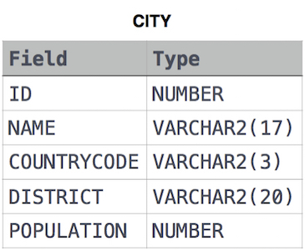

ANSWER:

select * from city where population>100000 and countrycode = "USA";