Part 1 : Website
I had built a website as a part of my HomeWork #2 ( www.hariharanm.com ). I tested it using webpagetest.org ‘s automatic webpage tester.
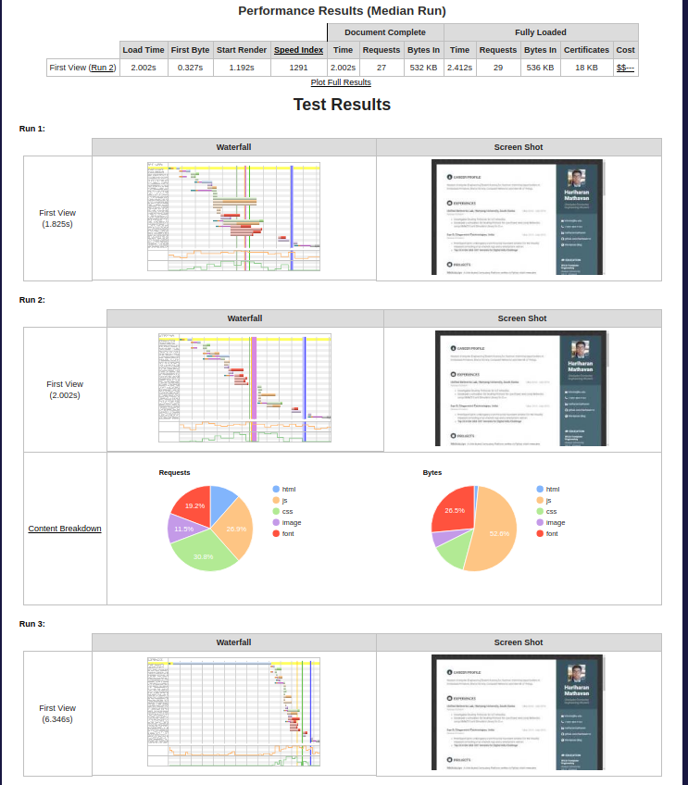

It had scored alright on all aspects except browser caching. This means that a person who visits my website repeatedly will have to download almost everything every single time.
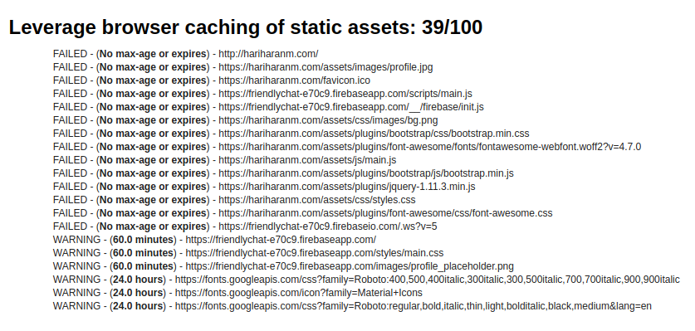
I also found that I could have compressed my images to save a lot of bandwidth.
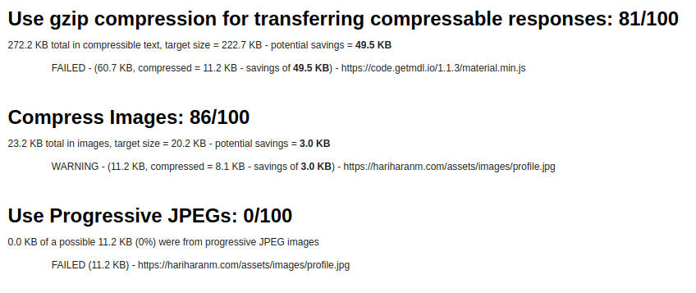

Part 2: Android App
I decided to use an app that I had built almost a year ago ( It is also on the play store https://play.google.com/store/apps/details?id=in.alcheringa.alcher17 ). This app is mostly static but contains a lot of images and animations. I decided to test whether the app can run properly on the top devices being used today.

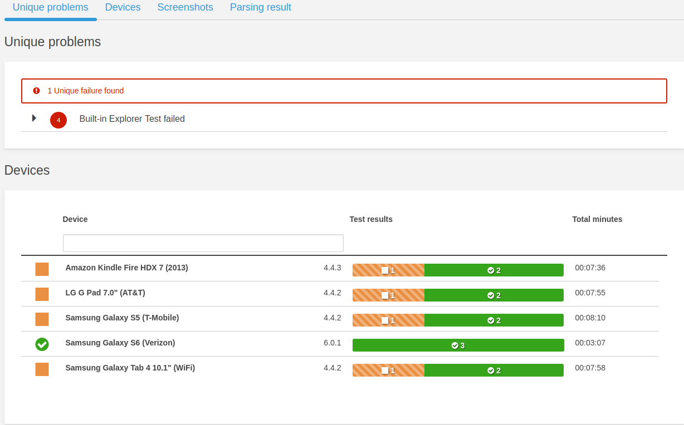

It failed the Built-in File Explorer test for almost all the cases. So I decided to look into the logs to find out what the problem was.

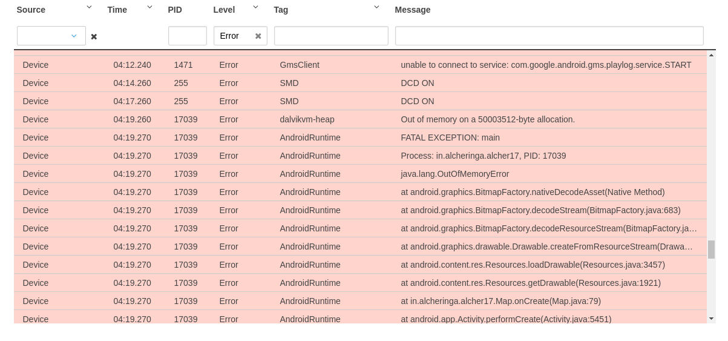
This says that I had a problem with the drawable. After watching the video, I found that the issue was with the resolution of an image I had used for a map. The image was just too huge and when it was zoomed it gave an OutOfMemoryError.

