|  |  |
| --- | --- |
| **20CS2016L – Database Systems Lab** | **URK22AI1048** |

|  |  |
| --- | --- |
| **Ex no:** | **9- DATABASE NORMALIZATION** |
| **Date** | **19-03-24** |

**Objective:**

To normalize the table for a given application.

**Description:**

Database Normalization is a technique that helps in designing the schema of the database in an optimal manner. The normalisation process is used to reduce the redundancy in a relation or set of relations. Anomalies in insertion, deletion, and update which can be caused by relation redundancy can be avoided by normalization. The process is incremental, and higher degrees of database normalisation cannot be performed until the preceding levels are met.

There are the four types of normal forms:

|  |  |
| --- | --- |
| Normal Form | Description |
| 1NF | A relation is in 1NF if it contains an atomic value. |
| 2NF | A relation will be in 2NF if it is in 1NF and all non-key attributes are fully functional dependent on the primary key. |
| 3NF | A relation will be in 3NF if it is in 2NF and no transition dependency exists. |
| 4NF | A relation will be in 4NF if it is in Boyce Codd normal form and has no multi-valued dependency. |
| 5NF | A relation is in 5NF if it is in 4NF and not contains any join dependency and joining should be lossless. |

**First Normal Form (1NF)**

* A relation will be 1NF if it contains an atomic value.
* It states that an attribute of a table cannot hold multiple values. It must hold only single-valued attribute.
* First normal form disallows the multi-valued attribute, composite attribute, and their combinations.

|  |  |
| --- | --- |
| **Instructor's name** | **Course code** |
| Prof. George | (CS101, CS154) |

The table is not in 1NF because of multi-valued attribute Course_code. The decomposition of the table into 1NF is shown below:

|  |  |
| --- | --- |
| **Instructor's name** | **Course code** |
| Prof. George | CS101 |
| Prof. George | CS154 |

**Second Normal Form (2NF)**

1. The table should be in the first normal form.
2. The primary key of the table should compose of exactly 1 column.

|  |  |
| --- | --- |
| **Student name** | **Course code** |
| Rahul | CS152 |
| Rajat | CS101 |

As per the second normal form definition, our enrollment table above isn’t in the second normal form. To achieve the same (1NF to 2NF), we can rather break it into 2 tables:

**Students:**

|  |  |
| --- | --- |
| **Student name** | **Enrolment number** |
| Rahul | 1 |
| Rajat | 2 |

The second column is unique and it indicates the enrollment number for the student. Clearly, the enrollment number is unique. Now, we can attach each of these enrollment numbers with course codes.

**Courses:**

|  |  |
| --- | --- |
| **Course code** | **Enrolment number** |
| CS101 | 2 |
| CS154 | 1 |

**Third Normal Form**

In the third normal form, the following conditions are required:

* The table should be in the second normal form.
* There should not be any functional dependency.

|  |  |  |  |
| --- | --- | --- | --- |
| **Course code** | **Course venue** | **Instructor's name** | **Department** |
| MA214 | Lecture Hall 18 | Prof. Ronald | Mathematics Department |
| ME112 | Auditorium building | Prof. John | Electronics Department |

Third normal incorporates functional dependency by decomposing the table into 2 separate tables:

|  |  |  |
| --- | --- | --- |
| **Course code** | **Course venue** | **Instructor's ID** |
| MA214 | Lecture Hall 18 | 1 |
| ME112 | Auditorium building, | 2 |

Here, the third column is the ID of the professor who’s taking the course.

|  |  |  |
| --- | --- | --- |
| **Instructor's ID** | **Instructor's Name** | **Department** |
| 1 | Prof. Ronald | Mathematics Department |
| 2 | Prof. John | Electronics Department |

### **Boyce-Codd Normal Form (BCNF)**

Boyce-Codd Normal form is a stronger generalization of third normal form. A table is in Boyce-Codd Normal form if and only if at least one of the following conditions are met for each functional dependency A → B:

* A is a superkey
* It is a trivial functional dependency.

### **Fourth normal form**

A table is said to be in fourth normal form if there is no two or more, independent and multivalued data describing the relevant entity.

### **Fifth normal form**

A table is in fifth Normal Form if:

* It is in fourth normal form.
* It cannot be subdivided into any smaller tables without losing some form of information.

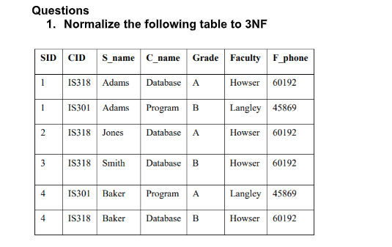

Std_1048(T2):

Course_1048(T3):

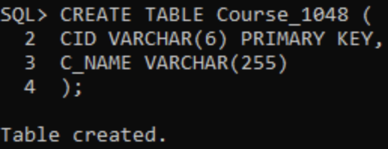

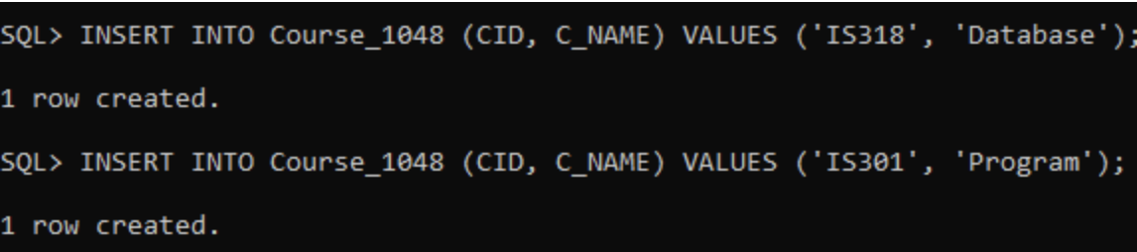

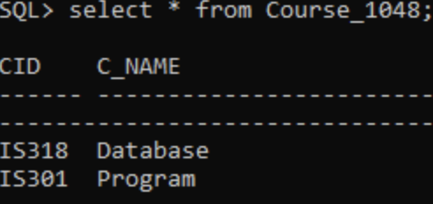

Common_1023(T4):

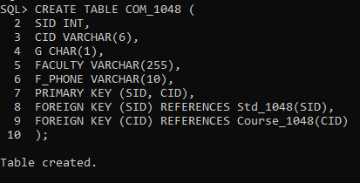

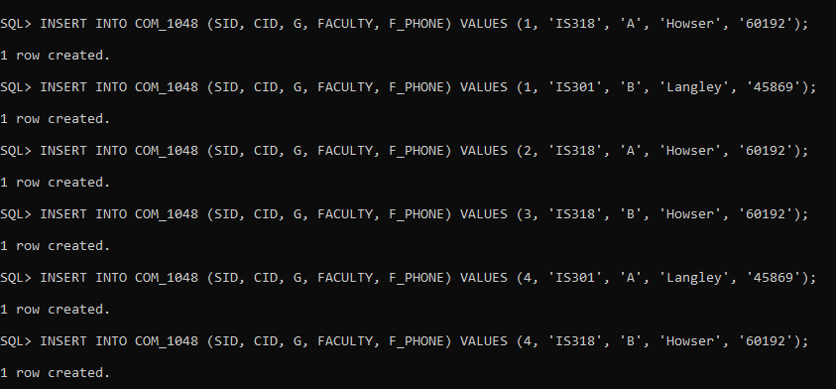

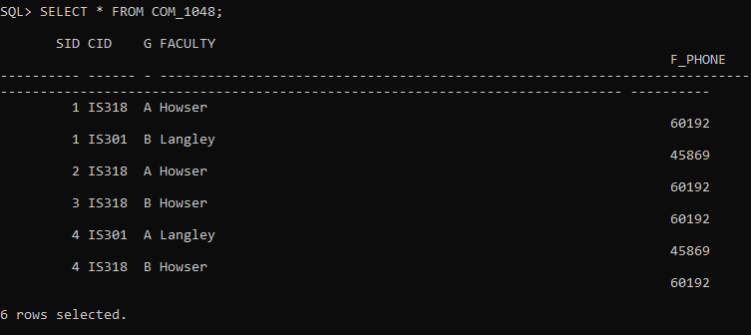

Fac_1048(T5):

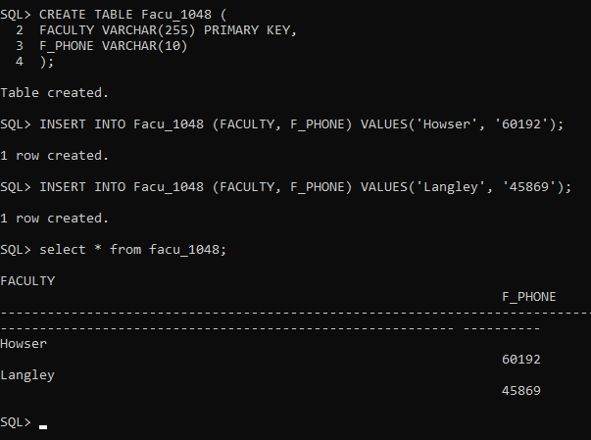

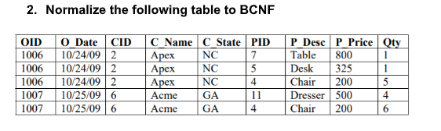

Q2_1048(T1):

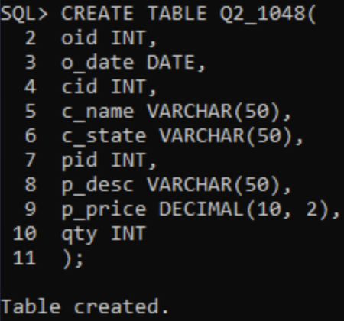

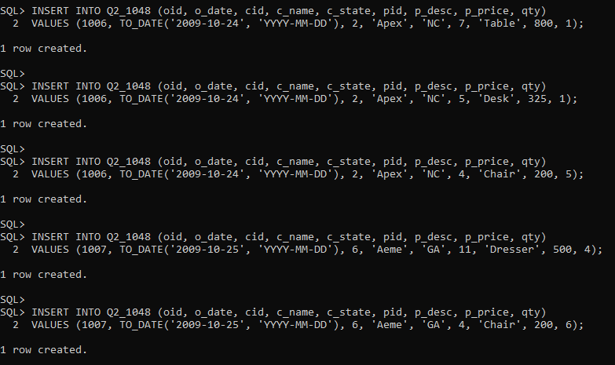

Q2_1048_Customer(T2)

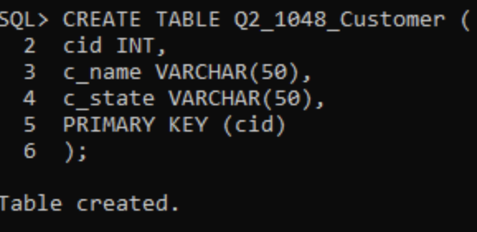

Q2_1046_Product(T3)

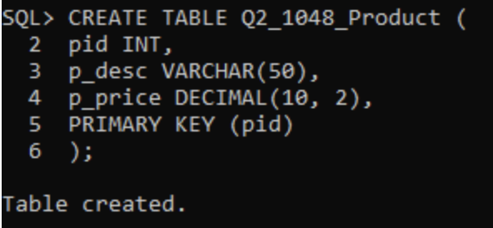

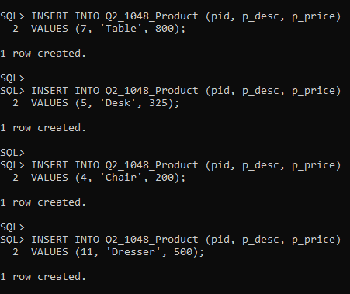

Q2_1048_Order(T4)

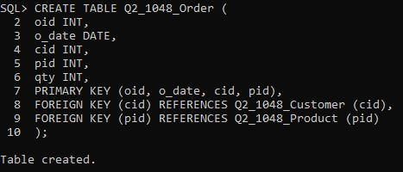

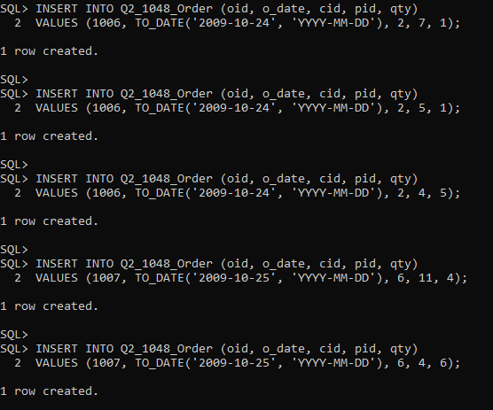

**Result:**

To normalize the table for a given application are successfully executed.