|  |  |
| --- | --- |
| **EXERCISE: 01** | **WEB BASED VISUALIZATION SYSTEM** |
| **DATE** | **12.07.2024** |

**AIM:**

To visualize data using various plots.

**ALGORITHM:**

1. Start
2. Import matplotlib.pyplot as plt.
3. Use the inbuilt functions of plt to plot line chart, bar chart, histogram, scatter plot and pie chart.
4. Update the default parameters to customize the plots.
5. Label and color the plots.
6. Display legends, if any.
7. Stop

**PROGRAM:**

1. **Line plot:**

import matplotlib.pyplot as plt

x = [1,2,3,4,5]

y = [20,40,80,120,240]

plt.xlabel("X-label")

plt.ylabel("Y-label")

plt.title('Graph - I')

plt.plot(x,y)

plt.show()

**OUTPUT:**

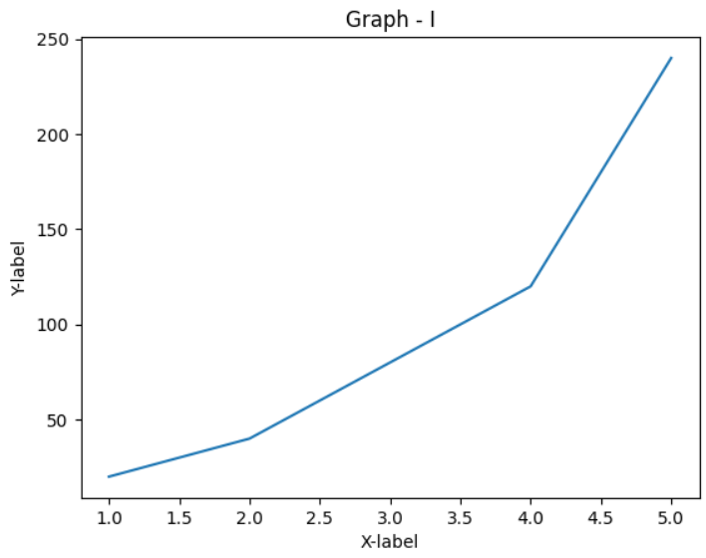

1. **Two lines on the same graph:**

x = [1,2,3]

y1 = [2,4,1]

y2 = [4,1,3]

plt.plot(x,y1,label = 'line1')

plt.plot(x,y2,label = 'line2')

plt.title('two line on the same graph')

plt.legend()

plt.show()

**OUTPUT:**

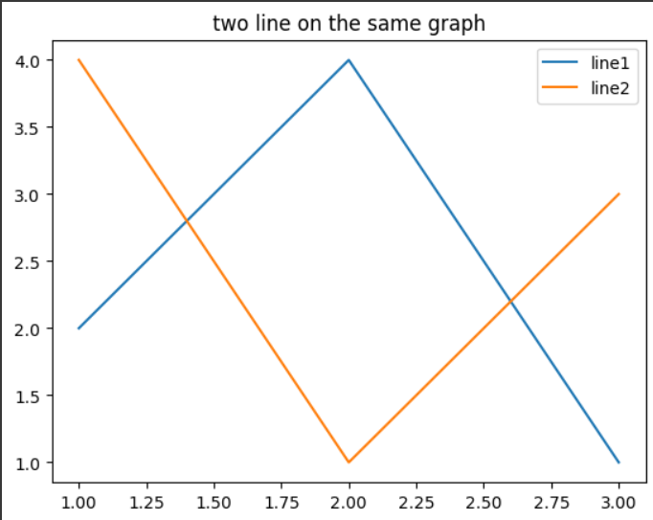

1. **Customized line plot:**

x = [1,2,3,4,5,6]

y = [2,4,1,5,2,6]

plt.figure(figsize = (10,4))

plt.plot(x,y,label = 'line1' , color = 'blue' , linestyle = 'dashed', linewidth = 3,marker = 'o', markerfacecolor='black', markersize=12)

plt.xlabel('X-axis')

plt.ylabel('Y-axis')

plt.title('Customizing plots')

plt.legend()

plt.show()

**OUTPUT:**

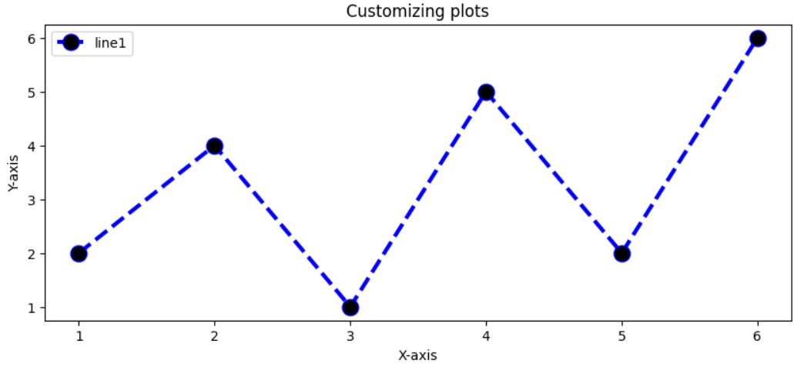

1. **Bar plot:**

x = [1,2,3,4,5]

y = [10,24,36,40,5]

tick_label = ['one','two','three','four','five']

plt.bar(x,y,tick_label = tick_label , width = 0.8, color=['grey' , 'orange'])

plt.xlabel('X-axis')

plt.ylabel('Y-axis')

plt.title('Custom colored bar plot')

plt.show()

**OUTPUT:**

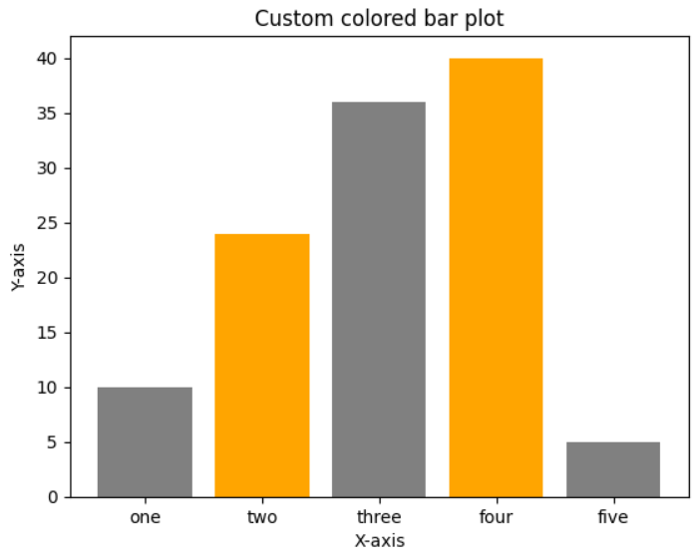

1. **Histogram:**

ages = [2,5,70,40,30,45,50,45,43,40,44,60,7,13,57,18,90,84,22,35,18,77]

range1 = [0,100]

bins = 5

plt.hist(ages,bins,range1,color = 'red',histtype='bar')

plt.title('Histogram')

plt.show()

**OUTPUT:**

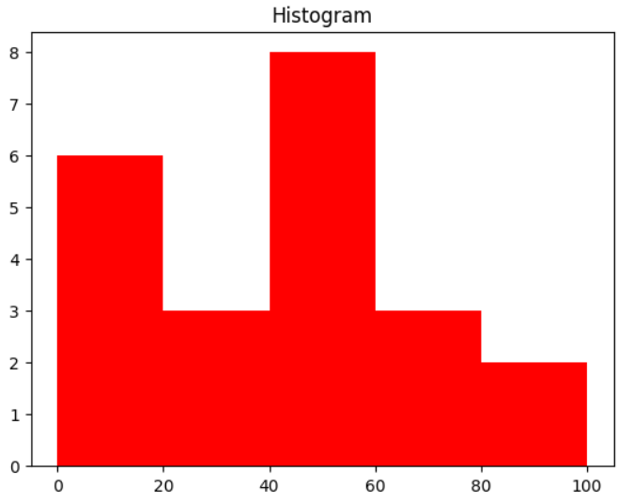

1. **Scatter plot:**

x = [x for x in range(1,11)]

y=[2,4,5,7,6,8,9,11,12,13]

plt.scatter(x,y,label = 'stars',marker = '*')

plt.xlabel('X-axis')

plt.ylabel('Y-axis')

plt.legend()

plt.show()

**OUTPUT:**

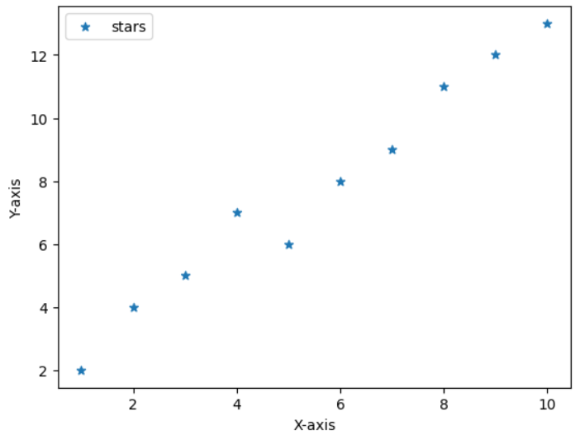

1. **Pie chart:**

activities = ['eat','sleep','work','play']

slices = [3,7,8,6]

colors = ['r','y','g','b']

plt.pie(slices,explode=[0,0,0,0.2],labels = activities, colors = colors,startangle = 30,shadow = True )

plt.title('Pie chart')

plt.show()

**OUTPUT:**

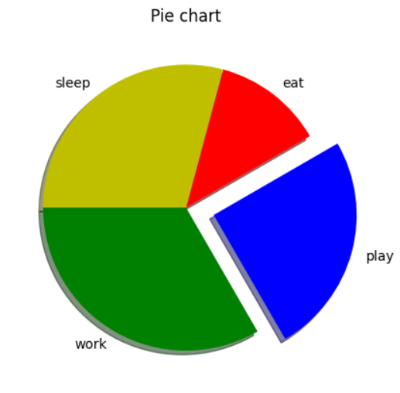

**RESULT:**

The web-based visualization techniques have been implemented and the results have been verified.