|  |  |
| --- | --- |
| **Ex. No. 3** | **2D And 3D Plotting** |
| Date | 25.07.2024 |

# AIM:

To plot 2D and 3D.

# ALGORITHM:

Step 1: Start the program

Step 2: import required libraries Step 3: Initialize the input variables Step 4: Plot the 2D and 3D plot Step 5: Stop the program

# PROGRAM:

1. **2D plotting:**

import matplotlib.pyplot as plt x1 = [0, 1, 2, 3, 4, 5]

y1 = [0, 2, 4, 6, 8, 10]

x2 = [0, 1, 2, 3, 4, 5]

y2 = [5, 4, 3, 2, 1, 0]

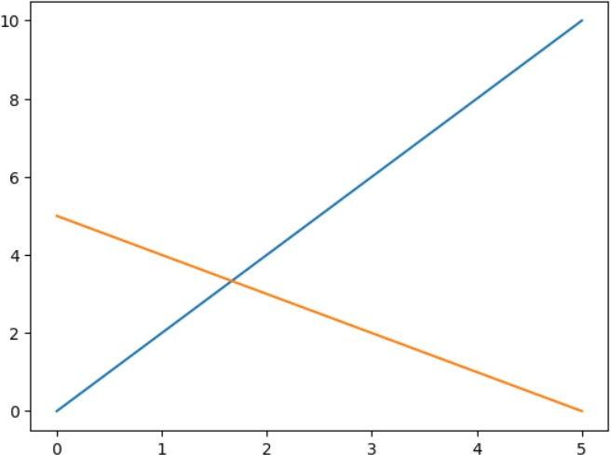plt.plot(x1, y1) plt.plot(x2, y2) plt.show() **OUTPUT:**

# 3D Plotting:

import matplotlib.pyplot as plt

from mpl_toolkits.mplot3d import Axes3D

x1 = [0, 1, 2, 3, 4, 5]

y1 = [0, 2, 4, 6, 8, 10]

z1 = [1, 2, 3, 4, 5, 6]

x2 = [0, 1, 2, 3, 4, 5]

y2 = [5, 4, 3, 2, 1, 0]

z2 = [1, 2, 3, 4, 5, 6]

fig = plt.figure()

ax = fig.add_subplot(111, projection='3d') ax.scatter(x1, y1, z1, c='r', marker='o', label='Line 1') ax.scatter(x2, y2, z2, c='b', marker='^', label='Line 2') ax.legend()

plt.show()

# OUTPUT:

**RESULT:**

The program of 2D and 3D plot is completed and output is verified.