|  |  |  |
| --- | --- | --- |
| **EX.NO:09** | **DESIGN OF WIRELESS LAN ACCESS** | **REG.NO: URK22AI1049** |
| **DATE: 11 -10 -2023** |

# AIM

To design Wireless LAN access and configure wireless router allowing for remote access from PCs as well as wireless connectivity with WPA2 security.

**DESCRIPTION**

Designing a secure and efficient Wireless LAN (Local Area Network) access involves careful planning and configuration to ensure seamless connectivity for both wired and wireless devices while maintaining the highest level of security. Below is a detailed description outlining the steps to design and configure a Wireless LAN access with a wireless router, allowing for remote access from PCs and wireless connectivity with WPA2 security

# CONFIGURATION COMMANDS

Router>en Router#conf t

Enter configuration commands, one per line. End with CNTL/Z. Router(config)#int gig0/0

Router(config-if)#no sh Router(config-if)#int gig0/0.10

Router(config-subif)#encapsulation dot1q 10

Router(config-subif)#ip addr 192.168.10.1 255.255.255.0 Router(config-subif)#

Router(config-subif)#int gig0/0.20

Router(config-subif)#encapsulation dot1q 20

Router(config-subif)#ip addr 172.168.10.1 255.255.0.0 Router(config)#int gig0/0.30

Router(config-subif)#encapsulation dot1q 30

Router(config-subif)#ip addr 172.17.40.1 255.255.0.0 Router(config-subif)#

Router(config-subif)#end Router#

Switch>en Switch#conf t

Enter configuration commands, one per line. End with CNTL/Z. Switch(config)#vlan 10

Switch(config-vlan)#name soory Switch(config-vlan)#vlan 20

Switch(config-vlan)#name 1023

Switch(config)#vlan 30 Switch(config-vlan)#name wireless Switch(config-vlan)# Switch(config-vlan)#int fa0/1

|  |  |  |  |  |  |  |
| --- | --- | --- | --- | --- | --- | --- |
| Switch(config-if)#switchport mode access Switch(config-if)#switchport access vlan 10 Switch(config-if)#int fa0/2  Switch(config-if)#switchport mode access Switch(config-if)#switchport access vlan 20 Switch(config-vlan)#int fa0/7 Switch(config-if)#switchport mode access Switch(config-if)#switchport access vlan 30 Switch(config-if)#int fa0/3  Switch(config-if)#switchport mode trunk  Switch(config-if)#switchport trunk allowed vlan 10,20,30  **PROCEDURE**   1. Configure IP Addressing on the Host PCs. 2. Configure Routers and Switch Interfaces. 3. Configure the wireless router (WRT300N) interface. 4. Test and Verify the Configurations.   **TOPOLOGY DIAGRAM**    **ADDRESSING TABLE** | | | | | | |
|  | **Device** | **Interface** | **IP Address** | **Subnet Mask** | **Default Gateway** |  |
| **R1** | **Gig0/0.10** | **192.168.1.1** | **255.255.255.0** | **NA** |
| **Gig0/0.20** | **172.168.1.1** | **255.255.0.0** | **NA** |
| **Gig0/0.30** | **172.17.40.1** | **255.255.0.0** | **NA** |
| **PC0** | **NIC** | **192.168.1.2** | **255.255.255.0** | **192.168.1.1** |
| **PC1** | **NIC** | **172.168.10.2** | **255.255.0.0** | **172.168.10.1** |
| **PC2** | **NIC** | **172.17.40.101** | **255.255.0.0** | **172.17.40.1** |
| **WRT300N** | **WLS** | **172.17.88.25** | **255.255.0.0** | **172.17.88.1** |

# OUTPUT

**Screenshot of successful ping from Wireless LAN PC to remote PC**.

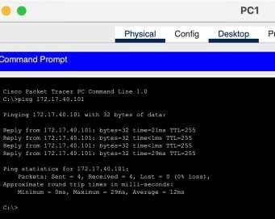

# Screenshot of show running-config of Switch

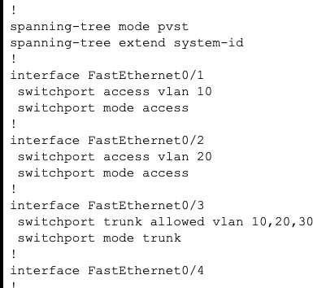

**Screenshot of show running-config of Router**

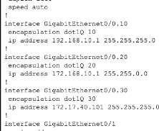

# Screenshot of Routing table

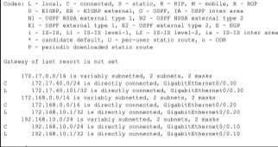

**Screenshot of show vlan brief**

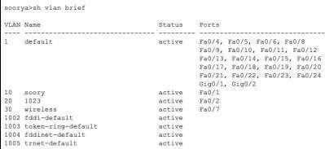

# Screenshot of Wireless Router GUI of wireless access and security.

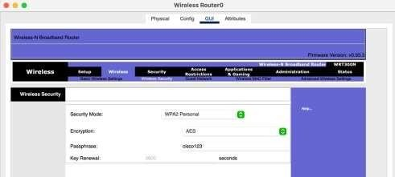

Screenshot of Wireless Router GUI of the network setup.

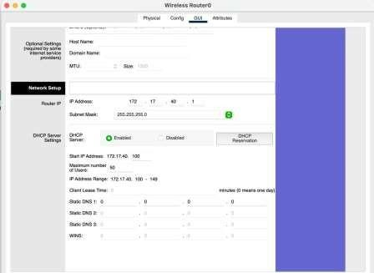

# Screenshot of Wireless Client

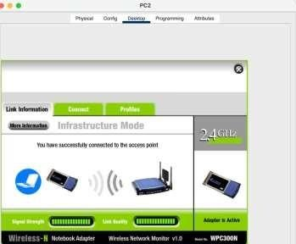

**RESULT**

The above topology was created and the packets and the data was transmitted between the PCto another wireless PC, the desired output was achieved from the above topology.