|  |  |  |
| --- | --- | --- |
| **EX.NO:08** | **Demonstration of Dynamic Routing** | **REG.NO: URK22AI1049** |
| **DATE: 04 -10 -2023** |

# AIM

To design a network topology to perform the initial router configurations required for connectivity by using the IP addresses and configure the RIPv2 dynamic routing that are needed to allow communication between the hosts.

**DESCRIPTION**

Dynamic routing, also called adaptive routing, is a process where a router can forward data via a different route for a given destination based on the current conditions of the communication circuits within a system.

# CONFIGURATION COMMANDS

ROUTER 1

Router>en Router#conf

Enter configuration commands, one per line. End with CNTL/Z. Router (config)#int fa0/0

Router (config-if)#ip addr 192.168.1.1 255.255.255.0 Router (config-if) #no sh

Router (config-if) #int se2/0

Router (config-if) #ip add 10.0.0.2 255.0.0.0 Router (contig-if)#no sh

Router (config-if) #int se3/0

Router (config-if) #ip add 12.0.0.2 255.0.0.0 Router (contig-if)#no sh

Router (confiq-if)#exit

Router (config)#ip route 192.168.2.0 255.255.255.0 10.0.0.3

Router (config)#ip route 192.168.3.0 255.255.255.0 12.0.0.3

ROUTER 2

Router>en Router#conf

Enter configuration commands, one per line. End with CNTL/Z. Router (config)#int fa0/0

Router (config-if)#ip addr 192.168.2.1 255.255.255.0 Router (config-if) #no sh

Router (config-if) #int se2/0

Router (config-if) #ip add 10.0.0.3 255.0.0.0 Router (contig-if)#no sh

Router (config-if) #int se3/0

Router (config-if) #ip add 11.0.0.2 255.0.0.0 Router (contig-if)#no sh

Router (confiq-if)#exit

Router (config)#ip route 192.168.1.0 255.255.255.0 10.0.0.2

Router (config)#ip route 192.168.3.0 255.255.255.0 11.0.0.3

ROUTER 3

Router>en

Router#conf

Enter configuration commands, one per line. End with CNTL/Z. Router (config)#int fa0/0

Router (config-if)#ip addr 192.168.3.1 255.255.255.0 Router (config-if) #no sh

Router (config-if) #int se2/0

Router (config-if) #ip add 11.0.0.3 255.0.0.0 Router (contig-if)#no sh

Router (config-if) #int se3/0

Router (config-if) #ip add 12.0.0.3 255.0.0.0 Router (contig-if)#no sh

Router (confiq-if)#exit

Router (config)#ip route 192.168.1.0 255.255.255.0 12.0.0.2

Router (config)#ip route 192.168.2.0 255.255.255.0 11.0.0.2

# PROCEDURE

1. Configure IP Addressing on the Host PCs.
2. Configure Routers Interfaces.
3. Configure the routers to install the dynamic routing in the routing table
4. Test and Verify the Configurations.

# TOPOLOGY DIAGRAM

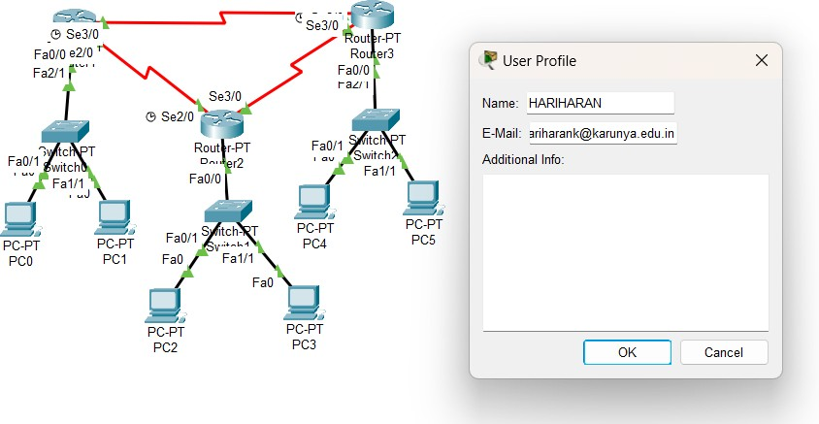

**ADDRESSING TABLE**

|  |  |  |  |  |
| --- | --- | --- | --- | --- |
| **Device** | **Interface** | **IP Address** | **Subnet Mask** | **Default Gateway** |
| **R1** | **Fa0/0** | **192.168.1.1** | **255.255.255.0** | NA |
| **Se 2/0** | **10.0.0.2** | **255.0.0.0** | NA |
| **Se3/0** | **12.0.0.2** | **255.0.0.0** | NA |
| **R2** | **Se2/0** | **10.0.0.3** | **255.0.0.0** | NA |
| **Se3/0** | **11.0.0.2** | **255.0.0.0** | NA |
| **R3** | **Fa0/0** | **192.168,2,1** | **255.255.255.0** | NA |
| **Se2/0** | **11.0.0.3** | **255.0.0.0** | NA |
| **Se3/0** | **12.0.0.3** | **255.0.0.0** | NA |
| **PC1** | **NIC** | **192.168.1.2** | **255.255.255.0** | 192.168.1.1 |
| **PC2** | **NIC** | **192.168.2.2** | **255.255.255.0** | 192.168.2.1 |

# OUTPUT

**Screenshot of Topology**

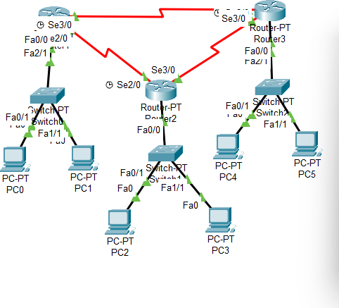

Screenshot of successful ping from PC to Router.

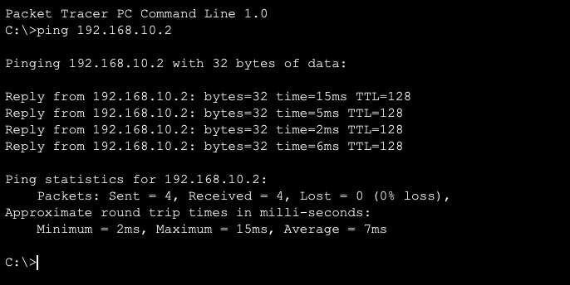

Screenshot of unsuccessful ping from PC to a remote PC.

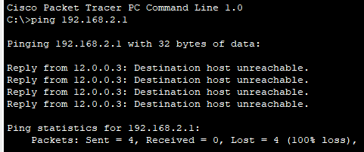

Screenshot of the configuration of RIPv2 from any one router

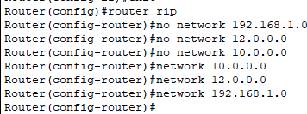

Screenshot of Routing Table of RIP

Screenshot of Show running-config

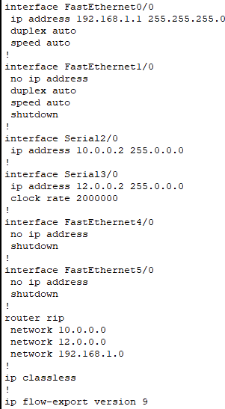

Screenshot of Show ip protocols

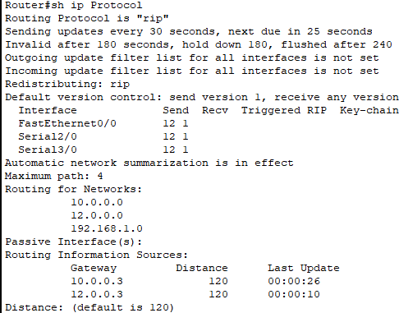

# RESULT

The above topology was constructed and the required output was achieved successfull