|  |  |
| --- | --- |
| **EXERCISE** | **7. FUZZY C-MEANS CLUSTERING** |
| **DATE** | **15.09.2024** |

**AIM:**

Implement fuzzy C-means clustering algorithm to cluster the given dataset.

**DESCRIPTION:**

**Fuzzy Clustering** is a type of clustering algorithm in machine learning that allows a data point to belong to more than one cluster with different degrees of membership.

**Applications in several fields of Fuzzy clustering:**

1. **Image segmentation:** Fuzzy clustering can be used to segment images by grouping pixels with similar properties together, such as color or texture.
2. **Pattern recognition:** Fuzzy clustering can be used to identify patterns in large datasets by grouping similar data points together.
3. **Marketing:**Fuzzy clustering can be used to segment customers based on their preferences and purchasing behavior, allowing for more targeted marketing campaigns.
4. **Medical diagnosis:** Fuzzy clustering can be used to diagnose diseases by grouping patients with similar symptoms together.
5. **Environmental monitoring:**Fuzzy clustering can be used to identify areas of environmental concern by grouping together areas with similar pollution levels or other environmental indicators.
6. **Traffic flow analysis:**Fuzzy clustering can be used to analyze traffic flow patterns by grouping similar traffic patterns together, allowing for better traffic management and planning.
7. **Risk assessment:**Fuzzy clustering can be used to identify and quantify risks in various fields, such as finance, insurance, and engineering.

**PROGRAM:**

import numpy as np

import skfuzzy as fuzz

import matplotlib.pyplot as plt

np.random.seed(0)

data = np.random.rand(100, 2)

n_clusters = 3

*# Apply fuzzy c-means clustering*

cntr, u, _, _, _, _, _ = fuzz.cluster.cmeans(

data.T, n_clusters, 2, error=0.005, maxiter=1000, init=None)

cluster_membership = np.argmax(u, axis=0)

print('Cluster Centers:', cntr)

print('Cluster Membership:', cluster_membership)

plt.figure(figsize=(8, 6))

*# Scatter plot for each cluster*

colors = ['b', 'g', 'orange']

for i in range(n_clusters):

plt.scatter(data[cluster_membership == i, 0], data[cluster_membership == i, 1],

c=colors[i], label=f'Cluster {i+1}')

plt.scatter(cntr[:, 0], cntr[:, 1], marker='x', color='red', s=200, label='Centroids')

*# Add labels and legend*

plt.xlabel('Feature 1')

plt.ylabel('Feature 2')

plt.title(f'Fuzzy C-means Clustering with {n_clusters} Clusters')

plt.legend()

plt.show()

**OUTPUT:**

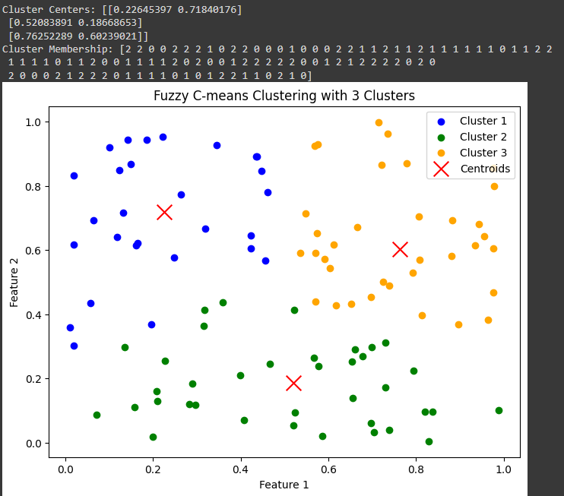

**RESULT:**

The above questions are coded and solved using the fuzzy C-means clustering algorithm.