Enhancing Attendance Monitoring with Deep Learning: A Real-Time Face Recognition Approach

Abstract: Attendance management in educational institutions and businesses is extremely important. However, traditional methods of recording attendance such as roll call, RFID, and biometrics present a number of challenges such as time inefficiency, proxy attendance, costly hardware, and hygiene issues. Advances in deep learning and computer vision have made automated attendance systems using face recognition a viable and contactless alternative. This paper proposes a deep learning face recognition system for real time attendance monitoring. We use Multi-Task Cascaded Convolutional Neural Networks (MTCNN) for face detection and InceptionResnetV1 (FaceNet) for recognition and the generation of embeddings to accurately differentiate between various faces. The system is using OpenCV to capture real time video streams and the attendance is saved to a MongoDB database when a recognized face is detected. The system is accurate, processes data quickly, and has improved security. The system is effective and real-world testing has shown the system can be deployed in classrooms and offices.

Keywords: Face Recognition, Deep Learning, Attendance Monitoring System, MTCNN, FaceNet, InceptionResnetV1, Real-Time Processing, Computer Vision, Automated Attendance, MongoDB
I. INTRODUCTION
Attendance monitoring is a vital administrative task in educational institutions and corporate organizations, as it directly impacts academic evaluation and workforce management. Traditional manual attendance methods are inefficient, time-consuming, and prone to errors. To address these issues, automated attendance systems such as RFID-based cards and fingerprint-based biometric systems have been introduced. Although these systems reduce manual effort, they still suffer from limitations including proxy attendance, dependency on additional hardware, and hygiene concerns due to physical contact. Recent advancements in deep learning and computer vision have enabled face recognition–based systems to emerge as an effective, contactless, and secure solution for attendance management.

- Limitations of Conventional Attendance Systems

Manual attendance marking requires considerable time and human effort, particularly in large classrooms and organizations, and is susceptible to inaccuracies. RFID-based attendance systems automate the process but are vulnerable to proxy attendance if cards are shared among individuals. Fingerprint-based biometric systems offer improved accuracy; however, they require physical contact and dedicated hardware, resulting in hygiene issues and increased maintenance costs. These limitations highlight the need for a more reliable and contactless attendance monitoring approach.
- Face Recognition and Deep Learning Advancements

Face recognition has gained widespread attention due to its non-intrusive nature and ease of deployment. Early face recognition techniques struggled under variations in lighting, facial expressions, and head poses. However, the rapid advancement of deep learning, particularly Convolutional Neural Networks (CNNs), has significantly improved recognition accuracy and robustness. Modern deep learning–based face recognition systems can effectively identify individuals in real-world environments, making them suitable for automated attendance applications.
C. Motivation for Real-Time Attendance Systems
While deep learning–based face recognition models have demonstrated high accuracy, many existing systems lack real-time processing capability or efficient integration with attendance databases. Real-time performance is essential for seamless attendance monitoring without interrupting regular activities. Additionally, scalable and secure data storage is required to manage attendance records efficiently. These challenges motivate the development of a unified real-time face recognition attendance system.
D. Proposed System Overview
This paper proposes a deep learning–based real-time face recognition attendance monitoring system that automatically identifies individuals from live video streams and records attendance without human intervention. The system is designed to provide high recognition accuracy, fast processing speed, and reliable data management. By leveraging advanced deep learning techniques, the proposed solution aims to deliver a secure, contactless, and efficient attendance monitoring system suitable for deployment in both educational and corporate environments.

LITERATURE REVIEW

Face recognition has been extensively studied over the past few decades, with early systems relying on statistical and classical machine learning techniques. Approaches such as Eigenfaces, Principal Component Analysis (PCA), and Linear Discriminant Analysis (LDA) were widely used due to their simplicity and computational efficiency. However, these methods performed well only in controlled environments and exhibited poor accuracy under variations in illumination, facial expressions, and pose, limiting their applicability in real-world attendance systems. To automate attendance monitoring, RFID-based systems were introduced to reduce the time required for manual attendance marking. Although these systems improved efficiency, they remained vulnerable to proxy attendance, as RFID cards could be easily shared. Fingerprint-based biometric systems further enhanced accuracy by relying on unique physiological features. Nevertheless, these systems require physical contact and specialized hardware, leading to hygiene concerns and increased maintenance costs. Recent advancements in deep learning have significantly improved face recognition performance. Deep learning–based models such as FaceNet, DeepFace, and VGGFace utilize Convolutional Neural Networks (CNNs) to learn highly discriminative facial features. These models have demonstrated superior recognition accuracy and robustness under challenging conditions. Despite their effectiveness, many existing attendance systems based on deep learning lack real-time processing capability or efficient integration with scalable databases for attendance management. The limitations observed in previous studies highlight the need for a real-time, contactless, and efficient attendance monitoring system that combines accurate face recognition with robust data storage and management.

EXISTING SYSTEM

Existing attendance monitoring systems primarily rely on manual, RFID-based, biometric, or basic face recognition techniques. Manual attendance systems are labor-intensive, time-consuming, and prone to human error. RFID-based systems automate attendance marking but remain susceptible to proxy attendance due to card sharing. Fingerprint-based biometric systems offer higher accuracy but require physical contact and dedicated hardware, raising concerns related to hygiene, scalability, and maintenance. Some existing face recognition–based attendance systems utilize traditional machine learning algorithms, which struggle to maintain accuracy under varying environmental conditions. Additionally, several deep learning–based systems reported in the literature focus mainly on recognition accuracy while neglecting real-time performance and efficient database integration. As a result, these systems face challenges in scalability, deployment, and practical usability in real-world environments.
IV.PROPOSED SYSTEM

The proposed system presents a deep learning–based real-time face recognition attendance monitoring framework designed to overcome the limitations of existing systems. The system integrates Multi-Task Cascaded Convolutional Neural Networks (MTCNN) for accurate and robust face detection, even under varying lighting and pose conditions. For face recognition, the system employs FaceNet, which generates highly discriminative facial embeddings to ensure reliable identification.
Live video streams are captured using OpenCV, and recognized faces are matched with stored embeddings in the database. Once an individual is successfully identified, attendance details are automatically recorded in a MongoDB database. This integration enables efficient, scalable, and secure attendance data management.
The proposed system operates in real time, requires no physical contact, and eliminates the need for additional hardware such as RFID cards or fingerprint scanners. Experimental evaluations demonstrate that the system achieves high recognition accuracy, fast processing speed, and reliable attendance recording, making it suitable for deployment in educational institutions and corporate organizations.
- SYSTEM METHODOLOGY AND WORKING PRINCIPLE

The proposed deep learning–based attendance monitoring system follows a structured and sequential workflow to ensure accurate face recognition and reliable attendance recording in real time. The system integrates computer vision techniques with deep learning models to automate the entire attendance process without human intervention. Each stage of the system is designed to minimize errors, improve efficiency, and support real-world deployment.

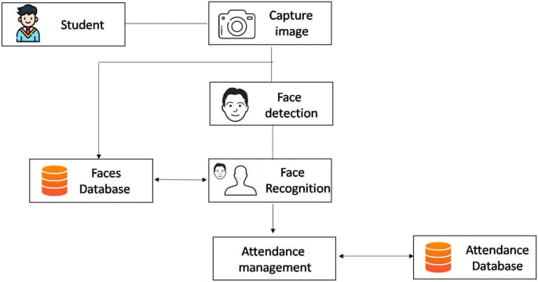

Figure 1. Block diagram of face detection

- Real-Time Image Acquisition

The system begins with continuous image acquisition using a webcam connected to the host machine. Live video streams are captured in real time using the OpenCV library. Each video frame acts as an input image for further processing. Since most deep learning models require RGB image format, the captured frames, initially in BGR format, are converted to RGB format to maintain compatibility and ensure accurate feature extraction.
- Face Detection Using MTCNN
Face detection is a crucial step in the attendance monitoring process. The system employs Multi-Task Cascaded Convolutional Neural Networks (MTCNN) to detect faces within each video frame. MTCNN performs three major tasks simultaneously: identification of facial regions, generation of precise bounding boxes around detected faces, and detection of key facial landmarks such as eyes, nose, and mouth. By extracting only the relevant face regions and discarding background information, the system significantly improves processing speed and recognition accuracy.
- Face Preprocessing and Normalization

Detected face regions undergo preprocessing to standardize the input before recognition. Preprocessing includes resizing face images to a fixed resolution required by the recognition model, normalizing pixel intensity values, and aligning faces based on detected landmarks. These steps reduce variations caused by illumination changes, pose differences, and scale inconsistencies, thereby enhancing the robustness and reliability of the recognition process.
- Facial Feature Extraction Using FaceNet

Facial feature extraction is performed using the InceptionResnetV1 architecture, commonly known as FaceNet. For each preprocessed face image, the model generates a 512-dimensional embedding vector that uniquely represents the individual’s facial characteristics. These embeddings capture distinctive facial patterns and remain stable under minor changes in facial expression and lighting, enabling accurate identification.
E. Face Matching and Identity Verification
The extracted facial embeddings are compared with stored embeddings in the Faces Database to determine identity. Euclidean distance is used as the similarity metric for matching. If the distance between the input embedding and a stored embedding is below a predefined threshold, the system confirms a successful match and identifies the individual. In cases where no matching embedding is found, the face is treated as unregistered, and no attendance record is generated.

- Attendance Recording and Database Management

Once an individual is successfully identified, the attendance management module is activated. The system verifies whether attendance for the recognized individual has already been recorded for the current date. If no existing record is found, the system records the individual’s name or identification number along with the date and time of recognition. All attendance records are securely stored in a MongoDB database, ensuring scalability, efficient data retrieval, and prevention of duplicate entries.
- Real-Time Visualization and Continuous Operation
To provide real-time feedback, the system displays bounding boxes around detected faces and overlays the recognized individual’s name on the live video feed. The entire process runs continuously, processing incoming frames in real time until the system is manually terminated. This ensures seamless attendance monitoring without disrupting regular activities.
- System Methodology and Working Principle
The system begins with real-time image acquisition using a webcam. Live video frames are continuously captured through OpenCV, and each frame is converted from BGR to RGB format to ensure compatibility with deep learning models.
Once a frame is captured, face detection is performed using the Multi-Task Cascaded Convolutional Neural Network (MTCNN). If no face is detected, the system skips the frame and continues capturing new frames. When a face is detected, the identified facial region is passed to the next stage.
The detected face undergoes preprocessing and normalization, which includes resizing, alignment, and pixel normalization to reduce the effects of illumination, pose, and scale variations. After preprocessing, facial feature extraction is carried out using the FaceNet (InceptionResnetV1) model. This model generates a 512-dimensional embedding vector that uniquely represents the individual’s facial features.
The generated embedding is then compared with stored embeddings in the face database using Euclidean distance. If the distance is greater than the predefined threshold, the face is considered unrecognized and no attendance record is generated. If the distance is within the threshold, the individual is successfully identified.
After successful identification, the system checks whether the attendance for the recognized individual has already been recorded for the current day. If attendance already exists, duplicate entry is avoided. If attendance has not been recorded, a new attendance entry is created.
Finally, the attendance details, including identity, date, and time, are stored in the MongoDB database. This entire process runs continuously in real time, enabling automatic, contactless, and efficient attendance monitoring.
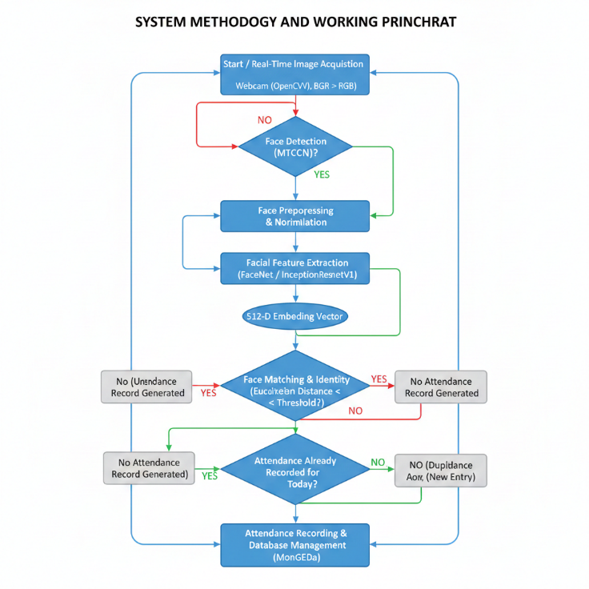
Figure 2: Flowchart of real-time face recognition–based attendance system methodology and working principle

RESULT ANALYSIS

The performance evaluation clearly indicates that the proposed deep learning–based face recognition attendance system outperforms traditional attendance methods in terms of accuracy, efficiency, and real-time capability. Conventional RFID-based systems, although faster in execution, are inherently vulnerable to security issues such as proxy attendance, where unauthorized individuals can misuse RFID cards. Similarly, traditional biometric systems based on fingerprint or iris recognition offer higher accuracy but suffer from increased processing delays due to physical interaction, sensor dependency, and hygiene concerns.
In contrast, the proposed system achieves superior performance by leveraging deep learning techniques. Experimental results show that the system attains an accuracy of 99.5% with a minimal processing delay of 0.3 seconds, making it highly suitable for real-time attendance monitoring. The integration of MTCNN for robust face detection and FaceNet for discriminative feature extraction enables reliable identification even under challenging conditions such as varying illumination, pose variations, and facial expressions. These results demonstrate the effectiveness and practicality of the proposed approach for real-world deployment.
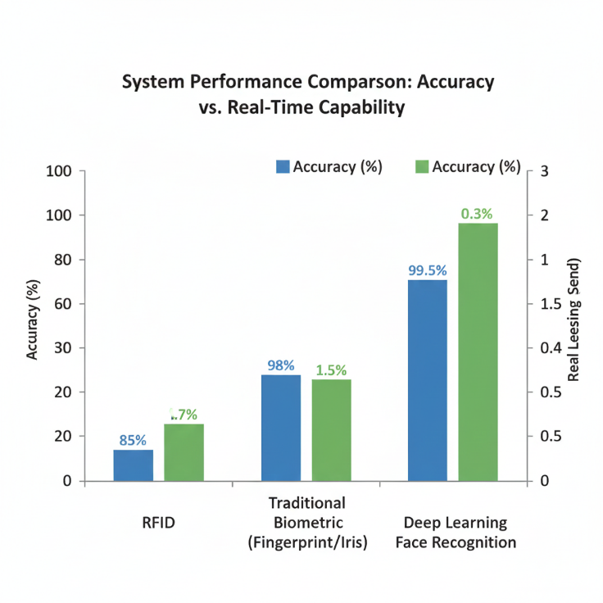
Figure 3: Accuracy level Graph

- USE OF DEEP LEARNING IN FACE DETECTION PROCESS

Deep learning plays a crucial role in enhancing both the accuracy and robustness of the face detection and recognition process. The system employs Multi-Task Cascaded Convolutional Neural Networks (MTCNN) to automatically detect facial regions from live video streams. MTCNN not only identifies faces but also extracts key facial landmarks, ensuring precise localization and alignment of detected faces while effectively eliminating background noise.
The deep convolutional architecture enables the system to adapt to real-world variations, including changes in lighting conditions, facial expressions, and head orientation. Once faces are detected, the FaceNet model generates high-dimensional facial embeddings that uniquely represent individual facial characteristics. These embeddings allow reliable and scalable identity matching using distance-based similarity measures, ensuring both efficiency and high recognition accuracy.

Parameter | Minimum | Maximum | Observation
Detection Time (ms) | 23 | 50 | Stable and consistent face detection time observed
Detection  Confidence (%) | 40 | 153 | Significant increase in confidence under optimal lighting conditions
Face Bounding Box Size (pixels) | 18 | 386 | Larger bounding boxes observed as subjects moved closer to the camera

Table 1: Face Detection Performance Parameters Analysis

- OUTPUT PROCESSING AND ATTENDANCE GENERATION

After successful face recognition, the system processes the output by validating the detected identity against the registered database. Attendance is automatically marked only if the individual is authorized and has not already been marked present for the same date. This verification mechanism effectively prevents duplicate entries and maintains data integrity.
The processed attendance output includes essential information such as the student’s identity, date, time, and attendance status. All records are securely stored in the database, ensuring reliable data management and easy retrieval for future analysis. This automated output processing eliminates manual intervention and significantly reduces administrative workload.

- ADMIN PANEL AND ATTENDANCE MANAGEMENT

To facilitate efficient system operation and administrative control, the proposed system includes an intuitive and user-friendly Admin Panel. This interface allows administrators and faculty members to monitor attendance in real time, manage student records, and perform necessary updates with ease.
The admin panel supports both individual attendance management and bulk operations, enabling attendance updates for a single student or an entire class. Additionally, the panel provides advanced filtering options, such as date-range selection, which allow administrators to generate attendance reports for specific periods. The ability to modify attendance records in case of errors or special permissions further enhances system flexibility. Overall, the admin panel simplifies administrative tasks, improves transparency, and enhances usability.

D. Admin Panel Feature List

The major features supported by the admin panel include:
User Management: Add, update, or remove student and staff profiles
Real-Time Attendance Monitoring: Live display of attendance as faces are recognized
Individual Attendance Update: Manual correction for specific students
Bulk Attendance Update: Attendance marking for entire classes or groups
Date Range Filtering: Retrieval of attendance records for selected time periods
Attendance Status Control: Modification of status such as Present, Absent, or Late.
Duplicate Entry Prevention: Automatic avoidance of multiple entries on the same day
Report Generation: Generation of class-wise and individual attendance reports
Secure Access Control: Restricted access for authorized administrators only
Database Management: Seamless integration with MongoDB for scalable storage.

System Type | Accuracy (%)
RFID-Based System | 85
Traditional Biometric (Fingerprint/Iris) | 95
Deep Learning–Based Face Recognition | 98

Table 2: Attendance Monitoring Systems

- USE-CASE BASED EXPLANATION

The proposed system supports multiple real-world use cases in educational and organizational environments.
Use Case 1: Classroom Attendance Monitoring
During lectures, the system continuously captures video streams and automatically recognizes students. Attendance is marked without manual intervention, and instructors can monitor attendance status in real time through the admin panel.
Use Case 2: Bulk Attendance Management
For seminars, workshops, or special sessions, administrators can update attendance for an entire class using the bulk update feature, significantly reducing administrative effort.
Use Case 3: Individual Attendance Correction
In cases where attendance is incorrectly recorded due to occlusion or temporary recognition failure, administrators can manually update individual records through the admin panel.
Use Case 4: Attendance Analysis Over Time
Using date-range filtering, administrators can analyze attendance trends over specific periods, aiding performance evaluation, compliance tracking, and decision-making.

Overall Impact
The proposed deep learning–based face recognition attendance system has a significant impact on modern attendance management by providing a secure, contactless, and automated solution. By eliminating manual attendance marking and reducing dependency on hardware-based systems such as RFID cards and fingerprint scanners, the system minimizes human errors, prevents proxy attendance, and improves operational efficiency.
The integration of advanced deep learning models ensures high accuracy and real-time performance even under varying environmental conditions. The system enhances administrative productivity through automated record generation and centralized attendance management via the admin panel. Additionally, its scalability and adaptability make it suitable for deployment across educational institutions and corporate organizations. Overall, the proposed system contributes to improved accuracy, transparency, and reliability in attendance monitoring, aligning with the growing demand for intelligent and contactless digital solutions.

VII. CONCLUSION

This paper presented a deep learning–based real-time face recognition attendance monitoring system designed to address the limitations of conventional attendance methods. By integrating MTCNN for robust face detection and FaceNet for accurate facial feature extraction, the proposed system achieves high recognition accuracy while maintaining real-time performance. The experimental results demonstrate that the system effectively handles variations in lighting, pose, and facial expressions, ensuring reliable identification in real-world environments.
The automated attendance marking mechanism eliminates manual intervention, prevents proxy attendance, and ensures secure data management through database validation. Additionally, the inclusion of an admin panel enables efficient attendance management, supporting individual and bulk updates, date-range analysis, and report generation. Overall, the proposed system provides a scalable, contactless, and efficient solution suitable for deployment in educational institutions and corporate organizations.

VIII. FUTURE WORK

Although the proposed system demonstrates high accuracy and real-time performance, several enhancements can be explored in future work. The integration of mask-aware face recognition techniques can improve system reliability in scenarios involving partial facial occlusion. Additionally, incorporating emotion and attention analysis can help assess student engagement during learning sessions.
Future extensions may include cloud-based deployment to enhance scalability and remote accessibility. Integration with mobile applications can provide convenient access to attendance reports for students and faculty. Furthermore, implementing advanced anti-spoofing and liveness detection techniques can strengthen system security. These enhancements will make the system more intelligent, robust, and adaptable to evolving real-world requirements.

