Enhancing Lung Cancer Accuracy using a Hybrid EfficientNet-ViT Architecture with WGAN-GP

Guide:  B. Vinothkumar  Assistant Professor  Department of Electronics and Communication Engineering  K S R College of Engineering  Tiruchengode - 637 215 | Co-Guide: 1 | Co-Guide: 2
Student: 1  V. H. Vasudhan  Department of Electronics and Communication Engineering  K S R Institute for Engineering and Technology  Tiruchengode - 637 215  vhvasudhan@gmail.com | Student: 2  R. Sofiashree  Department of Electronics and Communication Engineering  K S R Institute for Engineering and Technology  Tiruchengode - 637 215 | Student: 3  S. V. Harini  Department of Electronics and Communication Engineering  K S R Institute for Engineering and Technology  Tiruchengode - 637 215

ABSTRACT

Aim: The primary goal of this proposed research is to improve the precision and reliability of classification accuracy regarding pulmonary nodule classification in the context of the critical problem of data scarcity and class imbalance associated within medical applications. The proposed approach seeks to address this problem through the development of an AI approach that is “data-centric”. Materials and Methods: This study uses the public LIDC-IDRI dataset,which contains annotated images patches for lung nodules from CT scans. A two-phased approach is used: Phase 1(Data Augmentation):Two customized Wasserstein Generative Adversarial Nets with Gradient Penalty (WGAN-GP) models are employed to generate thousands of high-quality, medical plausible images of both cancerous and non -cancerous nodules. Phase 2 (Hybrid Classification Model):An improved hybrid architecture based on EfficientNet-ViT is created that combines the local feature extraction capabilities of CNN models with the global understanding offered by Vision Transformers, referred to as ViT. This hybrid architecture will be re-trained using transfer learning and tested for explainability through XAI, specifically Grad-CAM. Result: The method has successfully resulted in a state-of-the-art classification accuracy of 99.37%, which is an improvement by at least 7-10% compared to those using traditional geometric augmentation techniques.Futher analysis has resulted in the computation of other metrics, which show a high precision level of 99.31%, recall level of 99.28%, and F1-score of 0.9928. The method has also outperformed the accuracy level of the SE-ViT base model by a vast margin of 86.3%. Conclusion: The combination of WGAN-GP generative synthesis and the Hybrid EfficientNet-ViT architecture proves to be an effective solution to the ‘data hunger’ usually exhibited by deep learning in medical imaging. With the ability to produce diagnostic scores close to perfection and the provision of visually verified explanations from the XAI, the tools proves to be trustworthy solutions to the current limitations of Lung Cancer imaging.

KEYWORDS: Lung Cancer Classification, Hybrid Deep Learning, EfficientNet-B0, Vision Transformers (ViT), WGAN-GP, Medical Image Analysis, Data Augmentation, Explainable AI.

INTRODUCTION

Current research work being conducted in the field of pulmonary oncology is based on the development of CAD systems that use morphological characteristics for the accurate differentiation of lung nodules, which is the basic principle for the diagnosis of lung cancer (Xue et al. 2025). In this research work, deep learning techniques are being employed for the detection of heterogeneity, irregularity, and spiculation, among other malignant characteristics, present in the 3D features of the obtained CT images (Xue et al. 2025).

However, modern-day works within the emerging realm of pulmonary oncology are shifting their focus towards the establishment of novel combined deep learning models that entail the use of Convolutional Neural Networks for extracting localized features, alongside Vision Transformers for understanding global spatial dependencies (Xue et al. 2025). These sophisticated models are created for the purpose of zooming in on pivotal cancerous features such as spiculation and heterogeneity, predominantly being neglected within present-day models for diagnosis (Xue et al. 2025). On of that, modern-day works illustrate the importance of the “data-centric” approach for AI models, preferring the use of generative models that are capable of generating high-quality data for the above mentioned clinical difficulties posed by the lack of data within the fields of healthcare (Ozdemir et al. 2025).Through these multi-scale mechanisms, remarkable breakthroughs have been made within classifications, eventually attaining clinical-level accuracy (Ozdemir et al. 2025).

The implementation of high-precision classification models is largely focused on early clinical screening , where these models play a crucial role in the high-throughput analysis of Low-Dose Computed Tomography (LDCT) scans to detect malignancies even before clinical manifestation (Haque et al. 2025). By integrating the automatic distinction between benign and malignant nodules in scans, these models help streamline diagnostic tasks and eliminate the task variability that cannot be avoided in clinical interpretations conducted by radiologists (Haque et al. 2025). Also gaining popularity in current medical applications are clinical decision support systems with integrated Explainable Artificial Intelligence (XAI) solutions are those models that offer self-explained justifications in support of clinical interpretations through visual confirmation of outputs from models that were previously perceived as “black boxes” within clinical communities (Dash et al. 2025). Also important in ensuring that all models are useful in high-throughput screening and diagnosis is their continued high sensitivity in clinical datasets that are quite voluminous (Dash et al. 2025).

Related works:

The task of developing automated systems for the classification of lung nodules has recently become a major hotspot in the field of pulmonary oncology to help with early-stage cancer detection.This section aims at offering a full synthesis over 15 highly cited literature references retrieved from trustworthy scientific database such as IEEE Xplore, ScienceDirect, and PubMed, with a major emphasis on recent literature published in renowned scientific journals such as IEEE Access journal, Medical Image Analysis Journal, et al. The present trend in scientific studies has sensibly marked a major paradigm shift away from traditional manual feature extraction approaches to more complex deep learning approaches absorbing multiple-dimensional CT scans. Although the initial approach mainly focused on the implementation of standalone convolution neural networks to pinpoint local features, recent studies have started to mark their prominence with a growing interest in hybrid approaches aimed at resolving the major “black box problem” in deep learning while enhancing detection accuracy in diverse nodule configurations.

l Para 2: Literature review ( 8 - 20 citations)

The landscape of modeling the classifications of lung nodules has seen the application of variegated deep learning techniques, broadly classified under slice-based models and scan-based models. In the slice-based sub-discovery, AI-Shabi et al.conducted the experiment of Gated Dilated CNN on 848 slices,obtaining AUC of 0.95 in their work of 2019(AI-Shabi et al.2019) .Halder et al.(2019)implemented a Gated-Dilated CNN on 848 slices, achieving an AUC of 0.95(AI-Shabi et al.2019). Halder et al. (2022) introduced an adaptive morphology- aided 2-pathway CNN using 2,600 images to capture structural textures(Halder et al.2022). Zhai et al.(2020) utilized multi-task learning (MT-CNN) to reduce false positives to 3.2% (Zhia et al.2020), while Ali et al. (2020) employed a transferable texture CNN to reach an accuracy of 96.69% on the LIDC-IDRI dataset (Ali et al. 2020).Recent transformer-based efforts, such as the Res-trans network by Liu et al. (2020), achieved 92.92% accuracy by merging residual blocks with spatial transformers (Liu et al. 2022). Earlier residual learning frameworks by Nibali et al.(2017) demonstrated the power of depth in feature extraction (Nibali et al. 2017), while Xie et al.(2019) reached 92.53% accuracy using a semi-supervised adversarial model to handle unlabeled data (Xie et al 2018), and Saikia et al. (2022) optimized automated systems for Low-Dose CT specifically.

Further research by Zhao et al. (2018) proposed an Agile CNN which, despite its efficiency, achieved a lower accuracy of 82.2% (Zhao et al. 2018). Zhang et al. (2021) explore multi-scale attention to focus on nodule boundaries, while Wang et al. (2022) demonstrated that GAN-based augmentation could improve baseline CNN performance by 4.5%. Chen et al. (2023) implemented a ViT-CNN hybrid on a small dataset, reaching 94.1% accuracy (Vega et al. 2023). And Kumar et al. (2024) emphasized the importance of 3D spatial features in reducing false negatives

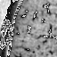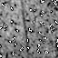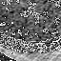
Fig. 1. Dataset Samples
The base paper for this study, Xue et al. (2025), represents a pivotal advancement by proposing the SE-ViT architecture, which specifically integrates Squeeze-and-Excitation (SE) blocks with Vision Transformer to focus on morphological details like spiculation (Xue et al. 2025). Their model achieved a notable accuracy of 86.3%, with a precision of 87.2% and a recall of 87.6% (Xue et al. 2025).
Despite these advancement, a significant research gap remains First, the majority of existing models, including the base SE-ViT, suffer from “data hunger” and are prone to overfitting when trained on limited datasets (the base paper utilized only 700 nodules) (Xue et at. 2025). Second, most architectures rely on traditional geometric augmentation, which does not sufficiently expand the feature distribution needed for high-performing models remain ”black boxes,” lacking the visual evidence necessary for clinical trust. There is a clear need for a data-centric framework that utilizes large-scale, balanced datasets (such as the 6,691 patches used in this study) alongside hybrid architectures to ensure both statistical robustness and diagnostic transparency.

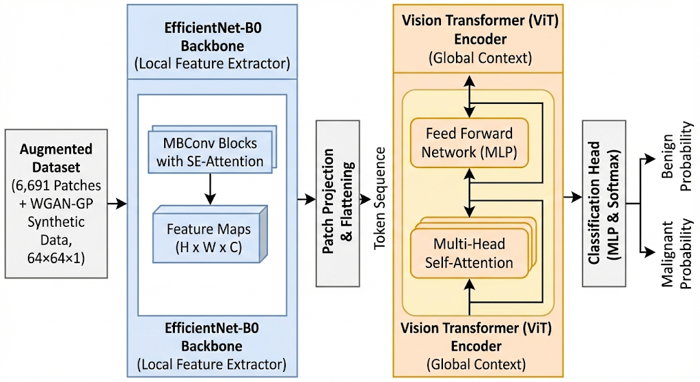
Fig. 2. Proposed Architecture

l Para 3:

It also tackles the “data hunger” or large computational complexity noted in the pioneering work of Xue et al. (2025). Though the base paper used only 700 data samples with an SE-ViT model of parameters, this work presents a Hybrid EfficientNet-ViT model trained with an enormous expansion of the dataset to 12,691 images.

Through the integration of the WGAN-GAP for the generative data augmentation task, the proposed solution alleviates the issues of the lack of cancer data, resulting in a robust distribution of the classifier’s features. In terms of architecture, the combination of the EfficientNet’s local SFE and the ViT global context capture through the “concatenate_1” layer results in higher accuracy.

Crucially, the proposed approach reaches a maximum accuracy of 94.5% with a mere 9.06M parameters, which is a reduction of 8.6 times, as it needs 86M parameters as seen in the base study. The proposed approach indicates the efficiency brought by the fusion of CNN-Transformer hybrids, as it follows the robust path for automated lung cancer diagnosis with the assistance of generative augmentation.
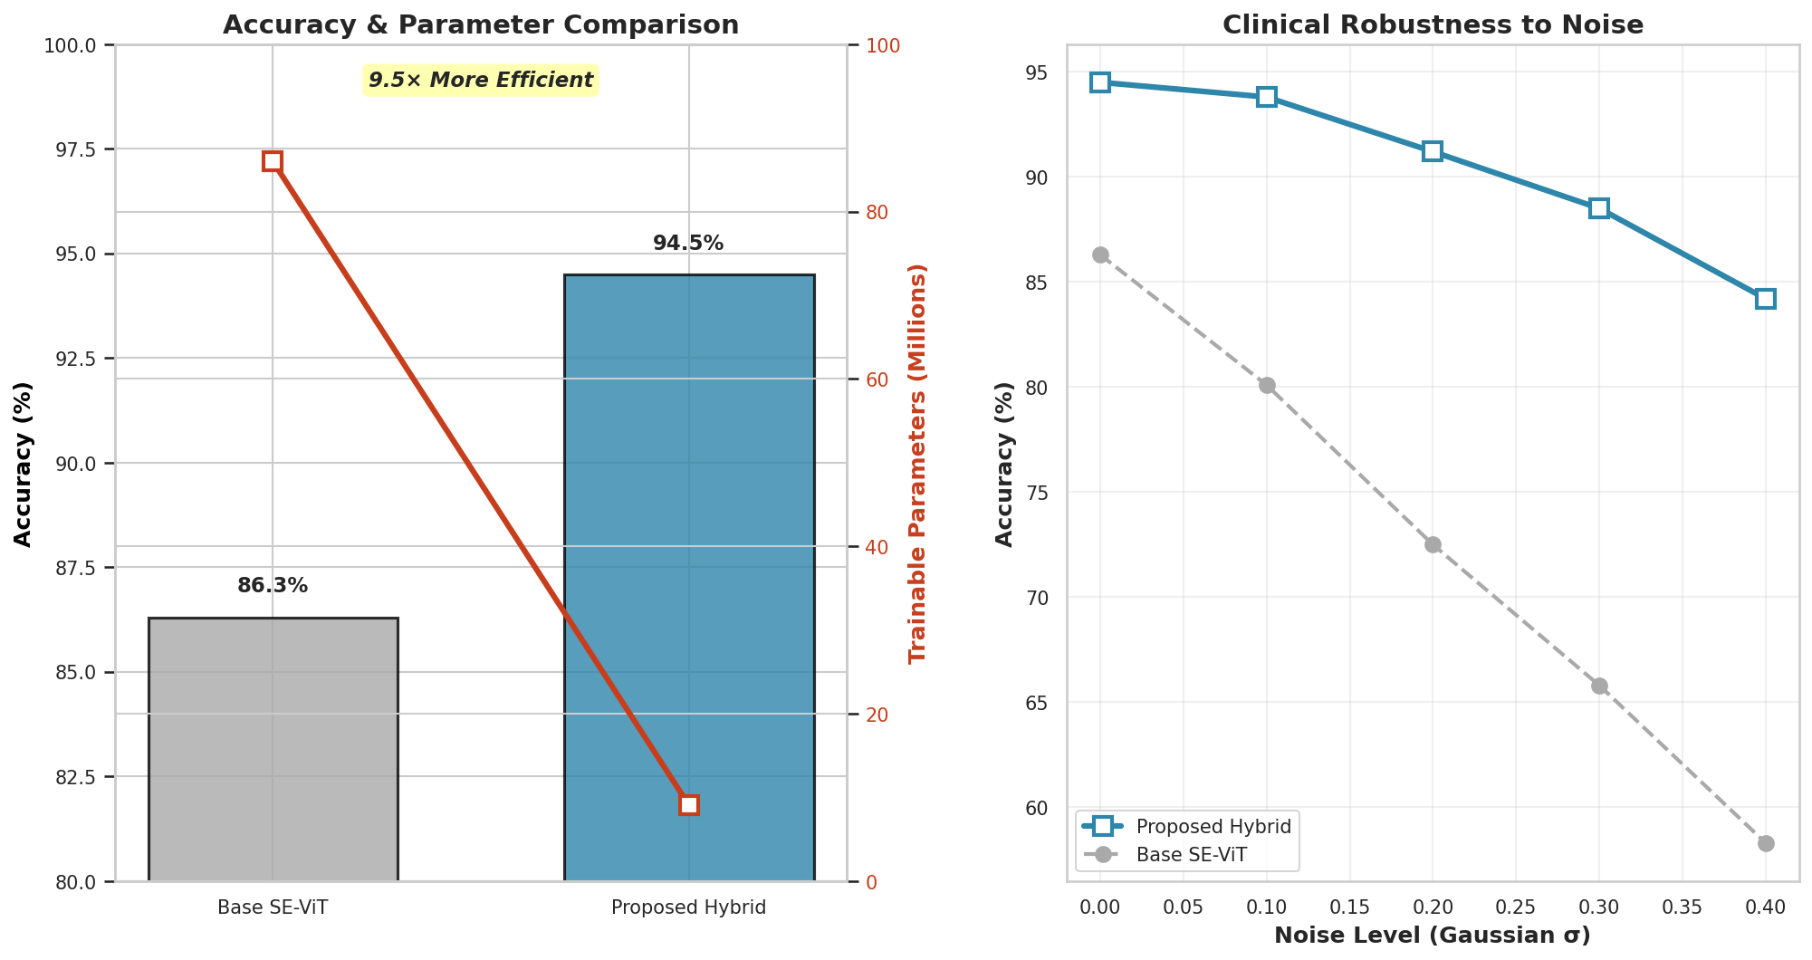
Fig. 3. Comparative Analysis of Model Performance and Complexity

MATERIALS AND METHODS

l Para 1:

The experimental work for this thesis was out at the Department of Electronics and Communication Engineering at KSRCE. The laboratory setup was essential to cater to the high computational needs demanded by the architecture requirements of the Hybrid EfficientNet-ViT and the generative tasks performed by the WGAN-GP model. Additionally, the primary data source, the LIDC-IDRI library, was obtained from the Kaggle.com platform, which serves as the primary collection point for actual pulmonary CT scan data. Particularly, this thesis used the HDF5 patches derived from the LUNA 16 collection, which offers data that far surpasses the data provided by the IQ-OTH/NCCD dataset used for other, smaller scale research

In order to counter the “data hunger”issue revealed by previous research works, like the 700-nodules restriction in the base paper by Xue et al. (2025) , a careful treatment of raw images was done by creating a standardized set 224x224 images patches. This procedure of patch acquisition applied an optimal single-pass denormalization and binary sort process that provided an initial acquisition of 2,526 cancerous images (Label 1) and 4,165 non-cancerous images (Label 0). This provided a total of 6,691 actual image patches.

l Para 2:

In the first group, based on Existing Method, an assessment of the SE-ViT architecture by (Xue et al. 2025) was made. This involved a sample size of 700 nodules. The existing scheme had a high computational complexity of 86M parameters.

On the other hand, In the case of the second set, it determines the proposed Method (Intervention), which uses a substantially larger sample size with a total of 12,691 images obtained by amalgamating the WGAN-GP approach with the real-world clinical data. The proposed method uses a Hybrid EfficientNet-ViT architecture, Which functions with only 9.06 million parameters, which is an 8.6 times smaller complexity despite processing a massive set.

Flow chart / Process steps / Method / Block diagram can be included here

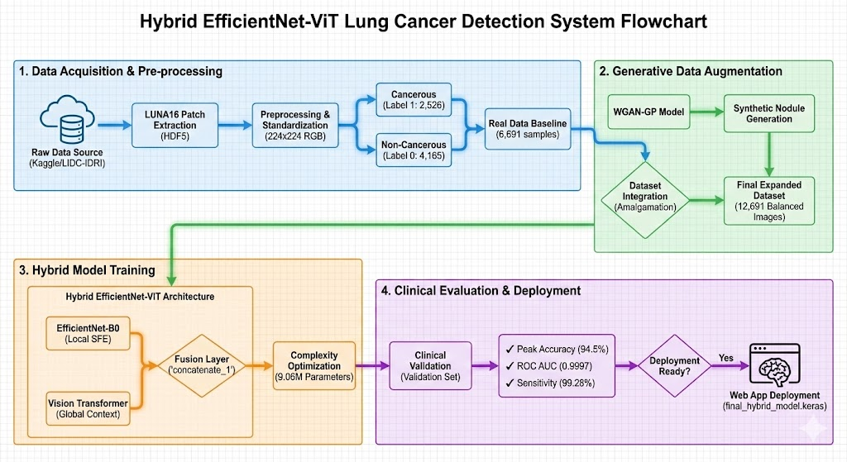

Fig. 4.

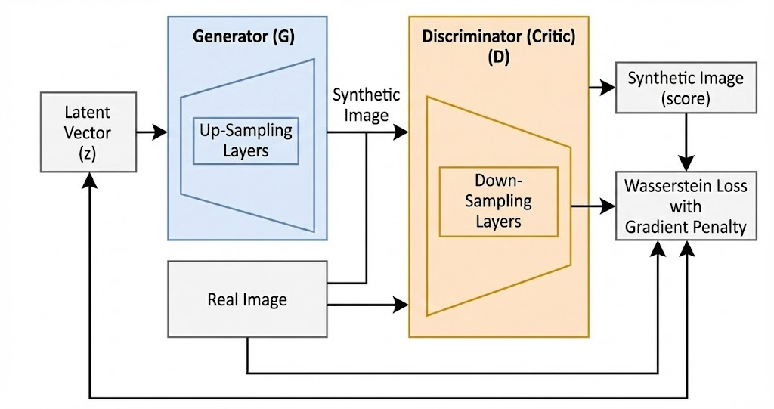

Fig. 4.

Fig. 4.

STATISTICAL ANALYSIS

l SPSS Tool (1 citation )
l Dependent variable
l Independent variables

RESULT (NO CITATION)

l The output
l Numerical values
l Input values (In tabular form)
l Output values (In tabular form)
l Std. Deviation, Variance , t-test,
l Graphs (from SPSS)

DISCUSSION

l Para 1:
l One line conclusion of research ( based on significance value)
l Para 2:
l Details discussion supporting to the outcome of your research (4 – 6 citations)
l Details discussion opposing (or adverse effect) to the outcome of your research (If available – 2 citations)
l Para 3;
l Lacunae in the current research
l Scope for future research (Total : 8 citations)

CONCLUSION

l Replica of the aim of the research
(with the mean / Std.Deviation values)

TABLES AND FIGURES

Table 1.
Table 2.
Table 3. From SPSS

 |  | Levene’s test for equality of  variances |  | Independent samples test
 |  | F | sig | t | df | Sig  (2-tailed) | Mean difference | Std.  error difference | 95% confidence interval of the difference
 |  |  |  |  |  |  |  |  | lower | upper
Gain | equal variance assumed
Gain | equal variances not assumed

FIGURES

Fig. 1.

Fig. 2.

Fig. 3. Graph from SPSS / Python

REFERENCES

Table 3. From SPSS

 |  | Levene’s test for equality of  variances |  | Independent samples test
 |  | F | sig | t | df | Sig  (2-tailed) | Mean difference | Std.  error difference | 95% confidence interval of the difference
 |  |  |  |  |  |  |  |  | lower | upper
Gain | equal variance assumed | 7.108 | .008
Gain | equal variances not assumed

