THREAT MODEL AND SECURE CONFIGURATION
Security assessment report | STRIDE-based analysis
Prepared as a beginner-friendly example for a small web application.

1. Objective and scope
Identify realistic security threats to a small web application, assess their likelihood and impact, and recommend proportionate defensive controls. The analysis uses the STRIDE threat-modelling method.

2. Assumptions and scope
- Because the screenshot does not name a particular application, this report uses a representative small web application with user registration/login, a browser-based interface, an application/API server, a database, an administrator dashboard, logging, and optional external email/payment services.
- The application is assumed to be internet-accessible and to store basic account/profile information. No real credentials, production data, or live systems are used in this example.
- All testing and configuration checks should be performed only in an environment you own or are explicitly authorised to assess.
In scope: browser-to-server traffic, authentication, application/API logic, database access, administrator functions, logs, and optional third-party services. Out of scope: physical security, the internal security of third-party providers, and a full production penetration test.

3. System assets
ID | Asset | Security needs
A1 | User account data | Confidentiality, integrity
A2 | Authentication credentials and sessions | Confidentiality, integrity
A3 | Application source code and configuration/secrets | Confidentiality, integrity
A4 | Database records | Confidentiality, integrity, availability
A5 | Admin functions and privileges | Integrity, availability
A6 | Audit logs and security events | Integrity, availability

4. Threat model diagram and data flows
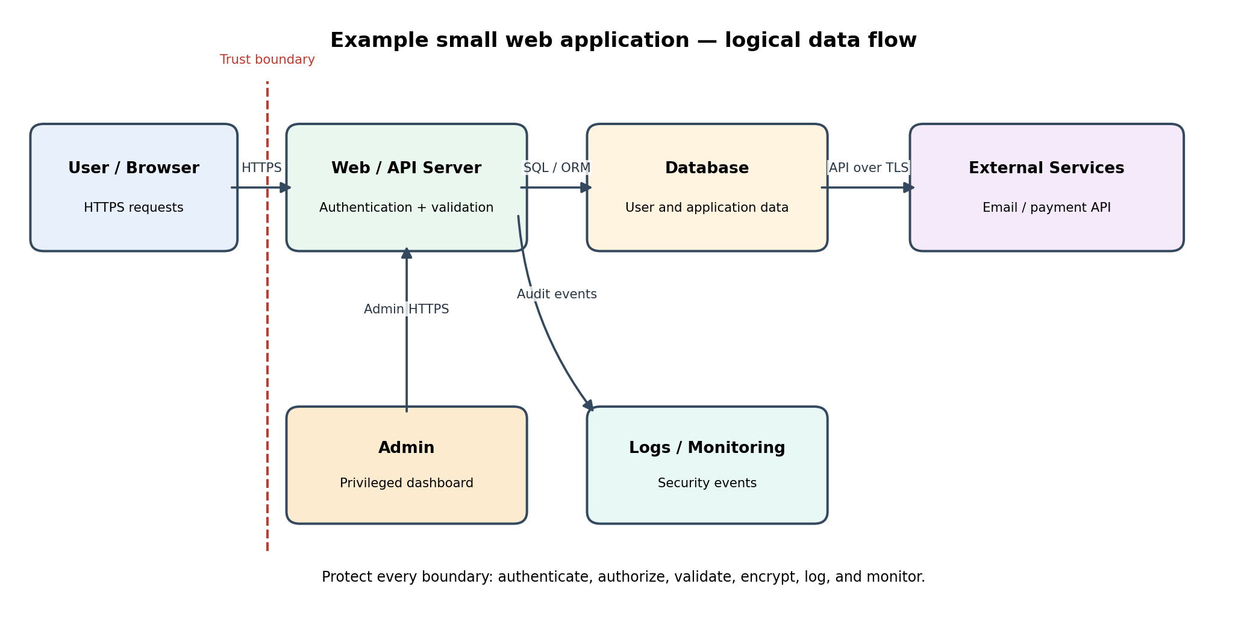
Main flows: (1) user browser sends HTTPS requests; (2) web/API server authenticates, validates and authorises requests; (3) server accesses the database through parameterised queries/ORM; (4) server communicates with external providers over TLS; (5) administrator uses a protected admin interface; (6) security events are sent to protected logs.
Trust boundaries: the public internet to the application edge; the application server to the database; the application to third-party services; and ordinary-user access to privileged admin functions. Treat all data crossing a boundary as untrusted until validated.

5. STRIDE threat analysis and risk register
Scoring: Likelihood and impact are Low / Medium / High / Very High. Overall risk is a qualitative prioritisation, not a measured probability. Reassess after implementation and testing.
ID / STRIDE | Threat scenario | Weakness / cause | Likelihood | Impact | Priority | Recommended controls
T1 / Spoofing | Attacker uses stolen credentials or a hijacked session to impersonate a user/admin. | Weak passwords, credential reuse, missing MFA, insecure session handling. | High | High | Critical | MFA for admins; strong password hashing; secure cookies; session rotation and expiry; login rate limiting.
T2 / Tampering | Attacker changes another user's data or alters requests/records. | Missing server-side authorisation and input validation; insecure direct object references. | Medium | High | High | Enforce object-level authorisation on every request; validate inputs server-side; use parameterised queries; integrity checks where appropriate.
T3 / Repudiation | A user or attacker denies performing a sensitive action and logs cannot establish what happened. | Insufficient or modifiable audit logging; missing timestamps and actor identifiers. | Medium | Medium | Medium | Record authentication and sensitive actions; use UTC timestamps, actor, action, target and outcome; restrict log access; centralise and protect logs.
T4 / Information Disclosure | Private data, credentials, tokens, or error details are exposed. | SQL injection, excessive API responses, public storage, verbose errors, missing TLS. | Medium | High | High | TLS everywhere; least-privilege database accounts; output minimisation; safe error messages; secret manager; access-controlled backups.
T5 / Denial of Service | Application becomes unavailable due to request floods or resource exhaustion. | No rate limits, expensive endpoints, unbounded uploads, weak capacity controls. | Medium | High | High | Rate-limit login and sensitive endpoints; request/body size limits; timeouts; pagination; monitoring; tested backup and recovery plan.
T6 / Elevation of Privilege | Ordinary user gains admin access or performs admin-only actions. | Broken role checks, default admin credentials, insecure admin endpoints. | Low | Very High | High | Deny by default; server-side role checks; separate admin accounts; MFA; remove default accounts; review permissions and test access boundaries.

6. Prioritised hardening plan
Priority | Related threats | Actions
P0 — Before release | T1, T2, T4, T6 | Enforce authentication and server-side authorisation; protect admin accounts with MFA; parameterise database queries; enable HTTPS; remove default credentials and debug mode.
P1 — High priority | T5, T3 | Add rate limits and resource caps; protect audit logs; monitor authentication failures and sensitive actions; verify backup restoration.
P2 — Continuous improvement | All threats | Patch dependencies; review security headers and CORS; conduct periodic access-control tests; update the threat model when features or data flows change.

7. Secure configuration checklist
- Transport: Redirect HTTP to HTTPS; enable TLS 1.2+ (prefer TLS 1.3); enable HSTS after confirming HTTPS works throughout.
- Authentication: Hash passwords with Argon2id or bcrypt using a suitable work factor; never store plaintext passwords; require MFA for administrators; rate-limit login and password-reset attempts.
- Sessions: Use Secure, HttpOnly and SameSite cookies; rotate session IDs after login/privilege changes; expire inactive sessions; invalidate sessions on logout/password reset.
- Authorisation: Check permissions on the server for every request and every object; use deny-by-default; separate user and admin roles; prevent direct-object-reference access.
- Input and database: Validate inputs on the server using allow-lists; encode output; use parameterised queries/ORM safely; limit upload types and sizes; avoid dynamic SQL.
- Configuration and secrets: Remove default accounts and sample pages; disable debug mode; remove unused services; keep secrets out of source control; use environment-specific secret storage; apply least privilege.
- Browser security: Set Content-Security-Policy, X-Content-Type-Options, Referrer-Policy and an appropriate frame-ancestors policy; configure CORS with explicit trusted origins.
- Logging and monitoring: Log login failures, privilege changes, access denials and sensitive data changes; do not log passwords, full tokens or unnecessary personal data; alert on unusual activity.
- Dependencies: Inventory dependencies; update supported versions; scan for known vulnerabilities; pin and review dependencies; remove unused packages.
- Backups and recovery: Encrypt backups; restrict access; define retention; test restoration; document incident contacts and recovery steps.
- Verification: Run authorised dependency/static checks and web security tests in a staging environment; retest after fixes; keep evidence and dates.

8. Verification / evidence checklist
Test ID | Test | Safe verification method | Expected result
TC1 | Unauthenticated access | Request a protected page/API without a session. | Request is rejected; no private data is returned.
TC2 | Role separation | Attempt an admin action using a normal user account. | Server returns 403/denies action; event is logged.
TC3 | Object-level access | User A requests User B's record by changing an object identifier. | Access is denied; no record data is disclosed.
TC4 | Input handling | Submit unexpected characters and oversized values in a staging form. | Input is safely rejected/handled; no database error or code execution.
TC5 | Session protection | Inspect session cookie flags and test logout/session expiry. | Secure, HttpOnly, SameSite are set; expired/logged-out session cannot be reused.
TC6 | Rate limiting | Make repeated login attempts in an authorised test environment. | Requests are throttled; monitoring records the event.

Evidence to retain: dated screenshots or redacted test output, configuration review notes, dependency scan summary, and a record of fixes/retests. Do not include real passwords, session tokens, personal data, or exploitable production details.

9. Conclusion
The most important risks for this example application are account/session compromise, broken authorisation, information disclosure, and privilege escalation. The recommended first step is to secure authentication and access control, protect data in transit and at rest, and remove unsafe defaults. Rate limiting, audit logging, monitoring, dependency maintenance and tested backups provide additional resilience. This is a starter threat model and should be updated to match the actual application architecture.

10. References
- OWASP, Threat Modeling — https://owasp.org/www-community/Threat_Modeling
- OWASP, Application Security Verification Standard (ASVS) — https://owasp.org/www-project-application-security-verification-standard/
- OWASP, Cheat Sheet Series — https://cheatsheetseries.owasp.org/
- Microsoft, STRIDE threat modeling — https://learn.microsoft.com/en-us/azure/security/develop/threat-modeling-tool-threats
Note: This report is an illustrative assessment. Replace the assumed architecture and controls with details from your actual application before submitting.

