VELLORE INSTITUTE OF TECHNOLOGY
Vellore - 632014, Tamil Nadu, India
PROJECT REPORT
Project: SMART CITY INFORMATION DASHBOARD
A Unified Municipal Information, Real-Time Environmental Telemetry & Civic Services Platform for Vellore
SUBMITTED BY
Student Name | Tadakala Hariharan
Registration No. | 24BAI0253
Programme | B.Tech Computer Science and Engineering
Year / Semester | Fall Semester, 2026
Course Name & Code | Cloud Architecture Design (BCSE355L)
Faculty Guide | Saranya P, Assistant Professor Sr. Grade 1
Institution | Vellore Institute of Technology, Vellore
Submission: October 2026

2. Objective of the Project
The primary objective of this project is to conceptualize, design, and implement a unified, centralized, and interactive web platform that consolidates essential civic and municipal information for the city of Vellore, Tamil Nadu (located at geographic coordinates 12.9165° N, 79.1325° E). The platform bridges the gap between disparate civic domains - integrating real-time atmospheric weather metrics, air quality telemetry, multi-modal transport schedules (intercity buses, Katpadi Junction trains, and regional airports), municipal public utilities (water supply, power grid load, and solid waste processing), emergency helplines, and municipal grievance registration into a single, cohesive digital portal tailored to Vellore's urban geography.
A critical focus of the system is the transformation of complex, multidimensional municipal telemetry into simple, intuitive, and highly visual formats. Rather than burdening users with dense raw numerical tables or unstructured bureaucratic documents, the dashboard leverages responsive interactive charts (powered by Chart.js) and geospatial maps (powered by Leaflet and OpenStreetMap). This visual paradigm ensures that ordinary citizens, university students, and transit visitors can effortlessly interpret environmental hazards, assess traffic congestion corridors, track transit delays, and monitor municipal utility health without requiring specialized technical knowledge or domain expertise.
Ultimately, the project aims to significantly enhance municipal management efficiency, empower citizens with reliable and timely information for daily decision-making, and promote a smarter, more sustainable, and resilient urban ecosystem. By employing modern, accessible web technologies - including React 18, TypeScript, Tailwind CSS, Zustand state management, and direct REST integrations with upstream Open-Meteo telemetry - the system demonstrates how cloud-ready web architectures can deliver scalable, zero-latency public information infrastructure with strict data provenance, offline resilience, and bilingual accessibility.

3. Existing System
In current municipal governance and public transit ecosystems, urban civic information across Vellore is severely fragmented across disconnected websites, standalone government portals, and static physical notice boards. Meteorological forecasts are provided through general state-level meteorological websites; bus schedules reside in state transport corporation reservation systems; train timetables are siloed within railway inquiry platforms; pollution statistics are published intermittently by regional pollution control boards; and municipal grievance registration requires navigating bureaucratic web forms. This structural separation forces citizens to consult numerous incompatible platforms simply to plan daily commutes or verify local safety conditions.
Furthermore, existing public portals exhibit an acute lack of real-time or synchronized data delivery. Information is frequently stale, inconsistent, or conflicting across different government sources, eroding citizen trust during critical weather fluctuations, extreme summer heatwaves, or transport disruptions. In addition, civic data is conventionally presented in complex, non-visual formats such as unstructured PDF circulars, raw data tables, or cluttered text pages that lack contextual filtering, geographic spatial mapping, or visual hierarchy.
Accessibility remains another critical bottleneck in the existing paradigm. Most municipal and transport portals feature rigid desktop-only layouts with zero mobile responsiveness, poor visual contrast failing WCAG standards, and absence of regional language localization. Citizens on mobile devices or those without technical proficiency encounter cumbersome user journeys with broken links, unverified telephone extensions, and blocking alert popups that impede emergency response and civic grievance tracking.
Table 3.1: Analysis of Existing System Deficiencies and Their Impact on Citizens
Problem in Existing System | Direct Impact on Citizens & Municipal Users
Fragmented Information Sources | Users must navigate 5+ disjointed portals for weather, buses, Katpadi trains, pollution, and complaints, wasting time and causing confusion.
Outdated & Stale Civic Data | Static schedules and un-synchronized reports display conflicting transit timings, outdated air metrics, and unverified landline contacts.
Complex, Non-Visual Formats | Dense tabular data and government circulars in PDF format make it difficult for citizens to quickly assess pollution severity or grid demand.
Poor Accessibility & Mobile UX | Lack of mobile drawer navigation, absence of regional Tamil language localization, and non-responsive maps prevent seamless smartphone usage.

4. Proposed System
The proposed Smart City Information Dashboard integrates multidimensional urban telemetry into an all-in-one single-page web application engineered with modern client-side standards. It aggregates climate conditions, air pollution indices, transit schedules across road, rail, and air corridors, municipal utility parameters, emergency rapid response contacts, citizen grievance lodging, and municipal development works into a single, intuitive interface. By consolidating these disparate data streams, the system provides instantaneous access to critical civic parameters, empowering citizens to make informed decisions regarding daily commutes, outdoor activity during heatwaves, and pollution avoidance.
For municipal authorities and district administrators, the proposed dashboard provides an integrated command overview. Officials can monitor water reservoir levels (Palar river infiltration basin and Otteri lake storage), track electrical substation load fluctuations across TANGEDCO distribution circles, assess ward-wise solid waste source segregation rates, and evaluate open public grievances by ward and category. The non-blocking reactive notification system guarantees that users receive immediate confirmation of actions without disruptive modal alerts.
Table 4.1: Functional Modules of the Vellore Smart City Information Dashboard
Dashboard Module | Functional Scope & One-Line Purpose
Overview Dashboard | Presents high-level city KPIs (live temp, AQI, grid load), live clock/date, demographic trend, and accident risk donut chart.
Climate Dashboard | Delivers live Open-Meteo atmospheric metrics, 12-hour hourly forecast curves, and 7-day extended temperature range analytics.
Pollution (AQI) Dashboard | Monitors live US AQI, particulate concentrations (PM2.5, PM10), gaseous levels, and dynamic health advisories per band.
Transport Dashboard | Synchronizes intercity bus bays, Katpadi Junction (KPD) train timetables, and airport transit guides with unified filtering.
Interactive GIS Map | Provides full-screen Leaflet mapping with categorical layer toggles for bus stops, hospitals, colleges, police, EV hubs, and Wi-Fi.
Civic Utilities & Grid | Tracks Palar basin reservoir capacity, TANGEDCO peak power demand, rooftop solar output, and ward-wise utility comparisons.
Emergency Services | Features click-to-call cards for national helplines (108, 100, 101) and district hospital numbers tagged with verification notices.
Civic Services & Grievances | Enables citizens to lodge validated complaints with automated tracking IDs and monitor status progression in LocalStorage.
Smart City Projects | Visualizes capital expenditure progress bars, completion timelines, and allocated budget vs. spent bar charts.
About & Privacy Policy | Outlines regional scope, data provenance disclaimers, zero-tracking privacy commitments, and MIT open-source license.
Data Provenance & Transparency Policy: To uphold scientific credibility and data transparency, the proposed system establishes a strict boundary between real-time telemetry and simulated civic planning models. Live data is fetched directly from Open-Meteo REST endpoints for Vellore coordinates (temperature, humidity, wind, rainfall probability, UV, US AQI, PM2.5, PM10, and gaseous pollutants), geographic tiles and point-of-interest markers are sourced live from OpenStreetMap via Leaflet, and the system clock operates in real-time. Conversely, traffic congestion indices, power grid demand curves, water reservoir storage, emergency hospital landline directories, public grievance records, and smart city mission expenditure figures are modeled sample datasets in /src/data, clearly tagged in the user interface with 'Sample Data' or 'Verify Before Use' badges to prevent misinformation.

5. System Design
5.1 Architecture Design
The system follows a decoupled three-layer software architecture designed for high scalability, rapid client-side rendering, and seamless transition from simulated datasets to production municipal APIs:
1. Presentation Layer (Client User Interface): Comprises the modern React 18 single-page application styled using Tailwind CSS utility classes. It provides responsive visual widgets, interactive Chart.js graphs (line, bar, pie, doughnut, polar area), full-screen Leaflet OpenStreetMap layers, theme toggling (Light/Dark mode), a persistent desktop sidebar, an accessible mobile drawer, and English/Tamil bilingual interface bindings.
2. Application Layer (Logic, State & Service Transformation): Acts as the core orchestrator. It houses the service layer (api.ts, complaintService.ts), which manages asynchronous HTTP fetching, timeout interception, and data normalization. It encapsulates Zustand state stores (useAuthStore, useThemeStore, useLanguageStore, useToastStore, useTransportFilterStore), coordinates synchronized multi-corridor transit filtering, manages LocalStorage persistence for grievance records, and maps numeric WMO weather codes and AQI numbers into actionable health advice.
3. Data Source Layer (External APIs & Mock Repositories): Encompasses both external open REST APIs and structured local municipal datasets. Real-time atmospheric and air quality observations are ingested from Open-Meteo without requiring API keys, map tiles are streamed from OpenStreetMap servers, and municipal planning models (power consumption, transit schedules, emergency contacts, utility zones, and projects) are maintained in strongly typed JSON data modules.
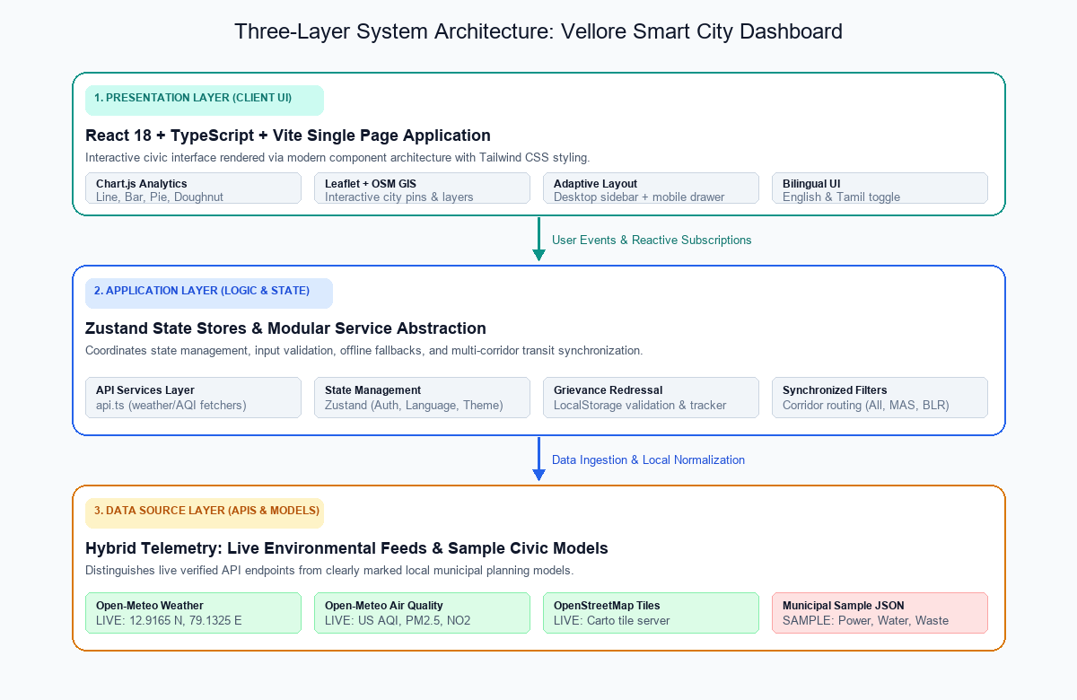
Figure 5.1: Three-Layer System Architecture Diagram of the Vellore Smart City Dashboard
5.2 Working Flow
The operational lifecycle of the dashboard progresses through four sequential stages: (1) Data Collection, where external REST endpoints and local structured models are polled; (2) Data Processing & Normalization, where the service layer intercepts timeouts, binds resilient offline fallbacks, and standardizes data structures; (3) State Dispatch & Routing, where Zustand stores propagate synchronized filter states, language dictionaries, and grievance records across subscribers; and (4) Frontend Presentation, where responsive Chart.js canvases and Leaflet map pins render the processed information dynamically.
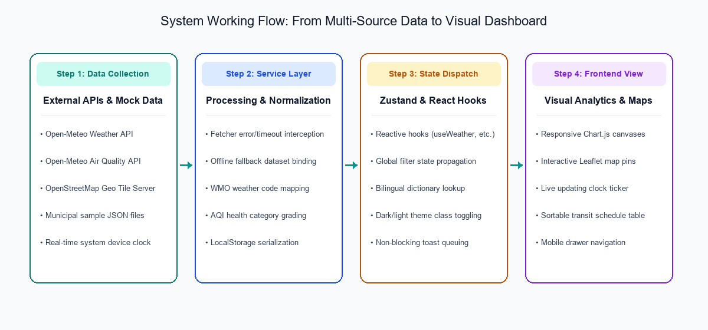
Figure 5.2: System Working Flowchart Depicting Data Flow from Source to Visual Dashboard

6. Technologies Used
The project is implemented using an industry-standard open-source JavaScript/TypeScript ecosystem. The technology stack was selected to achieve optimal runtime performance, strict type safety, zero-configuration static hosting, and modular maintainability as documented in the project's package.json.
Table 6.1: Comprehensive Technology Stack Specification
Technology | Category | Specific Purpose in This Project
HTML5 & CSS3 | Core Web | Provides semantic DOM structure and base styling primitives across all pages.
Tailwind CSS 3.4 | Styling Framework | Delivers utility-first styling, color tokens, dark mode classes, and responsive grids.
TypeScript 5.7 | Programming Language | Enforces strict type safety for Chart.js models, API responses, and store contracts.
React 18.3 | UI Library | Implements reusable component architecture, lifecycle hooks, and virtual DOM rendering.
React Router v6 | Client-Side Routing | Manages HashRouter navigation, lazy-loaded route splits, and deep URL linking.
Chart.js 4.4 | Data Visualization | Renders high-performance interactive Line, Bar, Pie, Doughnut, and PolarArea charts.
react-chartjs-2 | React Wrapper | Provides declarative React bindings and lifecycle registration for Chart.js instances.
Leaflet 1.9 & OSM | Geospatial GIS | Powers full-screen and mini interactive maps with OpenStreetMap tiles and custom SVG pins.
Open-Meteo APIs | External REST API | Supplies real-time weather and air quality telemetry for Vellore without API keys.
Vite 6.1 | Build Tool & Bundler | Provides lightning-fast HMR dev server and optimized production Rollup bundling.
Zustand 5.0 | State Management | Manages global stores for authentication, theme, bilingual translation, and route filters.
Vitest 3.0 | Testing Framework | Executes unit test suites for store logic, complaint persistence, and API helpers.
GitHub & Pages | VCS & Deployment | Hosts project repository and serves automated continuous static site deployments.
• Interface Foundation: HTML5 and CSS3 establish the semantic layout foundation, while Tailwind CSS accelerates rapid responsive design with custom color palettes and dark mode support.
• Interactivity & Type Safety: JavaScript and TypeScript power all client-side reactivity, providing asynchronous API coordination, input validation, and compile-time type checking.
• Component Architecture: React enables a modular component hierarchy that facilitates isolated testing, efficient virtual DOM updates, and declarative UI composition.
• Data Visualization: Chart.js, through react-chartjs-2, renders hardware-accelerated HTML5 Canvas visualizations across line charts, bar charts, infrastructure pie charts, and accident risk donut gauges.

7. Codes
The complete source code, test suites, assets, configuration scripts, and deployment pipelines for the Smart City Information Dashboard - Vellore are version-controlled and publicly accessible via the following verified endpoints:
Table 7.1: Project Repository, Production Deployment & Prototype Links
Resource Item | Endpoint URL / Location
Public GitHub Repository | https://github.com/hariharan957/smart-city-vellore-dashboard
Live Production Website | https://hariharan957.github.io/smart-city-vellore-dashboard/
Original Prototype Code Archive | https://drive.google.com/drive/folders/10RyxMr95miHZaL0_0jDweeDscXhHtWyM?usp=sharing
Repository Architecture Summary: The codebase follows conventional directory modularization under /src: components/layout houses the Header, Sidebar, and MobileDrawer; components/map contains Leaflet GIS wrappers; data/ maintains structured JSON models for transport, landmarks, and utilities; services/ handles Open-Meteo REST fetching and LocalStorage persistence; store/ contains Zustand state slices; and test/ contains automated Vitest suites.

8. Project Outputs (Results)
This section documents the visual output and interface results achieved across all functional pages of the deployed Vellore Smart City Information Dashboard. Each page is presented with an empty screenshot placeholder bounding frame (designed for inserting final browser captures) accompanied by a concise description of the functional modules, data visualizations, and user interaction capabilities rendered.
Figure 8.1: Citizen Access & Demo Login Page
[ Insert screenshot here ]
Description: Displays the prototype citizen authentication portal featuring full name and email input fields, a prominent demo-mode disclaimer badge, one-click guest access exploration, and persistent LocalStorage session initialization.
Figure 8.2: City Overview & Real-Time Intelligence Dashboard
[ Insert screenshot here ]
Description: Presents high-level city KPIs (live temperature, AQI, traffic flow, grid demand, reservoir level, open complaints), live updating clock/date, demographic trends (2021-2026), infrastructure land-use pie chart, power consumption bar chart with interactive load simulator, accident risk donut gauge, and a mini Leaflet map preview.
Figure 8.3: Climate & Weather Intelligence Dashboard
[ Insert screenshot here ]
Description: Visualizes real-time Open-Meteo atmospheric telemetry for Vellore coordinates (temperature, humidity, wind velocity and direction, UV index, precipitation) alongside a 12-hour dual-axis temperature/rain curve and a 7-day extended temperature range bar chart.
Figure 8.4: Air Quality Index (AQI) & Pollution Monitoring Dashboard
[ Insert screenshot here ]
Description: Displays live US AQI and European AQI readings, categorical health advisories per band, particulate concentrations (PM2.5, PM10) compared against WHO guidelines, gaseous metrics (NO2, CO, SO2, O3), and a 24-hour historical AQI trend line chart.
Figure 8.5: Multi-Modal Transit Hub Dashboard
[ Insert screenshot here ]
Description: Features synchronized corridor filtering (All Corridors, Chennai, Bangalore, Local), road bus departures from Vellore New Bus Stand, Katpadi Junction (KPD) railway departures (Shatabdi, Vande Bharat), airport transit guides, and a sortable master schedule table.
Figure 8.6: Interactive City GIS Map (Leaflet + OpenStreetMap)
[ Insert screenshot here ]
Description: Provides full-screen OpenStreetMap cartography centered on Vellore with layer filter pills (bus stops, hospitals, colleges, police stations, EV charging points, public Wi-Fi zones, heritage sites like Vellore Fort and Golden Temple), search filter, and HTML5 'Locate Me' GPS geolocation.
Figure 8.7: Municipal Utilities & Electrical Grid Dashboard
[ Insert screenshot here ]
Description: Monitors Palar river basin reservoir storage percentage with potable water quality indices, TANGEDCO power grid peak demand load curves and rooftop solar contribution, solid waste segregation percentages, and ward-wise utility efficiency comparison charts.
Figure 8.8: Emergency Services & Rapid First Response Hub
[ Insert screenshot here ]
Description: Provides one-click click-to-call cards for national emergency lines (108 Ambulance, 100 Police, 101 Fire, 1091 Women Helpline, 1930 Cyber Cell), local hospital extensions marked with 'Verify Before Use' badges, and analytical charts for ambulance response latency and police patrol sector distribution.
Figure 8.9: Civic Services & Grievance Redressal Tracker
[ Insert screenshot here ]
Description: Features a validated complaint lodging form (citizen name, phone number, ward, category, description, urgency level) and a live status tracker pipeline (Submitted -> In Review -> Field Inspection -> Resolved) persisted entirely within client-side LocalStorage.
Figure 8.10: Vellore Smart City Mission Projects Tracker
[ Insert screenshot here ]
Description: Tracks capital expenditure across flagship initiatives (Command & Control Centre, Otteri Lake Eco-Park, Smart Street Lighting, Rooftop Solar Grid, Katpadi Interchange Hub, Drainage Phase-II) with physical completion progress bars and an allocated budget vs. spent bar chart.
Figure 8.11: About Regional Scope & Privacy Policy Page
[ Insert screenshot here ]
Description: Articulates the regional scope of the Vellore portal, detailed data provenance distinctions (live Open-Meteo and OSM APIs versus modeled municipal samples), client-side privacy commitments (zero tracking cookies, local storage isolation), and MIT license terms.
Figure 8.12: Mobile Responsive View (Collapsible Drawer & Dashboard Feed)
[ Insert screenshot:  Mobile Drawer Menu View ] | [ Insert screenshot:  Mobile Dashboard Feed View ]
Description: Demonstrates mobile-first viewport adaptability on smartphone screens, illustrating the slide-out navigation drawer with touch targets and the vertical stacking of responsive overview KPI cards and analytics canvases.
Figure 8.13: Dark Mode Accessibility View
[ Insert screenshot here ]
Description: Illustrates the complete dark mode visual theme configured via Tailwind CSS class toggling, offering low-glare high-contrast readability (WCAG AA compliant) for night-time urban transit monitoring and reduced energy consumption.
Figure 8.14: Tamil Language (Bilingual Localization) View
[ Insert screenshot here ]
Description: Showcases instantaneous client-side language switching between English and Tamil (தமிழ்) across primary navigation links, section titles, and civic KPI metrics via the central Zustand translation dictionary.

