**TO SUPPLY LEFTOVER FOOD TO POOR**

**College Name: Kaamadhenu Arts and Science College**

**College Code: bru4p**

**Group project**

**TEAM ID: NM2025TMID21216**

**TEAM MEMBERS:**

* **Team Leader:** **KAMALESHWARI S**

**Email:** [kamaleshwari.cs23@kascsathy.ac.in](mailto:kamaleshwari.cs23@kascsathy.ac.in)

* **Team Member: ISHWARYA S**

**Email:** [aishwarya.cs23@kascsathy.ac.in](mailto:aishwarya.cs23@kascsathy.ac.in)

* **Team Member: INDHUMATHI A**

**Email:** [indhumathi.cs23@kascsathy.ac.in](mailto:indhumathi.cs23@kascsathy.ac.in)

* **Team Member: HARIHARAN A**

**Email:** [hariharan.cs23@kascsathy.ac.in](mailto:hariharan.cs23@kascsathy.ac.in)

**Project Description:**

This project is focused on the development and implementation of a Food Donation and Distribution Management System using Salesforce, designed to address the challenges of manual food donation tracking, volunteer management, beneficiary coordination, and communication between donors and the organization. The goal is to deliver a comprehensive solution that streamlines and automates various aspects of food collection and distribution, from donor registration to pickup scheduling, volunteer assignment, approval workflows, and reporting.

Through this project, we aim to enhance operational efficiency, data accuracy, and user experience for food donors, volunteers, and beneficiaries. By leveraging Salesforce's powerful platform, we will create a solution that enables better donor and volunteer relationship management, ensures timely food pickups and deliveries, and provides real-time visibility into key donation and distribution metrics. This will support the long-term goals of reducing food wastage, addressing hunger in underprivileged communities, and scaling operations as the initiative grows.

## Objectives:

1. **Improve Operational Efficiency:**
   * **Goal:** Automate manual food donation and distribution processes to reduce administrative tasks, streamline workflows, and optimize time spent on routine coordination.
   * **Measure:** Reduce the time spent on manual tracking and volunteer communication by **30% within the first 6 months** of implementation.
2. **Enhance Data Accuracy and Centralization:**
   * **Goal:** Ensure accurate and up-to-date donor, volunteer, and beneficiary data is centrally stored and accessible in Salesforce.
   * **Measure:** Achieve **100% accuracy in donor and beneficiary records within 3 months** post-deployment, with real-time updates on food availability and delivery status.
3. **Increase Timely Food Collection and Delivery:**
   * **Goal:** Automate pickup reminders and notifications to reduce delays in food collection and improve delivery efficiency.
   * **Measure:** Reduce delayed pickups by **25% within the first 6 months**, and achieve a **95% on-time delivery rate**.
4. **Improve Donor, Volunteer, and Beneficiary Satisfaction:**
   * **Goal:** Improve communication with automated alerts for food requests, pickup confirmations, delivery status, and acknowledgments.
   * **Measure:** Achieve a **20% improvement in satisfaction scores** related to communication and transparency (measured through feedback surveys).
5. **Improve Operational Visibility and Reporting:**
   * **Goal:** Provide real-time reports and dashboards to track food donations, volunteer activity, delivery status, and overall distribution impact.
   * **Measure:** Achieve **100% adoption of real-time reports and dashboards** by the project management and volunteer coordination teams within 2 months of deployment.

**DEVELOPMENT PHASE IN SALESFORCE:**

**Creating Developer Account:**

By using this URL **-** <https://developer.salesforce.com/signup>

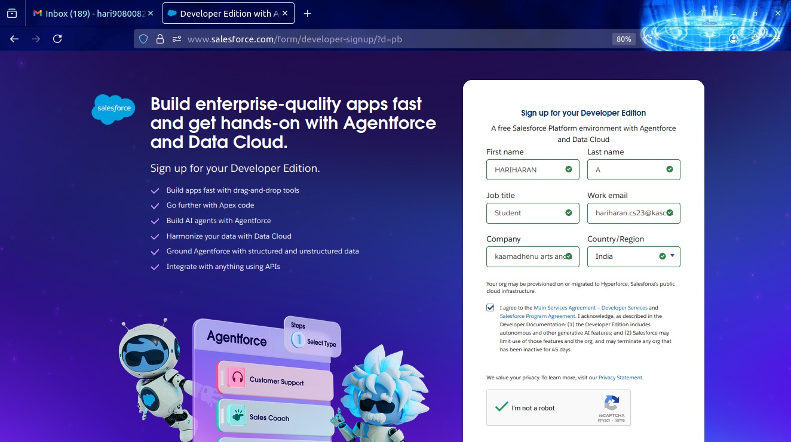

**Account Activation:**

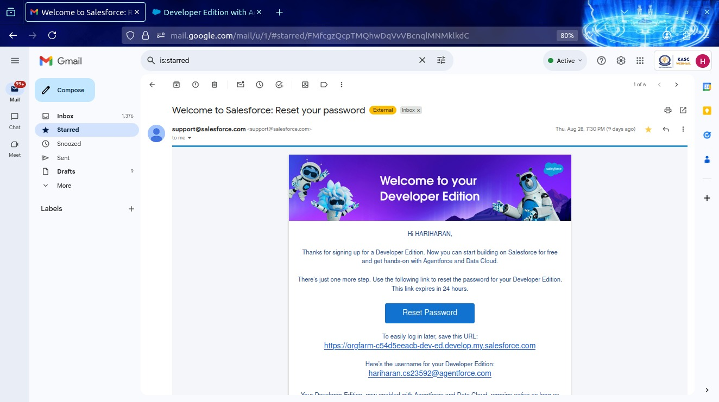

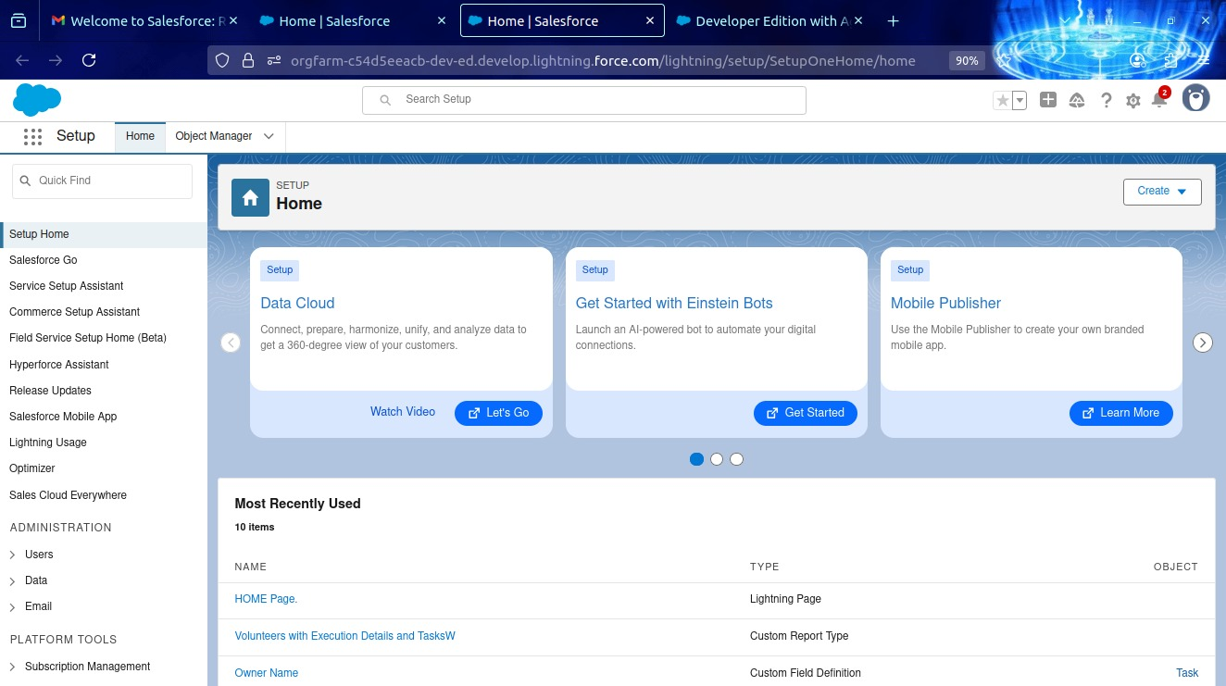

**Created Objects:**

* We need to create the objects in the name of venue, drop of point, task, volunteer, execution details

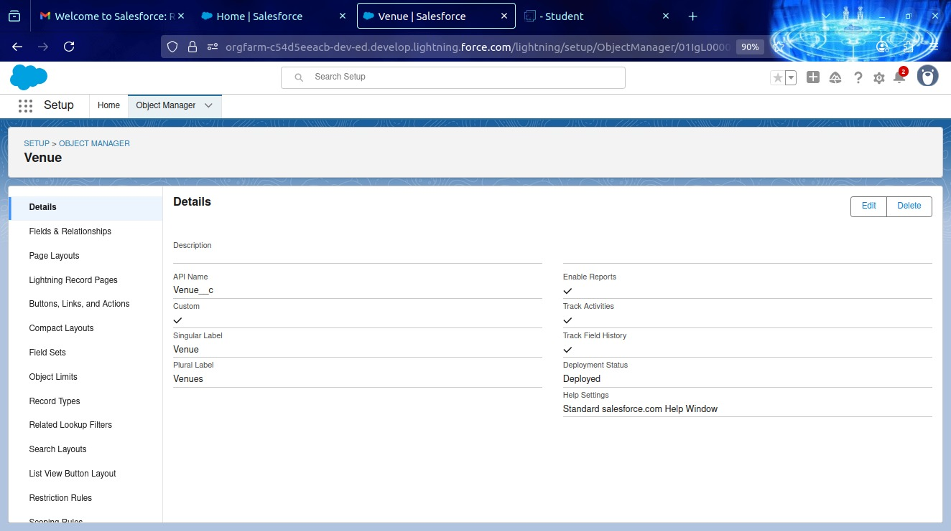

Venue Object

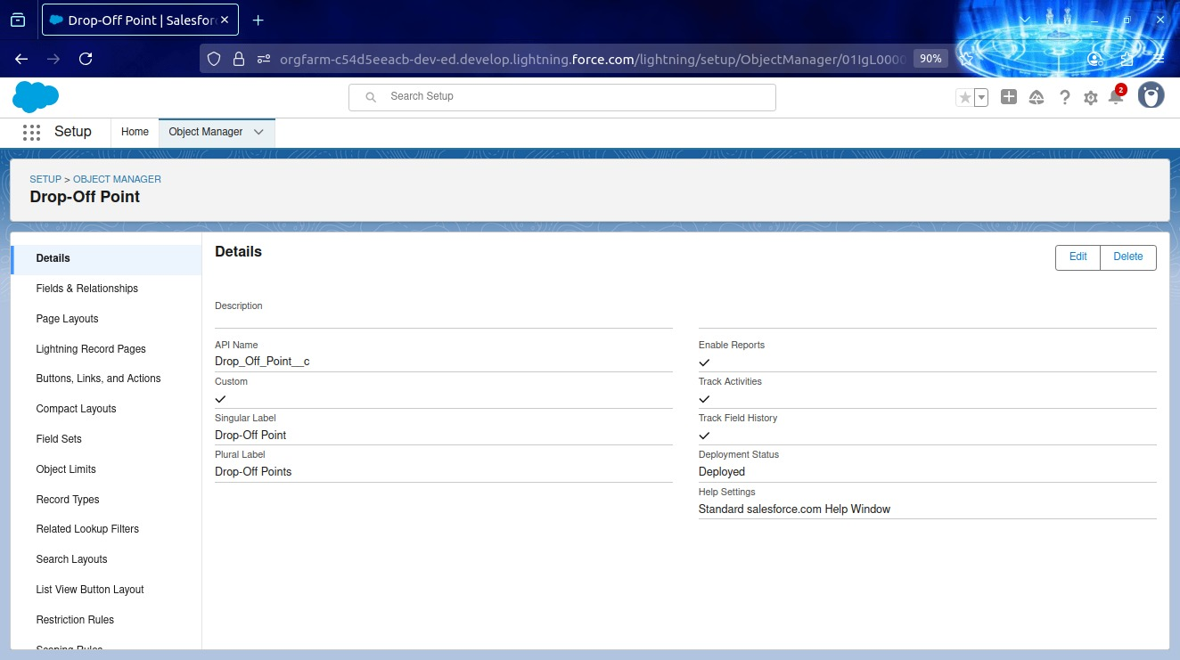

Drop off Point

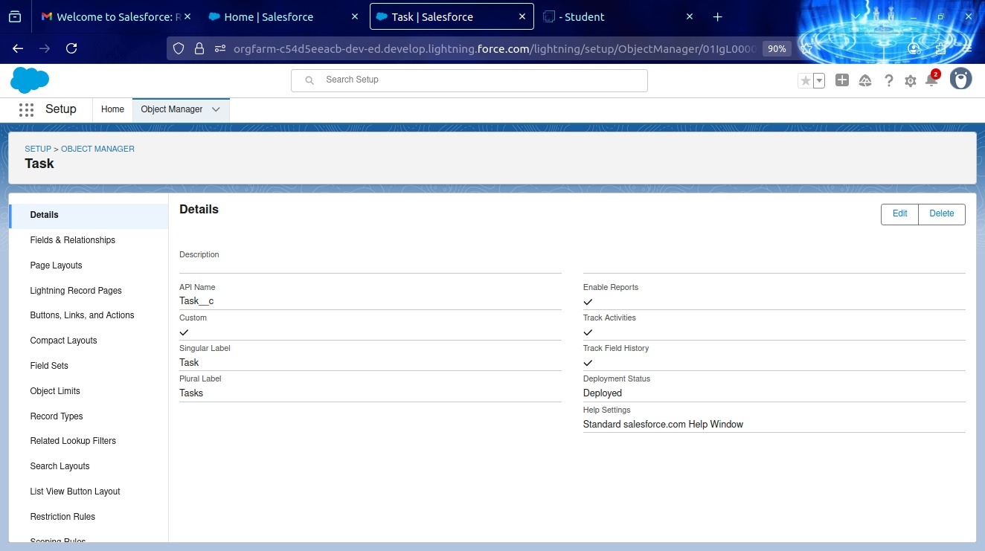

Task Object

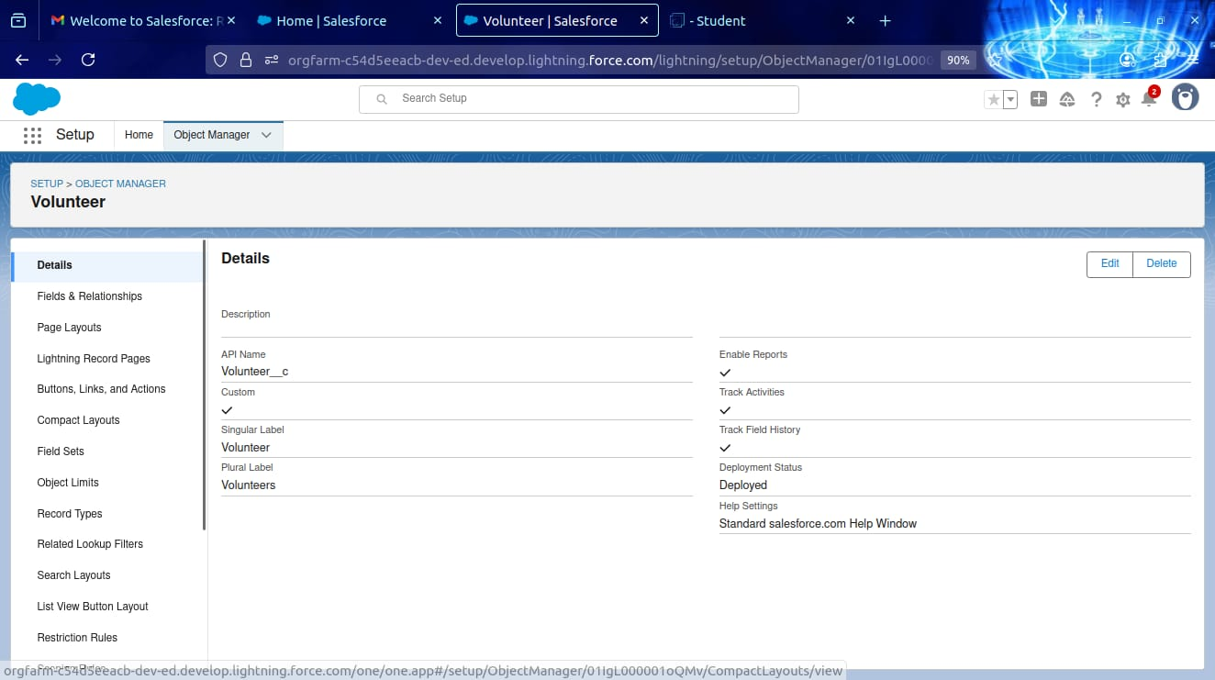

Volunteer Object

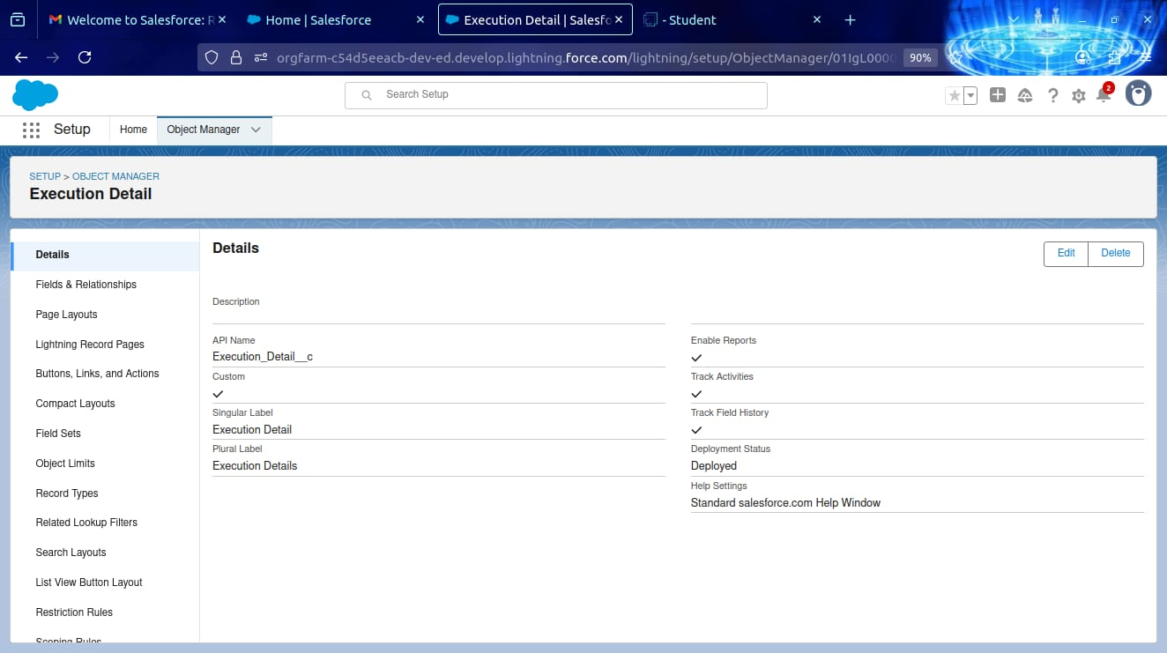

Execution Details Object

**Tabs:**

**Creating a custom Tabs:**

Creating a custom Tabs for those objects we created already in the custom Tabs section.

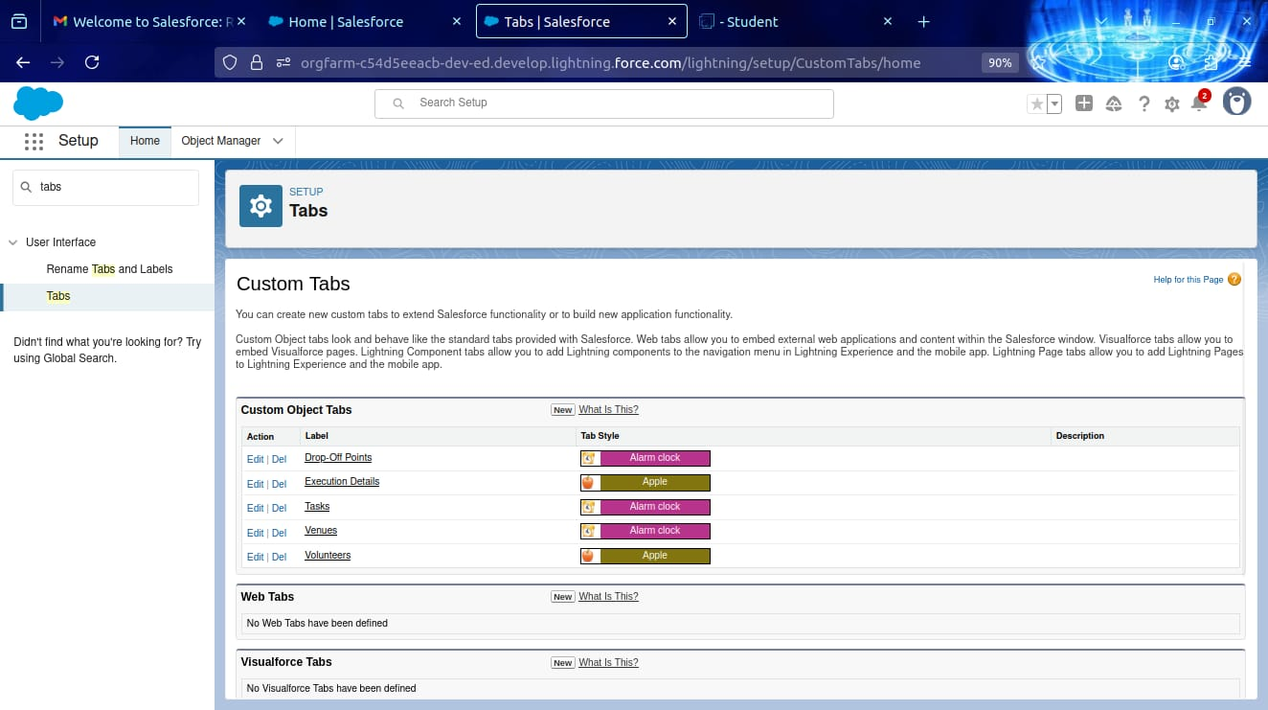

Custom Tabs for those five objects

**Create a Lightning App:**

* Create the Lightning app in the app manager and click the new lightning app Button then name it as FoodConnect.

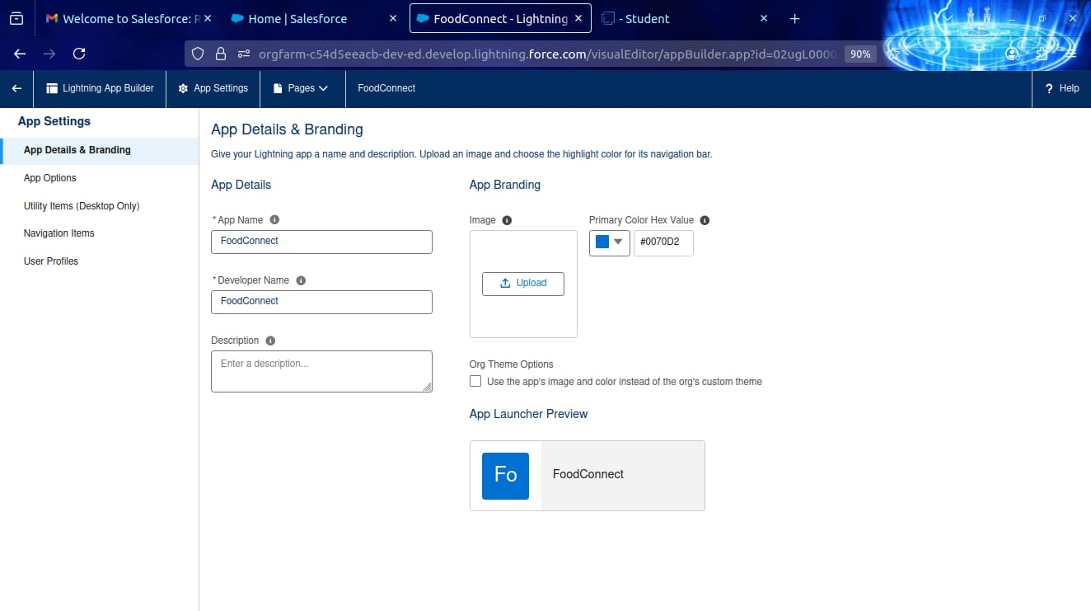

App Details and Branding

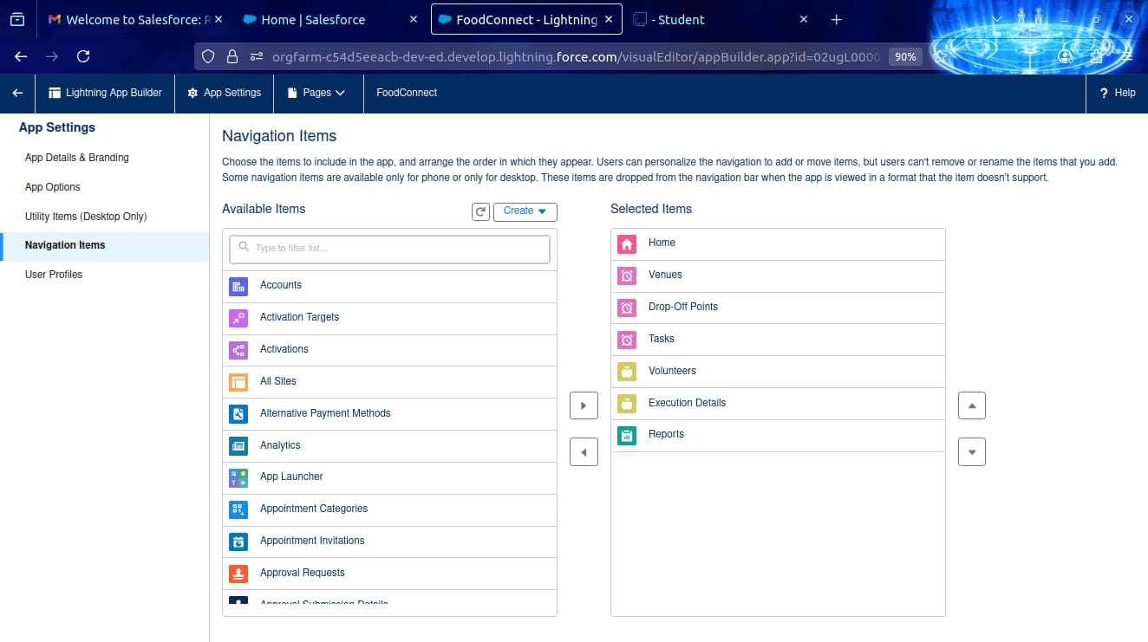

Navigation Items

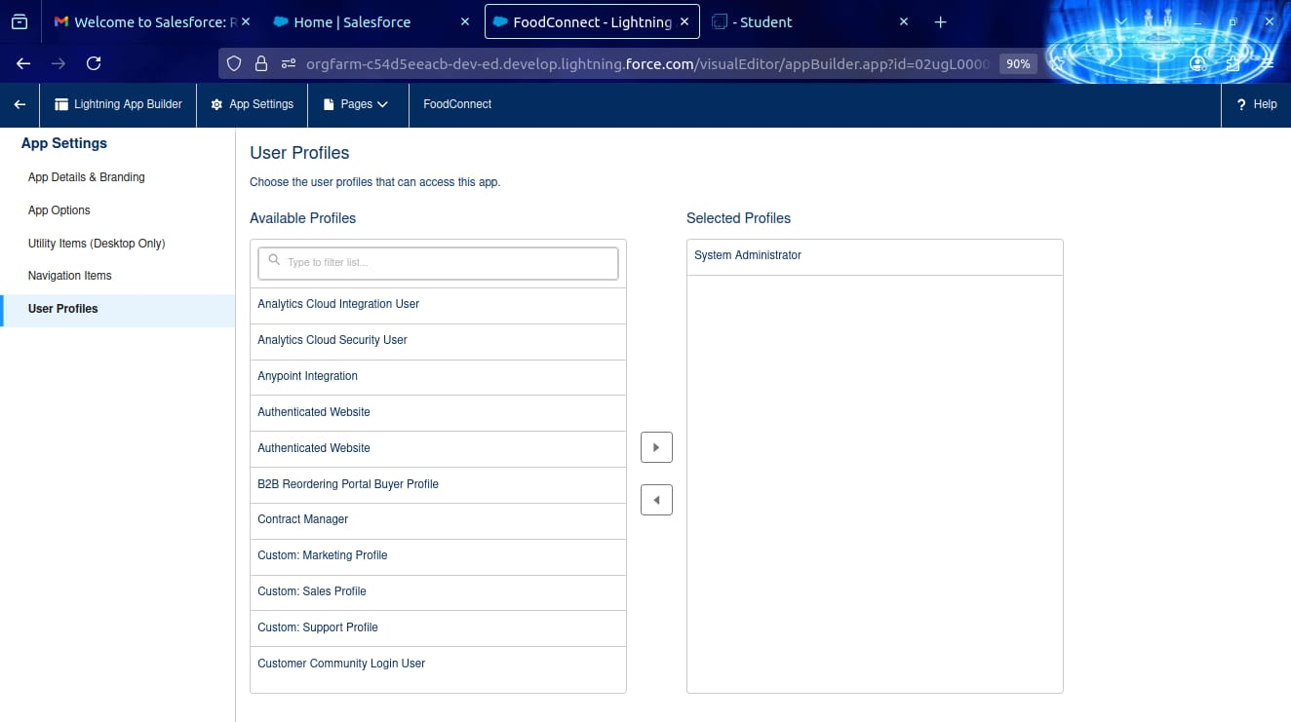User Profiles

**Fields:**

Created the fields in the venue, drop of point, task, volunteer, execution details for Relationship fields in objects.

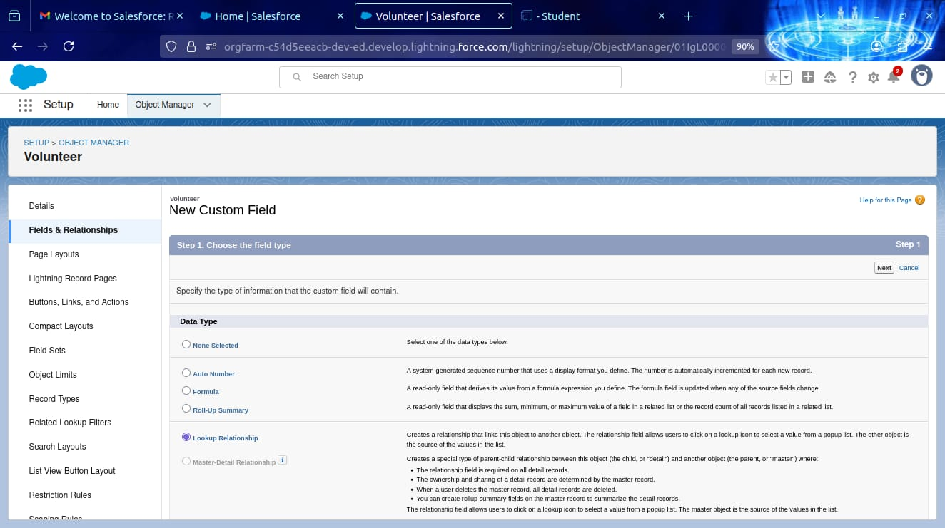

Creation of Lookup Relationship Field on Volunteer Object

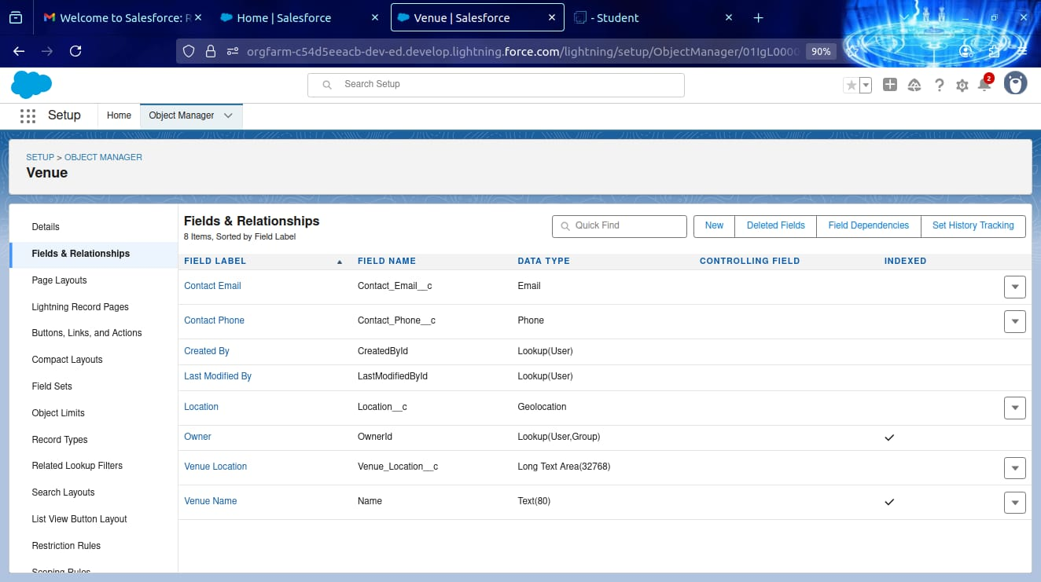

Created fields foe the Venue Object

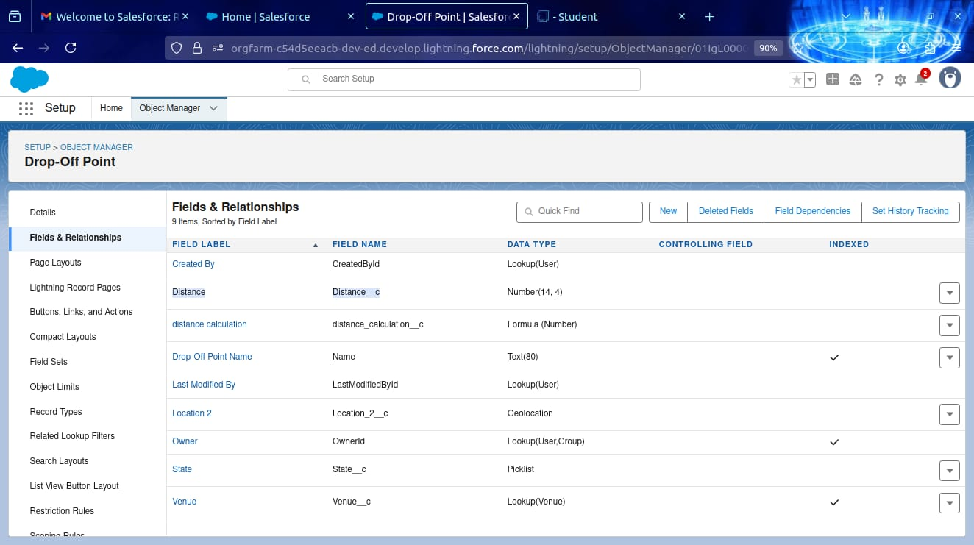

Created fields foe the Drop-Off Point Object

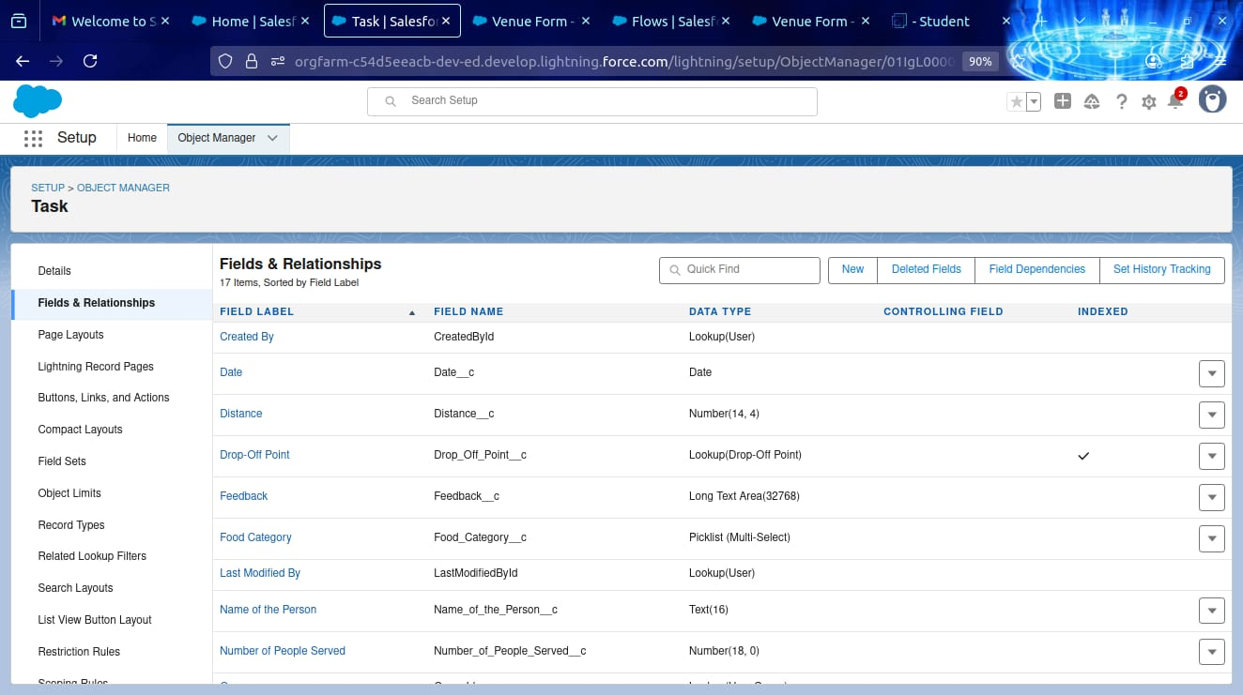

Created fields foe the Task Object

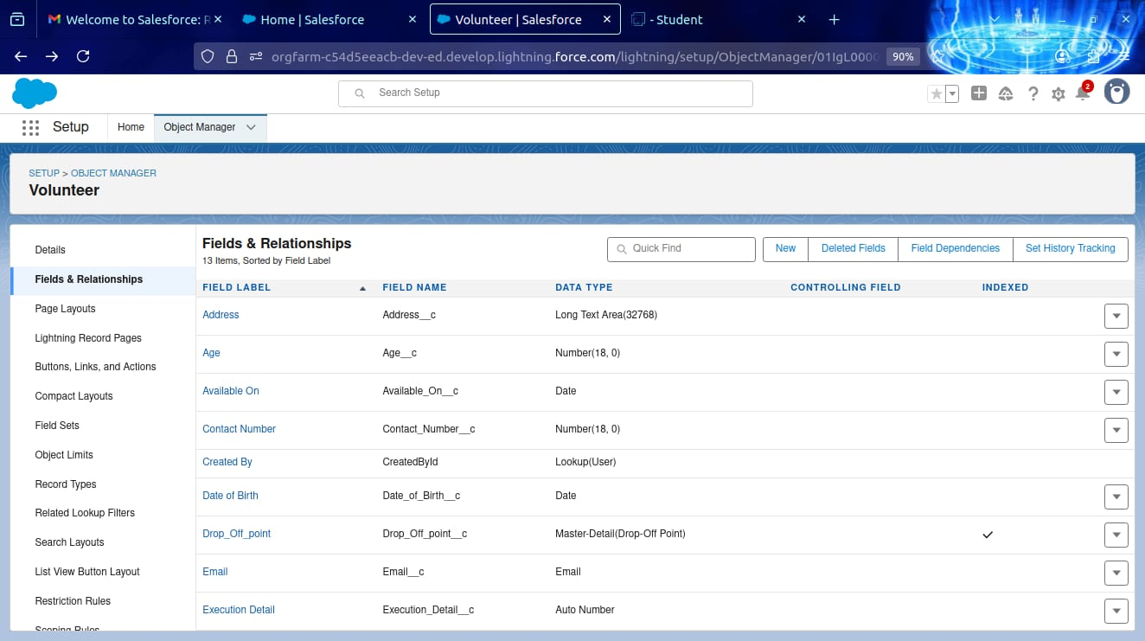

Created fields for the Volunteer Object

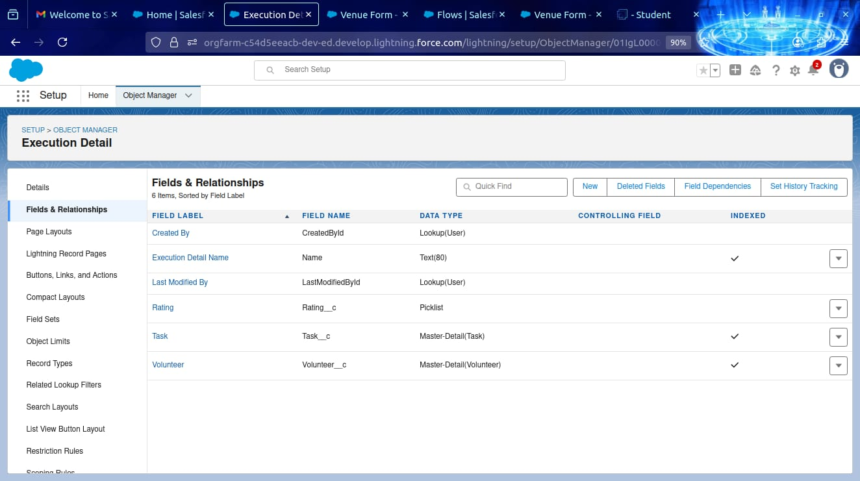

Created fields for the Execution Details Object

**Flows:**

* Created flow to Create A Record in Venue Object.

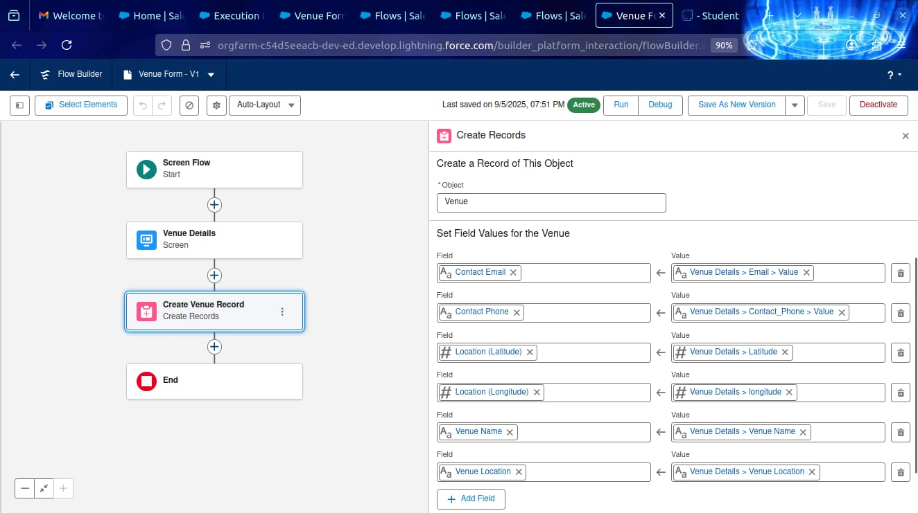

Created A Record in venue Object.

**Trigger:**

* Created an Apex Trigger and Named as a “DropOffTrigger”.

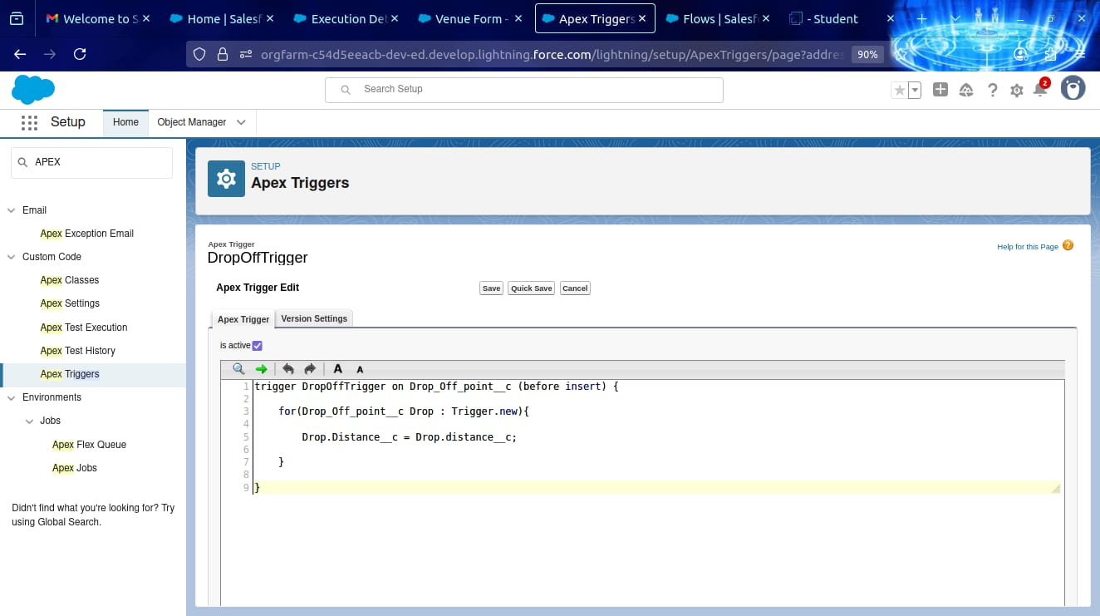

**Profile:**

* Create a Profile Name as NGOs Profile Under Clone beside Standard Platform User.

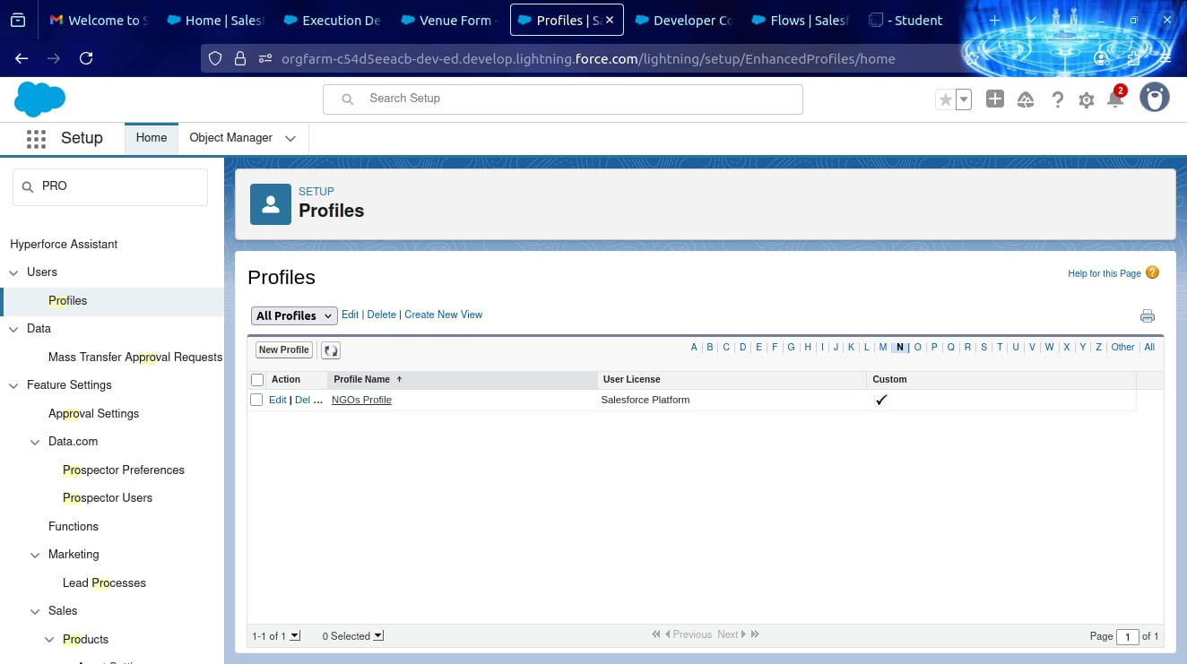

**Creation Of Users:**

* Create a User1 in General Information.

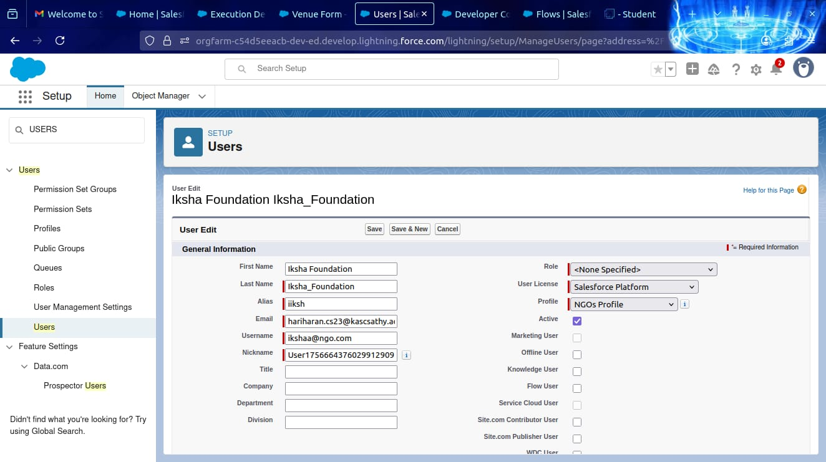

**Creation og User2,User3:**

* Create another Two Users by Following Steps in Activity-1 with Similar User License and Profile.

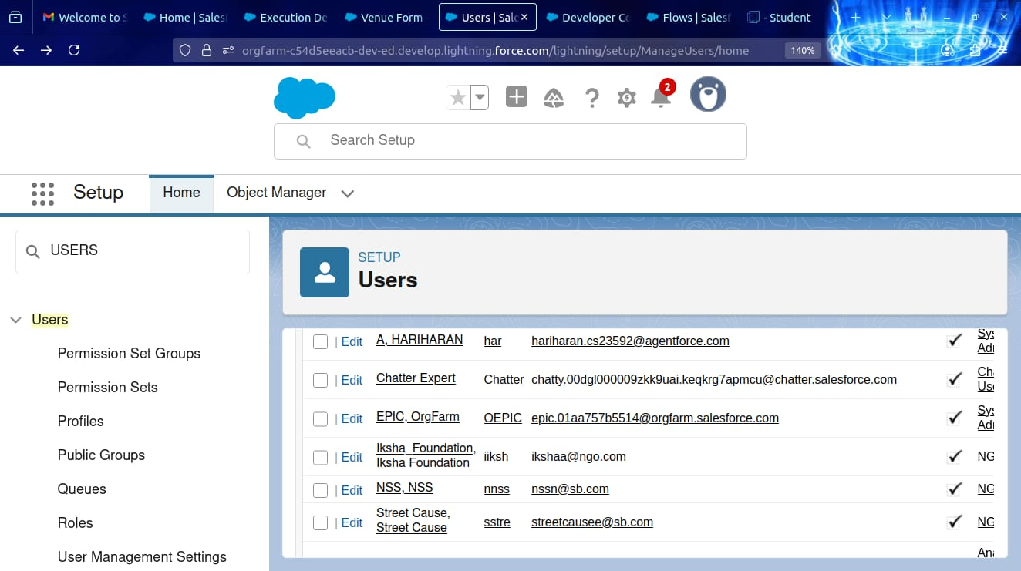

**Public Groups:**

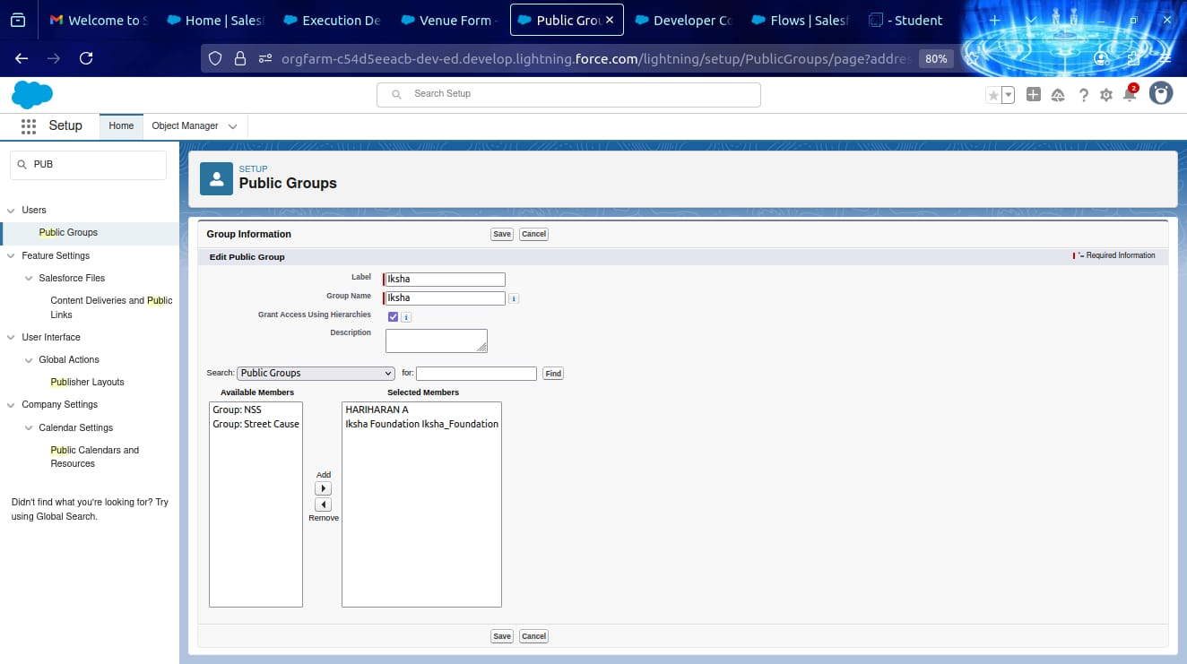

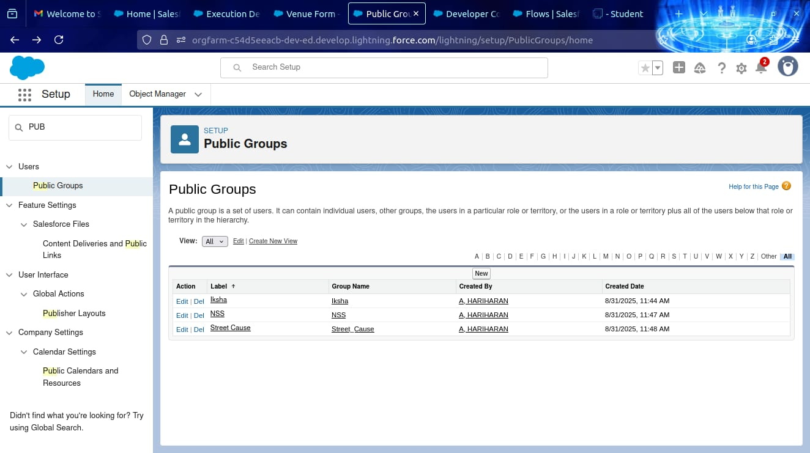

Created a Public Group1 and Public Group2.

**Report Types:**

* Create a Report types using with the label of Venue eith DropOff with Volunteer.

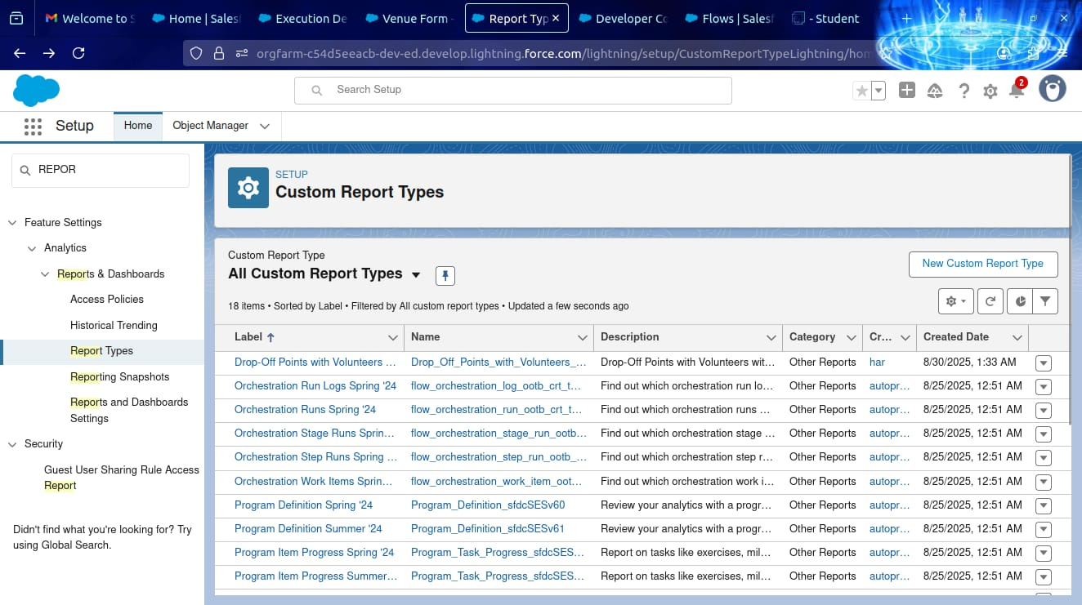

**Reports:**

* Creation of Report on Venue with DropOff with Volunteer.

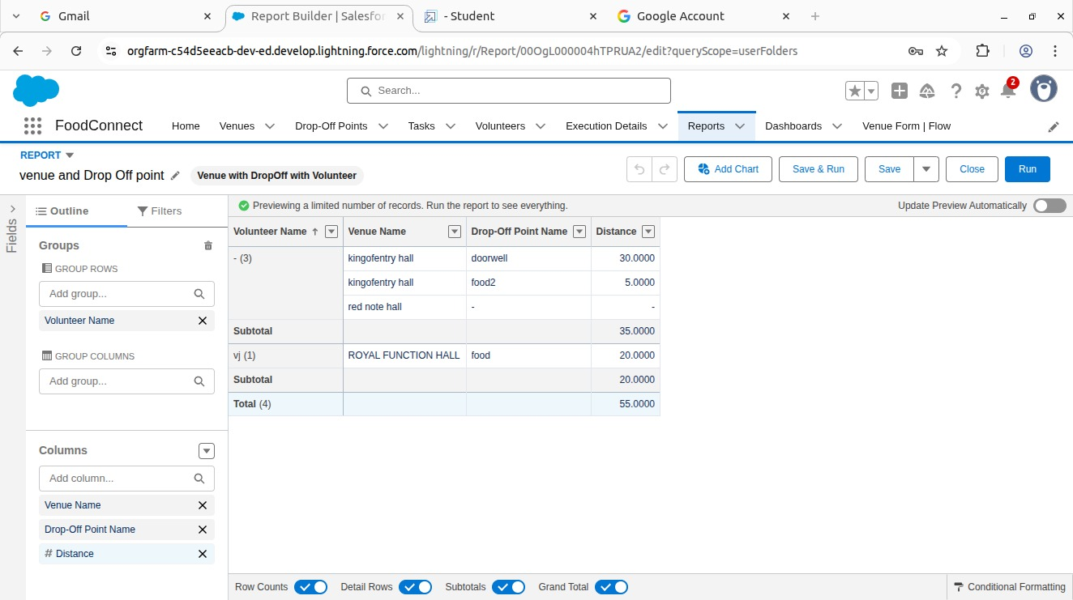

* Creation of Report on Volunteers with Execution Details and Tasks.

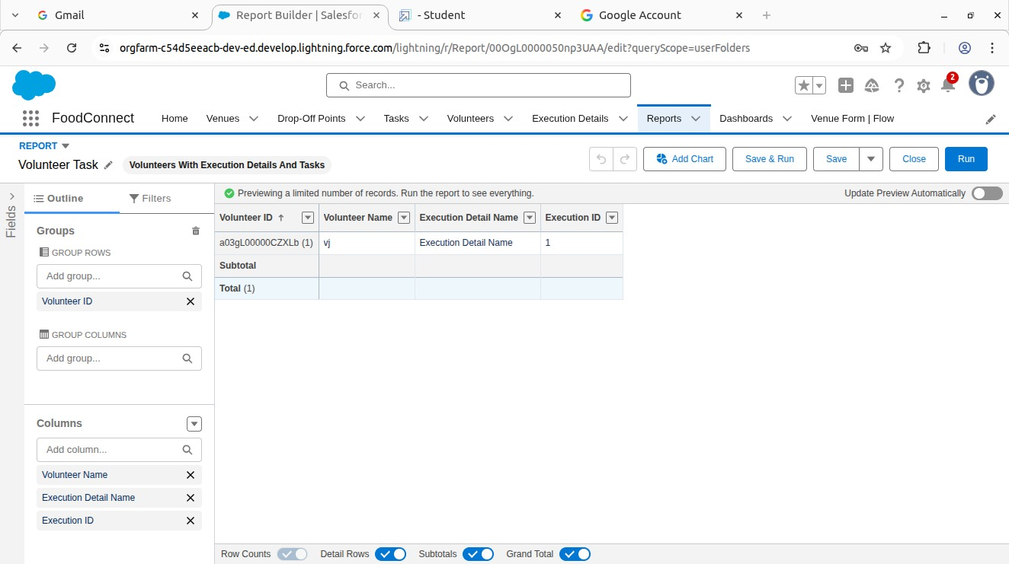

**Dashboards:**

* Adding Venue and Drop Off Point Report to the Dashboard.

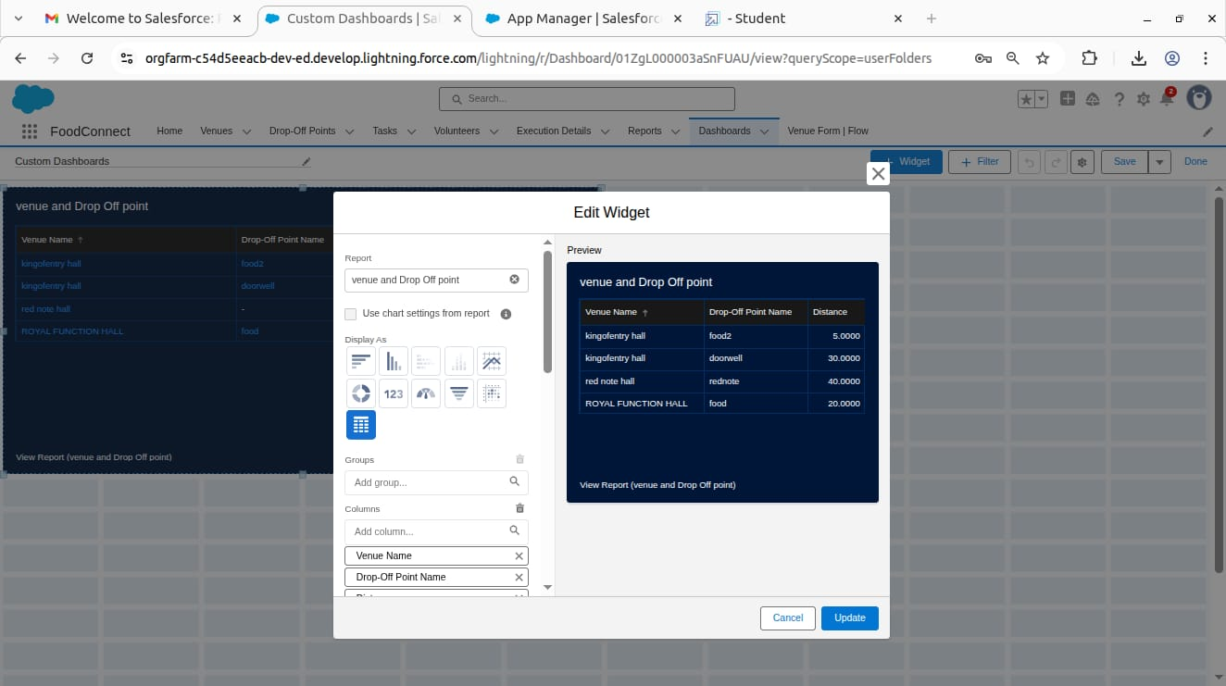

* Adding Volunteer Task Report to The Dashboard.

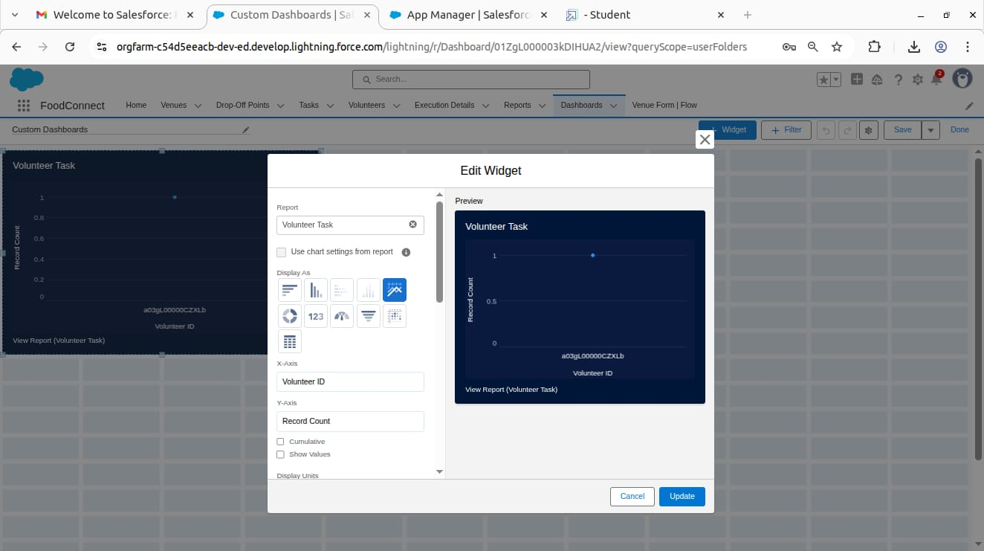

* Adding a picture to the Dashboard

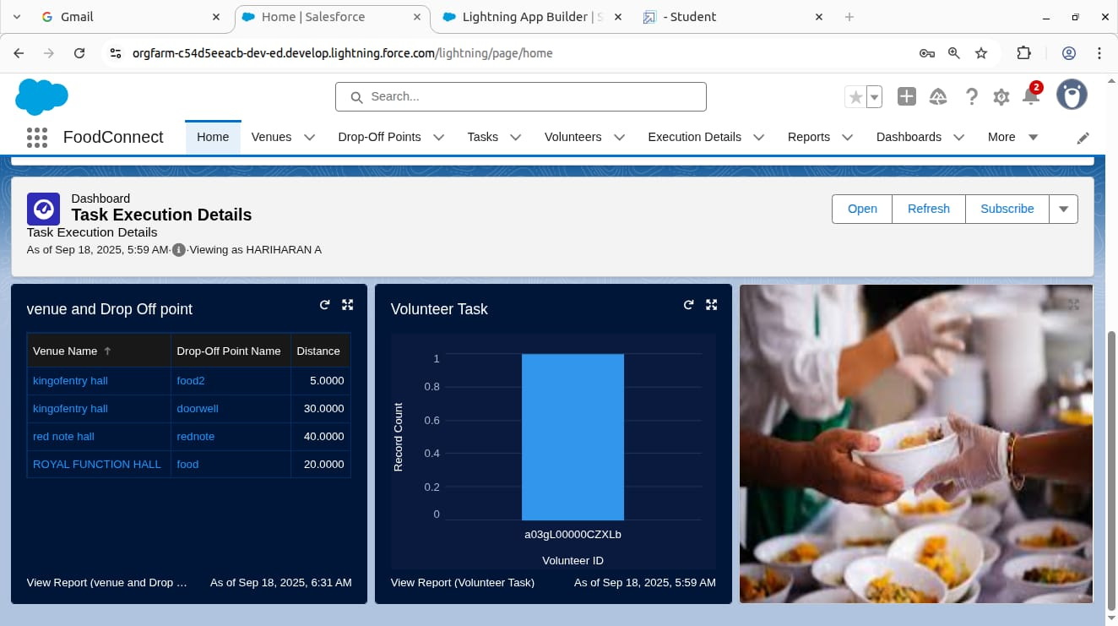

**Sharing Rules:**

* Creation of sharing rules for an Drop-Off point Sharing Rules.

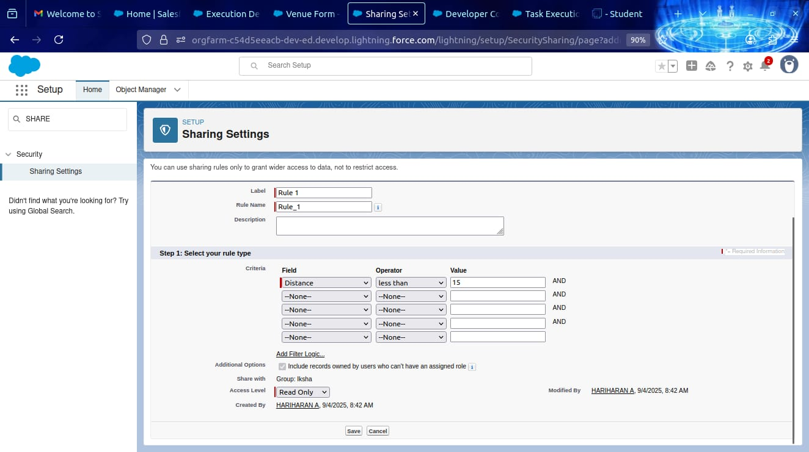

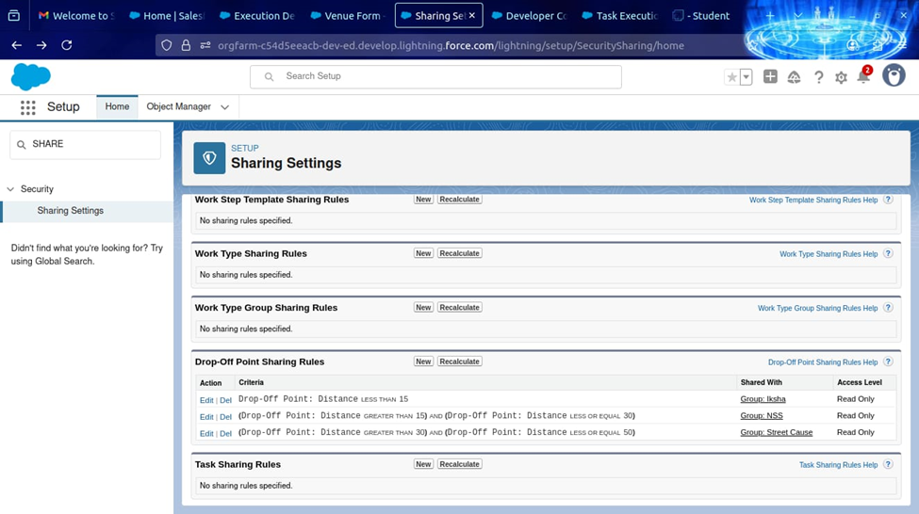

**Home Page:**

* Creation of Home Page with Lightning App Builder.

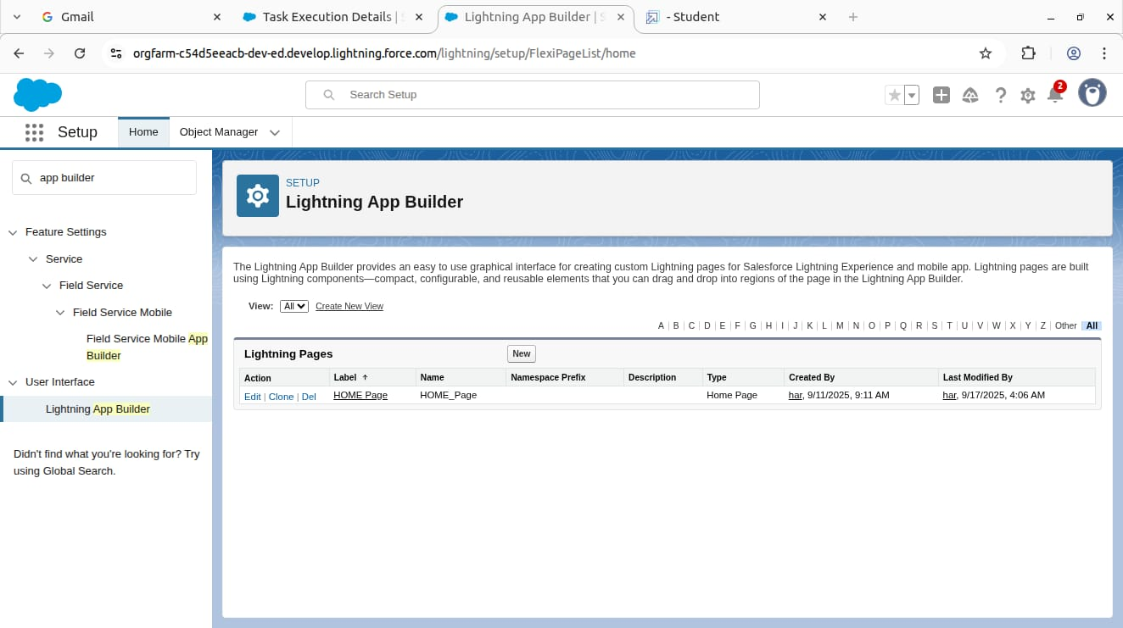

* Venue Form

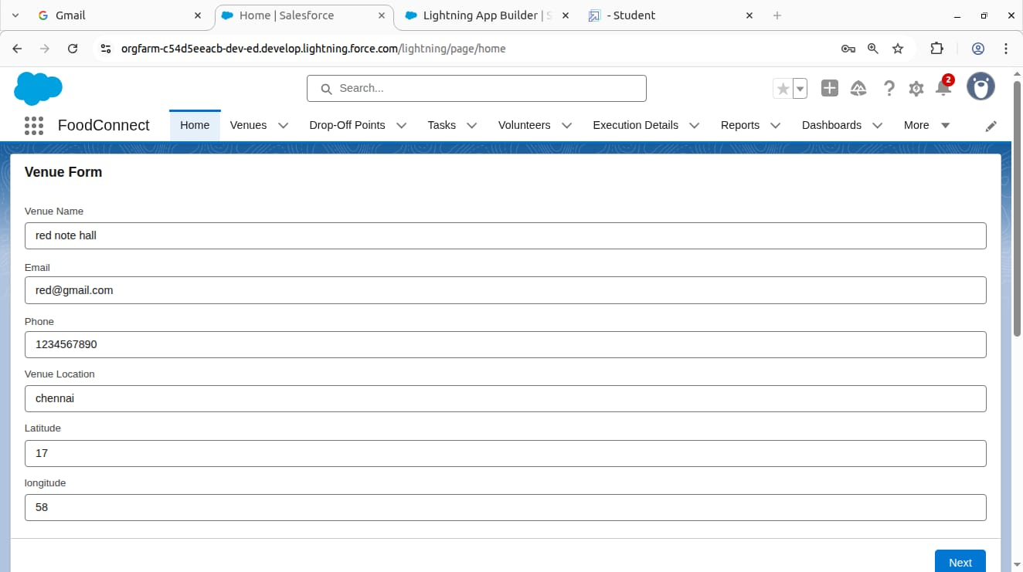

* Information Page.

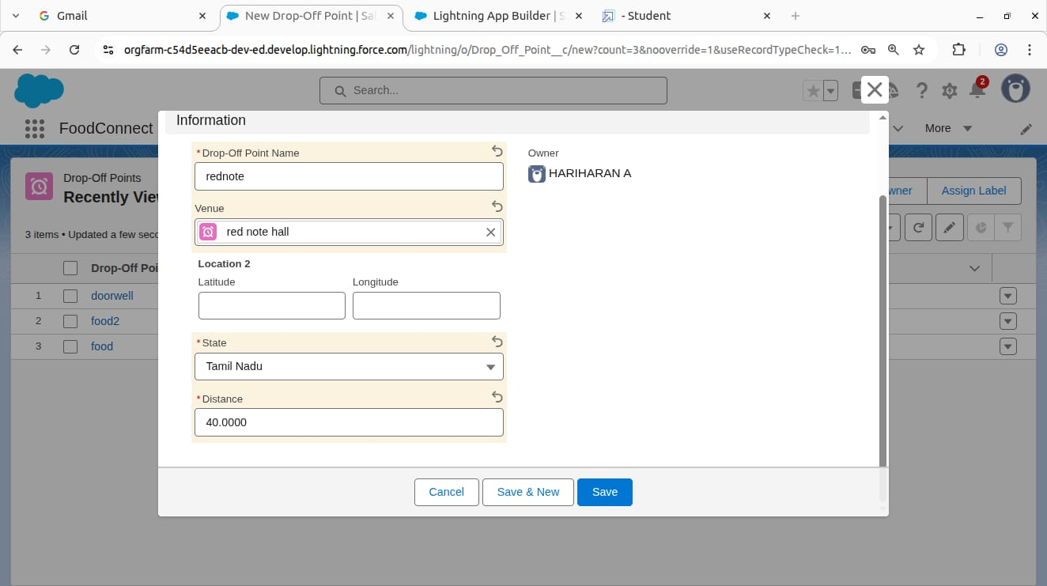

**RESULTS:**

Output Screenshots:

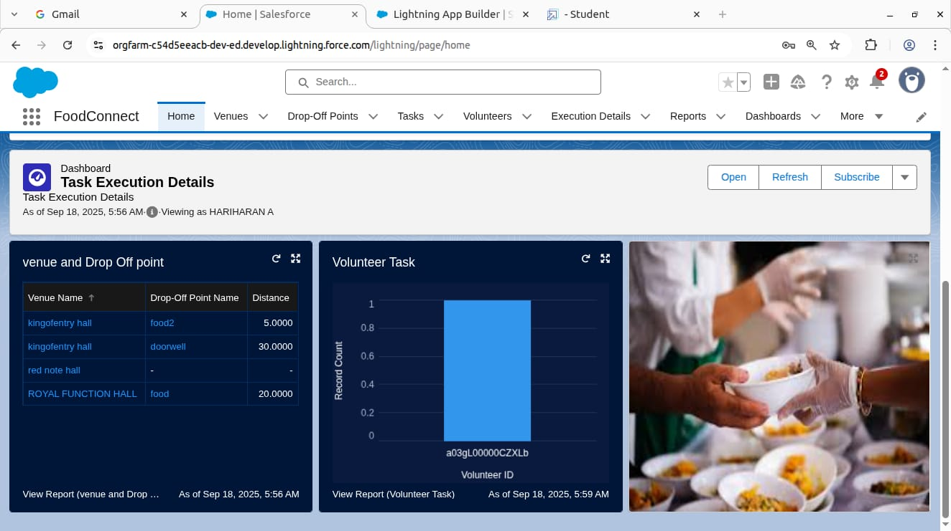

**Conclusion:**

By leveraging the Salesforce platform, the project successfully established a streamlined and transparent system for managing surplus food donations. Through efficient coordination with volunteers and timely delivery to beneficiaries, the project effectively addressed food insecurity while maximizing the utilization of available resources.

**APPENDIX:**

* **Source Code:** Provided in Trigger.

trigger DropOffTrigger on Drop_Off_point__c (before insert) {

for(Drop_Off_point__c Drop : Trigger.new){

Drop.Distance__c = Drop.distance_calculation__c;

}

}