- GET SELLERS along with their branches content type as XML.

HTTP Verb - GET

URL - http://localhost:8080/LocaleShop/service/sellers

Accept - application/xml

CONTENT TYPE - application/xml

<?xml version="1.0" encoding="UTF-8" standalone="yes"?>
<sellers>
<seller>
<branch>
<branchCity>coimbatore</branchCity>
<branchLocality>nggo colony</branchLocality>
<branchTown>thudiyalur</branchTown>
<description>tata store</description>
<id>1</id>
<latitude>10.57</latitude>
<longitude>76.5</longitude>
<name>tata store</name>
</branch>
<branch>
<branchCity>coimbatore</branchCity>
<branchLocality>viswanathapuram</branchLocality>
<branchTown>thudiyalur</branchTown>
<description>tata store</description>
<id>2</id>
<latitude>12.89</latitude>
<longitude>83.76</longitude>
<name>tata store</name>
</branch>
<id>1</id>
<name>Tata Store</name>
</seller>
<seller>
<branch>
<branchCity>trichy</branchCity>
<branchLocality>k k nagar</branchLocality>
<branchTown>k k nagar</branchTown>
<description>reliance store</description>
<id>3</id>
<latitude>13.89</latitude>
<longitude>86.76</longitude>
<name>reliance store</name>
</branch>
<id>2</id>
<name>Reliance Store</name>
</seller>
</sellers>

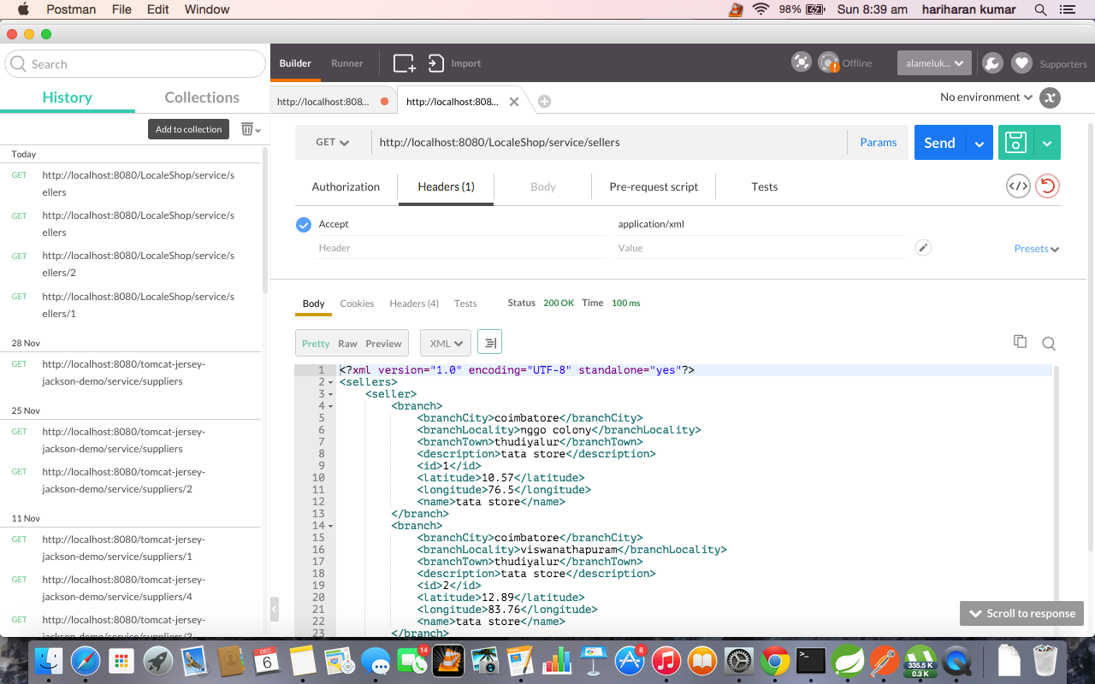

2) GET SELLERS along with their branches content type as JSON

HTTP Verb - GET

URL - http://localhost:8080/LocaleShop/service/sellers

Accept - application/json

CONTENT TYPE - application/json

{
"sellers": [
{
"id": 1,
"name": "Tata Store",
"sellerBranches": [
{
"id": 1,
"branchCity": "coimbatore",
"branchLocality": "nggo colony",
"branchTown": "thudiyalur",
"description": "tata store",
"name": "tata store",
"latitude": 10.57,
"longitude": 76.5
},
{
"id": 2,
"branchCity": "coimbatore",
"branchLocality": "viswanathapuram",
"branchTown": "thudiyalur",
"description": "tata store",
"name": "tata store",
"latitude": 12.89,
"longitude": 83.76
}
]
},
{
"id": 2,
"name": "Reliance Store",
"sellerBranches": [
{
"id": 3,
"branchCity": "trichy",
"branchLocality": "k k nagar",
"branchTown": "k k nagar",
"description": "reliance store",
"name": "reliance store",
"latitude": 13.89,
"longitude": 86.76
}
]
}
]
}

3) GET a particular SELLER based on id along with their branches(set appropriate XML/JSON headers for content type negotiation, refer above requests)

HTTP Verb - GET

URL - http://localhost:8080/LocaleShop/service/sellers/1

<?xml version="1.0" encoding="UTF-8" standalone="yes"?>
<sellerDTO>
<branch>
<branchCity>coimbatore</branchCity>
<branchLocality>nggo colony</branchLocality>
<branchTown>thudiyalur</branchTown>
<description>tata store</description>
<id>1</id>
<latitude>10.57</latitude>
<longitude>76.5</longitude>
<name>tata store</name>
</branch>
<branch>
<branchCity>coimbatore</branchCity>
<branchLocality>viswanathapuram</branchLocality>
<branchTown>thudiyalur</branchTown>
<description>tata store</description>
<id>2</id>
<latitude>12.89</latitude>
<longitude>83.76</longitude>
<name>tata store</name>
</branch>
<id>1</id>
<name>Tata Store</name>
</sellerDTO>

URL - http://localhost:8080/LocaleShop/service/sellers/2

{
"id": 2,
"name": "Reliance Store",
"sellerBranches": [
{
"id": 3,
"branchCity": "trichy",
"branchLocality": "k k nagar",
"branchTown": "k k nagar",
"description": "reliance store",
"name": "reliance store",
"latitude": 13.89,
"longitude": 86.76
}
]
}
