Sellers

HTTP Verb - GET

URL - <http://localhost:8080/LocaleShop/service/sellers>

Request Headers -

Accept → application/xml

Response Headers -

Content-Length → 2100

Content-Type → application/xml

Date → Tue, 22 Dec 2015 02:16:39 GMT

Server → Apache-Coyote/1.1

<?xml version="1.0" encoding="UTF-8" standalone="yes"?>

<sellers>

<sellers>

<sellerId>1</sellerId>

<name>Tata Store</name>

<description>Tata Store Department base</description>

<location>Coimbatore</location>

<branches>

<branchId>1</branchId>

<branchCity>coimbatore</branchCity>

<branchLocality>nggo colony</branchLocality>

<branchTown>thudiyalur</branchTown>

<description>tata store</description>

<name>tata store</name>

<latitude>10.57</latitude>

<longitude>76.5</longitude>

<createdDate>2015-12-13T00:00:00+05:30</createdDate>

<modifiedDate>2015-12-13T00:00:00+05:30</modifiedDate>

</branches>

<branches>

<branchId>2</branchId>

<branchCity>coimbatore</branchCity>

<branchLocality>viswanathapuram</branchLocality>

<branchTown>thudiyalur</branchTown>

<description>tata store</description>

<name>tata store</name>

<latitude>12.89</latitude>

<longitude>83.76</longitude>

<createdDate>2015-12-13T00:00:00+05:30</createdDate>

<modifiedDate>2015-12-13T00:00:00+05:30</modifiedDate>

</branches>

<createdDate>2015-12-08T00:00:00+05:30</createdDate>

<modifiedDate>2015-12-08T00:00:00+05:30</modifiedDate>

</sellers>

<sellers>

<sellerId>2</sellerId>

<name>Reliance Store</name>

<description>Reliance Store Department base</description>

<location>kambam</location>

<branches>

<branchId>3</branchId>

<branchCity>theni</branchCity>

<branchLocality>r k nagar</branchLocality>

<branchTown>k k nagar</branchTown>

<description>reliance store</description>

<name>reliance store</name>

<latitude>13.89</latitude>

<longitude>86.76</longitude>

<createdDate>2015-12-08T00:00:00+05:30</createdDate>

<modifiedDate>2015-12-12T00:00:00+05:30</modifiedDate>

</branches>

<branches>

<branchId>13</branchId>

<branchCity>tanjore</branchCity>

<branchLocality>r k nagar</branchLocality>

<branchTown>s h nagar</branchTown>

<description>reliance store</description>

<name>reliance store</name>

<latitude>13.89</latitude>

<longitude>86.76</longitude>

<createdDate>2015-12-13T00:00:00+05:30</createdDate>

<modifiedDate>2015-12-13T00:00:00+05:30</modifiedDate>

</branches>

<createdDate>2015-12-08T00:00:00+05:30</createdDate>

<modifiedDate>2015-12-08T00:00:00+05:30</modifiedDate>

</sellers>

</sellers>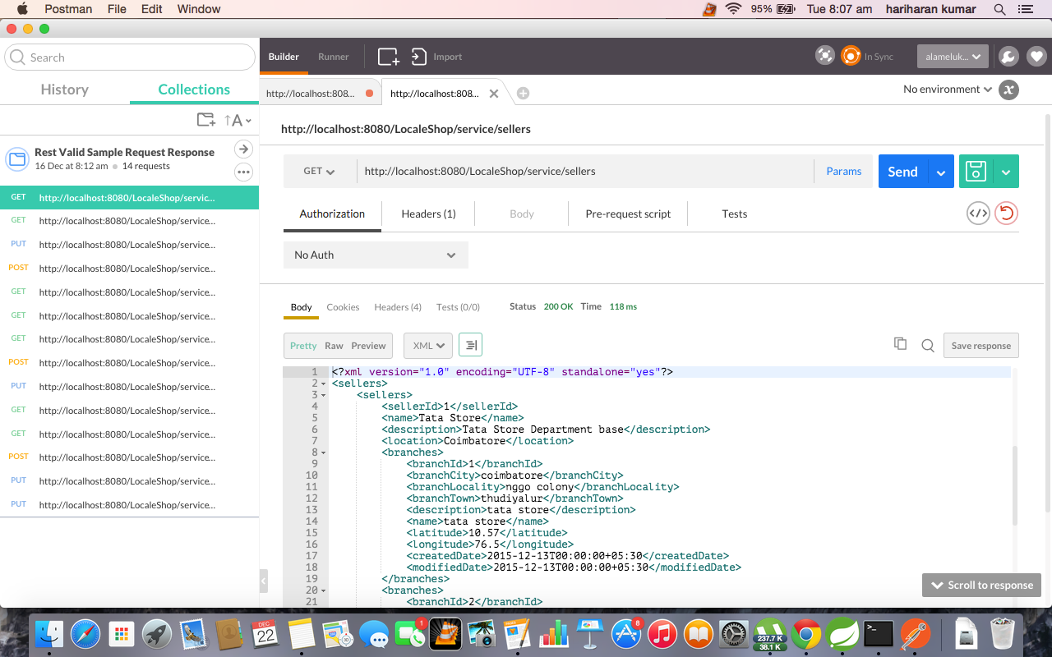

Seller by Id.

HTTP Verb - GET

URL - http://localhost:8080/LocaleShop/service/sellers/2

Request Headers -

Accept → application/xml

Response Headers -

Content-Length → 2100

Content-Type → application/xml

Date → Tue, 22 Dec 2015 02:16:39 GMT

Server → Apache-Coyote/1.1

{

"id": 2,

"name": "Reliance Store",

"description": "Reliance Store Department base",

"location": "kambam",

"sellerBranches": [

{

"branchCity": "theni",

"branchLocality": "r k nagar",

"branchTown": "k k nagar",

"description": "reliance store",

"name": "reliance store",

"latitude": 13.89,

"longitude": 86.76,

"id": 3,

"createdDate": 1449513000000,

"modifiedDate": 1449858600000

},

{

"branchCity": "tanjore",

"branchLocality": "r k nagar",

"branchTown": "s h nagar",

"description": "reliance store",

"name": "reliance store",

"latitude": 13.89,

"longitude": 86.76,

"id": 13,

"createdDate": 1449945000000,

"modifiedDate": 1449945000000

}

],

"createdDate": 1449513000000,

"modifiedDate": 1449513000000

}

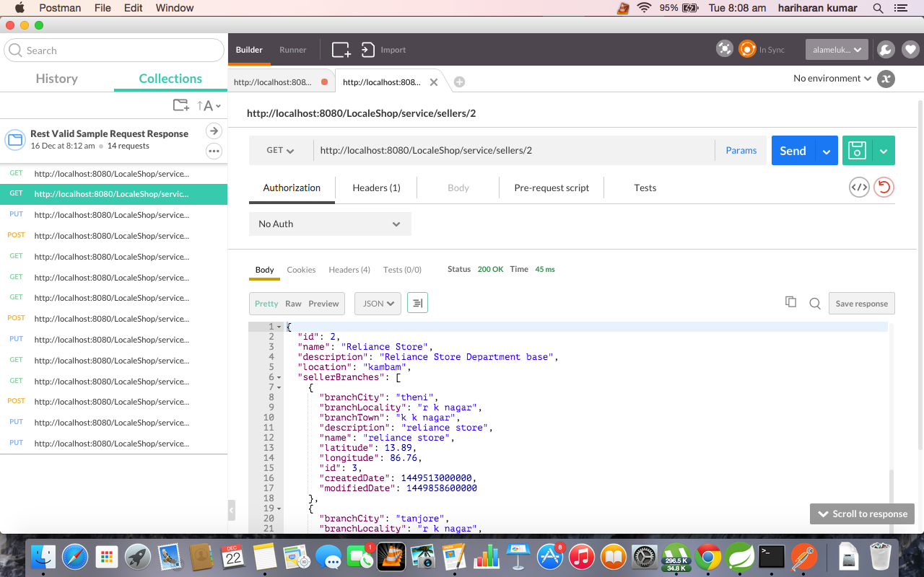

Seller by Id(updating one of seller branch and creating a new seller branch in the same PUT request).

HTTP Verb - PUT

URL - http://localhost:8080/LocaleShop/service/sellers/2

Request Headers -

Accept → application/json

Content-Type → application/json

{

"id": 2,

"name": "Reliance Store",

"description": "Reliance Store Department base",

"location": "kambam",

"createdDate": 1449513000000,

"modifiedDate": 1449513000000,

"sellerBranches": [

{

"id": 3,

"branchCity": "theni",

"branchLocality": "r k nagar",

"branchTown": "k k nagar",

"description": "reliance store",

"name": "reliance store",

"latitude": 13.89,

"longitude": 86.76,

"createdDate": 1449513000000,

"modifiedDate": "2015-12-12T00:00:00+05:30"

},

{

"branchCity": "tanjore",

"branchLocality": "r k nagar",

"branchTown": "s h nagar",

"description": "reliance store",

"name": "reliance store",

"latitude": 13.89,

"longitude": 86.76,

"createdDate": "2015-12-12T00:00:00+05:30",

"modifiedDate": "2015-12-13T00:00:00+05:30"

}

]

}

Response Headers -

Content-Length → 874

Content-Type → application/json

Date → Tue, 22 Dec 2015 02:21:33 GMT

Server → Apache-Coyote/1.1

{

"id": 2,

"name": "Reliance Store",

"description": "Reliance Store Department base",

"location": "kambam",

"sellerBranches": [

{

"branchCity": "theni",

"branchLocality": "r k nagar",

"branchTown": "k k nagar",

"description": "reliance store",

"name": "reliance store",

"latitude": 13.89,

"longitude": 86.76,

"id": 3,

"createdDate": 1449513000000,

"modifiedDate": 1449858600000

},

{

"branchCity": "tanjore",

"branchLocality": "r k nagar",

"branchTown": "s h nagar",

"description": "reliance store",

"name": "reliance store",

"latitude": 13.89,

"longitude": 86.76,

"id": 13,

"createdDate": 1449945000000,

"modifiedDate": 1449945000000

},

{

"branchCity": "tanjore",

"branchLocality": "r k nagar",

"branchTown": "s h nagar",

"description": "reliance store",

"name": "reliance store",

"latitude": 13.89,

"longitude": 86.76,

"id": 14,

"createdDate": 1449858600000,

"modifiedDate": 1449945000000

}

],

"createdDate": 1449513000000,

"modifiedDate": 1449513000000

}

Sellers.

HTTP Verb - POST

URL - http://localhost:8080/LocaleShop/service/sellers

Request Headers -

Accept → application/json

Content-Type → application/json

{

"name": "Kirla Store",

"description": "Kirla Store Department base",

"location": "suseendram",

"createdDate": "2015-12-12T00:00:00+05:30",

"modifiedDate": "2015-12-13T00:00:00+05:30",

"sellerBranches": [

{

"branchCity": "ooty",

"branchLocality": "r k nagar",

"branchTown": "k k nagar",

"description": "Kirla store",

"name": "Kirla store",

"latitude": 13.89,

"longitude": 86.76,

"createdDate": "2015-12-12T00:00:00+05:30",

"modifiedDate": "2015-12-13T00:00:00+05:30"

},

{

"branchCity": "tanjore",

"branchLocality": "r k nagar",

"branchTown": "s h nagar",

"description": "Kirla store",

"name": "Kirla store",

"latitude": 13.89,

"longitude": 86.76,

"createdDate": "2015-12-12T00:00:00+05:30",

"modifiedDate": "2015-12-13T00:00:00+05:30"

}

]

}

Response Headers -

Content-Length → 27

Content-Type → text/plain

Date → Tue, 22 Dec 2015 02:35:36 GMT

Server → Apache-Coyote/1.1

Seller Successfully created