Sensor-Based Simulation Using Arduino and LDR

Aim
To simulate an IoT-based light sensing system using Arduino Uno and an LDR (Light Dependent Resistor) in Tinkercad, where the LED
automatically turns ON or OFF depending on the light intensity.

Components Required
- Arduino Uno
- Breadboard
- LDR (Light Dependent Resistor)
- LED
- 10 kΩ Resistor
- 220 Ω Resistor
- Jumper Wires
- Tinkercad Simulator

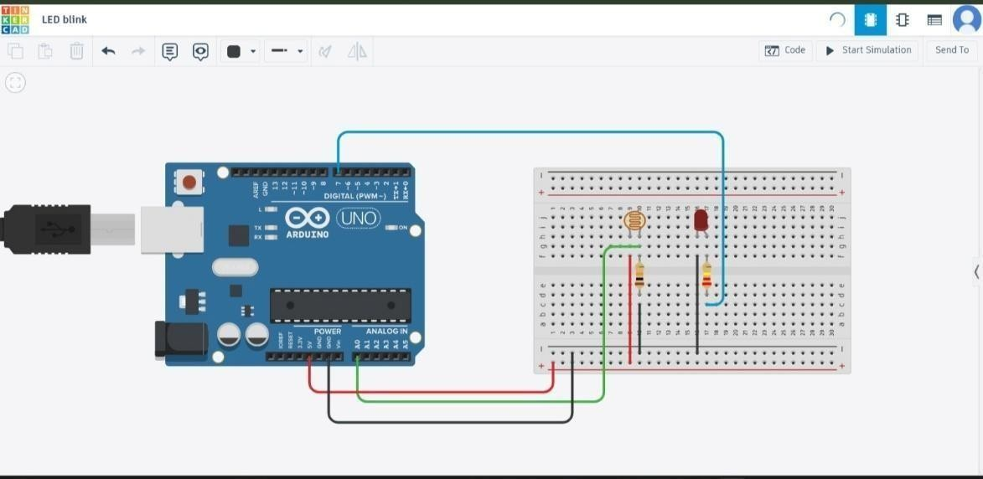
Circuit Diagram

Arduino Program

const int ledPin = 7; const int ldrPin = A0;

void setup() {

Serial.begin(9600);
pinMode(ledPin, OUTPUT); pinMode(ldrPin, INPUT);
}

void loop(){ int
ldrStatus=analogRead(ldrPin); Serial.println(ldrStatus);
if(ldrStatus <=80) {
digitalWrite(ledPin, HIGH);
} else{
digitalWrite(ledPin,LOW);
}
}

Working Principle

The LDR senses the surrounding light intensity and sends an analog signal to the Arduino through analog pin A0. The Arduino
continuously reads the sensor value. If the light intensity is below the predefined is threshold (dark condition), the Arduino turns the LED ON. If the light intensity above the threshold (bright condition), the LED turns the LED OFF. This demonstrates an automatic light control system.

Code Explanation

. const int ledPin = 7; – Defines LED connection to digital pin 7.
- const int ldrPin = A0; – Defines LDR connection to analog pin A0.
- analogRead(ldrPin); – Reads the light intensity from the LDR.
- if(ldrStatus <= threshold) – Checks whether the environment is dark.
- digitalWrite(ledPin, HIGH); – Turns the LED ON.
- digitalWrite(ledPin, LOW); – Turns the LED OFF.
- Serial.println(ldrStatus); – Displays the sensor value in the Serial Monitor.

Simulation Output

(LED ON)

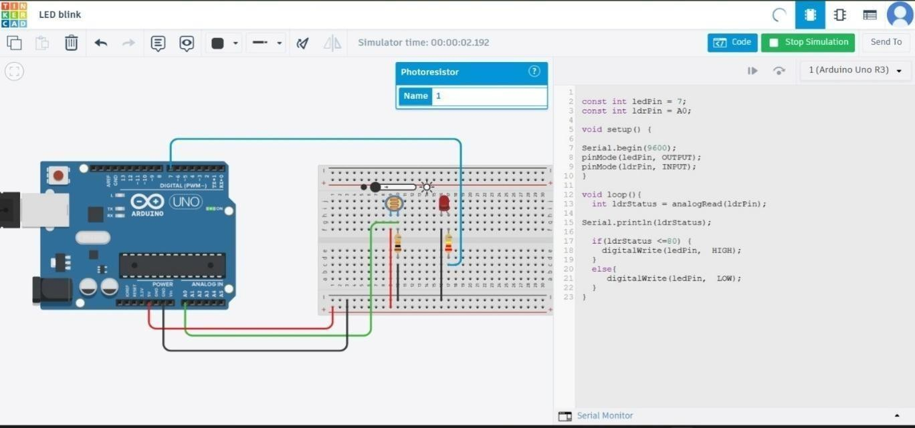

(LED OFF)

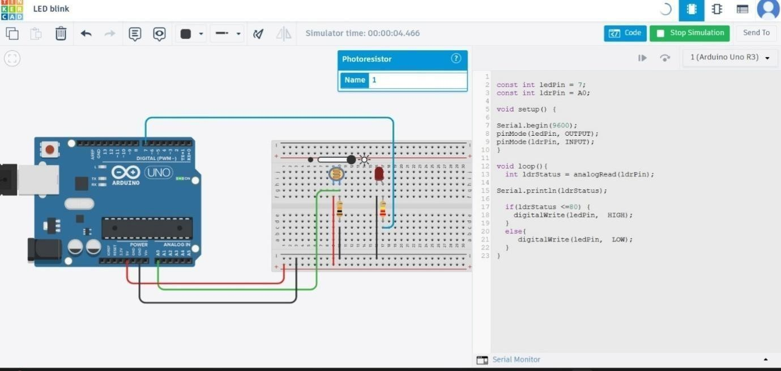

Result
The Arduino-based LDR sensor simulation was successfully
implemented in Tinkercad. The LED automatically turns ON in low light and turns OFF in bright light based on the LDR sensor readings.

Conclusion
The project demonstrates a simple IoT application for automatic lighting control. Using an LDR sensor and Arduino Uno, the system detects changes in light intensity and controls an LED accordingly.
This concept can be extended to real-world smart home and energysaving applications.

