**AWS-Ec2**

**Step 1**

**Name and tags**

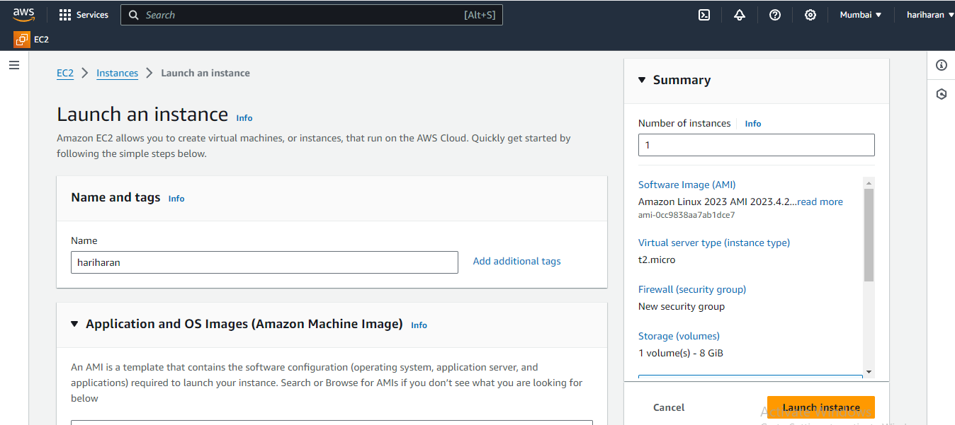

**Step 2**

**Application and OS Images**

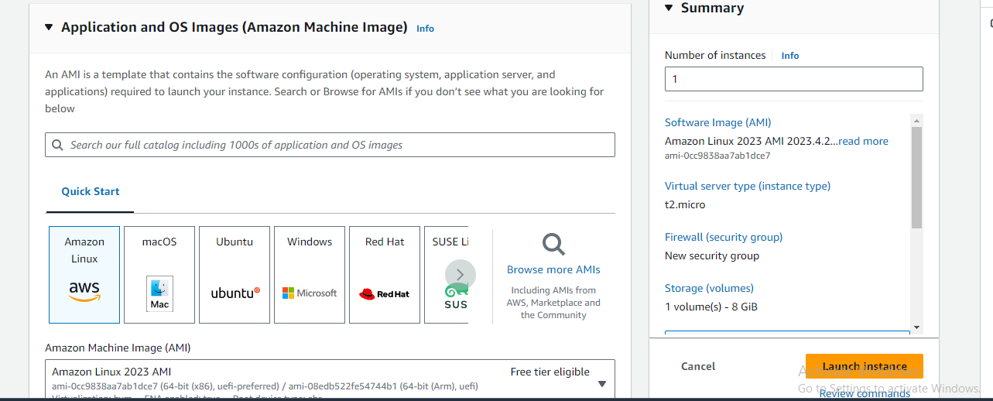

**Step 3**

**Instance type**

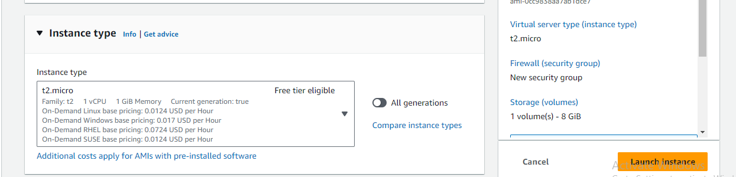

**Step 4**

**Key pair**

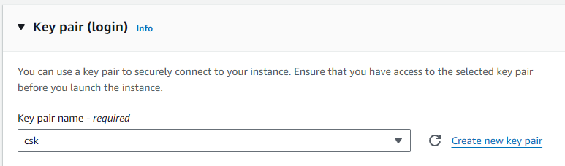

**Step 5**

**Vpc and subnet**

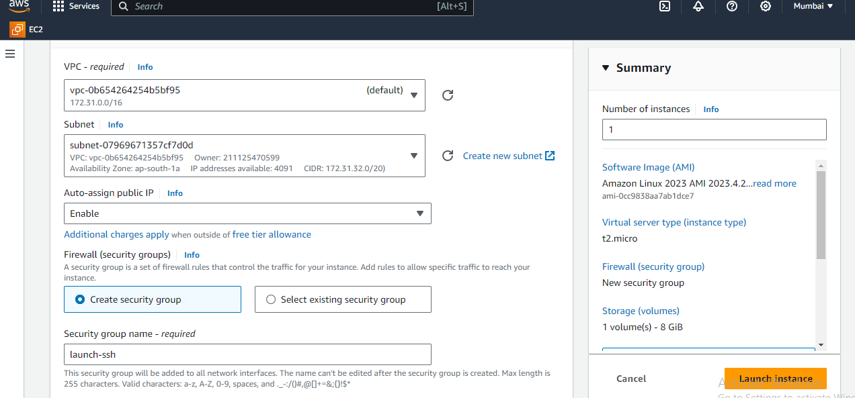

**Step 6**

**Ec2-instances**

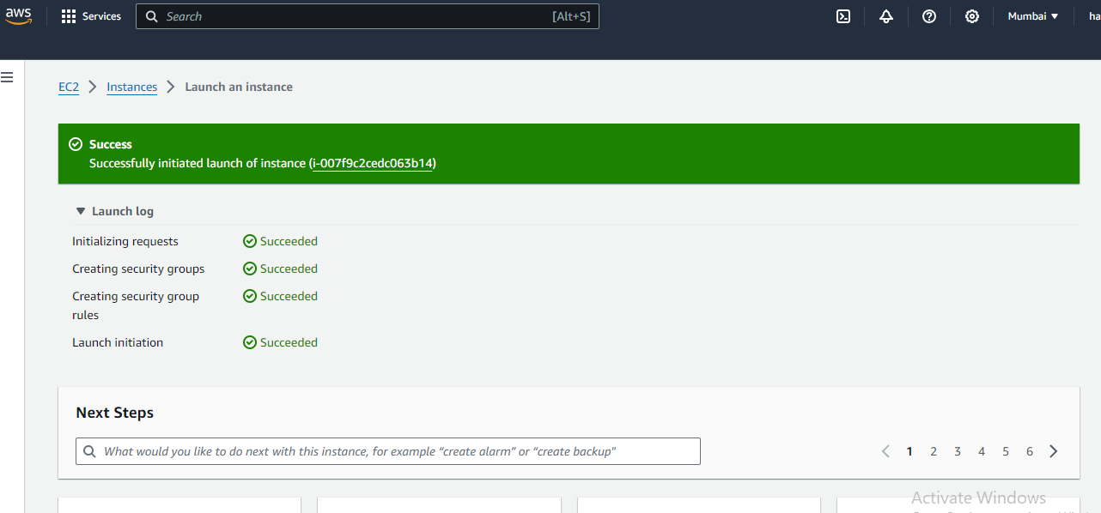

**Step 7**

**Mobaxterm enter**

**Step 8**

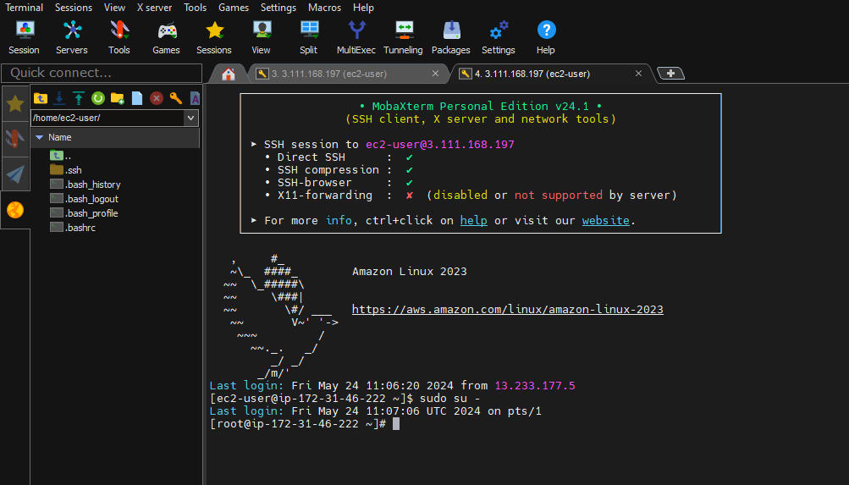

**Note**

**Boot strap [user data]**

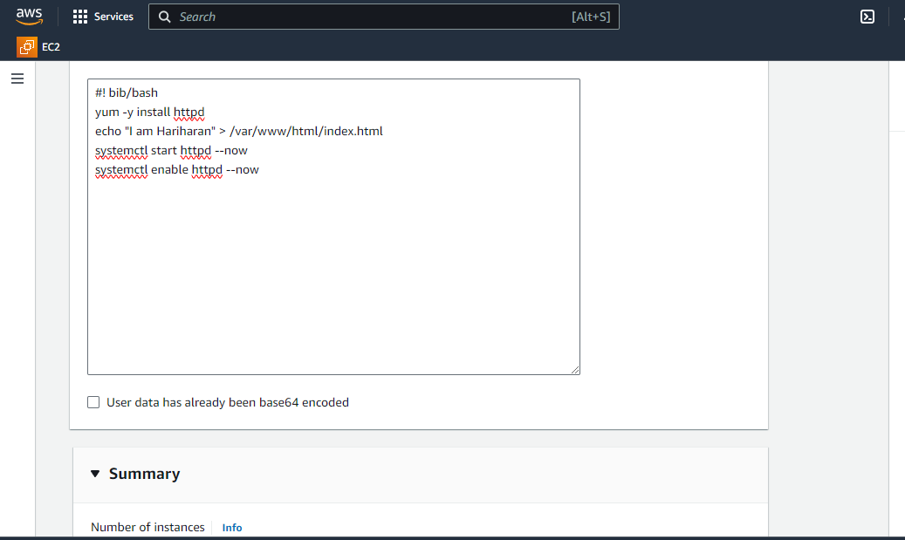

**Security group**

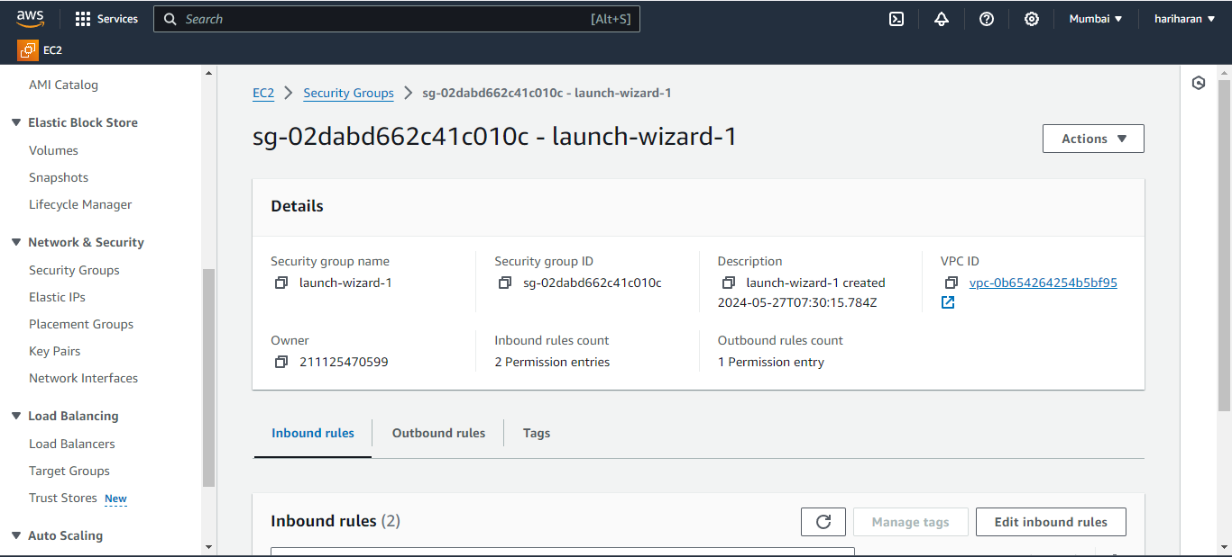

**Public Ip address to enter google enter**

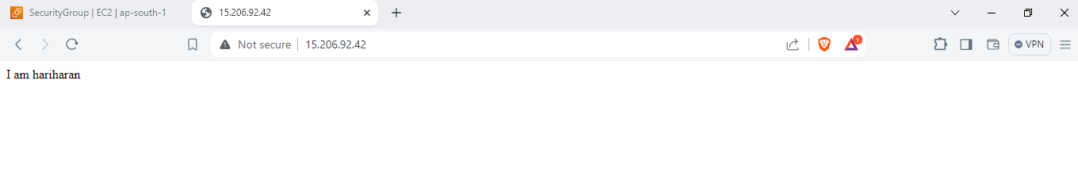

**Action**

**Image and create template**

**Create template from instance**

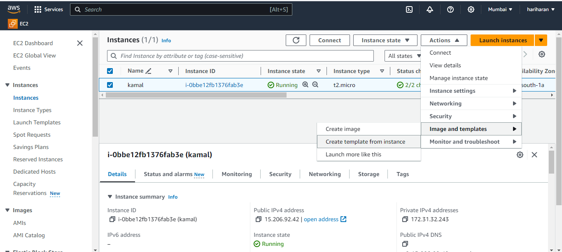

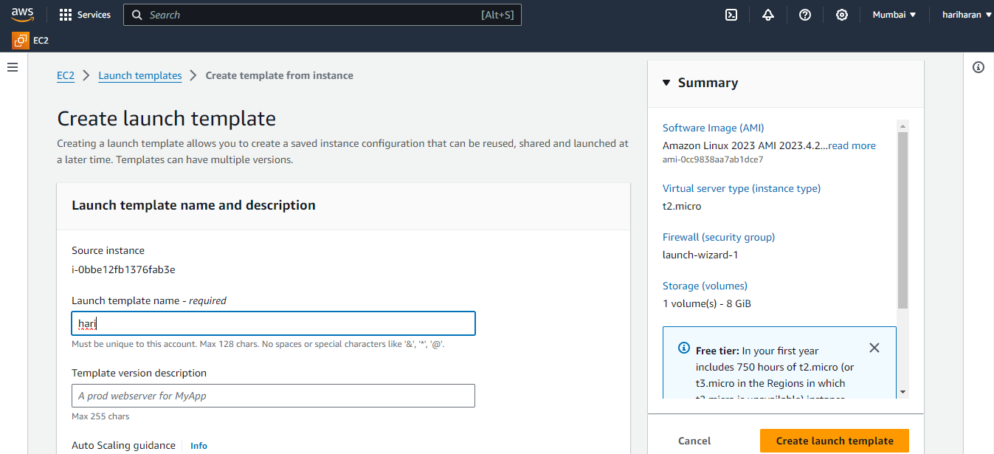

**Launch template**

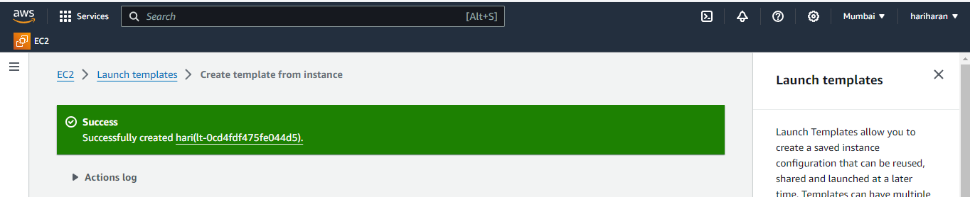

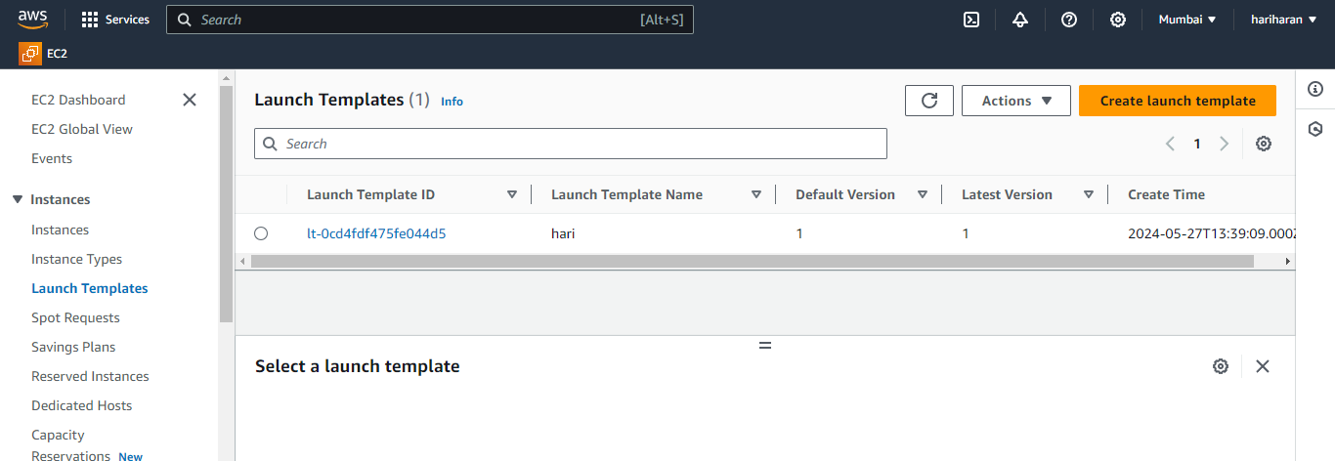

**If you delete a Ec2 instance after**

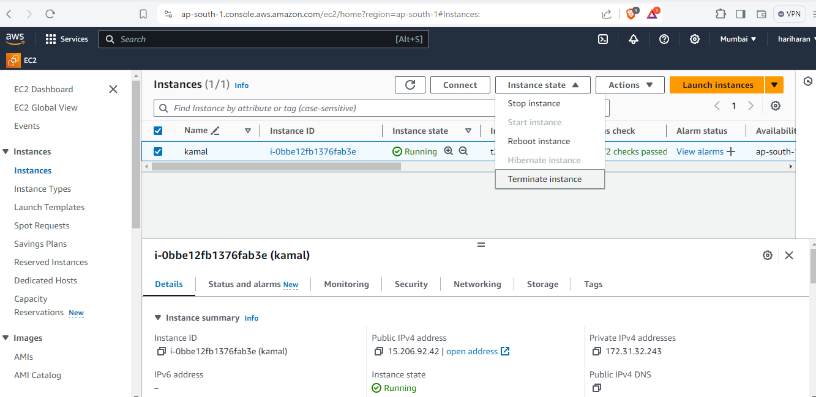

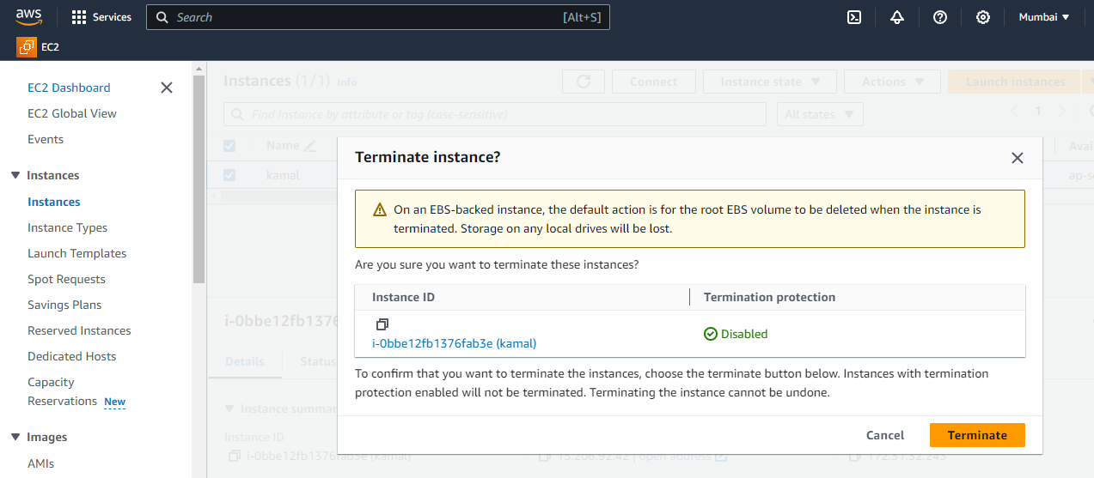

**After you launch template**

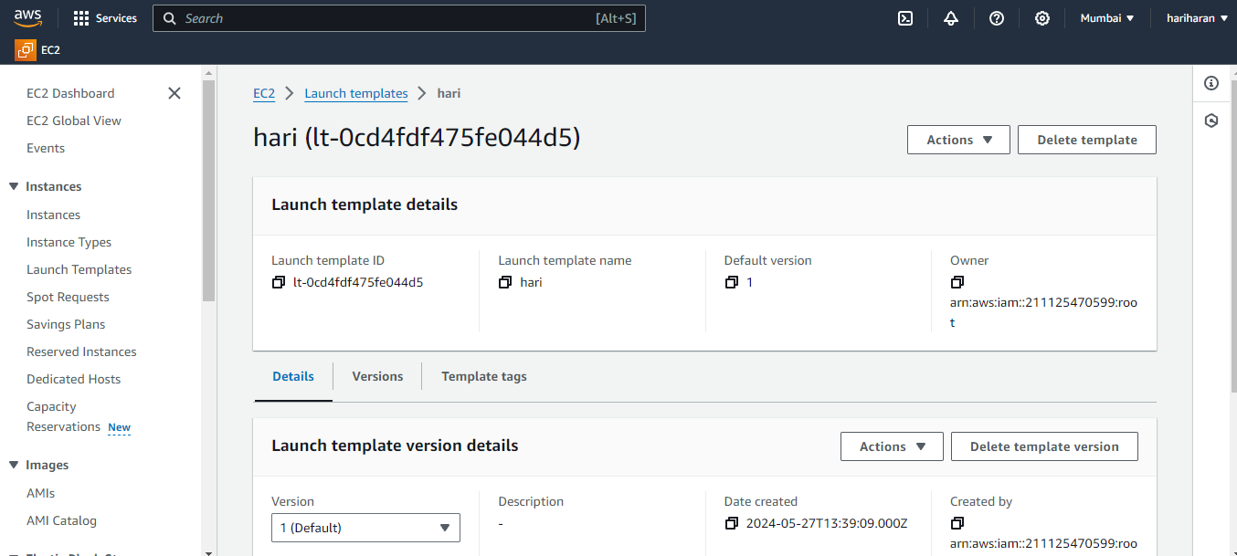

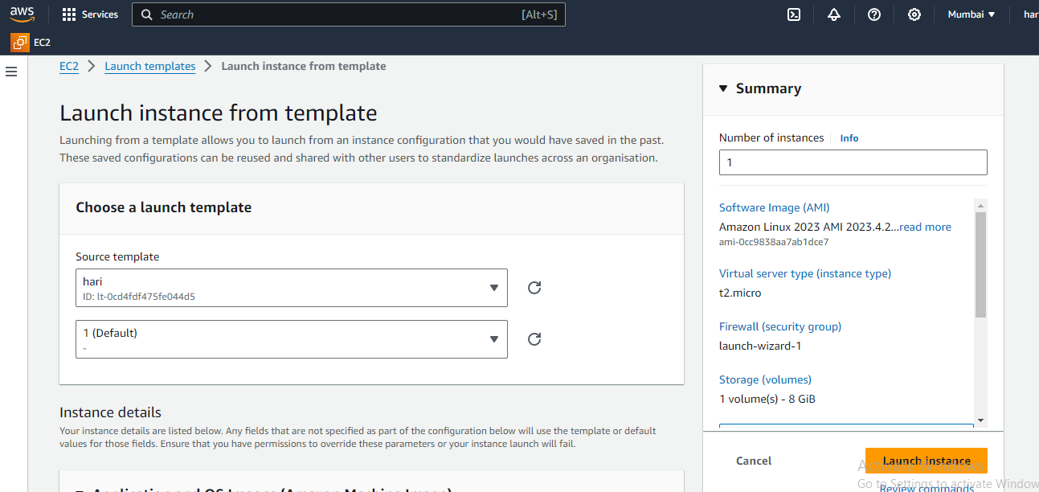

**Then you check the instances launch will to Ec2 instance public ip to google search**

