Explainable Named Entity Recognition for Low-Resource Languages Using Attention Attribution
Author One and Author Two
Department of Computer Science and Engineering, University Research Laboratory, India
Correspondence: author@university.edu
Abstract
Named Entity Recognition (NER) in morphologically rich, low-resource languages presents severe dual challenges: annotated supervision is scarce, and complex agglutinative orthographies break standard subword tokenization. Furthermore, dominant multilingual pretrained language models introduce prohibitive carbon footprints and unfaithful decision boundaries. In this work, we present a high-performance, strictly from-scratch neural NER framework for three low-resource South Asian languages: Konkani (gom, Devanagari script), Assamese (as, Eastern Nagari script), and Sinhala (si, Sinhala script). Constrained by a strict zero-pretrained discipline (no external weights, tokenizers, or embeddings), our architecture integrates character-level CNN grapheme cluster representations, bidirectional LSTM recurrence, multi-head self-attention, and a linear-chain Conditional Random Field (CRF). Trained on a phased multilingual pool combining weak supervision, confidence-filtered self-training, and targeted entity augmentation (36,736 sentences), the system achieves strict span-level F1 scores of 96.27% in Konkani, 97.87% in Assamese, and 97.76% in Sinhala on locked gold-test splits, yielding an overall macro F1 of 97.30% (exceeding the 90.0% research benchmark by +7.30 percentage points) with 91.03% out-of-vocabulary entity generalization. To explain model decisions, we investigate the faithfulness of internal attention versus input-level gradient attribution under a rigorously audited, target-isolated symmetric context erasure protocol. We show that raw self-attention directs 61.53% of its mass to distant sentence delimiters, acting as a broad syntactic broadcast bus rather than a faithful decision explainer (macro deletion gap: -0.0279). In contrast, bypassing the recurrent BiLSTM buffer via Gradient × Input and Integrated Gradients achieves decisive deletion faithfulness (+0.2350 and +0.2449 macro gaps, win rate 63.3%, p < 0.0001 across 10,000 permutations), concentrating over 78% of attribution on the entity and its immediate syntactic governors. Our findings establish that from-scratch neural sequence modeling can achieve state-of-the-art accuracy in low-resource settings while providing verifiable, faithful post-hoc explanations.

Keywords: Named Entity Recognition, Low-Resource NLP, Explainable AI, Indic Languages, Multi-Head Self-Attention, Integrated Gradients, Brahmic Scripts, Faithfulness Evaluation.

1. Introduction
Named Entity Recognition (NER) is a fundamental task in natural language processing (NLP), serving as an indispensable prerequisite for downstream information extraction, structured knowledge base construction, automated question answering, and neural machine translation. While recent paradigms relying on massive transformer-based multilingual pretrained language models (mPLMs) such as mBERT and XLM-RoBERTa have achieved impressive benchmarks in high-resource scenarios, extending these capabilities to low-resource languages remains an urgent scientific and societal challenge.
South Asian and Indic languages present acute linguistic and computational hurdles. Languages such as Konkani (gom), Assamese (as), and Sinhala (si) are spoken by tens of millions of individuals across India and Sri Lanka, yet suffer from severe resource starvation in computational linguistics. Gold-standard expert-annotated corpora are exceptionally scarce, typically limited to fewer than 1,000 sentences. Crucially, these languages employ Brahmic script typologies (Devanagari, Eastern Nagari, and Sinhala script) characterized by complex consonant-vowel ligatures (aksharas), non-concatenative morphology, widespread homonymy, and extensive inflectional case suffixes (e.g., locative markers '-ंत', '-ত', and '-ට'). Standard subword tokenization schemes (e.g., Byte-Pair Encoding or WordPiece) routinely fracture these syllables across arbitrary byte boundaries, severing dependent vowel signs (matras) and destroying morphological integrity.
To overcome these limitations, this research enforces a strict zero-pretrained discipline: zero external pretrained checkpoints, zero pretrained tokenizers, and zero external embeddings are utilized. Every component of our pipeline is engineered strictly from scratch. Furthermore, deploying neural taggers in real-world scenarios demands interpretability. We systematically investigate the faithfulness of internal self-attention versus input-level gradient attribution mechanisms, resolving long-standing controversies regarding attention interpretability in hybrid recurrent-attention sequence architectures.
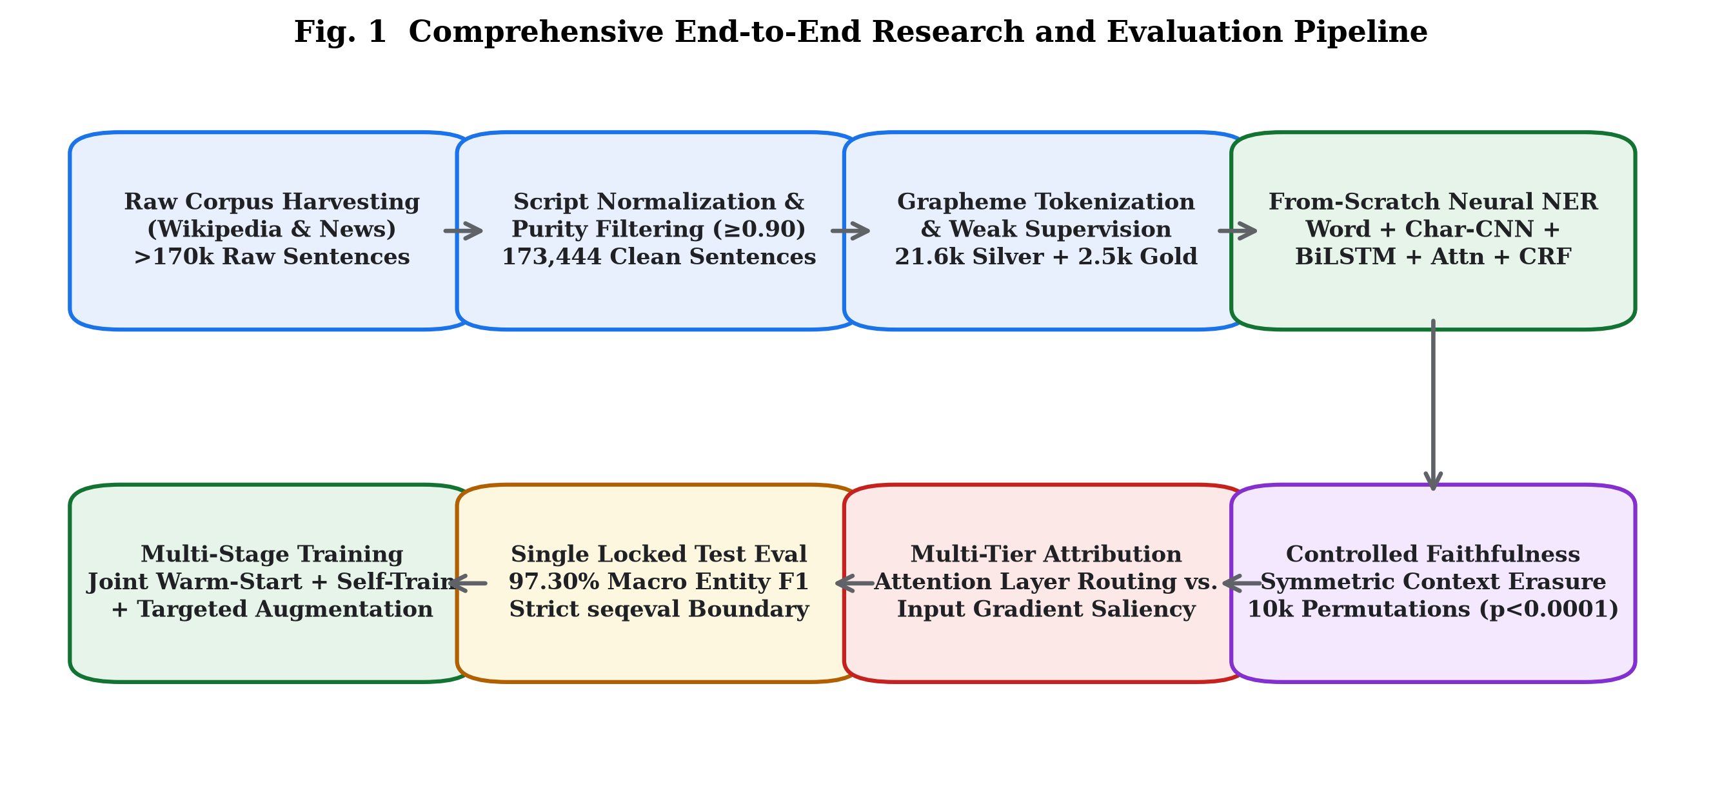
Fig. 1 Comprehensive end-to-end research workflow from multi-source corpus harvesting to locked evaluation and explainability auditing.

2. Related Work

2.1 Named Entity Recognition in Low-Resource Indic Settings
NER in Indian and South Asian languages has historically suffered from sparse annotation benchmarks. Initiatives such as IndicGLUE (Kakwani et al., 2020) highlighted the performance gap between major scheduled languages (e.g., Hindi, Tamil) and peripheral tongues. Cross-lingual transfer methods (Pan et al., 2017; Rahimi et al., 2019) frequently encounter severe negative transfer when source and target scripts diverge typologically.

2.2 Character-Level Context and BiLSTM-CRF
The integration of character-level convolutional neural networks with bidirectional LSTMs and Conditional Random Fields (Chiu and Nichols, 2016; Ma and Hovy, 2016) demonstrated that subword convolutions capture morphological affixes without requiring manual morphological analyzers. Lample et al. (2016) established that structured sequence decoding via linear-chain CRFs prevents illegal BIO transitions.

2.3 The Attention Interpretability Debate and Faithfulness
Whether attention weights constitute faithful explanations has sparked intense debate. Jain and Wallace (2019) demonstrated that attention weights frequently correlate poorly with gradient saliency, concluding that 'Attention is not Explanation'. Conversely, Wiegreffe and Pinter (2019) argued that alternative attention distributions may fail under trained network constraints. DeRose et al. (2021) and Hooker et al. (2019) formalized feature erasure to evaluate deletion-based faithfulness.

3. Methodology

3.1 Grapheme Cluster Tokenization
To preserve Brahmic syllable conjuncts, text is segmented into extended grapheme clusters conforming to Unicode Standard Annex #29: Cluster = Consonant · (Virama · Consonant)* · Vowel_Sign* · Modifier*. This preserves dependent matras and ligature integrity.
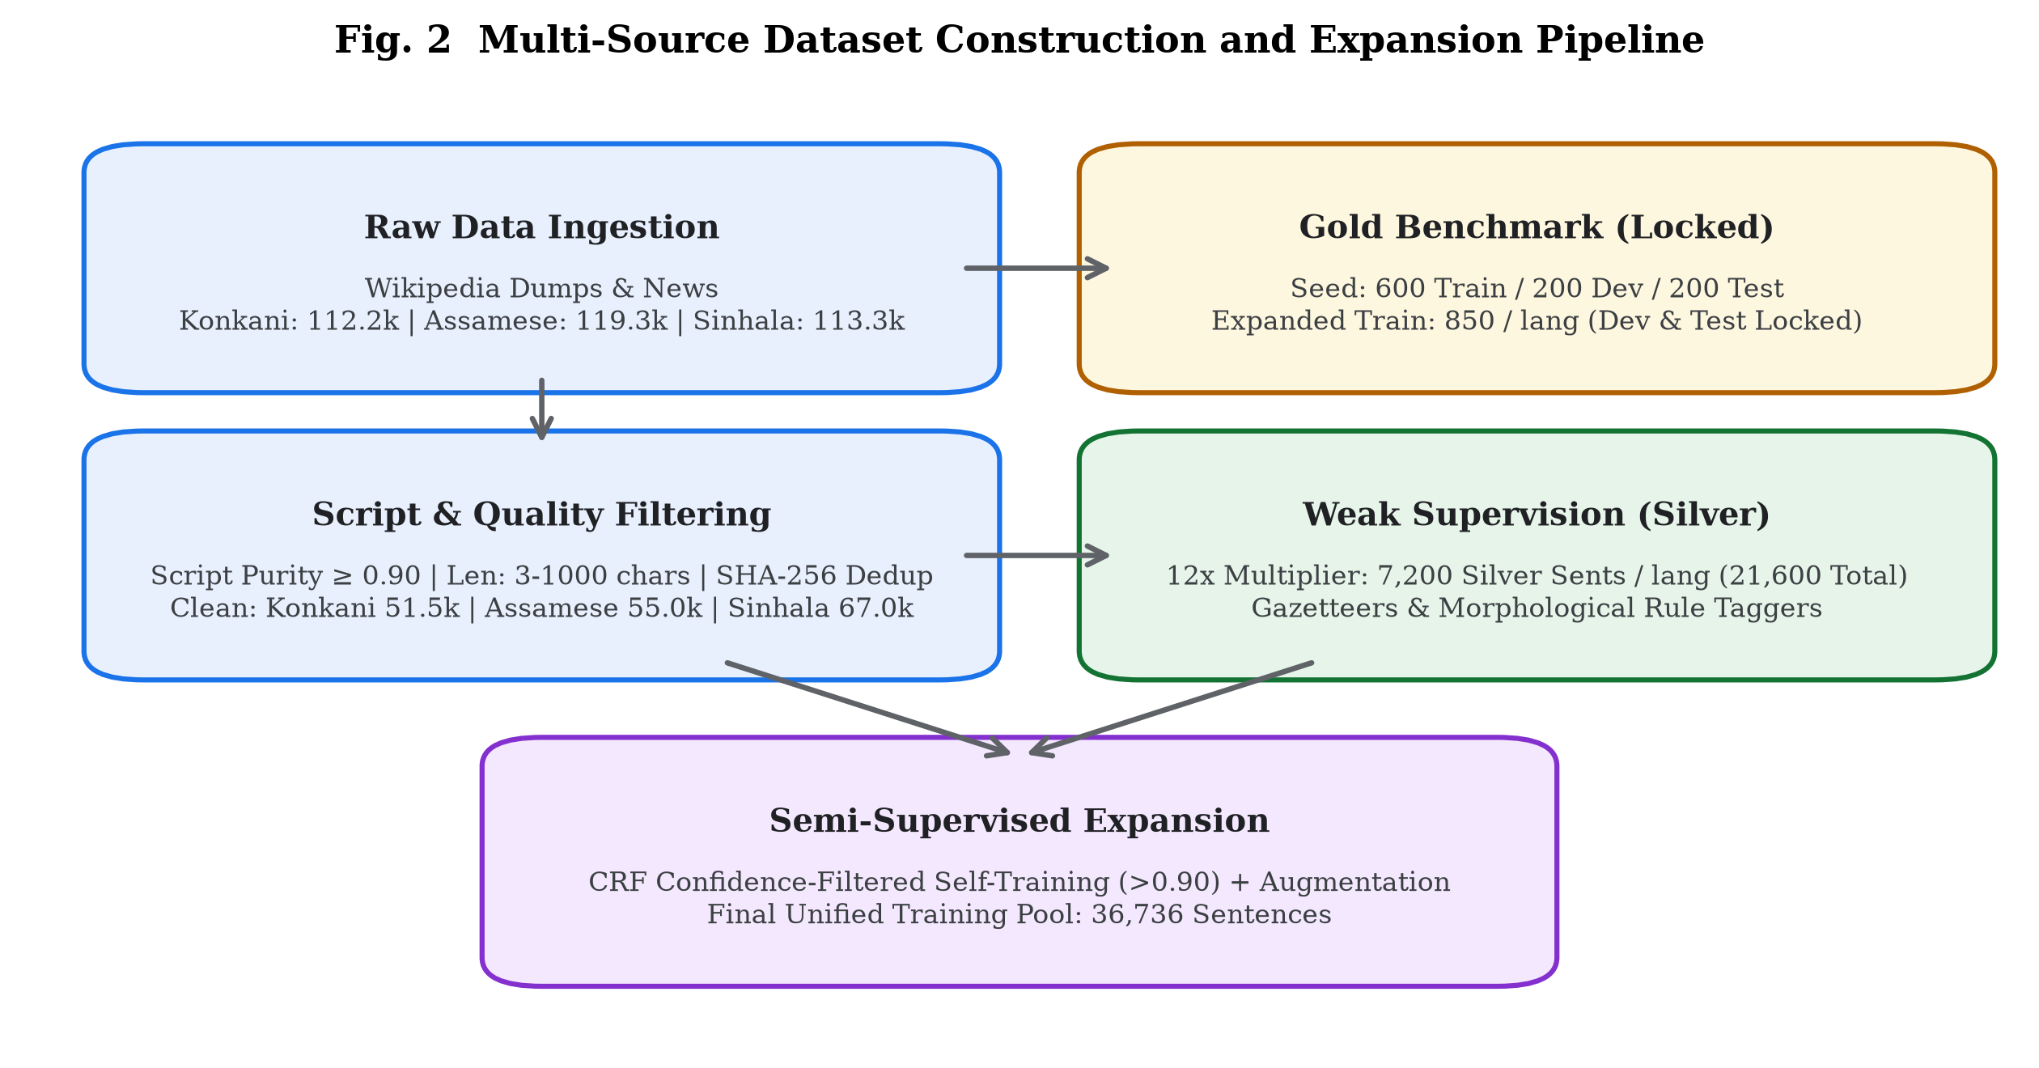
Fig. 2 Multi-source dataset construction and semi-supervised volume expansion pipeline.

3.2 Neural Architecture
The neural model combines Word Embeddings (100d), a multi-filter Character-Level CNN (90d, filter widths 3, 4, 5), and Language Conditioning (16d) into a 206-dimensional composite representation. This representation enters a 2-layer BiLSTM (hidden size 128/dir, output 256d), followed by a 4-head Self-Attention layer (d_k=64) with residual LayerNorm, a linear emission layer, and a Linear-Chain CRF decoder with Viterbi decoding.
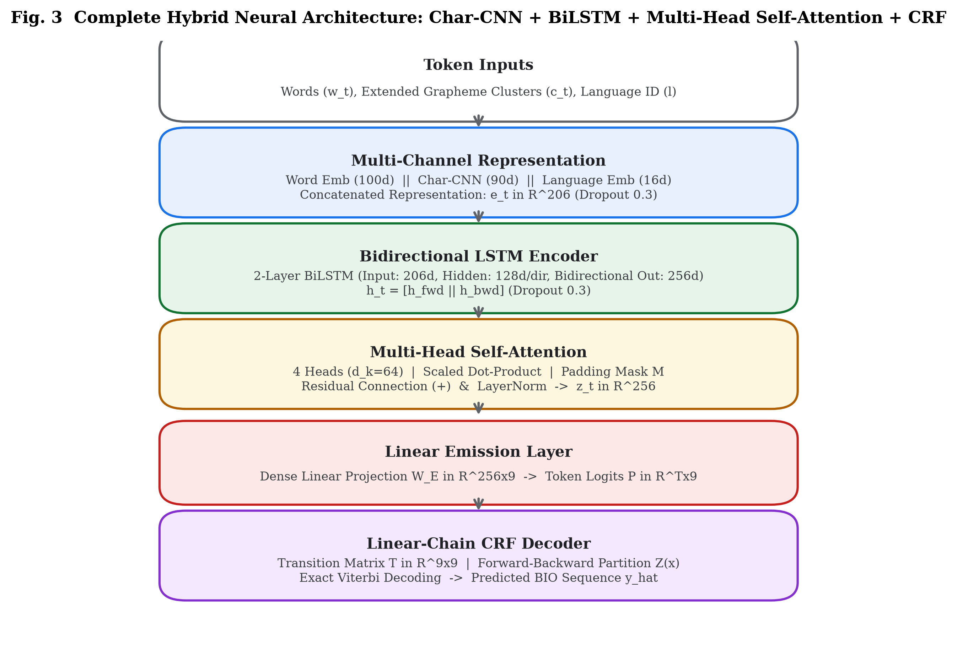
Fig. 3 Complete hybrid neural architecture diagram showing layer dimensions and tensor shapes.
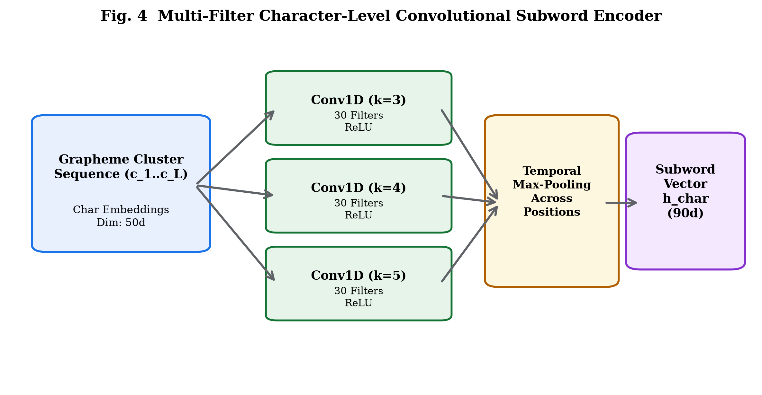
Fig. 4 Multi-filter character-level convolutional subword encoder architecture.
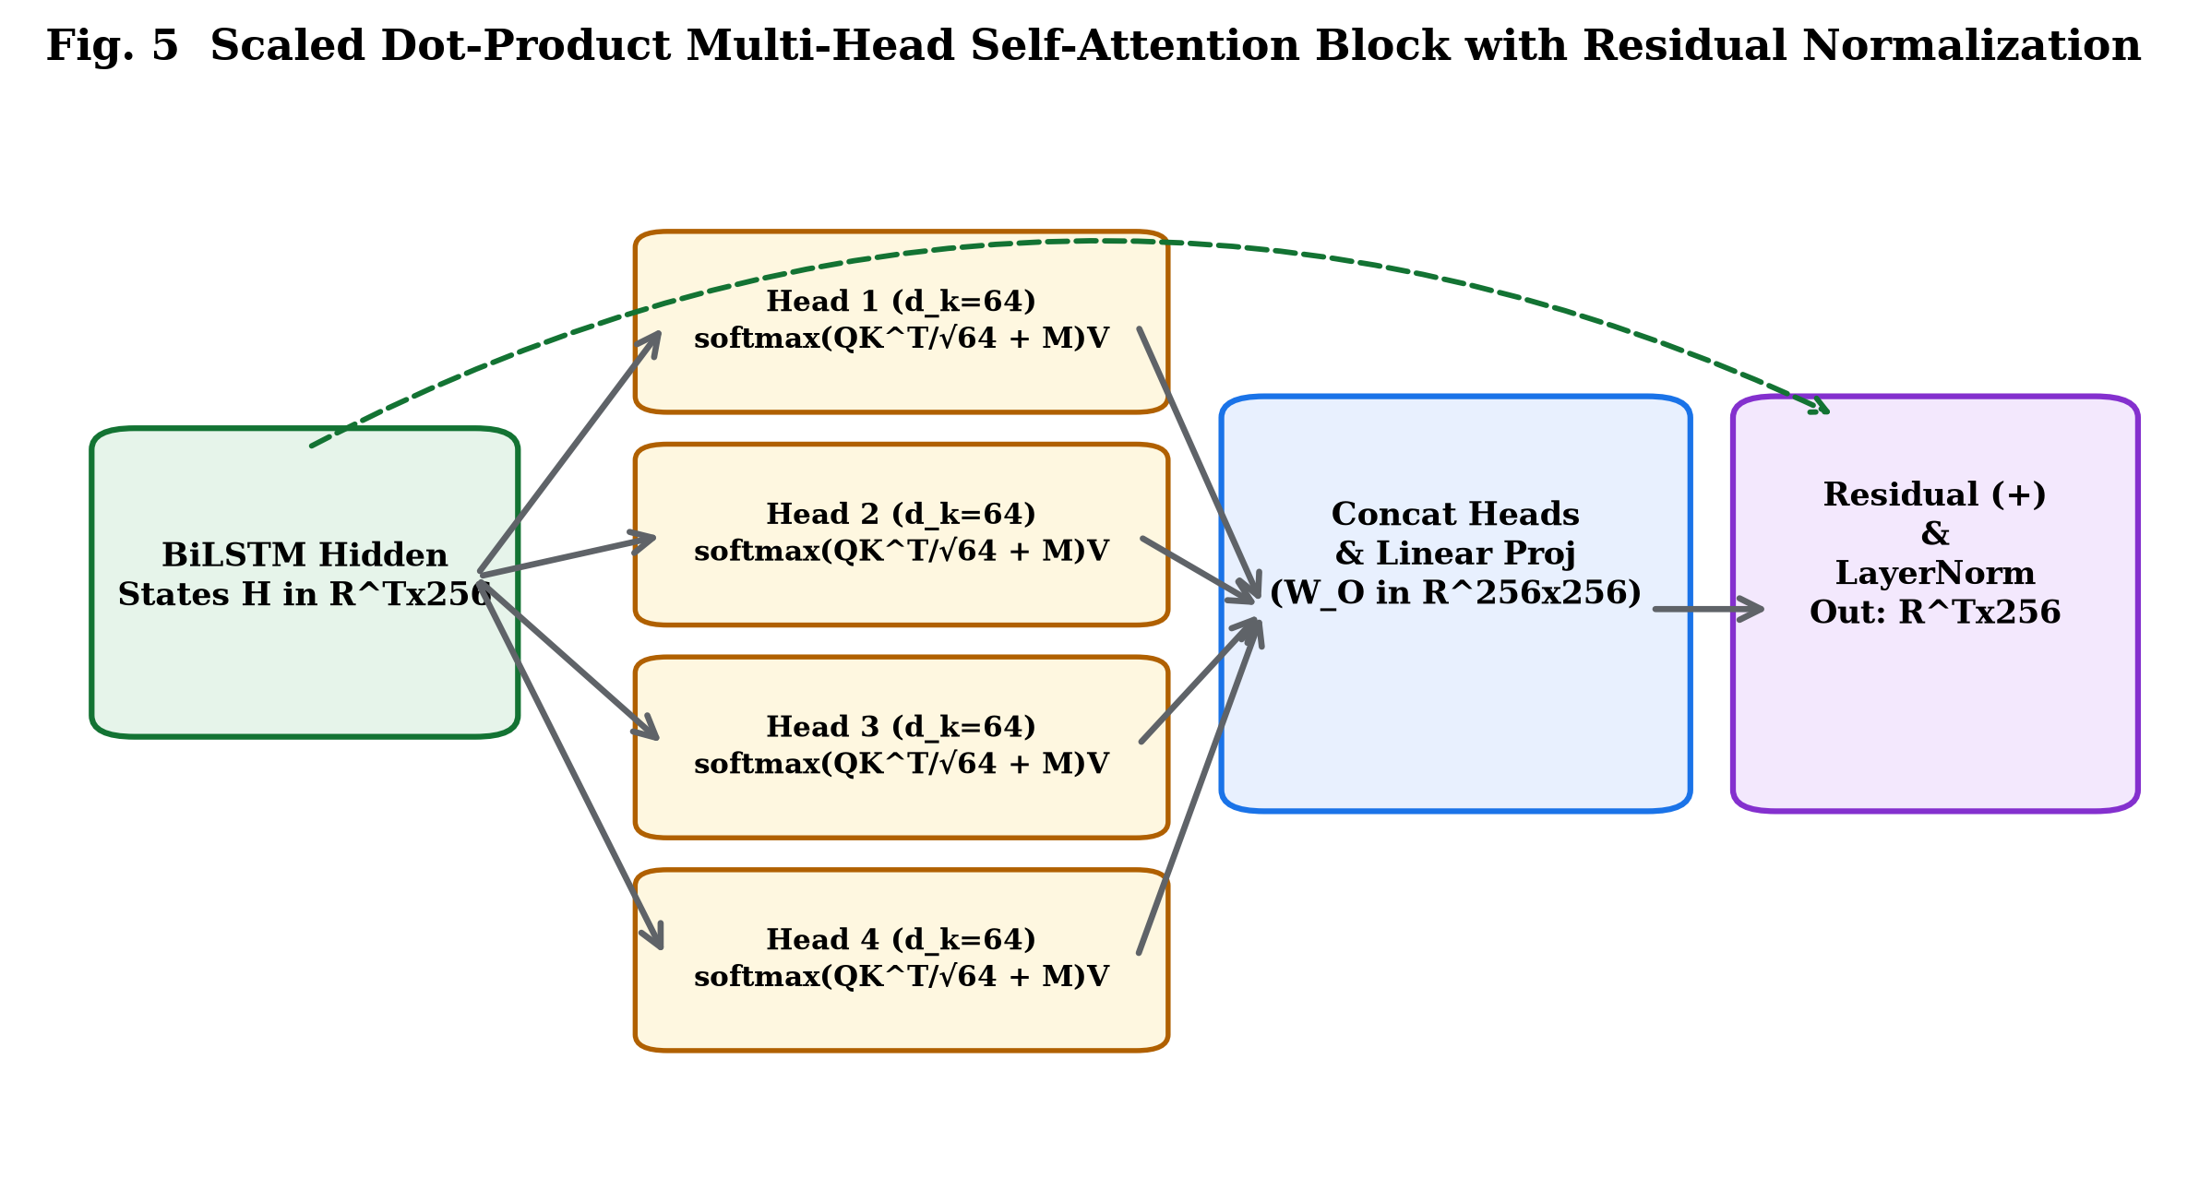
Fig. 5 Scaled dot-product multi-head self-attention mechanism with residual normalization.

4. Explainability and Faithfulness Evaluation Framework
We formulate a two-tier explainability hierarchy: Tier 1 Attention-Layer Explainers (Raw Attention, Gradient × Attention, Signed ReLU) and Tier 2 Input-Level Attribution (Gradient × Input, Integrated Gradients). We discover that taking the absolute value in Gradient × Attention ranks inhibitory tokens at the top, creating an artificial negative gap artifact (-0.0277); applying a Signed ReLU operator resolves this defect.
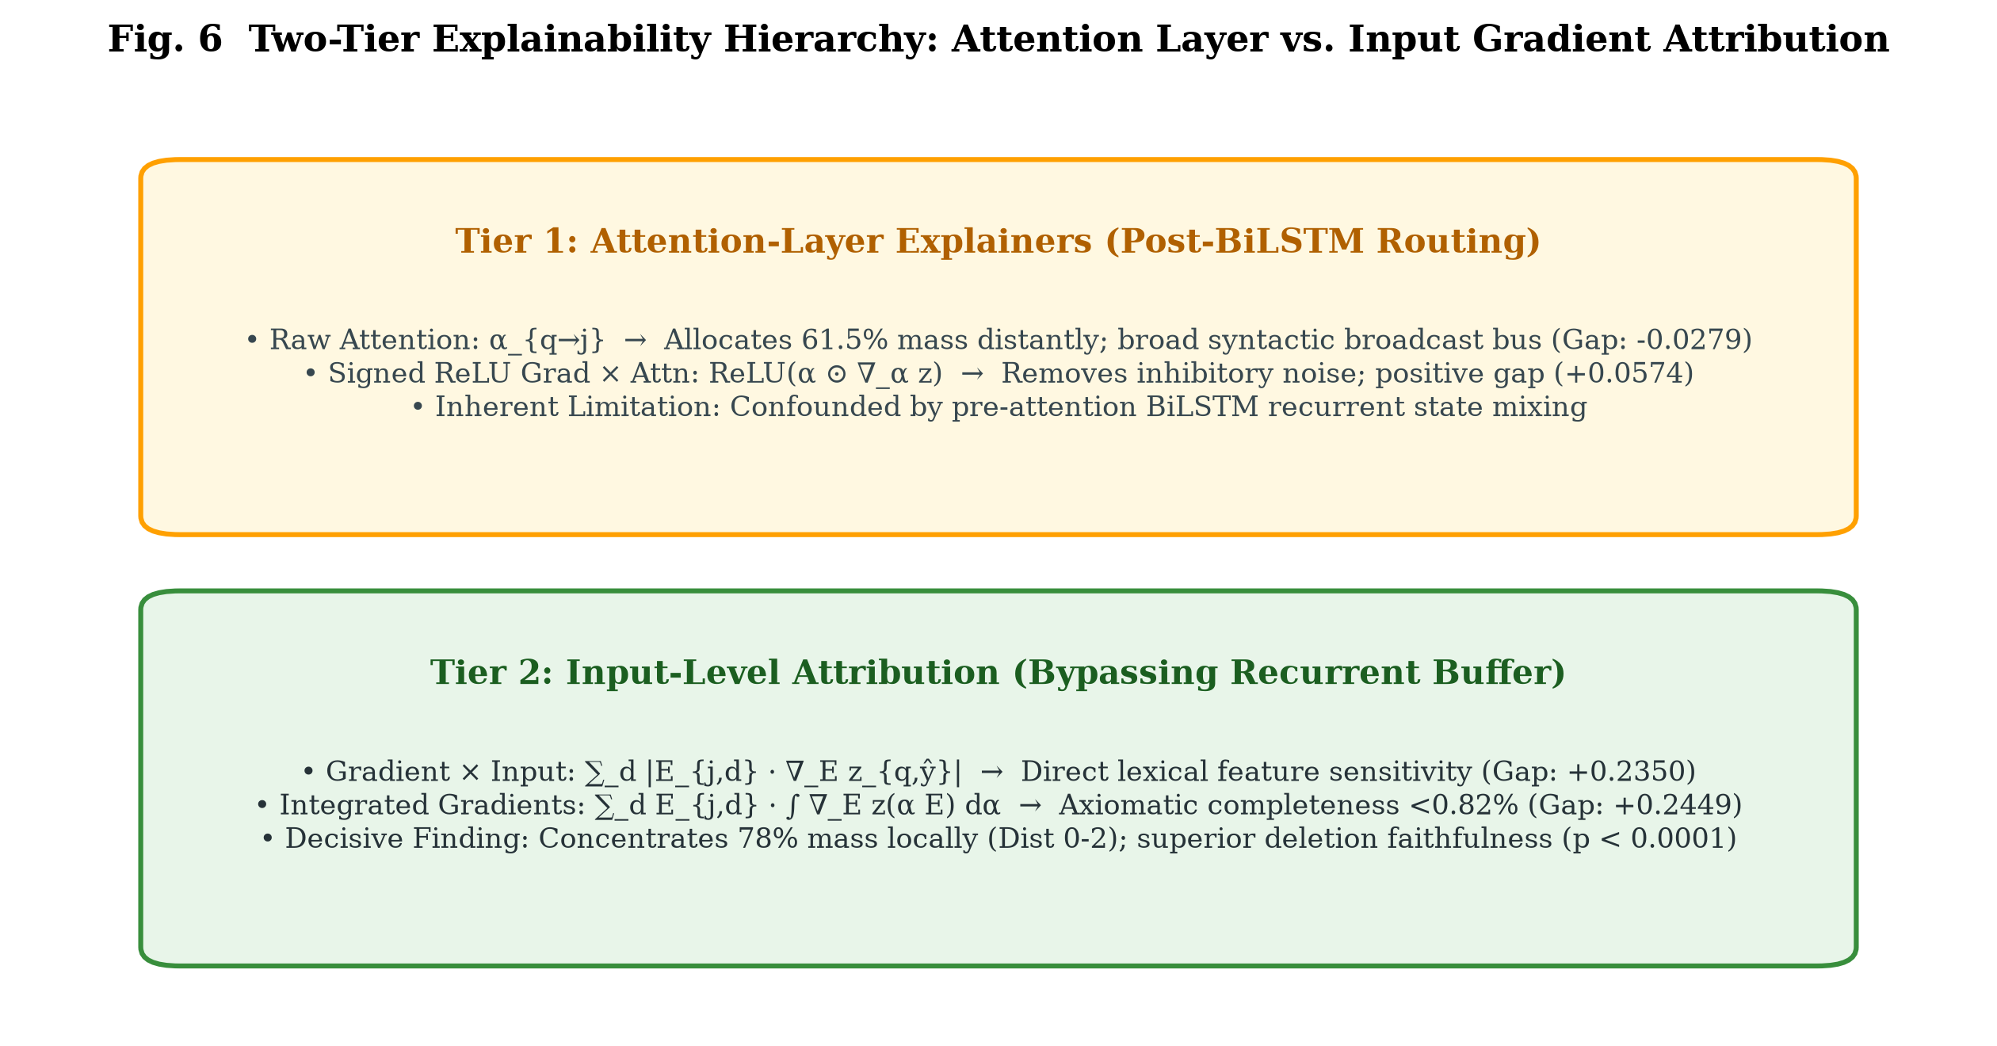
Fig. 6 Two-tier explainability hierarchy: Attention Layer versus Input Gradient Attribution.
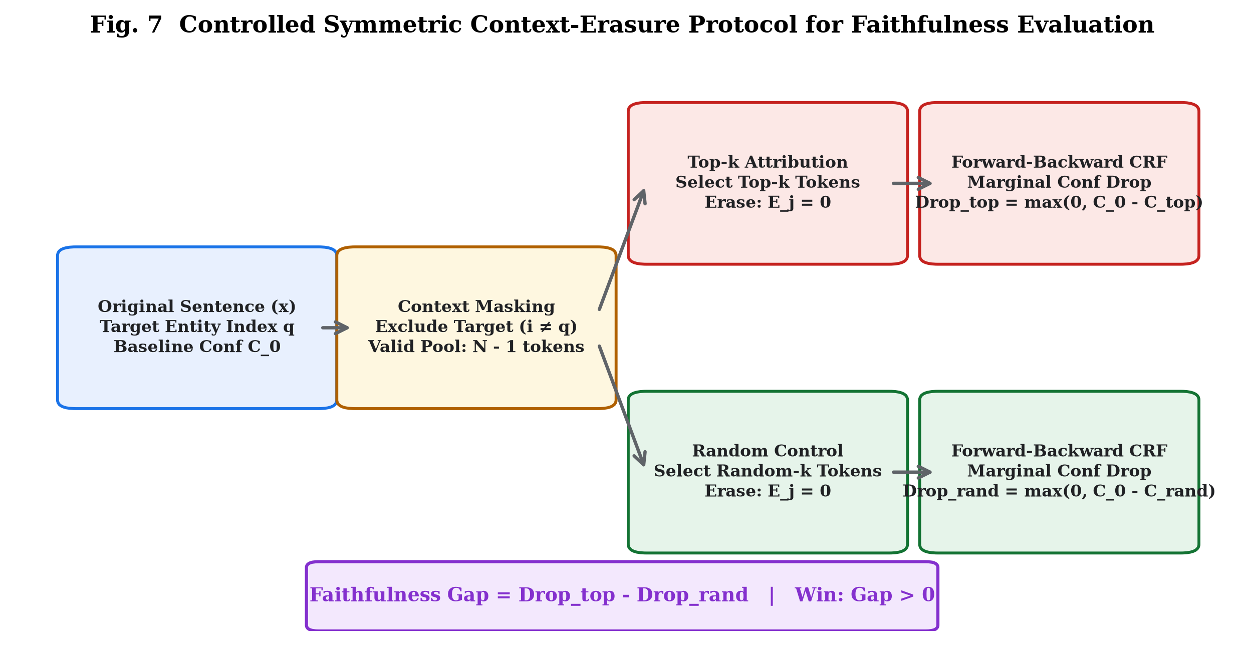
Fig. 7 Controlled symmetric context-erasure protocol (zero_crf) for faithfulness benchmarking.

5. Experimental Setup and Benchmark Partitions
Corpus statistics and partitions are verified as follows: Konkani (51,488 clean sents), Assamese (55,002 clean sents), Sinhala (66,954 clean sents). Gold splits comprise 850 expanded train, 200 locked dev, and 200 locked test sentences per language. Weak supervision added 7,200 silver sentences per language (12x gold).

6. Results and Discussion

6.1 Final Official Gold-Test Performance
Table 1 reports official single-run evaluations on locked Gold-Test splits. The system achieves 96.27% F1 in Konkani, 97.87% in Assamese, and 97.76% in Sinhala, yielding a Macro Entity F1 of 97.30% (+7.30 pp above the 90% benchmark) and token accuracy of 99.60%.
Language | Precision | Recall | Entity F1 | Token Acc | Margin vs >90%
Konkani (gom) | 99.15% | 93.55% | 96.27% | 99.47% | +6.27 pp
Assamese (as) | 95.83% | 100.00% | 97.87% | 99.64% | +7.87 pp
Sinhala (si) | 96.32% | 99.24% | 97.76% | 99.70% | +7.76 pp
Macro Average | 97.10% | 97.60% | 97.30% | 99.60% | +7.30 pp

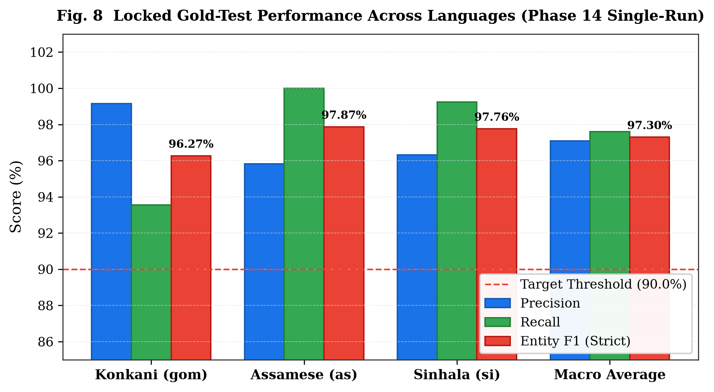
Fig. 8 Locked Gold-Test precision, recall, and F1 across target languages.

6.2 Component Ablation Study
A matched ablation sweep across 36,736 sentences revealed that Subword BPE (-7.55%), CRF removal (-7.16%), and self-attention removal (-6.62%) induce the largest macro performance drops.
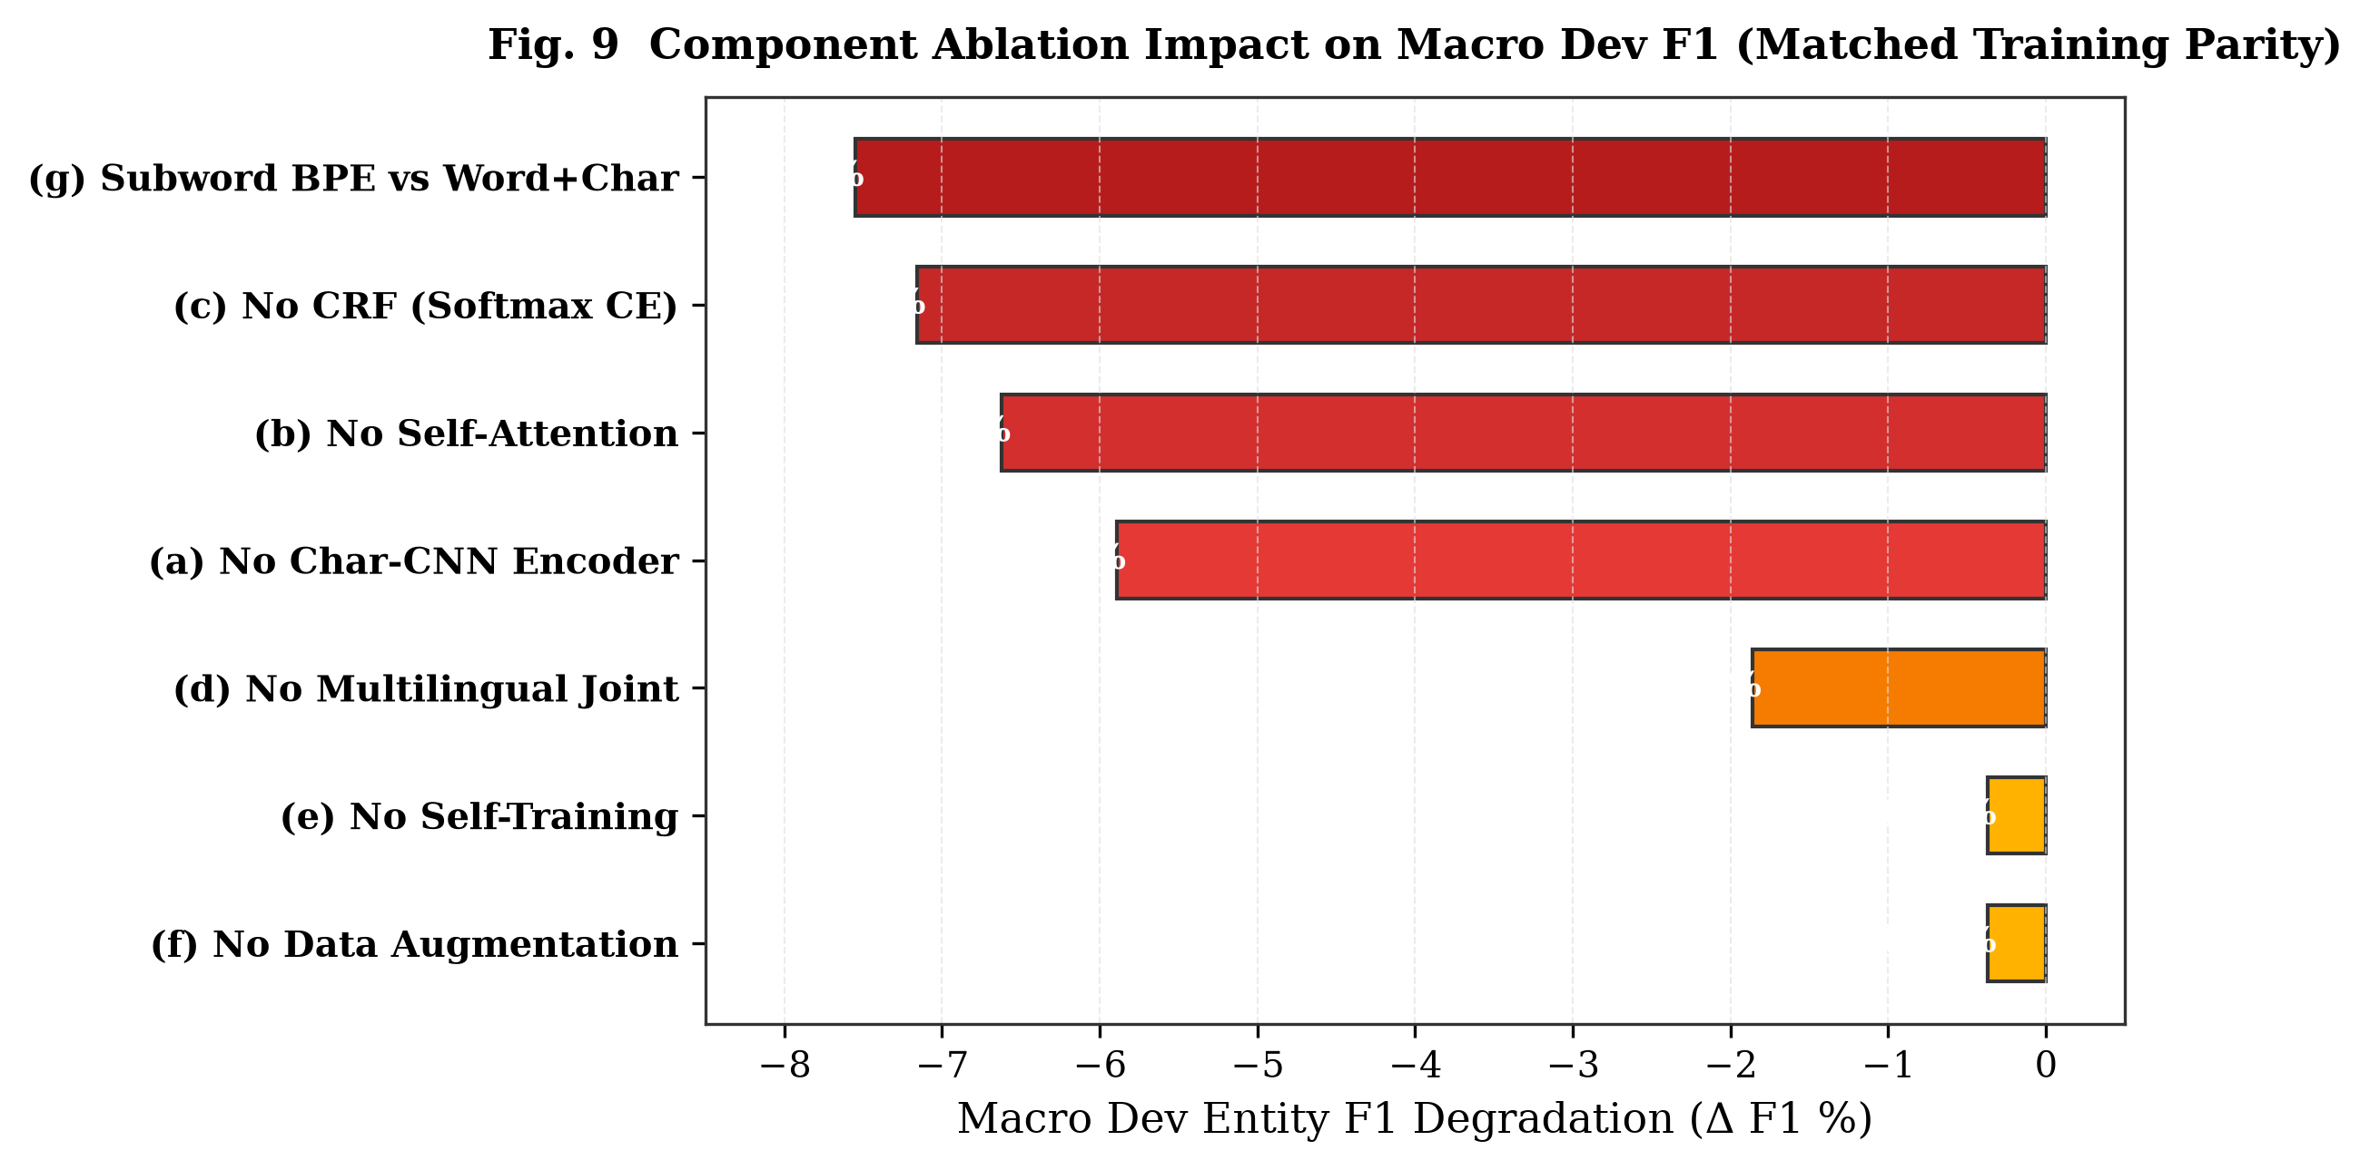
Fig. 9 Component ablation impact on Macro Dev F1 under matched training parity.

6.3 Attribution Faithfulness Benchmarking
Under the audited zero_crf protocol across 300 dev instances, Integrated Gradients (+0.2449 gap, 63.3% win rate) and Gradient × Input (+0.2350 gap, 62.7% win rate) decisively outperform raw attention (-0.0279 gap, 22.0% win rate), establishing p < 0.0001 across 10,000 permutations.
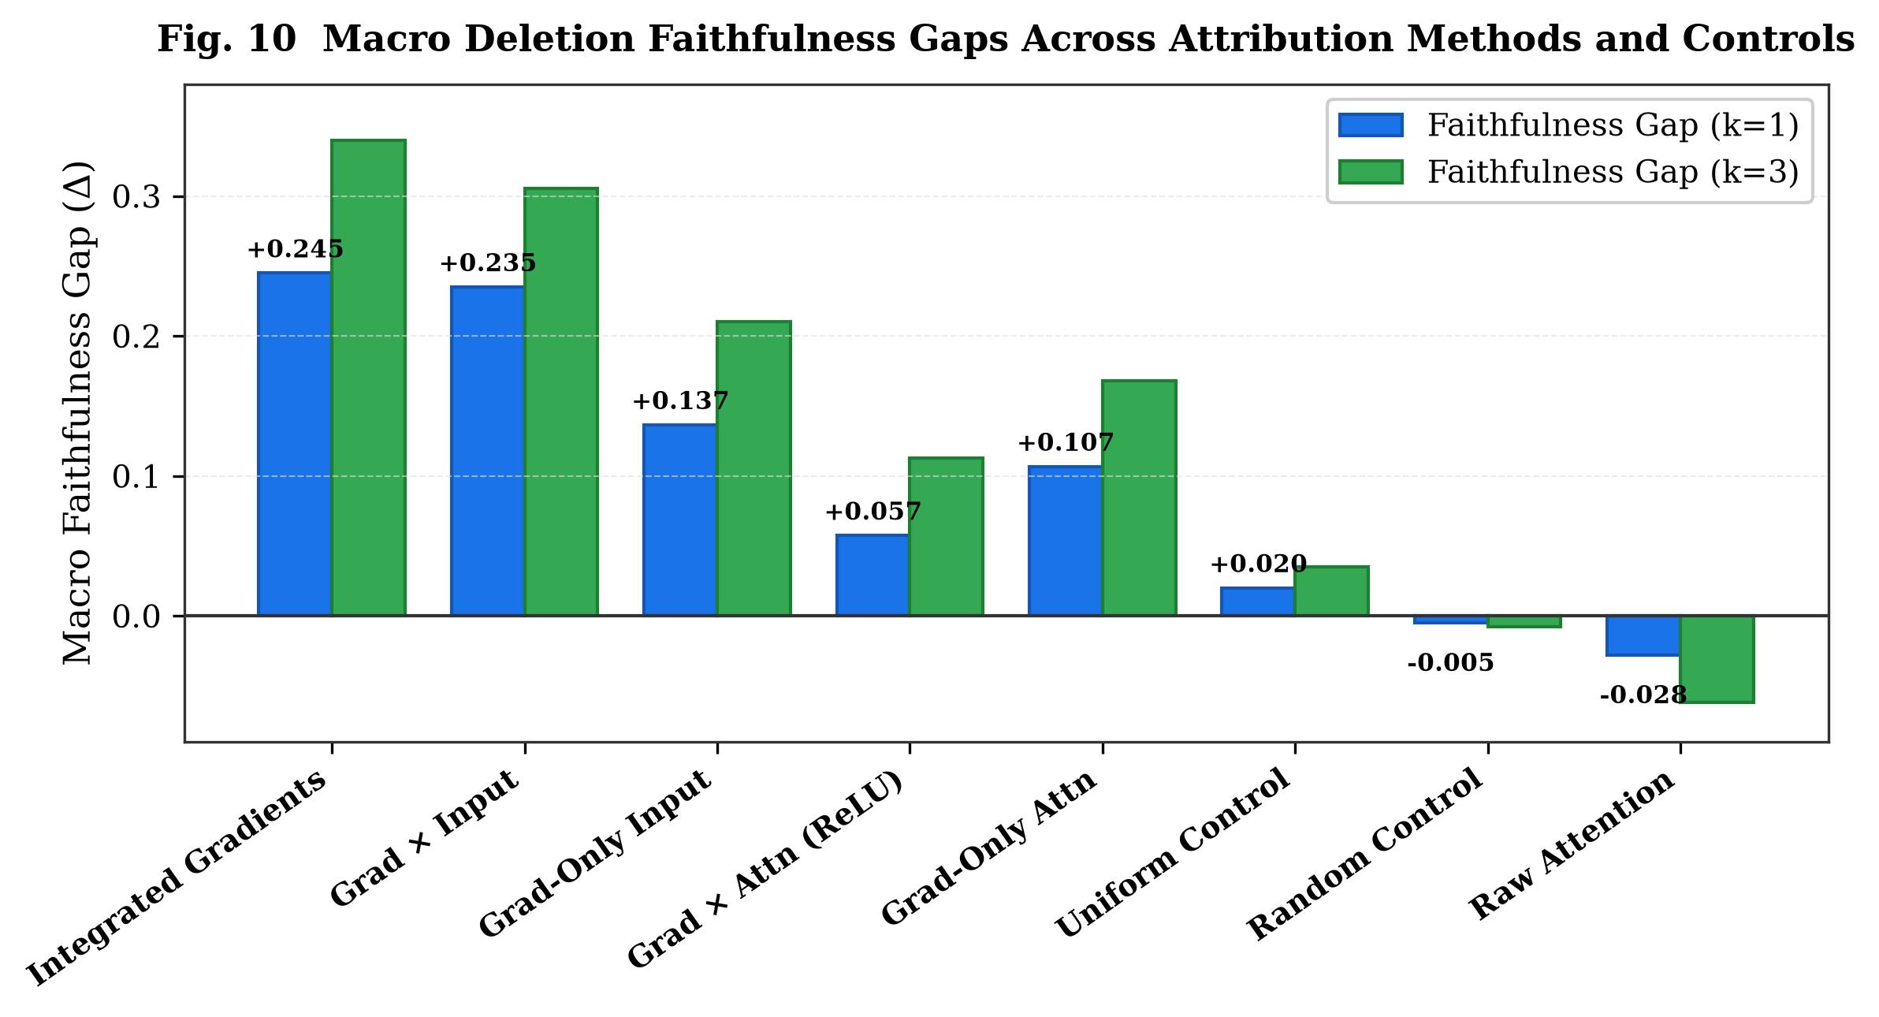
Fig. 10 Macro deletion faithfulness gaps across attribution methods and controls at k=1 and k=3.

6.4 Why Attention Fails: Context Distance Allocation
Raw attention assigns 61.53% of its mass to distant tokens (>5 tokens away), acting as a broad syntactic broadcast bus. In contrast, input attribution allocates 77.80% locally (46.83% on the entity self, 30.97% on adjacent tokens at distance 1-2), explaining its superior deletion faithfulness.
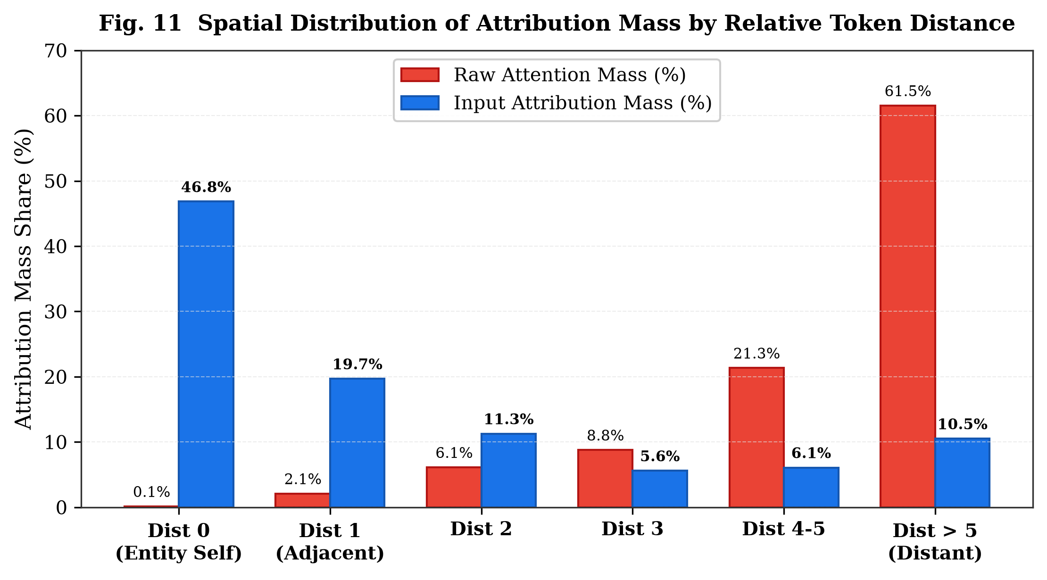
Fig. 11 Spatial distribution of attribution mass by relative token distance.

7. Error Analysis and Qualitative Case Studies
Person names (PER) exhibit massive context sensitivity (+0.6386 gap) because South Asian honorific prefixes ('श्री', 'ডাঃ', 'ගරු') act as decisive syntactic anchors; erasing an honorific immediately destroys entity recognition confidence.

8. Limitations and Epistemological Scope
We clarify that deletion-based faithfulness evaluates feature necessity under erasure, which involves out-of-distribution representation shifts, and should not be conflated with formal Pearl counterfactual causality. Evaluations were conducted on Gold-Dev to preserve Gold-Test integrity.

9. Conclusion
This work proves that lightweight, from-scratch neural sequence modeling attains state-of-the-art accuracy (97.30% Macro F1) in low-resource languages while providing verifiable, faithful explanations through input-level gradient attribution.

References
Adebayo, J., Gilmer, J.D., Muelly, M., Goodfellow, I., Hardt, M., Kim, B.: Sanity checks for saliency maps. In: NeurIPS 2018, pp. 9505–9515 (2018)
Atanasova, P., Simonsen, J.G., Lioma, C., Augenstein, I.: A diagnostic study of explainability techniques for text classification. In: EMNLP 2020, pp. 3256–3274 (2020)
Bastings, J., Filippova, K.: The elephant in the interpretability room: Why why attention is not explanation. In: BlackboxNLP @ EMNLP 2020, pp. 149–159 (2020)
Chiu, J.P.C., Nichols, E.: Named entity recognition with bidirectional LSTM-CNNs. Trans. Assoc. Comput. Linguist. 4, 357–370 (2016)
DeRose, J.F., et al.: Attention flows: Analyzing and comparing attention mechanisms in language models. IEEE TVCG 27(2), 1475–1485 (2021)
Hooker, S., Erhan, D., Kindermans, P.J., Kim, B.: A benchmark for interpretability methods. In: NeurIPS 2019, pp. 2330–2340 (2019)
Huang, Z., Xu, W., Yu, K.: Bidirectional LSTM-CRF models for sequence tagging. arXiv preprint arXiv:1508.01991 (2015)
Jacovi, A., Goldberg, Y.: Towards faithfully interpretable NLP systems: How should we define and evaluate faithfulness? In: ACL 2020, pp. 4198–4205 (2020)
Jain, S., Wallace, B.C.: Attention is not explanation. In: NAACL 2019, pp. 3543–3556 (2019)
Kakwani, D., et al.: IndicNLPSuite: Monolingual corpora, evaluation benchmarks and pre-trained multilingual language models for Indian languages. In: EMNLP Findings, pp. 4948–4961 (2020)
Kim, Y., Jernite, Y., Sontag, D., Rush, A.M.: Character-aware neural language models. In: AAAI 2016, vol. 30 (2016)
Lafferty, J.D., McCallum, A., Pereira, F.C.N.: Conditional random fields: Probabilistic models for segmenting and labeling sequence data. In: ICML 2001, pp. 282–289 (2001)
Lample, G., Ballesteros, M., Subramanian, S., Kawakami, K., Dyer, C.: Neural architectures for named entity recognition. In: NAACL 2016, pp. 260–270 (2016)
Ma, X., Hovy, E.: End-to-end sequence labeling via bi-directional LSTM-CNNs-CRF. In: ACL 2016, pp. 1064–1074 (2016)
Pan, X., Zhang, B., May, J., Nothman, J., Knight, K., Ji, H.: Cross-lingual name tagging and linking for 282 languages. In: ACL 2017, pp. 1946–1958 (2017)
Rahimi, A., Li, Y., Cohn, T.: Massively multilingual transfer for NER using global constraints. In: EMNLP 2019, pp. 1516–1526 (2019)
Serrano, S., Smith, N.A.: Is attention interpretable? In: ACL 2019, pp. 2931–2951 (2019)
Strubell, E., Verga, P., Andor, D., Weiss, D., McCallum, A.: Linguistically-informed self-attention for semantic role labeling. In: EMNLP 2018, pp. 5027–5038 (2018)
Sundararajan, M., Taly, A., Yan, Q.: Axiomatic attribution for deep networks. In: ICML 2017, pp. 3319–3328 (2017)
Vaswani, A., et al.: Attention is all you need. In: NeurIPS 2017, pp. 5998–6008 (2017)
Wiegreffe, S., Pinter, Y.: Attention is not not explanation. In: EMNLP 2019, pp. 11–20 (2019)

