VER-TC-01
Automated CSV

Version | Date | Author/s | Reason for Modification
0.1 | 19-Mar-2026 | Sridevi VR | Initial Version
1.0 | 13-Apr-2026 | Sridevi VR | Final Version

Document Revision History Table

Test Case Approval (Pre-Execution)

 | NAME | TITLE | SIGNATURE | DATE
Author | Sridevi VR | SQA Tester
Approver | Haritha Yellasiri | Sr. Director, SQA & Release Management
Compliance Review By | Maria Limosnero | Sr. Director, Compliance & Quality Assurance

Test Case Identification and Configuration Control:
Test Case ID | VER-TC-MOBILE-Error-019
Test Case Name: | SENSOR Already in Use
Software Item/ Subsystem | SUMMA System / SUMMA Mobile Application
Software Version | 2.0
Configuration Baseline | Will be documented in SDLC-SUMMA1-010 Verification and Validation Summary Report.

Requirements and Risk Traceability:
Requirement Document Information | SDLC-SUMMA1-002 Requirements Specification Document – SUMMA System
Related Requirement ID(s): | 3.7.11 - Start Abbott Libre Activity – Scan Error – Sensor already started
Associated Risk Control ID(s) | Not Applicable

Test Case Objective and Scope:
This test case verifies SUMMA Mobile Application for the below functionality:
- access the Summa Mobile Application and sign in
- add an Abbott activity, start an activity, and scan a sensor
- End Activity and scan the same sensor
- Verify participant receives sensor already in use alert

Expected Result defined for each step constitute the predefined acceptance criteria and provide objective verification evidence for the referenced requirements.
Preconditions and Test Environment:
- The user has access to Chrome or Firefox
- The user has access to the study URL
- A study with the below published schedule should be there in the test environment.
Milestone | Gap
Data Capture | 365
- The below activity is configured.
Activity Name | Activity Type
Freestyle Libre Sensor | Freestyle Libre 3

- Site and subject(s) are created and available in the system prior to test execution.
- The user has a compatible iOS mobile device meeting the following requirements:
- SUMMA Mobile Application installed
- Mobile device is connected to internet
- Bluetooth and required permissions are enabled
- The user has access to compatible Freestyle Libre 3 series sensor(s)
- Compatible sensor is available and properly configured

Acceptance Criteria:
The Expected Result column defines the predefined acceptance criteria for each test step. A step is considered passing when the observed result meets the Expected Result without deviation.

Req.  # | Step  No. | Test Procedure | Expected Result | Pass  /Fail | Comments
 | 1 | Load the Automated CSV Application URL into the browser.  Note down the URL below: | The Automated CSV Application login page loads successfully without any system error and displays:  • Username field  • Password field  • Login button (enabled) | Pass | Not Applicable
 | 2 | Enter a valid Username.  Enter a valid Password.  Click the Login button. | The user is logged into the Automated CSV Application successfully.  The Organization page should be displayed  Evidence_Step_2 | Pass | Not Applicable
 | 3 | Click on new Organization button | User should be able to see the  Organization name  Organization Code  Create Button | Pass | Not Applicable
 | 4 | Enter valid Organization name Enter valid Organization Code  Click on create Button | New Organization is created  Evidence_Step_4 | Pass | Not Applicable
 | 5 | Click on the created organization | The user is redirected to the Project page successfully.  The Project page is displayed without any system error. | Pass | Not Applicable
 | 6 | Click on create Project | User should be able to see the  Project Code *  Project Name *  System Name *  GxP Relevant  Initial Release Details  Release Name *  Start Date *  End Date *  Create project Button* | Pass | Not Applicable
 | 7 | Enter a valid Project Code.  Enter a valid Project Name.  Enter a valid System Name.  Select GxP Relevant.  Enter valid Initial Release Details.  Enter a valid Release Name.  Select a valid Start Date.  Select a valid End Date.  Click the Create Project button. | New Project is Created  Evidence_Step_7 | Pass | Not Applicable
 | 8 | Click on created Project | Requirement upload page is displayed | Pass | Not Applicable
 | 9 | Upload the following document  Requirement template  TestCase template  TestExecution template  Defect template | All selected documents are uploaded successfully without any system error.  The uploaded documents are displayed in the document list/grid with the correct file names.  Evidence_Step_9 | Pass | Not Applicable
 | 10 | Click on publish | User should be able to generate Rtm page | Pass | Not Applicable
 | 11 | Select the Requirement Template radio button and click Next.  Select the Test Case Template radio button and click Next.  Select the Test Execution Template radio button and click Next.  Select the Defect Template radio button and click Next.  Click Generate Traceability Matrix. | The Requirement Template is selected successfully and the user is navigated to the next screen.  The Test Case Template is selected successfully and the user is navigated to the next screen.  The Test Execution Template is selected successfully and the user is navigated to the next screen.  The Defect Template is selected successfully and the user is navigated to the next screen.  The Generate Traceability Matrix option is executed successfully and the Traceability Matrix is generated without any system error.  Evidence_Step_10 | Pass | Not Applicable

Objective Evidence
Evidence_Step_2:
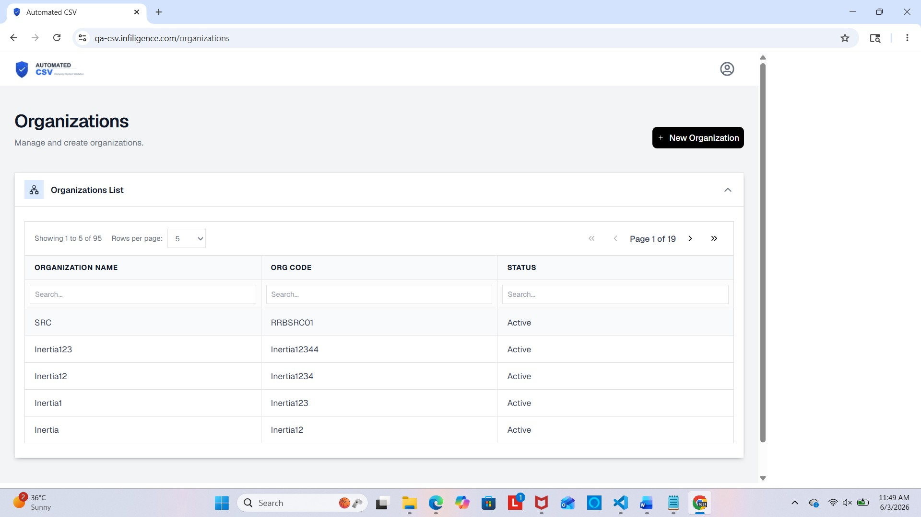

Evidence_Step_4:
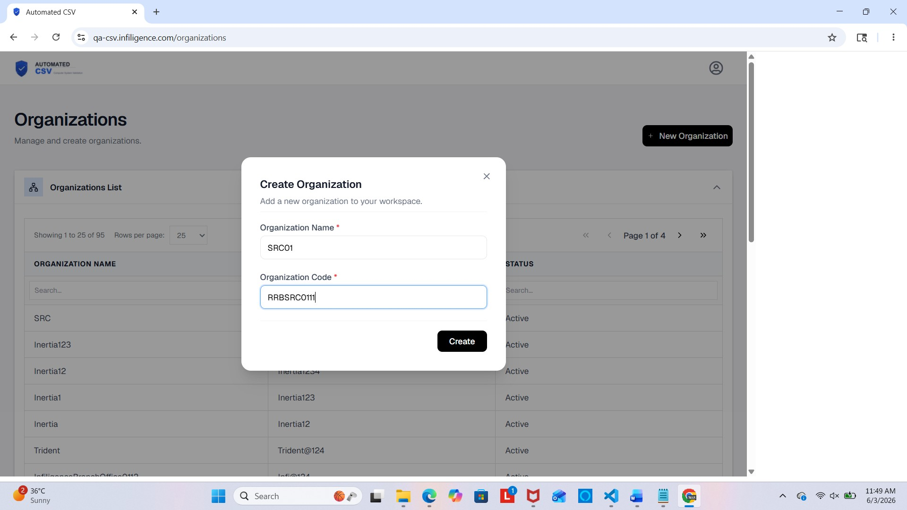

Evidence_Step_7:
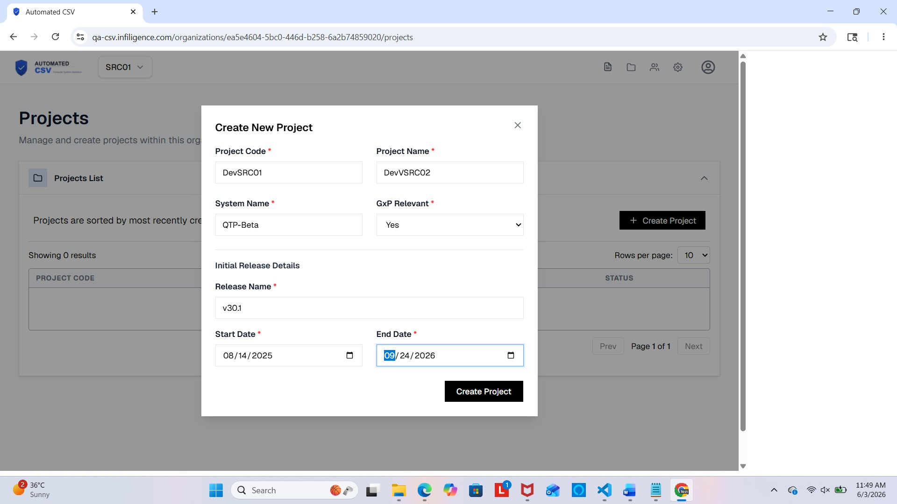

Evidence_Step_9
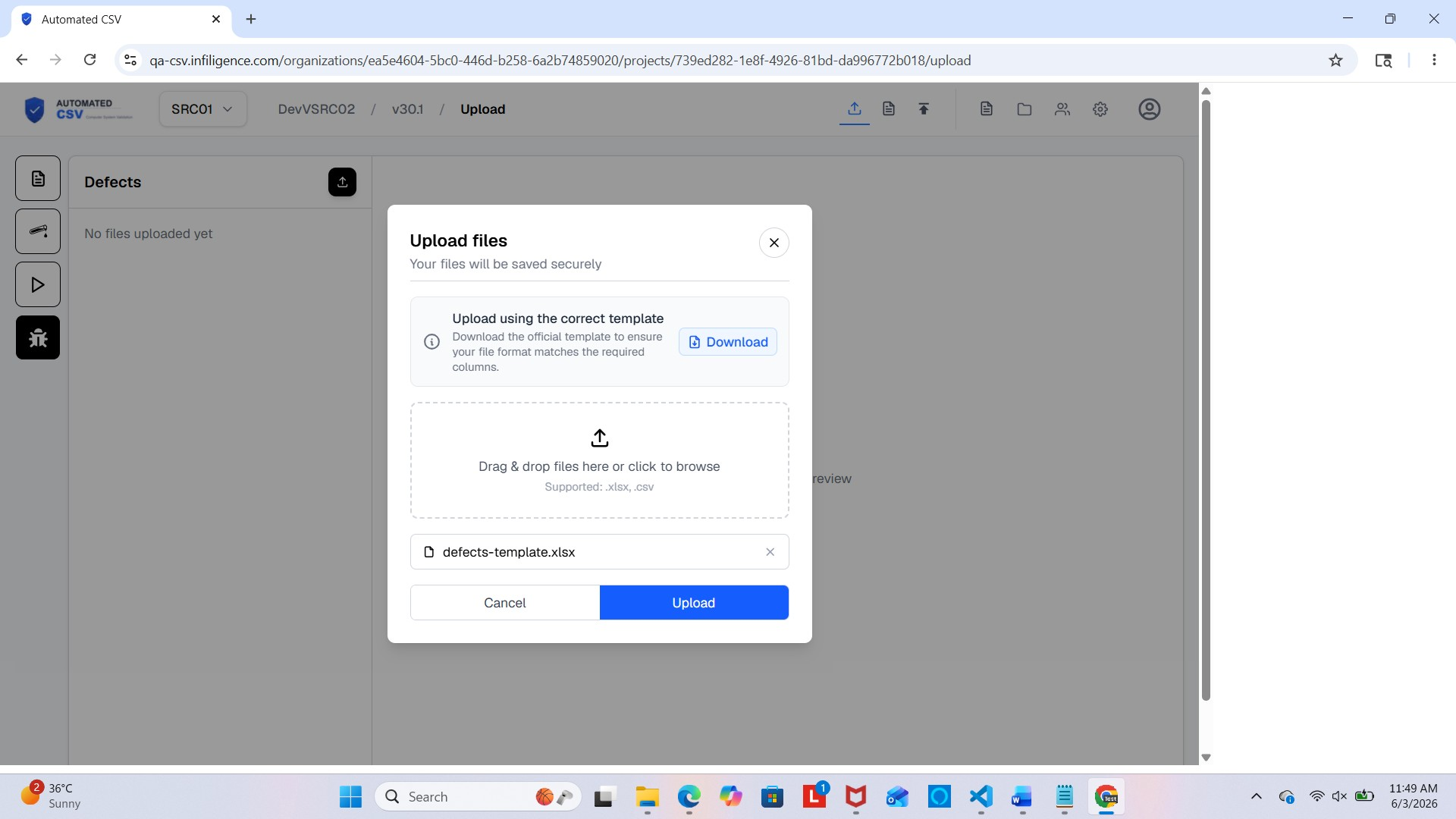

Evidence_Step_10
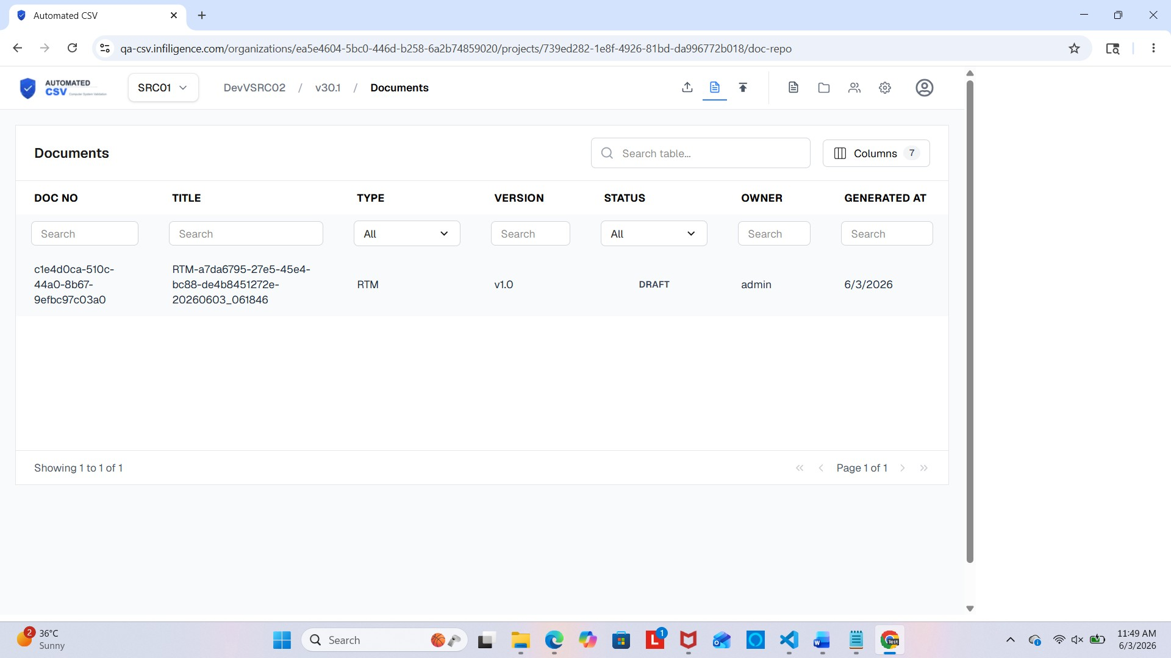

Test Execution Record
Browser Name | Not Applicable
Browser Version | Not Applicable
Mobile Phone | IPhone 17
Mobile OS Version | IOS 26.2.1

Overall Test Case Determination:
​​☐​ Pass
All verification steps meet predefined acceptance criteria without deviation.
​​☐​ Fail
One or more verification steps do not meet predefined acceptance criteria.
☐ Pass with Documented Deviation(s)
One or more deviations were identified; impact assessment completed; residual risk deemed acceptable; corrective action and re-verification status documented.
Deviation Record (If Applicable):
Issue ID | Description | Risk Impact Assessed (Y/N) | Re-Test Required (Y/N) | Status

See this SUMMA System’s Issue Log for detailed analysis

Test Cases Review and Approval (Post Execution):

 | NAME | TITLE | SIGNATURE | DATE
Executed By
Approver
Compliance Review

